Standard Operating Procedures for Managing Nonpoint Source BMP Data
and Other Inputs to the Chesapeake Bay Watershed Model

West Virginia
Purple font indicates edits made after 11/23/21 signed version

Alana Hartman, Potomac Basin Coordinator
West Virginia Department of Environmental Protection
22288 Northwestern Pike
Romney, WV 26757
(304) 822-7266

Alana Hartman, Project Manager, WVDEP – DWWM Date

Katheryn Emery, P.E. Acting Director, WVDEP – DWWM Date

Lucinda Power, US EPA CB Project Manager Date

Carin Bisland, US EPA CBPO QA Officer Date

TABLE OF CONTENTS
GROUP A. PROJECT MANAGEMENT 5
GROUP B. DATA ACQUISITION AND MANAGEMENT 8
B.1 BMPs for Agricultural Land Uses 8
B.2 Resource BMPs 16
B.3 BMPs for Developed Lands 17
GROUP C. FURTHER PROCEDURES 25
Group D. Data Review, Validation and Verification 30
Introduction 30
D.1. AGRICULTURE 32
D.1.1. Introduction 32
D.1.1.1 West Virginia’s Agriculture Verification Program Development Team 32
D.1.1.2 Verification Methods and Procedures (Cost Shared Practices) 33
D.1.1.3 Resource Improvement (non-cost shared) BMPs 37
D.1.1.4 Geographic Scale 37
D.1.1.5 Federal Agency Verification Protocol (USDA, NRCS, & FSA) 37
D.1.1.6 State Agency / Non-Governmental Organizations Protocol 37
D.1.1.7 Adjusted Lifespans 39
D.1.1.8 Programmatic Constraint 39
D.1.1.11 Communications Strategy 39
D.1.1.12 Agriculture BMP Types 40
D.1.2 Structural BMPs 40
D.1.2.1 BMP verification 41
D.1.2.2 BMP validation 41
D.1.2.3 BMP performance 41
D.1.3 Structural/Agronomic BMPs 41
D.1.3.1 BMP verification 41
D.1.3.2 BMP validation 42
D.1.3.3 BMP performance 42
D.1.4 Management BMPs 42
D.1.4.1 BMP verification 42
D.1.4.2 BMP validation 43
D.1.4.3 BMP performance 43
D.1.5 Annual BMPs 43
D.1.5.1 BMP verification 43
D.1.5.2 BMP validation 43
D.1.5.3 BMP performance 43
D.1.6 Lower “Priority” BMP Verification Protocols 43
D.2. FORESTRY 47
D.2.1 Forest Harvesting BMPs 51
D.2.1.1 BMP verification 51
D.2.1.2 BMP validation 52
D.2.1.3 BMP performance 52
D.2.2 Forest Conservation BMPs 52
D.2.2.1 BMP verification 53
D.2.2.2 BMP validation 53
D.2.2.3 BMP performance 53
D.2.3 Expanded Tree Canopy 53
D.2.3.1 BMP verification 53
D.2.3.2 BMP validation 55
D.2.3.3 BMP performance 56
D.2.4 Urban Riparian Forest Buffers 56
D.2.4.1 BMP verification 56
D.2.4.2 BMP validation 56
D.2.4.3 BMP performance 57
D.2.5 Riparian Forest Buffers 57
D.2.5.1 BMP verification 57
D.2.5.2 BMP validation 57
D.2.5.3 BMP performance 58
D.2.6 Tree Planting (Agricultural) 58
D.2.6.1 BMP verification 58
D.2.6.2 BMP validation 58
D.2.6.3 BMP performance 58
D.3. STORMWATER 62
D.3.1 Regulated BMPs (MS4s) 68
D.3.1.1 BMP verification 68
D.3.1.2 BMP validation 69
D.3.1.3 BMP performance 69
D.3.2 Semi-regulated BMPs 70
D.3.2.1 BMP verification 70
D.3.2.2 BMP validation 71
D.3.2.3 BMP performance 71
D.3.3 Non-regulatory BMPs 72
D.3.3.1 BMP Verification 72
D.3.3.2 BMP validation 72
D.3.3.3 BMP performance 73
D.3.4 Legacy BMPs 73
D.4. STREAM RESTORATION 78
D.4.1 BMP verification 80
D.4.2 BMP validation 81
D.4.3 BMP performance 81
D.5. WETLAND RESTORATION 83
D.5.1 BMP verification 86
D.5.2 BMP validation 87
D.5.3 BMP performance 87
D.5.4 Answers to wetlands evaluation questions listed on page 52 of the BMP Verification Panel’s August 7, 2015 report to the Partnership 87
D.6. SEPTIC SYSTEM BMPs 90
D.6.1. De-Nitrifying Septic Systems 90
D.6.2. Connections to Public Sewer 90
D.6.3. Septic System Pumping 90
D.7. BMPs owned or operated by Federal agencies, facilities, and landowners 91
TABLE 14. MAPPING OF JURISDICTION BMP VERIFICATION PROTOCOL COMPONENTS TO THE RELEVANT QAPP SECTIONS (SUGGESTED IN APPENDIX Q OF VERIFICATION FRAMEWORK) 92
REFERENCES 94
APPENDIX A: 2011 BMP REPORTING WORKSHEET.XLS 95
APPENDIX B: DESCRIPTION OF “AGGREGATED NRCS AND FSA DATA FOR ANNUAL PROGRESS REPORTING” 96
APPENDIX C: WV AGRICULTURE BMP DATABASE USER’S GUIDE 98
APPENDIX D: WEST VIRGINIA’S CUSTOM NEIEN APPENDIX WVCustom_NEIEN_NPS_BMP_P6_Appendix_111721.pdf 131
APPENDIX E: PRACTICE REVIEW FORM USED BY NRCS STAFF 134

GROUP A. PROJECT MANAGEMENT

Project Staff and Organization:
1. West Virginia Department of Environmental Protection (WVDEP) – Alana Hartman, Potomac Basin Coordinator (PBC), is the coordinator for this project and collects septic BMP data and information from local governments. Teresa Koon requests data from a USDA Forest Service contact. Samuel Canfield, Urban BMP Specialist (UBS), manages the WV Stormwater BMP Database and assesses the presence and condition of post-construction stormwater BMPs. Environmental Enforcement provides Notices of Termination to the UBS to identify completed projects ready for post-construction BMP verification.

The PBC will check the new entries in the Stormwater BMP database, and the UBS will check the new entries in the NPS BMP Database. See Group C below for descriptions of these QA/QC functions.

2. West Virginia Conservation Agency (WVCA) – Cindy Shreve serves as the Conservation Services Manager North and oversees data collection for the agency, including litter transport from private vendors and other grant- and state-funded agricultural BMP programs. Barbara Elliott and Amy Henry, Conservation Specialists, assist with submitting agricultural BMP data from the Chesapeake Bay grant-funded projects and Agricultural Enhancement Program (AgEP) in the Eastern Panhandle Conservation District. Ben Heavner, Conservation Specialist, assists with the agricultural BMP data collection for the relevant programs within the Potomac Valley Conservation District.

3. West Virginia Department of Agriculture (WVDA) – Matt Monroe, Assistant Director - Environmental Programs, will assist in overseeing WVDA’s agricultural BMP data collection. Jerry Ours, the West Virginia Nutrient Management Coordinator, assists WVCA with collecting poultry litter transport data, contributes to WVDA’s nutrient management plan tally, and checks the accuracy and completeness of nutrient management data. Mark Hedrick, Jason Dalrymple, Gina Alt, and Johnny Halterman, Nutrient Management Specialists, contribute to WVDA’s nutrient management plan tally. See section D.1.1 for additional staff involvement.

4. Farm Service Agency (FSA) – Kelly DeLucy and Mike Taylor support the collection and interpretation of FSA data. Data collection includes quarterly reports from county offices starting in mid-2012, which capture the date, length, width, and other details of each CREP contract. This will allow us to divide the year into the EPA-requested timeframe (July-June).

5. Natural Resources Conservation Services (NRCS) - local staff may respond to requests from WVCA or WVDEP staff for information.

6. Cacapon Institute – Frank Rodgers reports to DEP any BMPs installed at schools in WV’s Potomac Basin through the Potomac Headwaters Leaders of Watersheds (PHLOW) program. Frank Rodgers submits tree planting data from the CommuniTree Program to Alana Hartman.

7. Trout Unlimited – Dustin Wichterman or Ryan Cooper report to the DEP any BMPs installed through their work in the Potomac Counties of West Virginia.

8. County Health Departments (sanitarians or administrative personnel) providing information -- Berkeley County (Martinsburg), Grant County (Petersburg), Hampshire County (Augusta), Hardy County (Moorefield), Jefferson County (Charles Town), Mineral County (Keyser), Morgan County (Berkeley Springs), Pendleton County (Franklin).

9. Federal Facilities potentially providing information -- These facilities are listed in Appendix F of WV’s Watershed Implementation Plan, http://www.wvchesapeakebay.us/WIP/WIP.cfm

10. County governments potentially providing information:
Berkeley County*: Martinsburg, WV (Zack Walburn, Berkeley Co. Public Service Stormwater District)
Grant County: Petersburg, WV (Commission President)
Hampshire County: Romney, WV (County Commission staff)
Hardy County: Moorefield, WV (Melissa Scott, Planner)
Jefferson County: Charles Town, WV (Roger Goodwin, Chief County Engineer)
Mineral County: Keyser, WV (Commission President)
Morgan County: Berkeley Springs, WV (Planner)
Pendleton County: Franklin, WV (Commission President)

11. Municipalities potentially providing information:
Hedgesville, WV (Mayor)
Martinsburg, WV* (Jeff Wilkerson, Public Works Director)
Bayard, WV (Mayor Durst)
Petersburg, WV (Richard Harper)
Romney, WV (Mayor Keadle)
Capon Bridge, WV (Mayor Turner)
Moorefield, WV (Rick Freeman, City staff)
Wardensville, WV (Mayor Orndoff-Sayers)
Bolivar, WV (Mayor)
Charles Town, WV (City Staff)
Harpers Ferry, WV (Christy Huddle, Tree Committee chairperson)
Ranson, WV (City Staff)
Shepherdstown, WV (Frank Welch, Public Works)
Carpendale, WV (Mayor Lambert)
Elk Garden, WV (Mayor Droppleman)
Keyser, WV (Mayor Tillman)
Piedmont, WV (Mayor Boggs)
Ridgeley, WV (Mayor)
Bath (Berkeley Springs), WV (Debra Peck, Town Clerk)
Paw Paw, WV (Ron Davis)
Franklin, WV (Mayor Horan)

*Berkeley County and Martinsburg are the only local governments with MS4 permits. A third MS4 permittee in WV’s Chesapeake Bay watershed is the Division of Highways, with Stephen Sites as our contact.

12. Data are also potentially collected from:
- Watershed Associations
- Land Trusts and county Farmland Preservation programs
- Conservation Districts
- Public Service Districts
- Region 9 Economic Development Council, Megan Diehl

Project Objectives/Background:
The objective is to supply annual, nonpoint source BMP implementation data for inclusion into the Chesapeake Bay Watershed Model (CBWM) annual progress evaluations. We aim to count, as accurately as possible, the number and kinds of BMPs being implemented in the eight-county Potomac Basin of West Virginia. One reason is to obtain credit for, and document in one place, the worthy water quality improvement work carried out by multiple public and private entities in West Virginia. Another reason is so that the CBWM will reflect reality as closely as possible, and any assessments made by using the model will be as true as possible. Data collection occurs approximately July through November each year (due on December 1), gathering data about implementation that occurred the previous (July through June) year. Since West Virginia began participating in the Chesapeake Bay Program (CBP), we have continually expanded and refined our methods for collecting this data. We have done so while communicating with the CBP’s Watershed Modeling tools team and with representatives of other jurisdictions who participate in the workgroups. We have always used the best, most accurate, most detailed and reasonably attainable data, and we welcome suggestions for improvement.
- The BMP data we plan to report includes: implementation of a new BMP; maintenance of an existing BMP (not to be reported as a new practice); or renewed practices such as nutrient management plans.
- We do not plan to report existing practices in a new year under a new BMP name.
- With the exception of Conservation Tillage, BMPs’ units will be tracked directly. Units will not be calculated by estimating a percentage of total acres available.

Project Description and Schedule:
The purpose of the project is to produce, as accurately as possible, a count of BMPs installed each year. Data collection begins with the PBC contacting the personnel listed above during the summer via phone calls and e-mail, to remind them to initiate their respective data-gathering tasks.

The CBP annually calls for data from federal facilities using a template we provided: “Federal Facilities Reporting Data Template WV_06122014.xlsx.” If WVDEP receives data from the federal facilities, WVDEP will report the BMPs through NEIEN as appropriate. If they do not provide us with these data, we will still capture some stormwater management information from any projects one acre or greater, because they would have had to seek WVDEP’s Construction Stormwater Permit.

To seek data on developed lands BMPs that other databases, e.g., disturbance less than one acre, might have missed, WVDEP staff mails/emails an urban/suburban BMP worksheet to each of 8 counties and 21 incorporated municipalities, except Berkeley County and the City of Martinsburg (both MS4 permittees). This worksheet is provided as Appendix A. We may also use the annual reports from the MS4s to extract data. The MS4 permit requires permittees to inventory and track stormwater management practices deployed at new development and redevelopment projects; additional restoration practices, e.g., tree planting, may also be included.

For many of the agriculture BMPs, we receive data known as the “Aggregated NRCS and FSA data for Annual Progress Reporting” in October or November from Olivia Devereux. Details about its source and aggregation principles are provided in Appendix B. We share this dataset with representatives from the agriculture agencies and work out problems it raises, if any. Additional data is from the WVCA’s Chesapeake Bay funded projects and Agricultural Enhancement Program (AgEP), which support West Virginia’s agriculture community through the implementation of cost-share practices to reduce soil erosion, providing alternative water for livestock, and improving the productivity of agriculture acres. These programs are administered by the local Conservation Districts with assistance from the West Virginia Conservation Agency. Financial and technical assistance are offered as incentives to implement BMPs.

This project is considered ongoing because reporting to the CBP is required annually.

Geographic reporting units are by county, or in some cases by latitude/longitude point location if it is known. Urban Stormwater BMPs are reported with lat/long, except for some voluntary BMPs, which are summarized by county to protect privacy.

To ensure our entries use the proper titles of BMPs and measurement names, we refer to the “NEIEN NPS BMP P6 Appendix”, which is often updated and posted at http://webservices.chesapeakebay.net/schemas/. Included as Appendix D is a table based on that NEIEN Appendix, but cropped and annotated for WV’s use, “WVCustom_NEIEN_NPS_BMP_P6_Appendix_111721.pdf”.

GROUP B. DATA ACQUISITION AND MANAGEMENT
The rationale for collecting data on each of these BMPs is because they are credited in the Chesapeake Bay Watershed Model, unless otherwise noted below.

B.1 BMPs for Agricultural Land Uses

Definitions are from “CASTSourceData 8-24-2015.xlsx” accessed at https://cast.chesapeakebay.net/Home/SourceData , and Chesapeake Bay Program. 2018. Chesapeake Bay Program Quick Reference Guide for Best Management Practices (BMPs): Nonpoint Source BMPs to Reduce Nitrogen, Phosphorus and Sediment Loads to the Chesapeake Bay and its Local Waters, accessed at https://www.chesapeakebay.net/documents/BMP-Guide_Full.pdf.

Beginning in Progress Year 2012, we use some of the data provided to us by Olivia Devereux, known as the “Aggregated NRCS and FSA data for Annual Progress Reporting.” Details about its source and aggregation principles are in Appendix B. Therefore, we have assigned NRCS and FSA practice codes to CBP-defined practice names, as listed below. This source is denoted by “Aggregated NRCS/FSA data” below.

1. BMP name: Off Stream Watering without Fencing (Pasture Alternative Watering/Watering Facility)
Definition: This BMP requires the use of alternative drinking water sources, such as permanent or portable livestock
water troughs placed away from the stream corridor. Implementing off-stream shade for livestock is encouraged where applicable. The water supplied to the facilities can be from any source, including pipelines, spring developments, water wells, and ponds. In-stream watering facilities, such as stream crossings or access points, are not considered in this definition. The modeled benefits of alternative watering facilities can be applied to pasture acres in association with improved pasture management systems such as rotational grazing. This BMP is only applicable for livestock pastures that do not have stream exclusion practices, as pastures that exclude livestock from streams already provide alternative water sources as part of those practices.
NRCS practice(s) counted: 614 (Watering facility)
Source of data: “Aggregated NRCS/FSA data”, WVCA (e.g., Chesapeake Bay grant-funded projects), local NRCS staff
Procedure used to compile data: none
Data analysis: none
Checks for accuracy: Cross-checked with “Aggregated NRCS/FSA data”
Units: NO (number)

2. BMP name: Exclusion Fence with Forest Buffer
Definition: applicable to buffers planted in agricultural pasture settings, which includes installation of exclusion fencing to prevent livestock from grazing and trampling the buffer or entering the stream. Linear wooded areas that help filter nutrients, sediments, and other pollutants from runoff as well as remove nutrients from groundwater. The recommended buffer width is 100 feet, with a 35 feet minimum width required.
FSA practice(s) counted: CP22
Source of data: FSA’s reporting form regarding CREP fencing projects, WVCA (e.g., Chesapeake Bay grant-funded fencing projects), Trout Unlimited’s tally of practices
Procedure used to compile data: Since 2014, FSA has required their county offices to provide practice metrics on the one-time payment incentive form that is submitted to the conservation districts. WVCA staff then utilizes this information to compile data submission for the respective practices. For 2018 Progress, we removed maintenance dates from 1985-2002 (non-CREP) records of “Exclusion Fence with Forest Buffer” that we had entered for the calibration and Historical Data Cleanup effort described below. Therefore, they were no longer considered active in the 2018 Progress (v6) submittal. For the 2003 CREP records, we reduced the Hampshire County amount by the amount shown for 2018 in the “Expired Acreage” tab of the “Aggregated NRCS/FSA data” file, which was 350.9 acres.
Data analysis: Acres are reported
Checks for accuracy: Cross-checked with “Aggregated NRCS/FSA data”
Units: acres; we can now also enter length and width as separate measurements for the same BMP in NEIEN.
Historical Data Cleanup effort 2013-15: The basis for cleaned-up reporting of “Exclusion Fencing with Forest Buffer” was practice “CP22” as reported by USDA Farm Service Agency’s Conservation Reserve Enhancement Program (CREP) records 2001-2014. This is because these CP22 projects are at least 35 feet wide and are managed to result in forested buffers. CREP was generally not present prior to 2003 except in Jefferson County where reported activity occurred in 2001 and 2002. Asterisks in the source report from FSA indicated where FSA identified non-reportable activity (less than x projects in a year). We could not discern practices implemented, or even whether they were CREP or non-CREP. The table “Pasture Fence History 061815.xlsx” shows that we targeted FSA annual and cumulative CP22 values and considered data captured by Herb Peddicord (WV Div. of Forestry staff who checked with local FSA offices), Carla Hardy (WV Conservation Agency staff who is aware of some local CREP projects and works with FSA staff to provide more project measurements in recent years), and Olivia Devereux, (who has access to federal cost-share data and could answer questions as privacy restrictions allowed); final step was to replace asterisks with difference from cumulative report if appropriate (yellow cells). However, FSA cumulative 1996-2014 report still includes asterisks if reporting threshold was not met cumulatively (Morgan Co.).

Some CP21 includes livestock exclusion fencing; FSA staff attempted to capture pasture fence component and found 15 active acres in Grant County and 2.7 active acres in Hampshire County. CP21, by definition, is a filter strip on cropland, and filter strips might not be riparian. The CREP fencing associated with CP21 was to restrict grazing of the filter strip. Because of all the uncertainty, we chose not to include any CP21 in riparian fence assessment.
Non-CREP projects reported by WVCA and Trout Unlimited were also added to NEIEN as “Exclusion Fencing with Narrow Grass Buffers” or “…with Narrow Forest Buffers” as appropriate.

We chose not to adjust history 1985 -2002; this low-level activity was assumed as non-CREP and entered as “Exclusion Fencing with Narrow Grass Buffers.” For 1985-2001, fencing records already in the model “WV Land BMP History.xlsx” 1997, 2002 were distributed equally among years for which we were not given the annual data.
We did not use any “Access Control” or “Fencing” (both NRCS) practices in this historical data set.

2a. BMP name: Exclusion Fence with Grass Buffer
Definition: applicable to buffers planted in agricultural pasture settings, which includes installation of exclusion fencing to prevent livestock from grazing and trampling the buffer or entering the stream. Linear strips of grass or other non-woody vegetation maintained to help filter nutrients, sediment and other pollutants from runoff. The recommended buffer width for buffers is 100 feet, with a 35 feet minimum width required.
NRCS practice(s) counted: 390 (Riparian Herbaceous Cover), 393 (Filter Strip)
FSA practice counted: CP21, known to be streamside and width is 20’ or greater; must be entered as narrow grass buffer unless 35’ minimum width is confirmed.
Source of data: “Aggregated NRCS/FSA data”, WVCA (e.g., Chesapeake Bay -funded fencing projects), local NRCS staff, and Trout Unlimited’s tally of practices
Procedure used to compile data: If 393 can be determined to be streamside, should be entered as narrow grass buffer unless 35’ minimum width is confirmed. If it cannot be determined to be streamside, it cannot be used.
Data analysis: Acreages are summed by county.
Checks for accuracy:
Units: acres; alternatively, length and width can be entered as separate measurements for the same BMP in NEIEN.

2c. BMP name: Exclusion Fence with Narrow Forest Buffer
Definition: applicable to buffers planted in agricultural pasture settings, which includes installation of exclusion fencing to prevent livestock from grazing and trampling the buffer or entering the stream. Linear strips of
wooded areas maintained on agricultural land between the edge of fields and streams, rivers or tidal waters that help filter nutrients, sediment and other pollutants from runoff. Narrow forest buffer strips are between 10 and 35 feet in width.
Source of data: WVCA (e.g., Chesapeake Bay -funded fencing projects), local NRCS staff, Trout Unlimited’s tally of practices
Units: acres

2d. BMP name: Exclusion Fence with Narrow Grass Buffer
Definition: applicable to buffers planted in agricultural pasture settings, which includes installation of exclusion fencing to prevent livestock from grazing and trampling the buffer or entering the stream. Linear strips of grass
or other non-woody vegetation maintained on agricultural land between the edge of fields and streams, rivers or tidal waters that help filter nutrients, sediment and other pollutants from runoff. Narrow grass buffers are between 10 and 35 feet in width.
Source of data: WVCA (e.g., Chesapeake Bay -funded fencing projects), local NRCS staff, Trout Unlimited’s tally of practices
Units: acres

3. BMP name: Animal Waste Management Systems- Livestock
Definition: Practices designed for proper handling, storage, and utilization of waste generated from confined animal operations. Reduced storage and handling loss is conserved in the manure and available for land application.
NRCS practice(s) counted: 313 (Waste storage facility)
Source of data: “Aggregated NRCS/FSA data,” local NRCS staff
Procedure used to compile data: Collect email responses from NRCS staff. For 2018 Progress to determine which 1997-2003 (potentially expiring) structures are still in existence, WVDA staff consulted with NRCS field office staff and WVDA nutrient management specialists for first-hand knowledge.
Data analysis: Number of animals is converted into animal units using table 3.1 of Scenario Builder Documentation (see reference above). The factor used for cow/calf pairs is 1.472 animals per AU.
Checks for accuracy: Confirmed with local NRCS staff
Units: number of animals 🡪 animal units
Historical Data Cleanup effort 2013-15: WVCA intern recorded records of this practice documented in NRCS field office records. Units were Animal Units. WVDEP reported through NEIEN 116 records covering 1998-2011 of livestock structures, including mostly beef, but also dairy, goats, and horses.

4. BMP name: Animal Waste Management Systems-Poultry
Definition: Practices designed for proper handling, storage, and utilization of waste generated from confined animal operations. Reduced storage and handling loss is conserved in the manure and available for land application.
NRCS practice(s) counted: 313 (Waste storage facility)
Source of data: “Aggregated NRCS/FSA data,” local NRCS staff
Procedure used to compile data: Collect email responses from NRCS staff. In the WVDA database, the BMP is called Livestock Waste Management Systems or Poultry Waste Management Systems, with Measurement Name of BEEF_AU and POULTRY_AU. Default AU for a non-generator is 145. For 2018 Progress to determine which structures are still in existence, WVDA staff consulted with NRCS field office staff and WVDA nutrient management specialists for first-hand knowledge.
Data analysis: Number of animals is converted into animal units using table 3.1 of Scenario Builder Documentation (see reference above)
Checks for accuracy: Confirmed with local NRCS staff
Units: number of animals 🡪 animal units
Historical Data Cleanup effort 2013-15: WVCA intern recorded records of this practice documented in NRCS field office records. Units were Animal Units. WVDEP reported through NEIEN 281 records covering 1997-2011 of poultry structures, including broilers, pullets, layers, and turkeys.

5. BMP name: Barnyard Runoff Control/Containment
Definition: Includes the installation of practices to control runoff from barnyard areas. This includes practices such as roof runoff control, diversion of clean water from entering the barnyard, and control of runoff from barnyard areas. Different efficiencies exist if controls are installed on an operation with manure storage or if the controls are installed on a loafing lot without waste storage.
NRCS practice(s) counted: 558 (Roof runoff structures)
Source of data: “Aggregated NRCS/FSA data”, WVCA, local NRCS staff
Procedure used to compile data:
Data analysis: none
Checks for accuracy: Cross-checked with “Aggregated NRCS/FSA data”
Units: # of systems starting in 2014 Progress Year, we report the (sometimes) smaller number from the column labeled RecordCount. For the history, 2012 & 2013 numbers were corrected to follow this protocol.
Historical Data Cleanup effort 2013-15: WVCA intern recorded 1997-2011 records of this practice documented in NRCS field office records, in units of # contracts (which is what we used) and total feet of gutter. In 2010 and 2011 Progress years, however, the Aggregated NRCS/FSA data that was used resulted in possible double counting in certain counties, so those records from WVCA’s intern summary were eliminated.

6. BMP name: Conservation Tillage –Additional Acres
Definition: Conservation tillage involves planting and growing crops with minimal disturbance of the surface soil. Conservation tillage requires two components, (a) a minimum 30% residue coverage at the time of planting and (b) a non-inversion tillage method. Each segment is assigned a default amount of conservation tillage based on historical data from the Conservation Technology Information Center (“Documentation Appendix 6”- reference unclear). Note: short-term expert panel recommendations were approved October 2013. Specifying acres under this BMP adds the specified acres to the historical amount. Only one submission unit may be used per scenario. Some instances of these practices have been reported to us in recent years, but we have not submitted them because the acres are incompatible with the new percent method described below.
Source of data: “Aggregated NRCS/FSA data” – note none has been reported from this source from 2007 on.
Procedure used to compile data: none
Data analysis:
Checks for accuracy:
Units: acres
Historical Data Cleanup effort 2013-15, and beyond: We accepted CTIC numbers to the extent that they were trending upward. When they went the other way, we either retained the previous year’s value until we had specific acres reported (NRCS “Residue Tillage Management” acres – the same as we have previously reported) or we ramped to the latter year to avoid large jumps. One exception is Pendleton Co., where we ramped up the numbers from 0.5 to 0.8 on the advice of county extension agents. In this case, we did not take into account the Residue Tillage Management numbers (column K).
We entered these as the last date of the Progress year (June 30) for the year given, from 1984 through 2015. We used BMP name Conservation Tillage and Measurement Name “Percent Available Land,” with units of “Percent.” We used the same numbers for each county in Progress years 2016-2021.

7. BMP name: Cover Crops
Definition: Cover crops are short-term crops grown after the main cropping season to reduce nutrient and sediment losses from the farm field. The selected crop species and management of cover crops vary based on the farmer’s needs and preferences. This type of cover crop may not be harvested in the spring.
NRCS practice(s) counted: --
Source of data: WVCA’s Chesapeake Bay [“Implementation Grant”]-funded program
Procedure used to compile data: staff enters acreages into a table by county, using measurement names from the approved NEIEN appendix. These describe the crop, planting method, and timing. Within measurement names, they are aggregated by county.
Data analysis:
Checks for accuracy:
Units: acres
Historical Data Cleanup effort 2013-15: We entered into NEIEN a county total for each year (using the last date from each progress year period) from the reporting spreadsheets we used in the past. Most of this BMP data came from NRCS staff c. 2003-2005, then NRCS’ PRS database (looking up practice #340) 2006-2009, then NRCS staff 2010-2011, then USGS agreement 2012-2014. In 2006 there was one entry from the Lost River voluntary BMP assessment. All NRCS data and all other data through 2009 is reported as Measure Name “Area Planted,” which I believe maps to Late Other Wheat, the most conservative cover crop type. Beginning 2009, Agricultural Enhancement Program (AEP) Cover Crop projects were also entered, and for these we recorded more specifics about species, planting type, and timing.

8. BMP name: Commodity Cover Crops
Definition: Cover crops are short-term crops grown after the main cropping season to reduce nutrient and sediment losses from the farm field. Commodity Cover Crops do not receive fall nutrients. The selected crop species and management of cover crops vary based on the farmer’s needs and preferences. Winter cereals such as barley, rye and wheat are often harvested in the spring, unlike many traditional species of cover crops.
NRCS practice(s) counted: 340 (Cover crops) ) – unlike the historical data described above, we entered these NRCS-reported cover crops with measurement name “BARLEY Early NO TILL Commodity” in Progress Year 2018-‘21.
Source of data: “Aggregated NRCS/FSA data”, WVCA’s Chesapeake Bay [“Implementation Grant”]-funded Program
Procedure used to compile data: staff enters acreages into a table by county, using measurement names from the approved NEIEN appendix. These describe the crop, planting method, and timing. Within measurement names, they are aggregated by county.
Data analysis:
Checks for accuracy:
Units: acres

9. BMP name: Grass Buffers
Definition: These practices are only applicable on converted cropland. Linear strips of grass or other non-woody
vegetation maintained to help filter nutrients, sediment and other pollutants from runoff. The recommended
buffer width for buffers is 100 feet, with a 35 feet minimum width required.
9.a. Narrow Grass Buffers: These practices are only applicable on converted cropland. Linear strips of grass or other non-woody vegetation maintained between the edge of fields and streams, rivers or tidal waters that help filter nutrients, sediment and other pollutants from runoff. Narrow grass buffers are between 10 and 35 feet in width.
10. BMP name: Loafing Lot Management
Definition: The stabilization of areas frequently and intensively used by people, animals or vehicles by establishing vegetative cover, surfacing with suitable materials, and/or installing needed structures. This does not include poultry pad installation.
NRCS Practice(s) counted: 561 (Heavy use area protection)
Source of data: “Aggregated NRCS/FSA data,” local NRCS staff, and WVCA’s Chesapeake Bay [“Implementation Grant”]-funded projects.
Procedure used to compile data: Given the caveat in the definition, we do not report the thousands of acres of 561 labeled as “poultry” that show up in our counties in the NRCS/FSA report. New method 2016 Progress: use beef “ac” provided in “Aggregated NRCS/FSA data” but multiply by 145 to get AU. 2017 not reported despite beef entries in NRCS report. 2018 method: report beef acreage (don’t convert to AU) with measurement name “Area Implemented”.
Data analysis: n/a
Checks for accuracy: n/a
Units: acres
Historical Data Cleanup effort 2013-15: West Virginia did not previously report this BMP in Progress submissions. WVCA intern recorded records of this practice documented in NRCS field office records. Units were Animal Units. WVDEP reported through NEIEN 178 records covering 1996-2011.

11. BMP name: Animal Mortality Composting
Definition: A physical structure and process for disposing of any type of dead animal. Composted material is land applied using nutrient management plan recommendations (CAST documentation). Mortality composters involve composting routine mortality in a designed, on-farm facility, with subsequent land application of the compost. This prevents the necessity to bury dead animals that could result in nutrient leachate or the rendering of dead animals for processing into animal feeds or incineration. Mortality composting can be, and is, applied to various species including poultry, swine, and dairy calves (p. 395 MAWP).
NRCS practice(s) counted: 316 (Animal Mortality Composters) also 317 manure (and other organic byproducts) composters
Source of data: “Aggregated NRCS/FSA data”
Procedure used to compile data: none of these practices appear in this report, going back to 2007.
Data analysis: n/a
Checks for accuracy: n/a
Units: systems, but “animal units” seems more appropriate
Historical Data Cleanup effort 2013-15: WVCA intern recorded records of this practice documented in NRCS field office records.

12. BMP name: Non-urban Stream Restoration
Definition: This BMP maintains the integrity of streambanks by preventing or controlling erosion.
NRCS practice(s) counted: 580 Streambank and Shoreline Protection
Source of data: “Aggregated NRCS/FSA data” with follow-up to local NRCS staff to learn what kind of project it was. Combined with county level Trout Unlimited, Canaan Valley Institute, and WVCA data, with staff follow-up to learn type of project.
Procedure used to compile data: WVCA staff enters feet of each project into a table with county, submits overall spreadsheet of WVCA data to DEP’s PBC.
Data analysis: Feet from “Aggregated NRCS/FSA data” report sometimes cannot be reported due to possible double counting by other projects from T.U. and WVCA.
Checks for accuracy:
Units: feet

13. BMP name: Nutrient Management Plan (Nutrient Management Core N)
Definition: The implementation of a site-specific combination of nutrient source, rate, timing, and placement into a strategy that seeks to optimize agronomic and environmentally efficient utilization of nitrogen (N) and phosphorus (P). Improvement in nutrient-use efficiency necessitates documentation of nutrient management implementation
strategies that are suitable for independent verification. The BMPs for Nutrient Management are categorized into Core Nutrient Management and Supplemental Nutrient Management for both N and P. In Nitrogen Core Nutrient Management, applications of nitrogen are made in accordance to all of the following elements as applicable:
• Land-grant university recommendations for nitrogen applications at field level.
• Manure analysis and volume, using either test or book values to determine nitrogen content.
• Calibration of spreader/applicator.
• Yield estimates and cropping plan at the field level.
• Cropping and manure application history at the field level.
NRCS practice(s) counted: 590 (Nutrient management), on Crop and Pasture land uses.
Source of data: NRCS (“Aggregated NRCS/FSA data”): in 2021, WVCA staff may also begin to provide data to WVDA on plans they complete; WVDA calculates precise number of acres in plans for 3 year fiscal (standard Bay reporting cycle). Beginning in 2014, all certified nutrient management planners are required to submit an annual report to WVDA to enable WVDA to count nutrient management plans in which its staff were not involved. For Progress 2016, WVDA asked non-WVDA planners to submit their data as of the end of the fiscal year, i.e. 6/30/16 (despite the fact that those planners are already required to tally their numbers for the state at the end of each calendar year.) WVCA acres are captured through a verbal request, but they had none in progress year 2016. WVDA sent email request to NRCS District Conservationists asking for their fiscal year NMP numbers, and received some data from Hampshire County. Anything missed by not requesting numbers from other planners would be very small; will show up in end of year reporting and go on next year’s report.
Procedure used to compile data: staff enters acreages into a table by county
Data analysis: Acreages provided by WVDA are added across all 8 counties by land use (crop, hay, and pasture). Then the NMP acreages are entered by county and land use.
Checks for accuracy: The WVDA Nutrient Management Coordinator is familiar with the few planners who submit reports from outside the agency and uses best professional judgment to identify anomalies in the data.
A secondary check occurs when data is entered into the WVDA BMP database by the Assistant Director.

Units: acres
Historical Data Cleanup effort 2013-15: 1) source: Poultry Integrator - We used numbers from one poultry company that represented most of the acreage that experienced planning at the time. The records used were sampling records, which don’t record the start and end dates of the plans. County totals for each county from 2004-08 show percentages of approximately:
Hardy = 64%, Pendleton = 14%, Hampshire = 9%, Grant = 8%, Mineral = 5%
But since I was not given the county annual totals, I submitted the total numbers I was given, broken down by these county percentages. Also, not knowing which plans included the P index and other details (most of the crop), we called them all “Tier 1.”

The planner involved in 2004-2008 attests the land uses to which NMPs are applied have stayed roughly the same through the present in these Potomac Valley counties. We still need to check whether for 1997-2004 that was also the case. Highest pasture (in 2013 Progress year the WVDA & non-agency planners’ totals resulted in 44%), then hay (31%), then crop (25%).
Data are in “WV NMP Historical data cleanup 2015_proportions_used.xlsx” These were entered with 12/31/xxxx of the year in which they appeared on the spreadsheet from WVDA.

2) source: WVCA’s North Fork Project – I was given acres of each NMP, all of which were in Pendleton County. If pasture plus another land use was listed, I entered it under pasture, the more conservative credit. If crop & hay were both listed, I entered it under crop, because I believe crop and hay get the same credit. Each NMP was considered to get credit for the year it was listed (entered as 12/31/xxxx) and also the following 2 years, so I entered each one twice more with the subsequent years assigned, so that the land uses would stay correct. In some cases I was able to lump some NMPs if the year, county and land use were the same.

3) source: NRCS – In 2013, WVCA staff looked at paper records in NRCS field offices and recorded acres of NMPs written. We used these data, aggregated to county. In addition, NRCS staff submitted their 1985-2003 acres or estimated acres of NMPs (and many other BMPs) by field office around 2004 when the Bay Program asked for historical data. We assumed each District Conservationist or other staff entered reasonable numbers at that time. For the Martinsburg field office, we assigned half the acres to Berkeley Co. and half to Morgan Co. The numbers from this historical estimation effort were used unless we had a number from the data-gathering effort in 2013, when WVCA staff looked at paper records in NRCS field offices; data from the 2013 effort were considered superior and used whenever both were available for a given county/year. Finally, each county’s annual total of new plans was entered in NEIEN for that year, but also carried forward into the overall county total for the next two years thereafter. We called this our 3-year running total. These are the numbers we entered in NEIEN to represent NRCS NMPs for this period, each representing an annual snapshot of plans that were active. (how broke down by land use, if at all?) For NRCS from these sources, we had to discard the 2010 numbers because they are already in the 2010 numbers below – maybe had to discard 2011-2013 also because can’t be sure not already counted.

4) source: WVDA and some NRCS, more recent years -
2010 numbers are re-created in NEIEN using new “Tier 1 Acres,” and are taken from NRCS report and WVDA report, which were mutually exclusive that year. These were entered with a date of 06/30/2010.
2011 and 2012 are re-created in NEIEN using new “Tier 1 Acres,” and I just copied them from the most recent NEIEN progress run report.

14. BMP name: Prescribed Grazing (Precision Rotational Grazing)
Definition: This practice utilizes a range of pasture management and grazing techniques to improve the quality and quantity of the forages grown on pastures and reduce the impact of animal travel lanes, animal concentration areas or other degraded areas. PG can be applied to pastures intersected by streams or upland pastures outside of the degraded stream corridor (35 feet width from top of bank). The modeled benefits of prescribed grazing practices can be applied to pasture acres in association with or without alternative watering facilities. They can also be applied in conjunction with or without stream access control. Pastures under the PG systems are defined as having a vegetative cover of 60% or greater.
NRCS practice(s) counted: 528 (prescribed grazing) & 528A on Crop and Pasture land uses.
Source of data: “Aggregated NRCS/FSA data” and WVCA staff (for Bay-grant funded divisional fence and prescribed grazing practice)
Procedure used to compile data: Cross-checked with “Aggregated NRCS/FSA data”
Data analysis: Acreages are summed by county.
Checks for accuracy:
Units: acres

15. BMP name: Riparian Forest Buffers (agricultural land)
Definition: These practices are only applicable on converted cropland. Linear wooded areas that help filter nutrients, sediments and other pollutants from runoff as well as remove nutrients from groundwater. The recommended buffer width is 100 feet, with a 35 feet minimum width required.
15.a. Narrow Forest Buffers: These practices are only applicable on converted cropland. Linear strips of wooded areas maintained on agricultural land between the edge of fields and streams, rivers or tidal waters that help filter
nutrients, sediment and other pollutants from runoff. Narrow forest buffer strips are between 10 and 35
feet in width.
NRCS practice counted: 391 (Riparian Forest Buffer) Note that none of these have been reported in the “Aggregated NRCS/FSA data,” which goes back to 2007.
Source of data: “Aggregated NRCS/FSA data;” and WVCA may also have acreages from their own projects to add. If so, specific location and other information may be available for separate entry.
Procedure used to compile data: WVCA compiles projects into a tab of overall reporting spreadsheet.
Data analysis: If length and width are provided, acreage is calculated. Acres are summed by county, or in the case of projects whose details are known and that are assured to be not double-counted, they are entered individually.
Checks for accuracy:
Units: acres; we can now also enter length and width as separate measurements for the same BMP in NEIEN.
Historical Data Cleanup effort 2013-15: Please see the first paragraph of the historical data cleanup notes for BMP #2 above, “Stream Access Control with Fencing.” Because of this new method of calling these practices “Exclusion Fencing with Forest Buffer,” we only entered these acres representing CP22 once. CP22 associated with CREP has forest buffers of minimum 35ft width.

16. BMP name: Tree planting (agricultural land)
Definition: Tree planting includes any tree planting, except those used to establish riparian forest buffers, targeting lands that are highly erodible or identified as critical resource areas.
NRCS practice(s) counted: 612 (Tree/Shrub Establishment)
Source of data: “Aggregated NRCS/FSA data”; WVCA may have projects to report periodically.
Procedure used to compile data: In the WVDA database, we entered these as Tree Planting with Measurement Name of Area Planted.
Data analysis: Acreages are summed by county.
Checks for accuracy:
Units: acres; we can now also enter length and width, or number of trees planted, as separate measurements for the same BMP in NEIEN.

17. BMP name: Wetland Restoration
Definition: Agricultural wetland restoration activities reestablish the natural hydraulic condition in a field that existed prior to the installation of subsurface or surface drainage. Projects may include restoration, creation and enhancement acreage. Restored wetlands may be any wetland classification including forested, scrub-shrub or emergent marsh.
NRCS practice(s) counted: 646 (Shallow Water Development & Management), 657 (Wetland Restoration); according to wetland workgroup participants 11/6/13, 656 and 658 are also possibilities. 657 might include rehabilitation.
Source of data: “Aggregated NRCS/FSA data”, Trout Unlimited or USFWS’s Partners for Fish and Wildlife Program might also have some of these to report.
Procedure used to compile data: Email responses from TU or USFWS are used.
Data analysis: Acreages are summed by county.
Checks for accuracy:
Units: acres

18. BMP name: Land Retirement (Conventional Till to Pasture)
Definition: Converts land area to pasture. Agricultural land retirement takes marginal and highly erosive cropland out of production by planting permanent vegetative cover such as shrubs, grasses, and/or trees. Agricultural agencies have a program to assist farmers in land retirement procedures.
NRCS practice(s) counted: 2013 Progress year: Establishment of permanent introduced grasses and legumes
Source of data: “Aggregated NRCS/FSA data”
Procedure used to compile data:
Data analysis: none
Checks for accuracy:
Units: acres

19. BMP name: Manure Transport
Definition: Transport of excess manure in or out of a county. Manure may be of any type—poultry, dairy, or any of the animal categories. Transport should only be reported for county to county transport. Movement within the same county should not be included.
Source of data: WVCA compiles the list. Information is obtained from the litter transfer (CBay funded) program and brokers.
Procedure used to compile data: WVCA enters the tonnage, type, sending county and receiving county into a table.
Data analysis: All data is reported to the Chesapeake Bay Program with the receiving county specified, even if it is within the Chesapeake Bay watershed. Tons are summed by county.
Checks for accuracy:
Units: tons (=2000 lbs)
Historical Data Cleanup effort 2013-15: 2005, 2006 & 2009 we were given receiving counties. From one source in 2009, the sending counties were said to be split between Grant, Hardy and Pendleton, so I split those tonnages equally between those 3 counties. That particular source was said to be broilers and turkeys – I entered them as broilers.
2008 we were not given a receiving county, so I could not enter those data, even though the sources stated the litter was transferred outside the Bay watershed.
Jan.- June 2007 no data were reported.

B.2 Resource BMPs

20. BMP name: Forest Harvesting Practices
Definition(s): Land harvested under Division of Forestry’s (WVDOF’s) permitting process, using Logging Sediment Control Act’s required BMPs.
Source of data: By law, all timber harvest operations are required to notify the WV Division of Forestry. The notifications include, among other items, acreage to be harvested, what type of harvest, location and time period. Data from the notifications are entered into the LONIE system. (Logging Operation Notification, Inspection and Enforcement) The system was developed by the Appalachian Hardwood Center at West Virginia University.
Procedure used to compile data: The LONIE system can be queried to report on a number of different requests and compile them as an Excel spreadsheet. For acreage reporting, we use job start dates only to avoid double counting. WVDOF reports acres to WVDEP staff.
Data analysis: 97% of the timber registration acres are reported for this BMP. Rationale: Occasionally, we do have illegal logging activity that is discovered after the fact and does not get reported. We do not track these because there are others that we never discover. 2% is an estimate of unknown illegal activity that may or may not have BMP’s applied. This number is probably higher in other parts of the state but not a major problem in the Potomac drainage.
Checks for accuracy: See Section D.2.1.
Units: acres
Historical Data Cleanup effort 2013-15: WV DOF staff provided acreage registered under logging permits 2003-2014 and these were entered directly into NEIEN as county totals by year. I assigned each entry the last date of the reporting year. Keeping this method consistent into the present meant that I had to delete each 2011 record that had been in NEIEN and replace them with this new number. My notes indicate that in 2011 we had used 98% of the hvf acreage in the 2010 NA scenario.

21. BMP name: Forest Conservation
Definition(s): Forest land use protected under conservation easement. We realize the BMP guidance from Chesapeake Bay Program says only Maryland is eligible for this BMP at this time, but we still feel this BMP (with above definition) is worth tracking.
Source of data: WVDOF staff contacts the region’s land trusts and other local organizations involved in conserving land, e.g. county farmland protection agencies, to determine the acreage to report in this category. We attempt to track location of acres reported, or a property name, so they will not be double counted in the future.
Procedure used to compile data: Contact organizations and ask whether they oversaw any contracts to this effect and how many acres these contracts represent within each county; add acres within each county.
Data analysis: presumably none needed
Checks for accuracy: Our region is small enough that if we saw an unreasonably large number in any of these categories reported on by counties and municipalities, we could question the location.
Units: acres

B.3 BMPs for Developed Lands

The Phase 6 Chesapeake Bay Watershed Model includes “developed” land uses such as Buildings and other, Roads, Tree Canopy over Impervious, Tree Canopy over Turf Grass, and Construction.

The Stormwater Performance Standard Expert panel reports for New Stormwater Performance Standards for New and Re-Development BMPs and New Stormwater Performance Standards for Retrofit BMPs led to a shift in the way many of the BMPs listed here are reported. BMPs that comply with design standards approved by the CBP as either Runoff Reduction or Stormwater Treatment BMP are reported as New/Retrofit Runoff Reduction/Stormwater Treatment Performance Standard BMPs.

(from p. 12 of above-referenced report, http://www.chesapeakebay.net/documents/Final_CBP_Approved_Expert_Panel_Report_on_Stormwater_Performance_Standards_LONG.pdf).

Design details for many compliant BMPs can be found in the “West Virginia Stormwater Management Design and Guidance Manual,” which can be accessed at http://www.dep.wv.gov/WWE/Programs/stormwater/MS4/Pages/StormwaterManagementDesignandGuidanceManual.aspx. For up to date information regarding acceptable BMPs please visit https://chesapeakestormwater.net/ for more details.

WVDEP has implemented the new “Conforming” performance standard reporting for applicable BMPs with information indicated in blue font in the flowchart that follows. Stormwater BMPs that do not meet the new performance standards, such as Dry (Extended) Detention Ponds will still be reported using the old Non-Conforming method indicated in orange boxes of the flowchart. http://www.chesapeakebay.net/channel_files/19137/attachment_f--flow_charts_for_stormwater_performance_standards.pdf

Historical BMP data cleanup effort 2013-2015
Stormwater BMPs
Prior to 2011, we used to report pledged BMPs that developers put on their Construction Stormwater General Permit applications before beginning a development project. In 2011, WVDEP’s Stormwater Specialist (CBRAP funded) began inspecting, verifying and cleaning up BMPs we’d been reporting since 2006 Progress Year (which began July 1, 2005). Visual inspections were performed using guidance communicated by the Chesapeake Bay Program; more detailed procedures were not yet finalized for WV’s BMP verification program. A stormwater BMP database was developed by TetraTech, and the BMPs we previously kept in spreadsheets were copied to the database. This database was later discontinued, but the information was extracted and is currently being managed as an Excel file periodically brought into a GIS so the map and attributes can co-exist. This project has also involved a summer intern, a WVU GIS intern, and a temporary employee. In 2015, US EPA convinced WV DEP to identify and verify Stormwater BMPs implemented prior to 2006. Due to lack of permitting information, the Stormwater Specialist used local government data, GIS analysis, and in-field observations to identify and verify pre-2006 BMPs.

For the BMP History Cleanup, the coordinates were imported into Google Earth, and using the historical images it was determined whether construction had actually occurred. For sites where a change was identified, a field visit was made to verify presence and performance of BMPs. This resulted in some BMPs being deleted from the system, and others being added. Where coordinates were incorrect, they were corrected prior to field visits using supporting data from the Construction Permit application, aerial photos, and local information when possible. Previously reported BMPs that could not be verified were removed from the Stormwater BMP database. Implementation Date and the latest Inspection Date were recorded for each BMP. Note that inspection dates are all 2011 or later. Due to BMP lifetime issues and crediting, pre-2011 inspection dates reported to NEIEN are fictional for the sole purpose of keeping BMPs active. This was done only for BMPs that were verified for presence and performance between 2013 and 2016, and for which approximate implementation dates could be determined. This method was discussed with and approved by Matt Johnston in 2015.

Impervious area, total drainage area, and volume treated were entered for each BMP. When these values were not explicitly included in the permit information, a hand-drawn outline was made in the field and later drawn on Google Maps or ArcGIS and the area calculation tool generated the total drainage area and impervious area treated. When these data were provided in permit documents, the Stormwater Specialist checked whether they were reasonable during the verification inspection. If they did not seem reasonable, then the method described above was used to correct it. Treatment volume could be calculated using total area and impervious area if the “treated to 1” standard” box was checked on the application. If a different performance standard was indicated in the application, the appropriate calculations were used. Some BMPs, especially older ones, did not have enough data for these calculations; in this case they were reported with the total drainage area (old method). At times, submitted construction drawings were consulted, but this method proved to be too inefficient. If estimates had to be made, they were always made on the conservative side. Additional BMPs were identified visually, but not included in this historical dataset because there was not enough information to warrant reporting them.

Definitions
Definitions are from “CASTSourceData 8-24-2015.xlsx” found at https://cast.chesapeakebay.net/Home/SourceData.

22. BMP name: Wet Ponds and Wetlands (Stormwater Treatment Performance Standard)
Definition: A water impoundment structure that intercepts stormwater runoff then releases it to an open water system at a specified flow rate. These structures retain a permanent pool and usually have retention times sufficient to allow settlement of some portion of the intercepted sediments and attached nutrients/toxins/pollutants. Until recently, these practices were designed specifically to meet water quantity, not water quality objectives. For Wet Ponds, there is often little or no vegetation living within the pooled area nor are outfalls directed through vegetated areas prior to open water release. Nitrogen reduction is minimal.
Source of data: Beginning fall 2005, applicants for construction stormwater permits are asked to indicate which permanent stormwater management practices they will use and the number of acres draining to each. WVDEP staff enters these applications into the Environmental Resources Information System (ERIS) database within a few days of receipt, and the Stormwater Specialist queries this information for the progress year after June 30. The query includes Industrial Stormwater permittees. Throughout the year, Environmental Enforcement submits permit IDs for which Notices of Termination have been issued to the Stormwater Specialists who then verify post-construction BMPs. In addition, the Potomac Basin Coordinator sends a letter with a blank table to the appropriate person in county government, incorporated municipalities, and watershed groups, asking him/her to fill out the table with appropriate units of each urban/suburban BMP installed in the county in the past calendar year. BMPs are also identified in MS4 annual reports and through interactions with MS4 personnel. Homeowner BMPs are potentially collected by Cacapon Institute through their online app.
Procedure used to compile data: ERIS reports are run for the construction stormwater general permit (sites >3 acres) and Notice of Intent sites (1-3 acres). An ERIS report is also run for Industrial Stormwater permits. To access NPDES applications, the SWS logs into ERIS, selects “Permit Application Reports” in the Reports tab, selects a appropriate permit type and sub type (such as Construction Stormwater GP), and adds selection criteria for all counties of interest using “IN” as the operator. After retrieving and saving the information, the permit type/sub type is changed to other permit applications of interest, such as Construction Stormwater NOI. WVDEP Environmental Enforcement staff emails a list of “Notice of Termination” for completed construction projects to the Stormwater Specialist upon request), and at a minimum once a year. The Stormwater Specialist also uses the WV DEP e-permitting site to get detailed permit information for current projects, and AppXtender for closed permits. In addition, BMPs identified by MS4 permittees in their annual report and through direct interaction with local Stormwater personnel are spot-checked and entered into the database. Cacapon Institute reports any verified Homeowner BMPs in aggregate form (for privacy reasons) and BMPs they installed themselves. Data recorded in the database includes, at a minimum: BMP type/names (Wet Pond, bioretention, permeable pavement, etc.), Project type (new/re development, retrofit, new, converted, enhanced, restored), Units (dependent on BMP, usually acres, acre-feet), Total units treated, Location (lat/long), Date installed and date inspected. Additional parameters are listed in Section D3.
Data analysis: None needed; BMPs will be entered separately instead of being summed by county, whenever possible. Cacapon Institute delivers homeowner BMPs in aggregate form by county. For BMPs with missing data the method described in the previous section (Historic Data Cleanup) was used.
Checks for accuracy: Both desktop and in-field spot-checks. The letter mentioned above may serve as a check for accuracy.
Units: acres for non-conforming BMPs; acres and acre-ft for new performance standard BMPs

23. BMP name: Dry Extended Detention Ponds
Definition: Dry Extended Detention (ED) Ponds (or basins) are depressions created by excavation or berm construction that temporarily store runoff and release it slowly via surface flow or groundwater infiltration following storms. Dry ED basins are designed to dry out between storm events, in contrast with wet ponds, which contain standing water permanently. As such, they are similar in construction and function to dry detention basins, except that the duration of detention of stormwater is designed to be longer, theoretically improving treatment effectiveness. Dry extended detention ponds or basins that provide for a gradual release of storm water in order to increase settling of pollutants and to reduce stormwater volumes downstream at a given time; and that are usually dry between rainfall events.
Source of data: see source of data for #22.
Procedure used to compile data: See procedure used for #22.
Data analysis: See data analysis for #22
Checks for accuracy: See #22
Units: acres drained

23.a. Dry Detention Ponds
Definition: Dry Detention Ponds are depressions or basins created by excavation or berm construction that temporarily store runoff and release it slowly via surface flow or groundwater infiltration following storms.
Source of data: See source of data for #22
Procedure used to compile data: See procedure used for #22
Data analysis: See data analysis for #22
Checks for accuracy: See checks for accuracy for #22
Units: Measurement name is “Area Treated,” units are acres.

24. BMP name: Urban Infiltration Practices (Runoff Reduction Performance Standard)
Definition: w/ Sand, Veg. - A/B soils, no underdrain: A depression to form an infiltration basin where sediment is trapped and water infiltrates the soil. No underdrains are associated with infiltration basins and trenches, because by definition these systems provide complete infiltration. Design specifications require infiltration basins and trenches to be built in good soil, they are not constructed on poor soils, such as C and D soil types. Engineers are required to test the soil before approved to build is issued. To receive credit over the longer term, jurisdictions must conduct yearly inspections to determine if the basin or trench is still infiltrating runoff.
w/o Sand, Veg. - A/B soils, no underdrain: A depression to form an infiltration basin where sediment is trapped and water infiltrates the soil. No underdrains are associated with infiltration basins and trenches, because by definition these systems provide complete infiltration.
Source of data: See source of data for #22
Procedure used to compile data: See procedure used for #22
Data analysis: See data analysis for #22
Checks for accuracy: See checks for accuracy for #22
Units: Measurement name is “Drainage Area,” units are acres.

24.a. BMP name: Bioretention/Raingardens (Runoff Reduction Performance Standard)
Definition: An excavated pit backfilled with engineered media, topsoil, mulch, and vegetation. These are planting areas installed in shallow basins in which the storm water runoff is temporarily ponded and then treated by filtering through the bed components, and through biological and biochemical reactions within the soil matrix and around the root zones of the plants. Three categories are possible: A/B soils, no underdrain; A/B soils, underdrain; and C/D soils, underdrain.
Source of data: See source of data for #22
Procedure used to compile data: See procedure used for #22
Data analysis: See data analysis for #22
Checks for accuracy: See checks for accuracy for #22
Units: Measurement name is “Area Treated,” units are acres.

24.b. BMP name: Bioswale (Runoff Reduction Performance Standard)
Definition: With a bioswale, the load is reduced because, unlike other open channel designs, there is now treatment through the soil. A bioswale is designed to function as a bioretention area.
Source of data: See source of data for #22
Procedure used to compile data: See procedure used for #22
Data analysis: See data analysis for #22
Checks for accuracy: See checks for accuracy for #22
Units: Measurement name is “Area Treated,” units are acres.

25. BMP name: Urban Filtering Practices (Stormwater Treatment Performance Standard)
Definition: Practices that capture and may temporarily store stormwater then pass it through a filter bed of either sand or an organic media. There are various sand filter designs, such as above ground, below ground, perimeter, etc. An organic media filter uses another medium besides sand to enhance pollutant removal for many compounds due to the increased cation exchange capacity achieved by increasing the organic matter. These systems require yearly inspection and maintenance to receive pollutant reduction credit.
Source of data: See source of data for #22
Procedure used to compile data: See procedure used for #22
Data analysis: See data analysis for #22
Checks for accuracy: See checks for accuracy for #22
Units: Measurement name is “Area Treated,” units are acres.

26. BMP name: Urban Grass Buffer (Runoff Reduction Performance Standard)
Definition: Linear strips of planted grass or other non-woody vegetation between the edge of urban/suburban land use and streams or rivers. “This BMP changes the land use from pervious urban to pervious urban. Therefore, there is no change and no reduction from using this BMP.”
Source of data: See source of data for #22
Procedure used to compile data: See procedure used for #22
Data analysis: See data analysis for #22
Checks for accuracy: See checks for accuracy for #22
Units: acres or length and width

27. BMP name: Urban Forest Buffers
Definition: An area of trees at least 35 feet wide on one side of a stream, usually accompanied by trees, shrubs and other vegetation that is adjacent to a body of water. The riparian area is managed to maintain the integrity of stream channels and shorelines, to reduce the impacts of upland sources of pollution by trapping, filtering, and converting sediments, nutrients, and other chemicals.. Note: expert panel recommendations are expected in 2014.
Source of data: See source of data for #22; Also WVDOF and other agency partners’ knowledge of projects.
Procedure used to compile data: See procedure used for #22
Data analysis: See data analysis for #22
Checks for accuracy: See checks for accuracy for #22.
Units: acres or length and width

28. BMP name: Impervious Surface Reduction (Runoff Reduction Performance Standard)
Definition: Reducing impervious surfaces to promote infiltration and percolation of runoff storm water.
Source of data: See source of data for #22
Procedure used to compile data: See procedure used for #22
Data analysis: See data analysis for #22
Checks for accuracy: See checks for accuracy for #22
Units: acres

29. BMP name: Street Sweeping Pounds (none has been reported in recent years but it is possible)
Definition: Street sweeping measured by the weight of street residue collected. Street sweeping and storm drain cleanout practices rank among the oldest practices used by communities for a variety of purposes to provide a clean and healthy environment, and more recently to comply with their National Pollutant Discharge Elimination System stormwater permits. The ability for these practices to achieve pollutant reductions is uncertain given current research findings.
Source of data: The Potomac Basin Coordinator sends a letter with a blank table to the appropriate person in county government, incorporated municipalities, asking him/her to fill out the table with appropriate units of each urban/suburban BMP installed in the county in the past calendar year. Street sweeping is not reported to the Bay Program unless the entity reports that they performed street sweeping >/= 24 times per year. Data from the annual reports from the MS4s is also a potential source.
Procedure used to compile data: Each qualifying report from a municipality is entered separately into the NPS BMP database.
Data analysis: None needed; BMPs will be entered separately instead of being summed by county, whenever possible. If reported in pounds, divide by 2000 to convert to tons.
Checks for accuracy:
Units: tons (=2000 lbs)

30. BMP name: Urban Stream Restoration (none has been reported in recent years but it is possible)
Definition: Stream restoration in urban areas is used to restore the urban stream ecosystem by restoring the natural hydrology and landscape of a stream, helping to improve habitat and water quality conditions in degraded streams.
Source of data: The Potomac Basin Coordinator sends a letter with a blank table to the appropriate person in county government and incorporated municipalities, asking him/her to fill out the table with appropriate units of each urban/suburban BMP installed in the county in the past calendar year. In addition, agency partners may also report these projects.
Procedure used to compile data: None needed
Data analysis: None
Checks for accuracy: None
Units: linear feet

31. BMP name: Tree Planting (developed lands)
Definition: any tree plantings on any site except those along rivers and streams, which are considered forested buffers and are treated differently. Note: expert panel recommendations have changed the definitions of tree planting BMPs, replaced by 31a and 31b, below.
Source of data: Cacapon Institute, WVCA, until ~2019 also WVDOF
Procedure used to compile data:
Data analysis: Sum the county totals from the different sources. Divide by 100 to get “acres.”
Checks for accuracy:
Units: acres; we can now also enter # of trees planted, and/or length and width as separate measurements for the same BMP in NEIEN.
31a. Urban Tree Canopy: Expanding tree canopy involves increasing the overall percent of tree cover in a geographically defined locality on developed land. Credit is applied according to the number of new acres (net gain) of tree cover, i.e., amount of canopy expansion. If trees are not planted in a contiguous area, such as for street trees, then acres of trees can be approximated using the following conversion factor: 100 trees = 1 acre of new tree cover. Accurate crediting for urban tree canopy is currently being developed. Please consult updated forest and urban stormwater workgroup publications for up to date conversion and reporting requirements.
31b. Urban Forest Planting: Planting trees on urban pervious areas at a rate that would produce a forest-like condition over time. The intent of the planting is to eventually convert the urban area to forest. If the trees are planted as part of the urban landscape, with no intention to convert the area to forest, then this would not count as urban forest planting, but rather as urban tree canopy. Note: The WV MS4 permit lists this Urban Forest Planting BMP as Urban Tree Planting BMP. Adjustments to MS4 definitions are anticipated for the 2019 reissuance of MS4 permits.
32. BMP name: Erosion and Sediment Control Level 2
Definition: This level of performance reflects the more stringent ESC requirements that have been adopted by local and state governments in the Bay watershed over the last several years, and generally conform to the standard requirements in EPA’s 2012 Construction General Permit. These include a greater sediment treatment capacity (typically 3600 cubic feet/acre), surface outlets, more rapid vegetative cover for temporary and permanent stabilization, and improved design specifications for individual ESC practices to enhance sediment trapping or removal. In addition, many states now have construction phasing requirements for larger sites and all require more frequent self-inspections and regulatory inspections.
Source of data: Applicants for coverage under WVDEP NPDES Stormwater Construction Permit
Procedure used to compile data: WVDEP enters data into a database (ERIS), then searches the database for acreage permitted in the period of interest, under the Notice of Intent (NOI) and General Permit (GP). These data are summed by county.
Data analysis: annual average acreage is calculated for each county.
Checks for accuracy: WVDEP Environmental Enforcement Inspector enforces compliance for sites 1 acre or greater. The CAST BMP summary should show that this BMP is applied to 100% of the available acres.
Units: acres disturbed
Historical Data Cleanup effort 2013-15: For history 2011 and prior, we compiled our Best Professional Judgment for historical Erosion and Sediment Control BMPs and the extent of concurrently disturbed areas by county, by year. “WV CSGP and extent history.xlsx” Permit program was initiated in 1993. Program regulated disturbances greater than 3 acres 1993-2002; greater than 1 acre 2003-present. Program requirements qualify as Level 1 ESC 1993-2007; Level 2 2008 –present

Notes on the “Extent” we provided to the Bay Program modeling team, Sept. 2015: Extent = BMP area 2003-present. Extent is more than BMP area 1993-2002 to recognize no regulation of 1-3 acres disturbances. Backwards rolling averages by county used to populate extents 1985-1992.

33. BMP name: Urban Nutrient Management Plan
Definition: An urban nutrient management plan is written, site-specific plan which addresses how the major plant nutrients (nitrogen, phosphorus and potassium) are to be annually managed for expected turf and landscape plants and for the protection of water quality. The goal of an urban or turf and landscape nutrient management plan is to minimize adverse environmental effects, primarily upon water quality, and avoid unnecessary nutrient applications. It should be recognized that some level of nutrient loss to surface and groundwater will occur even by following the recommendations in a nutrient management plan. The impacts of urban nutrient management plans will differ from lawn-to-lawn depending on nutrient export risk factors. This BMP is the default for lawns with an unknown risk type.
Source of data: none, currently
Procedure used to compile data: None needed.
Data analysis: Sum the totals from the different sources by county.
Checks for accuracy: None
Units: acres

34. BMP name: Septic Connection
Definition: Septic connections/hookups represent the replacement of traditional septic systems with connection to and treatment at wastewater treatment plants (WWTPs).
Source of data: Public Service Districts (PSDs)
Procedure used to compile data: WVDEP staff calls PSDs and asks them how many septic systems were connected to sewer lines in the past calendar year.
Data analysis: numbers are summed by county if applicable.
Checks for accuracy: Unreasonably large numbers overall could be questioned.
Units: number of systems

35. BMP name: Septic Pumping
Definition: Septic systems achieve nutrient reductions through several types of management practices, including frequent maintenance and pumping. On average, septic tanks need to be pumped once every three to five years to maintain effectiveness. The pumping of septic tanks is one of several measures that can be implemented to protect soil absorption systems from failure. When septic tanks are pumped and sewage removed, the septic system’s capacity to remove settable and floatable solids from wastewater is increased.
Source of data: Septic pumping companies with DEP permits to dispose of septage at POTWs or by land application.
Procedure used to compile data: WVDEP’s PBC queries ERIS database for companies permitted to dispose of sewage in the 8-county region or nearby. PBC calls septic pumping companies in the region and asks how many tanks they pumped per county in the past calendar year.
Data analysis: some companies do not track number of septic tanks pumped, so we must take the number of gallons reported to WVDEP under their permit and estimate number of tanks by dividing by 1000. Also, some companies do not track the county in which the pumping was done, so we ask them to estimate the percent of their total pumping business conducted in each county. Then we multiply the total tanks they reported by the appropriate county percentage.
Checks for accuracy:
Units: number of systems

36. BMP name: Septic Denitrification
Definition: 50% Denitrification Units with Conventional In Situ: The septic system should employ a 50% denitrification unit for pre-treatment of waste with no enhanced in situ treatment system within the soil treatment unit. This BMP should be used only for systems that employ recirculating media filters (RMF) or integrated fixed-film activated sludge (IFAS) pre-treatment technologies, but do not employ enhanced in situ treatment systems.
50% Denitrification Units with Enhanced In Situ: The septic system should employ both a 50% denitrification unit for pre-treatment of waste and an enhanced in situ treatment system within the soil treatment unit. This BMP should be used only for systems that employ recirculating media filters (RMF) or integrated fixed-film activated sludge (IFAS) pre-treatment technologies. The system must also employ shallow-placed, pressure-dosed dispersal units or elevated sand mounds with pressure-dosed dispersal for in situ treatment within the soil treatment unit.
Source of data: partners’ knowledge of 319 or other grant-funded projects
Procedure used to compile data: aggregate by county
Data analysis:
Checks for accuracy:
Units: count (number of systems)

GROUP C. FURTHER PROCEDURES
Assembling data:
For some non-stormwater BMPs, the PBC uses Google Sheets to assemble and store the BMP data. Files are stored on a Google drive within WVDEP’s system, and are backed up nightly by the Information Technology Office. The file structure is easy to understand: Alana’s My drive/Chesapeake Bay Documents/bmp spreadsheets/…then filed under the “Progress Year,” e.g., 2013 July - 2014 June, for which the data were collected.

These data are then entered by hand into the NPS BMP database, accessible at https://apps.dep.wv.gov/npsbmp/index.cfm, as either county summary data or individual record data for each BMP. This database was created in fall 2010, and the ability to enter components and land use information was added in fall 2011. For the annual data submission, the NPS BMP Database is used to convert the data to an “xml” file.

One of WV’s 2015 milestones in the agriculture sector was to “develop and implement a tracking and reporting system for agricultural non-cost-shared BMPs.” The West Virginia Department of Agriculture contracted with Tetra Tech to develop a comprehensive database that can be used by multiple individuals in West Virginia to store collected agricultural BMP data. This data could include WVDA, WVCA NRCS, FSA and NGO data as well as any non-cost share data that is acquired each year.

The West Virginia Department of Agriculture is the lead on the maintenance and support of the database as well as the QA of the data and annual submittal to EPA. Individuals from multiple agencies and nonprofits will have the ability to collect and enter data. This data can be entered in one record at a time or as a larger batch. All WVDA-managed data is entered as batch uploads, with the exception of some forest buffer and tree planting data entered 2019 and earlier by WVDOF, which was entered using the individual BMPs Detail screens (see Figure 2.2.3 in Appendix C). The database is designed to allow queries to assist in determining if BMPs are “expiring” and need to be re-verified. The user’s guide is included as Appendix C.

For stormwater BMPs, the “WV Stormwater BMP Database” was completed by TetraTech for WVDEP in 2013. This database was used for the stormwater BMPs in 2012 as a test; Tetra Tech acquired the data from DEP’s ERIS database, DEP staff checked it for accuracy, and TetraTech submitted the xml file to NEIEN. For 2013 and 2014 Progress, the WV Stormwater BMP Database was used to generate an “xml” file. One of WV’s 2015 milestones in the stormwater sector is to “work with DEP ITO and/or Tetra Tech to incorporate new stormwater performance standards and retrofits into BMP and land use change database.” The current Stormwater database developed in-house is maintained by the Stormwater Specialist. Please note that BMPs where the exact construction date could not be determined have 7/1/xxxx listed as the implementation date in the database. For BMPs that were implemented during one progress year, but the inspection was not performed until the next progress year, the inspection date is listed as 6/30/xxxx. This is only done if there is confidence that the BMP functioned appropriately during the construction year. The data is converted to an xml through an in-house developed converter on the WV DEP Development Intranet at https://devintranet.dep.gov/apps/bmptool/uploadfile.cfm/

Data review and verification process (also see Group D, below):

By early November, the PBC will review for accuracy and completeness, 10% of the new entries in the WV Stormwater BMP database, limiting this review to the fields that are relevant to the Chesapeake Bay Program requirements. The SS will perform a review for accuracy and completeness on 10% of the new entries in the NPS BMP Database. In both cases, if substantial (>10%) errors or omissions are detected, a full review of all entries will be performed in order to ensure accuracy and inform a better procedure for the following year.

At this time, with the exception of BMPs entered for the Phase 6 model calibration, all BMPs transmitted from WV through NEIEN to CAST use the BMP Event Status Code “Implemented,” but we recognize that we can and will begin to use other codes such as “Implemented with verification by State agency” and “Exceeded or out of life span.”
Since the 2015 Progress period, West Virginia has not reported any un-inspected stormwater BMPs.

Reporting data to EPA:
The PBC submits “NPS BMP Database” xml files to the National Environmental Information Exchange Network (NEIEN). Beginning with the 2013 BMP Progress submission, an additional xml file generated by the “WV Stormwater BMP Database” was submitted in this manner. WVDA also emails an xml file to WVDEP who submits it to the National Environmental Information Exchange Network (NEIEN).

WVDEP has been using a “full refresh” approach, where previous NEIEN submissions are overwritten by re-submitting the same data again, sometimes with slight modifications based on new knowledge. In contrast, the WVDA XML files represent new data from a 12-month progress period. Therefore, past XMLs from the WVDA database must also be used in each year’s Progress scenario.

To ensure our entries are in the proper format, we work with DEP’s Information Technology staff to assign the most recent NPS BMPs codes for NEIEN input tables. The most recent version is the NEIEN_NPS_BMP_Codes_List.xlsx, accessed at http://webservices.chesapeakebay.net/schemas/. To ensure our entries use the proper titles of BMPs and measurement names, we refer to the “NEIEN NPS BMP P6 Appendix”, which is often updated and posted at the website above. Included here as Appendix D is a table based on that NEIEN Appendix, but cropped and annotated for WV’s use.
Work-flow diagram of the data management structure

Data Sources Method of input State Agency Databases
Various sources as described in QAPP text. Examples:
NEIEN

WVDEP NPS BMP Database
Email & phone; manual entry by PBC
*

WVCA’s cover crops & litter transport, septic system BMPs, forest harvesting BMPs, T.U.

Potomac Basin Coordinator (PBC) enters BMPs manually and generates an xml file

PBC uploads all xml files to node
Email; manual entry by WVDA & WVCA
Various agriculture & forest buffer BMPs

Ag NPS BMP Database
WVDA emails xml to PBC

WVDA Nutrient Management plans, WVCA’s Bay Grant-funded practices, USDA database results through USGS, FSA CREP

WVDA staff enters BMPs manually and generates an xml file

UBS emails xml to PBC

WV Stormwater BMP Database
Database query; manual entry by UBS

WV DEP’s permits database

**

UBS pulls records from ERIS, edits and updates them, and generates an xml file

Construction projects are given a registration number that stays with the record in the WV Stormwater Database.

*UBS checks 10% of new records before finalizing xml file from database

**PBC checks 10% of new records before finalizing xml file from database
Cumulative versus annual:
Measurements of “annual” BMPs submitted through NEIEN are considered to represent the number on the ground during that progress year. In contrast, measurements of “cumulative” BMPs submitted through NEIEN are added to the cumulative total of BMPs from the previous year’s submission.
Reasonableness of each BMP’s implementation level:
Reports are circulated to lead staff in various sectors so they can review the final totals and/or subsets of the data for reasonableness. Errors in units or other database-related errors may be revealed during the Progress Review period, when the CBP modeling team provides NEIEN reports and schedules review meetings with the PBC and other staff to discuss BMP levels that seem too high or too low.
Other Inputs Provided to the Chesapeake Bay Watershed Model
Acres of Harvested Forest
By law, all timber harvest operations are required to notify the WV Division of Forestry. The notifications include, among other items, acreage to be harvested, what type of harvest, location, and time period. Data from the notifications are entered into the Logging Operation Notification, Inspection and Enforcement (LONIE) system. The system was developed by the Appalachian Hardwood Center at West Virginia University. The LONIE system can be queried to report on a number of different requests and compile them as an Excel spreadsheet. For acreage reporting, we use job start dates only to avoid double counting. WVDOF reports these acres to WVDEP staff when CBP issues the data call, around August.

Permitted Construction Acres
Concurrently disturbed acres for each Chesapeake Bay watershed county in WV are recorded monthly. This data is pulled directly from ERIS, WVDEP’s in-house database for permits. We report the total acres of disturbance permitted under the Construction Stormwater General Permit for each county at the end of that month.

Number of Septic Inspections or Permits (as an estimate of number of new septic tanks)
Source of data: 8 county health departments
Procedure used to compile data: WVDEP staff calls each health department, and the appropriate personnel (sanitarian or other staff member) reports the number of inspections they conducted in the previous calendar year. If they do not have this number and are unwilling to tally it, we ask for the number of permits issued.
Data analysis: Number is summed by county.
Units: number of systems

Group D. Data Review, Validation and Verification
West Virginia’s Verification Program for Nonpoint Source BMPs

Introduction

This section of the QAPP describes the strategies utilized by West Virginia agencies to verify that practices that are reported to the Chesapeake Bay Program are in place and functioning as intended. It also describes how the agencies ensure the accuracy of data collection and reporting methods used to measure the efficiency of nutrient attenuation practices implemented in the state.

The following paragraph from Strengthening Verification of Best Management Practices Implemented in the Chesapeake Bay Watershed: A Basinwide Framework (http://www.chesapeakebay.net/documents/CBP%20BMP%20Verification%20Framework_Oct2014_Final_No%20appendices.pdf ) frames this effort.

“The Bay Program partners must view verification as the means to strengthen our confidence in local implementation efforts. The Bay Program partners must have confidence that these reported practices are actually being implemented, are functioning and are preventing and reducing pollution runoff to local streams, groundwater and the Bay. The implementation of the verification protocols described here will not only increase public certainty in the reported practices, but it will help ensure those practices are operating in the intended ways to reduce nutrient and sediment pollutant loads to local streams, groundwater and Bay tidal waters. The Bay Program partners want to make sure all jurisdictions are fully accounting for all nutrient and sediment pollutant reduction actions taken across the watershed. For example, we know partners are under accounting the non-cost shared practices that agricultural producers are implementing without government funding. Furthermore, verifying what’s on the ground and is functioning gives everyone confidence that Bay Program partners will achieve the expected nitrogen, phosphorus and sediment pollution reductions over time.”

With this in mind, West Virginia’s objective is to collect and report agricultural Best Management Practice implementation data to EPA for inclusion in the Chesapeake Bay Watershed Model (CBWM) for annual progress evaluations. The aim is to count as accurately as possible the number and types of BMPs being implemented in the eight-county Potomac Basin of West Virginia. One reason is to obtain credit for and document in one place the worthy water quality improvement work carried out by multiple public and private entities in West Virginia. Another reason is so that the CBWM will reflect reality as closely as possible, and any assessments made by using the model will be as accurate as possible. Funding for the Verification Program is from various sources including State Agency funding and Funds from EPA’s Chesapeake Bay Regulatory and Accountability Program (CBRAP) Grant.

West Virginia will continue collecting and reporting practices annually and will make refinements to the program based on funding, staff availability, producer willingness to participate, and other programmatic constraints. West Virginia’s Verification Program is based on voluntary principles and will work to verify agricultural practices on farms whose owners are willing to share information with Federal and State Agencies and Non-Governmental Organizations. West Virginia producers have a strong history of working with state agencies’ programs and technical assistance and these one-on-one interactions will continue to provide opportunities to confirm existence and function of BMPs.

Verification Principles
PRINCIPLE 1: PRACTICE REPORTING
Verification is required for practices, treatments, and technologies reported for nitrogen, phosphorus, and/or sediment pollutant load reduction credit through the Chesapeake Bay Program (CBP) partnership.

Verification protocols may reflect differing tools and timelines for measurement, as appropriate, for a specific BMP. For example:
- A permit (e.g., MS4) may establish periodic inspections for a regulatory BMP;
- A contract may govern examinations of a cost-shared structural (e.g., manure storage
structure) or annual (e.g., cover crops) BMPs; or
- A statistical sampling may best define measurement for non-cost shared structural, annual
and/or management BMPs.

Verification protocols will ensure that under normal operating conditions:
- Structural practices are properly designed, installed, and functionally maintained to ensure that they are achieving the expected nitrogen, phosphorus, and sediment pollutant load reductions reviewed and approved to by the CBP Partnership;
- Practices, including annual practices, meet the CBP Partnership’s implementation and
management definitions;
- Practices are consistent with or functionally equivalent to established practice definitions
and/or standards;
- Practices are not double counted; and
- Practices are currently functional at the time of seeking credit and not removed from the landscape.

For verified practices not consistent with, nor fully or partially functionally equivalent to, established practice definitions and/or standards, partners and stakeholders can seek CBP Partnership approval for crediting through the established CBP Partnership’s BMP review protocol.

Any practice, treatment, and technology (or partial or full equivalency) approved by the CBP Partnership that is properly tracked, verified, and reported will be incorporated into the CBP Partnership’s models and credited in the accounting of progress toward the jurisdictions’ milestones and in the interpretation of observed trends in monitoring data.

PRINCIPLE 2: SCIENTIFIC RIGOR
Verification of practices assure effective implementation through scientifically rigorous and defensible, professionally established and accepted sampling, inspection, and certification protocols regardless of funding source (cost share versus non-cost share), source sector (agriculture, urban, etc.), and jurisdiction (state, local). A method and schedule for confirmations to account for implementation progress over time will help ensure scientific rigor. Verification shall allow for varying methods of data collection that balance scientific rigor with cost-effectiveness and the significance of, or priority, placed upon the practice in achieving pollution reduction.

PRINCIPLE 3: PUBLIC CONFIDENCE
Verification protocols incorporate transparency in both the processes of verification and tracking and reporting of the underlying data. Levels of transparency will vary depending upon source sector, acknowledging existing legal limitations and the need to respect individual confidentiality to ensure access to non-cost shared practice data.

PRINCIPLE 4: ADAPTIVE MANAGEMENT
Advancements in Practice Reporting and Scientific Rigor, as described above, are integral to assuring desired long-term outcomes while reducing the uncertainty found in natural systems and human behaviors. Verification protocols will recognize existing funding and allow for reasonable levels of flexibility in the allocation or targeting of those funds. Funding shortfalls and process improvements will be identified and acted upon when feasible.

PRINCIPLE 5: SECTOR EQUITY
Each jurisdiction’s program should strive to achieve equity in the measurement of functionality and effectiveness of the implemented BMPs among and across the source sectors.

Strategies for the following six sectors are described in subsequent chapters:
- Agriculture
- Forestry
- Stormwater
- Stream restoration
- Wetland restoration

D.1. AGRICULTURE

D.1.1. Introduction

D.1.1.1 West Virginia’s Agriculture Verification Program Development Team

West Virginia Department of Agriculture (WVDA) – Matt Monroe, Assistant Director - Environmental Programs will assist in overseeing West Virginia’s Verification Program. Jerry Ours, Nutrient Management Program Coordinator will assist in development of verification protocols, review of Nutrient Management verification records and review of litter transfer data. Mark Hedrick, Jason Dalrymple, Gina Alt, and Johnny Halterman are certified Nutrient Management Planners.
West Virginia Conservation Agency (WVCA) – Cindy Shreve serves as the Conservation Services Program Manager North and oversees data collection for the agency including litter transport from private vendors and other grant- and state-funded agricultural BMP programs. Barbara Elliott and Amy Henry, Conservation Specialists, assist with the submission of agricultural BMP data from the Agricultural Enhancement Program (AgEP) and other grant programs in the Eastern Panhandle Conservation District. Ben Heavner, Conservation Specialist in the Potomac Valley assists with the agricultural BMP data collection for the AgEP Program and other grant programs within the Potomac Valley Conservation District including litter transport from private vendors.
West Virginia Department of Environmental Protection (WVDEP) – Alana Hartman, Potomac Basin Coordinator (PBC) works with all sectors in implementation of the State’s WIP and assists with annual data submittal to the Bay Program. Teresa Koon, Assistant Director for Water and Waste Management is a technical contact on this project. David Montali (Tetra Tech Contractor through WVDEP) is a technical contact on this project.
USDA Natural Resources Conservation Service (NRCS) – District Conservationists in local Field Service Centers will assist in collection and interpretation of USDA NRCS data and will assist with providing USDA NRCS data to State Agencies for inclusion in the annual submittal to the Bay Program.
USDA Farm Service Agency (FSA) –Mike Taylor supports the collection and interpretation of FSA data.

D.1.1.2 Verification Methods and Procedures (Cost Shared Practices)

Currently, NRCS cost-share programs have been the major driver of agriculture projects in the Chesapeake Bay watershed of West Virginia.
Annually, West Virginia submits data from all available sources including Federal and State Agencies. All BMPs submitted annually will comply with current Federal Program Standards except for programs which do not currently have Federal Standards such as manure transport. All BMPs in Table 1, except nutrient management and a portion of manure transport, are cost shared practices as well. NRCS standards and specifications are described in the Electronic Field Office Technical Guide (EFOTG).
West Virginia will rely on verification programs already in place until each agricultural BMP has reached the end of its lifespan, see Table 1. After each BMP’s lifespan has expired, State Agencies and NGOs will verify the following practices on a periodic basis until the practices can no longer be credited. For more detail, see Table 2.
BMPs that have been approved by the Chesapeake Bay Program for modeled credit are listed in Table 1.
Table 1: West Virginia Agriculture BMPs for Priority Verification
WIP Priority | BMP Name / Grouping | BMP Type | Method | Lifespan
High | Exclusion or Divisional Fencing | Structural | Visual | 20
High | Forest & Grass Buffers | Structural / Agronomic | Visual | 5
High | Animal Waste Management System | Structural/Management | Visual | 15
Medium | Barnyard Runoff Control | Structural | Visual | 15
High | Composters | Structural | Visual | 15
High | Nutrient Management | Management | Paperwork Review | 1 Year NRCS, 3 Year State
High | Cover Crops | Annual | Visual | 1
Medium | Loafing Lot Management | Structural | Visual | 10
High | Manure Transport | Annual | Paperwork Review | 1
Medium | Precision Rotational Grazing/Prescribed Grazing | Management | Paperwork Review | 1 (Most are for 3 Years)
Medium | Pasture Alternative Watering/Watering Facility | Structural | Visual | 20
High | Stream Restoration | Structural | Visual | 10
Medium | Wetland Restoration | Structural | Visual | 15

High Priority BMPs were emphasized in the Phase II WIP because they achieve significant nutrient and sediment reductions, are supported by state and federal cost-share programs and are local priorities. (Verification Guidance Appendix P).
Agriculture BMP Types (see Table 1) are described in Section D.1.12.
Table 2: West Virginia Agriculture BMP Program Design (Table 8 in the guidelines)
 |  |  | Initial Inspection (and throughout lifespan period) |  |  |  |  | Follow Up Check (Post-lifespan)
WIP Priority | BMP Name / Grouping | BMP Type | Method | Frequency | Who Inspects | Documentation | Standard | Follow Up Inspection | Statistical Sub-Sample | Response if Problem | Lifespan | Data QA, Recording and Reporting | Adjusted Lifespan
High | Exclusion or Divisional Fencing | Structural | Visual | 1 time post construction and as needed | NRCS and WVCA | Written Notes and Electronic Files | Federal |  |  |  | 20
High | Forest or Grass Buffers | Structural / Agronomic | Visual | CREP, WVDOF protocols | NRCS/FSA | Written Notes and Electronic Files | Federal | . |  |  | 5
High | AWMS | Structural | Visual | 1 time post construction and as needed | NRCS | Written Notes and Electronic Files | Federal |  |  |  | 15
High | Barnyard Runoff Control | Structural | Visual | 1 time post construction and as needed | NRCS | Written Notes and Electronic Files | Federal |  |  |  | 15
High | Composters | Structural | Visual | 1 time post construction and as needed | NRCS | Written Notes and Electronic Files | Federal |  |  |  | 15
High | Nutrient Management | Management | Paperwork Review | State 1 time every 3 years | NRCS/WVDA/WVCA | Written Notes and Electronic Files | Federal / State |  |  |  | 1 year NRCS, 3 year state
High | Conservation Till | Annual | Visual | Once post practice | NRCS | Written Notes and Electronic Files | Federal |  |  |  | 1
High | Cover Crops | Annual | Visual | Once post practice | NRCS WVCA | Written Notes and Electronic Files | Federal / State |  |  |  | 1
Medium | Loafing Lot Management | Structural | Visual | Once post practice | WVCA, NRCS | Written Notes and Electronic Files | Federal |  |  |  | 10
High | Manure Transport | Annual | Paperwork Review | Once post practice | WVDA WVCA NRCS | Written Notes and Electronic Files | Federal / State / Individual Producer |  |  |  | 1
Medium | Precision Rotational Grazing/Prescribed Grazing | Management | Paperwork Review | Once per year for three years | NRCS | Written Notes and Electronic Files | Federal |  |  |  | 1 (most are for 3 years)
Medium | Pasture Alternative Watering/Watering Facility | Structural | Visual | 1 time post construction and as needed (319 once per year for 5 years) | NRCS WVCA | Written Notes and Electronic Files | Federal |  |  |  | 10
High | Stream Restoration | Structural | Visual | WVCA once during build, then annually 5 years, NRCS 1 time post construction | NRCS WVCA (319 grants NGOs) | Written Notes and Electronic Files | Federal / State (PE signature) |  |  |  | 10
Medium | Wetland Restoration | Structural | Visual | 1 time post construction (easements every year) | NRCS WVCA | Written Notes and Electronic Files | Federal / NGO |  |  |  | 15

D.1.1.3 Resource Improvement (non-cost shared) BMPs
Resource Improvement Best Management Practices (RI) are non-cost shared BMPs that are typically financed by the agricultural producer or other non-public entity or source and may or may not meet the practice standards associated with federal and state cost-share programs. West Virginia is planning to collect Resource Improvement (RI) BMP data during farm visits and begin working with Chesapeake Bay Program staff to get model credit for these practices. We will refer to the Resource Improvement Practice Definitions and Verification Visual Indicators Report, http://www.chesapeakebay.net/documents/RI_Report_5_8-8-14.pdf), which specifies that “Jurisdictions will utilize approved AgWG recommended quality assurance methods and frequency for spot-checking all non-cost shared and RI practices per The Chesapeake Bay Program Partnership Agricultural Workgroup’s Agricultural BMP Verification Guidance.”

D.1.1.4 Geographic Scale
While all BMP data will be collected at the site-specific scale including latitude and longitude, West Virginia will report aggregated data to the Bay Program at the county level.

D.1.1.5 Federal Agency Verification Protocol (USDA, NRCS, & FSA)
Upon installation of new Best Management Practices, Federal Agencies verify that every practice was installed according to existing standards. After installation, NRCS maintains a 5% check on each practice (5% of fence, 5% of structures, etc.). For more information on Conservation Technical Assistance (CTA), see Subpart C – Providing Conservation Technical Assistance
http://directives.sc.egov.usda.gov/RollupViewer.aspx?hid=17131 . If an inspection reveals that an installed BMP does not meet its relevant standard, the producer will bring it up to standard. This would trigger a re-check.
Practices implemented as NRCS Conservation Technical Assistance (CTA) projects did not receive cost-share from USDA. CTA project data generally receives a lower level of QA/QC than data for other practices. CTA practices are included in conservation plans, but have not previously been reported by most states.
Initial inspections of Conservation Reserve Program/Conservation Reserve Enhancement Program (CRP/CREP) projects are mostly visual field inspections completed by the agency, however, landowners are given the option of self-reporting. Next, a two year status report is completed and then projects are spot checked according to an established protocol, which is described in the FSA Handbook - Agricultural Resource Conservation Program, Part 17: Compliance and Spot Checks http://www.fsa.usda.gov/Internet/FSA_File/2-crp_r05_a21.pdf. There are no other requirements for annual reporting. When participants re-enroll in CREP, this prompts a new inspection.

D.1.1.6 State Agency / Non-Governmental Organizations Protocol

After practices expire and are no longer being reviewed by Federal Agencies, State Agencies will take over and work with willing landowners on a voluntary basis to collect cost share and non cost share BMPs that have been implemented.
- Exclusion or Divisional Fencing (FI)
- Forest or Grass Buffer (FI)
- Animal Waste Management System (FI & FR)
- Barnyard Runoff Control (FI)
- Composters (FI & FR)
- Nutrient Management (FI & FR)
- Conservation Till (FR, AS)
- Cover Crops (FR, AS)
- Manure Transport (FR)
- Precision Rotational Grazing/Prescribed Grazing (FR & AS)
- Pasture Alternative Watering/Watering Facility (FI & RS)
- Stream Restoration (FI)
- Wetland Restoration (FI)

Farm Inventory (FI)
A survey or listing of physical BMPs completed by certified, trained technical staff, or by the producer. The survey or listing is based on physical inspection. The reliability of the information and the level of verification depends upon the intensity and frequency of the survey, the training of the person completing the survey, and whether the person completing the survey must certify to its accuracy with penalties for false information.
Office/Farm Records (FR)
An evaluation of paperwork on record at the conservation district office or the farm operation itself rather than an on-site inspection of physical BMPs. Records alone are not considered an adequate method for verification, but can be a critical complement to other methods, especially when associated with non-visual assessment BMPs.
Agency-sponsored Surveys (AS)
A survey of a statistical sampling of farms. Limitations on the reliability of data are similar to those for farm inventory and office/farm records. Periodic surveys and associated reports published by the National Agricultural Statistics Service (NASS), Conservation Effects Assessment Program (CEAP) and Natural Resources Inventory (NRI) are examples of this type of survey.
Remote Sensing (RS)
A science-based review of images or photographic signatures verified through aerial photography, satellite imagery, or similar methods to identify physical practices on the landscape. This method may involve site-by-site imaging or statistical sampling. Implementing a sufficient land-based sampling validation protocol is necessary for ensuring the analysis of the remote images or photographic signatures are calibrated to actual conditions.
Data to be collected during inspections:
- Organization who collected data
- Farm/Site Name
- County
- BMP Name
- BMP Details (varies by BMP, i.e. Cover Crop Type, Planting Date, Number of Animals etc.)
- Lat/Long
- Units
- Farm/Tract/Field
- Progress Year
- BMP Status
- Date of Collection
- Date of Implementation
- BMP Lifespan
- Adjusted Lifespan (for future verification)
- Prior Land Use
- Post Land Use
- Cost Shared (yes/no)
- Meets NRCS Standards (yes/no)
- Photos or other documents to attach
(optional)

D.1.1.7 Adjusted Lifespans

10 YEARS
- Animal Waste Management System
- Barnyard Runoff Control
- Composters
- Pasture Alternative Watering/Watering Facility
- Pasture Fencing
- Loafing Lot Management (i.e. Heavy Use Area Protection)
- Stream Restoration*
- Wetland Restoration*
*BMPs covered under Section D.4 Stream Restoration and Section D.5 Wetland Restoration
3 YEARS
- Nutrient Management
- Forest or Grass Buffer
1 YEAR
- Conservation Till
- Cover Crops
- Manure Transport
- Precision Rotational Grazing/Prescribed Grazing

D.1.1.8 Programmatic Constraint

West Virginia’s Verification Program is based on voluntary principles and will work to verify agricultural practices on farms whose owners are willing to share information with Federal and State Agencies and Non-Governmental Organizations. Producers have a strong history of working with state agencies’ programs and technical assistance and these one-on-one interactions will continue to provide opportunities to confirm existence and function of BMPs. Some of these programs include cover crops, nutrient management, manure and soil tests, and lime and grazing programs.

D.1.1.11 Communications Strategy

The West Virginia Department of Agriculture and West Virginia Conservation Agency plan to continue a joint outreach campaign to help the public become aware of the State’s Verification Program.
Avenues for outreach may include:
• Newspapers
• WVDA Market Bulletin
• WV Poultry Association
• Farm Bureau

D.1.1.12 Agriculture BMP Types

The agriculture BMPs are organized into four separate BMP categories, and each is described in the following sections.
- Structural
- Structural/Agronomic
- Management
- Annual

Note: Stream restoration and wetland restoration are discussed in Sections D.4 and D.5.

Definitions below are from:
- CASTSourceData 8-24-2015.xlsx downloaded from http://casttool.org/Documentation.aspx
- Chesapeake Bay Program. 2018. Chesapeake Bay Program Quick Reference Guide for Best Management Practices (BMPs): Nonpoint Source BMPs to Reduce Nitrogen, Phosphorus and Sediment Loads to the Chesapeake Bay and its Local Waters. https://www.chesapeakebay.net/documents/BMP-Guide_Full.pdf
- Developing best management practice definitions and effectiveness estimates for nitrogen, phosphorus and sediment in the Chesapeake Bay watershed” December 2009, by Dr. Thomas Simpson and Sarah Weammert, University of Maryland Mid-Atlantic Water Program http://archive.chesapeakebay.net/pubs/BMP_ASSESSMENT_REPORT.pdf . In some cases, more detailed definitions are provided in Group B.

D.1.2 Structural BMPs
Structural BMPs include:
- Exclusion or Divisional Fencing: Stream access control with fencing involves excluding a strip of land with fencing along the stream corridor to provide protection from livestock. The fenced areas may be planted with trees or grass, or left to natural plant succession, and can be of various widths. This BMP excludes animals from streams. It incorporates both alternative watering and installation of fencing that eliminates livestock access to narrow strips of land along stream.
- Agriculture Waste Management Systems: Practices designed for proper handling, storage, and utilization of wastes generated from confined animal operations.
- Barnyard Runoff Containment: Includes the installation of practices to control runoff from barnyard areas. This includes practices such as roof runoff control, diversion of clean water from entering the barnyard and control of runoff from barnyard areas.
- Composters: A physical structure and process for disposing of deceased animals. Composted material is combined with poultry litter and land applied using nutrient management plan recommendations. Mortality composters involve composting routine mortality in a designed, on-farm facility, with subsequent land application of the compost. This prevents the necessity to bury dead animals that could result in nutrient leachate, or rendering of dead animals for processing into animal feeds or incineration. Mortality composting can be, and is, applied to various species including poultry, swine and dairy calves.
- Pasture Alternative Watering/Watering Facility: This BMP requires the use of alternative drinking water sources away from streams to reduce the time livestock spends near and in streams and on streambanks which reduce direct manure deposition to streambeds and banks and also reduce erosion and nutrient deposition to riparian areas. Alternative watering facilities typically involve the use of permanent or portable livestock water troughs placed away from the stream corridor. The source of water supplied to the facilities can be from any source including pipelines, spring developments, water wells, or ponds. In-stream watering facilities such as stream crossings or access points are not considered in this definition.
- Loafing Lot Management: The stabilization of areas frequently and intensively used by people, animals or vehicles by establishing vegetative cover, surfacing with suitable materials, and/or installing needed structures. This does not include poultry pad installation. Enter units of acres.

D.1.2.1 BMP verification
West Virginia’s structural BMPs are driven by cost-share and non-cost-share programs. Each practice will be inspected one time post construction. If not up to standard, the producer is required to bring the practice up to standard and NRCS conducts a follow up inspection. The inspection method will be visual and will be conducted by the funder, which could be NRCS. These staff members will be trained as outlined in 2.1.6. The staff members will ensure that each structural BMP meets the Federal standards.
As practices reach the end of their projected lifespans, adjusted lifespans will be assigned and on this basis they will be verified to assure they are still in place and functioning as originally designed. Information will be recorded in WVDA’s database, spreadsheets, and written files.
The inspection process will be documented in and checked against this QAPP. Results will be reported to USEPA and/or the public by county.

D.1.2.2 BMP validation
The WVDA will prevent double-counting by performing a database/paper check of an adequate statistical sample.

D.1.2.3 BMP performance
Agriculture group indicated that this is not applicable

D.1.3 Structural/Agronomic BMPs
This grouping of BMPs includes:
- Forest or Grass Buffers (including narrow buffers): Buffers are tree or grass plantings between fields and rivers and streams. They are linear strips of vegetation along rivers and streams, helping to filter nutrients, sediment, and other pollutants carried in runoff. Min width = 35’, recommended 100’ Narrow buffers (between 10’ and 35’ are also included in this definition.

D.1.3.1 BMP verification
West Virginia’s Structural/Agronomic BMPs are driven by cost-share and non-cost-share programs. The verification is decided by CREP, WVCA, WVDOF, and NGO protocols. The Structural/Agronomic BMPs described above will be inspected according to the protocols listed below. Details on verification strategy for each agency are included in Section D.1.5.
- Forest or Grass Buffer - CREP, WVDOF protocols

The inspection method will be visual and will be conducted by NRCS, WVCA, WVDOF, or NGO depending on the BMP and/or funder. These staff members will be trained as outlined in Section D.1.1.9. The staff members will ensure that each structural BMP meets the Federal standards.
As practices reach the end of their projected lifespans, adjusted lifespans will be assigned and on this basis, they will be verified to assure they are still in place and functioning as originally designed. Information will be recorded in WVDA’s database, spreadsheets, and written files.
Information will be recorded in written notes and an electronic form. The inspection process will be documented in and checked against this QAPP. Results will be reported to USEPA and/or public by county.

D.1.3.2 BMP validation
The WVDA will prevent double-counting by performing a database/paper check of an adequate statistical sample. Additional checks for accuracy are defined by BMP in Group B of this QAPP.

D.1.3.3 BMP performance
Agriculture group indicated that this is not applicable

D.1.4 Management BMPs
- Precision Rotational Grazing: This practice utilizes a range of pasture management and grazing techniques to improve the quality and quantity of the forages grown on pastures and reduce the impact of animal travel lanes, animal concentration areas or other degraded areas.
- Nutrient Management: Application of nutrients to croplands [although WVDA also keeps track of nutrient management plans’ pasture and hay acreage, as well, so these can be reported separately]. Details type, rate, timing, and placement of nutrients for each crop. Soil, plant tissue, manure and/or sludge tests used to assure optimal application. Revised every 2-3 years.

D.1.4.1 BMP verification
Management BMPs are driven by cost-share and non-cost-share programs. These BMPs are inspected through on-site farm visits and records review. The Management BMPs will be inspected as follows:
- Nutrient Management Plans will be reviewed by the state one time every 3 years (this is driven by the need to update the plan).
- Precision Rotational Grazing BMPs will be inspected post project completion/plan development and then once annually (due to the cumulative nature of this BMP, a threshold will eventually be reached and only a percentage will be able to be verified annually).

Nutrient Management Plans that are reported as part of West Virginia’s annual progress are revised at a minimum of every three years. This process includes an on-farm, face-to-face meeting at a minimum of every three years with producers. This visit includes verification of the implementation of the expiring Nutrient Management Plan based on a records review, collection of soil samples, discussion of production expectations and writing of a revised plan utilizing RUSLE2 and P-Index. Certified nutrient management planners then meet again face-to-face with producers to deliver and review the plan. A portion of producers also request nutrient management plan changes during the life of their plan. These mid-plan changes include crop changes with fertilizer recommendations and nutrient loss risk assessment.
The inspection method will be paperwork-based and will be conducted by the funder, which could be NRCS, WVDA, NGO, or WVCA. The staff members will ensure that each management BMP meets the Federal and/or State standards. Information will be recorded in written notes and electronic files. The inspection process will be documented in and checked against this QAPP. Results will be reported to USEPA and/or public by county.

D.1.4.2 BMP validation
The WVDA will prevent double-counting by performing a database/paper check of an adequate statistical sample.

D.1.4.3 BMP performance
Agriculture group indicated that this is not applicable

D.1.5 Annual BMPs

- Manure Transport: Transport of excess manure in or out of a county. Manure may be of any type—poultry, dairy, or any of the animal categories. Transport should only be reported for county to county transport.
- Cover Crops: Non-harvested winter cereal cover crops, including wheat, rye and barley, designed for nutrient removal.
- Conservation Till: Conservation tillage involves planting and growing crops with minimal disturbance of the surface soil. Conservation tillage requires two components, (a) a minimum 30% residue coverage at the time of planting and (b) a non-inversion tillage method.

D.1.5.1 BMP verification
BMPs in the annual category are driven by cost-share and non-cost-share programs. Annual BMPs are inspected through visual reviews except for manure transport, which is inspected through a paperwork review. All Annual BMPs are inspected one time after the practice occurs. The inspection method will be visual and will be conducted by the funder, which could be NRCS or WVCA according to the funder’s protocol (See Section D.1.5). These staff members will be trained as outlined in Section D.1.9. The staff members will ensure that each structural BMP meets the federal, state, or individual standards. Information will be recorded in written notes and electronic files. The inspection process will be documented in and checked against this QAPP. Results will be reported to USEPA and/or the public by county.
Cost shared litter transfer is tracked and verified utilizing a series of forms which verify litter type, analysis, origin, updated compliance of nutrient management plan, volume and receiving farm address along with certified weigh tickets on the trucking.

D.1.5.2 BMP validation
The WVDA will prevent double-counting by performing a database/paper check of an adequate statistical sample.

D.1.5.3 BMP performance
Agriculture group indicated that this is not applicable.

D.1.6 Lower “Priority” BMP Verification Protocols
Verification Protocols will not be developed for the following BMP’s due to low crediting in the model:
- Land Retirement
- Horse Pasture Management

Table 3: Summary of Agricultural BMP verification program
A. Program  Component | B. Program Elements | C.1 Structural BMPs Verification Program | C.2 Structural/ Agronomic BMPs Verification Program | C.3 Management BMPs Verification Program | C.4 Annual BMPs Verification Program
i. BMP Verification | 1. What was the driver for BMP  installation? | Cost-share and Non-Cost-Share | Cost-share and Non-Cost-Share | Cost-share and Non-Cost-Share | Cost-share and Non-Cost-Share
 | 2. How many BMPs will be inspected? | Percentage | Percentage | Percentage | Percentage
 | 3. How is inspection frequency and location determined? | Voluntary program dependent on willing landowners | Voluntary program dependent on willing landowners | Voluntary program dependent on willing landowners | Voluntary program dependent on willing landowners
 | 4. How often are BMPs/groups of  BMPs inspected? | 1 time post construction and as needed (EXCEPT FOR Pasture Alternative Water - 1 time post construction and as needed (319 once per year for 5 years) | 1 time post construction and as needed | Nutrient management - 1 time every 3 years; Precision Rotational Grazing- once per year for three years | Once post practice
 | 5. What is the method of inspection? | Visual | Visual | Paperwork Review | Visual and Paperwork Review for Manure Transport
 | 6. Who will conduct the inspection and is he/she certified/trained? | NRCS, WVCA, WVDA | NRCS, WVCA, WVDA, NGO | NRCS, WVDA WVCA NGO et.al. All nutrient management planners in the state of WV are certified. | NRCS, WVDA WVCA NGO et.al.
 | 7. What needs to be recorded for each inspection? | If it meets Federal Standards | If meets Federal standards | If it meets Federal/State standards | If meeting Federal/State/Individual Producer standards
 | 8. Is execution of the inspection process documented in and checked against an updated quality assurance (QA) plan? | Yes | Yes | Yes | Yes
 | 9. How is collected data recorded? | Written notes and electronic files | Written notes and electronic files | Written notes and electronic files | Written notes and electronic files
 | 10. At what resolution are results reported to EPA and/or the public? | By county | By county | By county | By county
ii. BMP Data  Validation | 11. What is the QA/QC process to prevent double-counting or counting of BMPs no longer in place? | Database/paper check of adequate statistical sample | Database/paper check of adequate statistical sample | Database/paper check of adequate statistical sample | Database/paper check of adequate statistical sample
 | 12. What is the method used to validate state’s ability to collect and report correct data? | Database/paper check of adequate statistical sample | Database/paper check of adequate statistical sample | Database/paper check of adequate statistical sample | Database/paper check of adequate statistical sample
 | 13. If data is provided by external independent party or industry, what method is used to provide adequate QA for acceptance by the Chesapeake Bay Program? | Database/paper check of adequate statistical sample | Database/paper check of adequate statistical sample | Database/paper check of adequate statistical sample | Database/paper check of adequate statistical sample
 | 14. Who conducts data validation? | WVDA | WVDA | WVDA | WVDA
iii. BMP Performance | 15. What is the process to collect data to assess BMP performance and confirm consistency with the Chesapeake Bay Program’s approved BMP efficiencies? | N/A | N/A | N/A | N/A
 | 16. Who collects BMP effectiveness data? | N/A | N/A | N/A | N/A

D.2. FORESTRY
West Virginia’s Forestry Verification Program Development Team:

West Virginia Department of Agriculture (WVDA) – Matt Monroe, Assistant Director - Environmental Programs will help to coordinate the verification of Riparian Forest Buffers and Tree Planting on Agricultural land uses West Virginia’s Verification Program.
West Virginia Conservation Agency (WVCA) – Cindy Shreve serves as the Conservation Services Manager North and oversees data collection for the agency including Riparian Forest Buffers and other BMPs implemented with Clean Water Act Section 319 projects.
West Virginia Division of Forestry (WVDOF) – participates in the Chesapeake Bay Program’s Forestry Workgroup. CREP Forester (hiring in process) whose area includes Grant, Mineral, Hampshire, Hardy and Pendleton Counties. The person in this position will help to design CREP plantings, so will help to conduct verification activities on these sites. LOA Foresters and LSCA Foresters are involved in these protocols.
USDA Farm Service Agency (FSA) – Mike Taylor support the collection and interpretation of FSA data.
Cacapon Institute – Frank Rodgers, Executive Director, will help with verification of Expanded Tree Canopy and Urban Riparian Forest Buffers. Cacapon Institute is the WVDEP Bay Program partner endorsed to represent WV urban forestry issues to the CBP Forestry Work Group, Zachary Norris, BMP Tracking Specialist, will coordinate with WVDOF Chesapeake Watershed Forester to help track, report, and verify urban and non-farm-bill Tree Planting projects.

Forests cover the majority of the landscape in each Bay state. Protection of forested lands and restoration of trees in priority areas, such as riparian forest buffers (RFBs) along streams and shorelines, are vital for Bay watershed water quality and ecological health. The CBP Executive Council adopted an ambitious, science-based RFB goal in 2007 as part of the Forest Conservation Directive. Riparian forest buffers planted on agricultural land are one of the BMPs on which the states are most relying to achieve Bay water quality goals in their Phase II Watershed Implementation Plans. In addition to RFBs, other forestry BMPs play an increasingly important role, especially in the urban sector.
Forests are not generally pollution sources. Instead, they absorb and use nutrients (greatly reducing nutrients from airborne sources, for example) and retain and use sediment, thus aiding pollution prevention. Four of the five Forestry BMPs covered by this guidance are types of tree planting designed to improve environmental and water quality conditions in currently non-forested areas, including tree planting in riparian areas. These tree planting practices apply to agricultural and urban landscapes. The forest harvesting BMPs are the only BMPs applied specifically to current forest landscapes at this time.
Generally speaking, forest planting BMPs (riparian forest buffers and tree planting) are intended to last for a very long time. After verifying that buffer and tree planting projects have been installed and surviving according to plans, and after performing site inspection and maintenance during the initial growth period or until considered established), forest BMPs will become easier to verify by aerial photography and inexpensive to maintain over the long term compared with other types of BMPs. Once the tree planting is established, the principal remaining concern is whether effectiveness of buffers will be undermined by concentrated flow or channelization circumventing the benefits of the buffer.
The six forestry BMPs for which verification guidance is presented are:
- agricultural riparian forest buffers
- agricultural tree planting
- expanded tree canopy
- urban riparian forest buffers
- forest harvesting BMPs
- forest conservation
Because of similarities in how the two agricultural BMPs are implemented, and how the urban forestry BMPs are implemented, they are grouped accordingly. The intensity of verification efforts is intended to be in direct proportion to contribution that a BMP makes to overall TMDL pollutant reduction in West Virginia’s Watershed Implementation Plan.
Table 4: West Virginia Forestry BMP Program Design (Table 8 in the guidelines)
 |  | Initial Inspection (and throughout lifespan period) |  |  |  |  | Follow Up Check (Post-lifespan)
WIP Priority | BMP Name | Method | Frequency | Who Inspects | Documentation | Standard | Follow Up Inspection | Statistical Sub-Sample | Response if Problem | Lifespan | Data QA, Recording and Reporting | Adjusted Lifespan
Low | Forest Harvesting BMPs | Visual Inspection | 100% Initial inspection and 100% final Reclamation | WVDOF LSCA foresters | Timber Harvest inspection reports | State | Additional inspections probable during the operation | 100% | Work with loggers to address concerns – verbal warnings & Compliance orders. If Severe – have regulatory action (fines). | Life of the Notification | Database – GIS polygons provided at parcel level to WVDOF BMP db. (LONIE) | Beyond notification only if problems exist
Low | Forest Conservation BMPs | Visual | 100% after Conservation. WVDOF receives aerial Photo to verify. | Managing agency | Electronic files maintained by the managing organization. WVDOF maintains historical record to prevent double counting | State/  Federal | Vary depending on Managing agency policy
Medium | Expanded Tree Canopy
High | Urban Riparian Forest Buffers | Visual | 100% receive initial inspection | WVDOF WVCA NGO | Written Notes and Electronic Files | Federal | WVCA  WVDOF  NGO et al. | Visual | Refer to Technical Resource or Sunset | 15
High | Forest Buffer | Visual | 100% receive initial inspection | NRCS FSA WVDOF WVCA NGO | Written Notes and Electronic Files | Federal | WVDA WVCA WVDOF NGO et.al. | Visual | Refer to Technical Resource or Sunset | 15 | Toolkit/PRS; WVCA Electronic; WVDA Electronic + new database; WVDOF electronic
Medium | Tree Planting | Visual | Once post practice | NRCS WVDOF | Written Notes and Electronic Files | Federal |  | Aerial Coverage | Refer to Technical Resource or Sunset | 15 | Toolkit/PRS; WVDOF electronic

D.2.1 Forest Harvesting BMPs
Forest Harvest BMPs Description: Forest harvesting practices are a suite of BMPs that minimize the environmental impacts of logging, including road building and site preparation. These practices can greatly reduce the suspended sediments and other pollutants that can enter waterways as a result of timber operations. The CB model currently assumes an average of 1% of forest is harvested in any given year, unless more accurate data are supplied by the state. The modeled pollution load from forest harvesting is reduced based on the annual number of acres of forest harvesting BMPs reported.
Current procedure: All States have adopted recommended BMPs for timber harvesting and forest management activities (also called Silvicultural BMPs) that have the potential to impact water quality. These water quality BMPs have common elements although they may vary from state-to-state and their use is site dependent. For the purposes of monitoring, WV harvest BMPs are grouped by area of concern such as:
- Roads and timber loading areas
- Stream crossings
- Stream Management Zones or Riparian areas

D.2.1.1 BMP verification
WV’s Logging and Sediment Control Act (LSCA) (WV Code 19-1B-12) requires all timber harvest operations to notify the WV Division of Forestry (WVDOF). Additionally, timber operators must complete an initial BMP course and refresher courses every 3 years.
All BMPs associated with registered timber harvest operations on public and private land will be inspected at least three times according to DOF policy. WV law mandates only a final inspection for reclamation. It depends upon whether all LSCA positions are filled, whether additional inspections are completed.
Trained WVDOF LCSA Foresters will conduct inspections. Timber operators also receive training on BMPs, and must refer to the BMP manual. WVDOF LCSA Foresters will record whether BMPs are in place, meet prescribed standards, and are functioning as designed. If any of these are lacking, it will be recorded.
Table 5: Prescribed standards by Forest Harvesting BMP type
General Forest Harvesting BMPs | Haul/skid Roads and timber loading areas | Streamside Management Zones (wetlands managed same way) | Stream Crossings
Reclamation on all areas after harvest is complete. | Road surface and grades, proximity to streams, good drainage practices including culvert size/waterbars. Landings, location and water control structures. | Landing and roads offsets. No equipment allowed except for crossing at 90 degrees with water structures. Seeding and mulching after construction | Water structures standardized, seeding and mulching after construction

Enforcement is triggered by inadequacies in the following categories: license, logging certification, notification, signage, muddy water, operating in a stream, skid/haul road (see Table 5), condition of County/State road, tops in stream, job not reclaimed. The law empowers the WVDOF to issue compliance orders to correct problems and, when necessary, to suspend a logging operation until specified conditions are made to bring the operation into compliance with the law.
The inspecting agency does have a BMP manual, but there is no QA plan in place to check against.
The collected data is recorded in the LONIE (Logging Operation Notification, Investigation and Enforcement) database. The following information is digitally entered in the LONIE database: First visit: “Notification Form;” Second and subsequent visits: “Investigation Form;” Final visit: “Final Inspection Form.” If problems are found with the BMPs during the process, “Compliance Orders” and hard-copy “Tickets” are issued, and “Suspensions” and “Suspension Releases” are used as needed.
The acres of forest registered as timber operations are aggregated by county and entered into the NEIEN (National Environmental Information Exchange Network) for annual progress reporting.

D.2.1.2 BMP validation
By law, all timber harvest operations are required to notify the WVDOF prior to beginning operations. The notifications include, among other items, acreage to be harvested, what type of harvest, location, and time period. Data from the notifications are entered into the LONIE system. The system was developed by the Appalachian Hardwood Center at West Virginia University.
The procedure used to compile data is the LONIE system, which can be queried to report on a number of different requests and compile them as an Excel spreadsheet. For acreage reporting, we use job start dates only to avoid double counting. WVDOF reports acres to WVDEP staff.
Ninety eight percent (98%) of the registered acres with BMPs applied are reported. The rationale for this is that occasionally, we do have illegal logging activity that is discovered after the fact and does not get reported. We do not track these because there are others that we never discover. 2% is an estimate of unknown illegal activity that may or may not have BMPs applied. Therefore, the WVDOF adds this 2% to the total number of known harvest acreage.
The process to prevent double counting is basic. First, we are certain of not double-counting because only unique close-out dates are queried. Second, there is a database check of the query to ensure that the same tract of harvested timber was not reported by two or more harvest companies.
WVDOF is the regulatory agency that will conduct the data validation. They employ three LSCA foresters. Staff includes supervisor of LCSA foresters and the Assistant State Forester. These positions are fully staffed.

D.2.1.3 BMP performance
Assessment of BMP performance and consistency with the Chesapeake Bay Program’s approved BMP efficiency will be conducted by the Region 1 LSCA Specialist.
The BMP manual is revised at least every 5 years by a committee including university researchers, WVDEP, and industry representatives. Also, Federal (USFS) Fernow Research Forest provides recent information through committee networks. WVDOF staff participate in Chesapeake Bay Program Office (CBPO) Forestry Workgroup.
The WVDOF will collect BMP effectiveness data.

D.2.2 Forest Conservation BMPs
There are currently many agencies coordinating land conservation in the West Virginia Potomac drain counties. The WVDOF works with the Forest Legacy Program. Other NGO’s involved include: Potomac Conservancy, Cacapon & Lost River Land Trust, Land Trust of the Eastern Panhandle, Nature Conservancy, and Conservation Fund. Also each county has a Farmland Protection Board. In addition, other land is protected through programs such as the American Battlefield Protection Plan and The Outdoor Heritage Conservation Fund.

D.2.2.1 BMP verification
The 2007 Forest Conservation directive is the driver for BMP installation. Inspections will be completed by the managing organization. Inspections will occur one time after conservation, and additional inspections will vary depending on the agency. The number of acres of forestland conserved will be inspected. The first inspection will be completed through aerial coverage and the method of subsequent year inspections will be determined by the controlling agency.
WVDOF staff contacts the region’s land trusts and other local organizations involved in conserving land, e.g. county farmland protection agencies, to determine the number of acres conserved in each county. WVDOF attempts to track location of acres reported, or a property name, so they will not be double counted in the future. WVDOF staff will also conduct aerial coverage analyses.
Data will be maintained by the managing organization. Information recorded describing each conservation project and QA varies by managing organization.
The collected data, acres of forestland conserved, is recorded by county in an excel spreadsheet by WVDOF. This information is currently reported annually by the WVDOF to the US Forest Service.
Forest Conservation acreage is expected in perpetuity.

D.2.2.2 BMP validation
The WVDOF staff will contact the region’s land trusts and other local organization to verify.
The location of acres reported, and/or property names are recorded so that acres will not be double counted. The region is small therefore, if an unreasonably large number of acres in any of those categories are reported by agencies, the locations could be questioned.

D.2.2.3 BMP performance
WVDOF staff will collect the data to assess the BMP performance and confirm consistency with the Chesapeake Bay Program approved BMP efficiencies by contacting the region’s land trusts and other local organizations involved in conserving land, e.g. county farmland protection agencies, to determine acreages to report in this category.

D.2.3 Expanded Tree Canopy
Expanding tree canopy involves increasing the overall percent of tree cover in a geographically defined locality on developed land. Credit is applied according to the number of new acres (net gain) of tree cover, i.e., amount of canopy expansion. If trees are not planted in a contiguous area, such as for street trees, then number of trees can be converted to acres using the following conversion factor: 100 trees = 1 acre of new tree cover. All tree planting data is aggregated and submitted to the state by a locality for further aggregation to the CB model per land-river segment.

D.2.3.1 BMP verification
BMP installation was/is driven by the Forest Restoration Strategy.
All tree canopy expansion areas will be inspected. Every 5 years, a locality should re-assess the tree canopy in its defined boundaries to show that there has not been a decrease in overall canopy.
Cacapon Institute, in cooperation with the WV Chesapeake Bay Forester and WV Urban & Community Forestry Council, will determine frequency and locations to be inspected. WV Bay Program aggregates all BMP reporting through the WVDEP. Any Tree Canopy Expansion will be evaluated for each municipality reporting tree plantings. (Note: The CBP Forestry Workgroup is working on an Urban Tree Canopy land cover map for the entire Bay Watershed that could be completed as early as 2018. Thereafter, every five years, a new UTC land cover map will be produced. The verification method discussed here and in the riparian forest section are intended to be stop-gap measures to ensure verification interim, prior to the improved verification anticipated under the Forestry Work Group’s plan.)
This is important especially since tree canopy losses may occur despite good policies and practices for urban forestry. Ongoing problems for tree canopy are the expansion of invasive pests such as emerald ash borer, required tree trimming for electrical reliability standards, and natural aging of trees.
Tree canopy will be assessed every two years by Cacapon Institute using iTree Canopy or similar human-eye interpretation of aerial imagery. iTree Canopy produces a statistical assessment of land cover and can be used to evaluate aerial imagery. Similar tools are available in Arc GIS. Statistical assessment does NOT map tree canopy, it projects the likelihood of land cover change over time. Expanded Tree Canopy will cover only developed lands, not forest, agriculture, or riparian areas. “Developed lands” are determined by the Chesapeake Bay Program and the GIS shapefiles are available from CBP. Riparian areas will be clipped, or removed, from the study area using CBP shapefiles for HUD stream data sets by setting 35’ riparian buffers aside. (These will be assessed separately – see Urban Riparian Forest Buffers below).
The method of inspection is as follows. iTree Canopy type surveys utilize NAIP (National Agriculture Inventory Program) <2 meter resolution natural color aerial imagery for human-eye land cover interpretation. Land cover will be assessed using the USDA Forest Service-University of Vermont 7-land cover sets: canopy, green space, bare soil, water, building, road/railroad, and transportation-other (impervious). From this classification of points, a statistical estimate of the amount or percent cover in each cover class can be calculated along with an estimate of uncertainty of the estimate (standard error (SE)). iTree explains this as follows:
“To illustrate how this is done, let us assume 1,000 points have been interpreted and classified within a city as either “tree” or “non-tree” as a means to ascertain the tree cover within that city, and 330 points were classified as “tree”. To calculate the percent tree cover and SE, let:
N = total number of sampled points (i.e., 1,000)
n = total number of points classified as tree (i.e., 330), and
p = n/N (i.e., 330/1,000 = 0.33)
q = 1 – p (i.e., 1 - 0.33 = 0.67)”

To ensure a rigorous assessment/analysis a Standard Error (SE) of >90 (i.e. +/- 5%) is desirable.
Standard Error (SE) = √ (pq/N) (i.e., √ (0.33 x 0.67 / 1,000) = 0.0149)
Using iTree Canopy in the most recent NAIP a set of data points will be established. These can be compared to NAIP imagery from six years prior (NAIP is collected on odd-numbered years). The analysis will show, statistically speaking, if Tree Canopy is expanding or declining.
Cacapon Institute has been conducting iTree Canopy inventories since 2006. iTree Canopy is provided by the USDA Forest Service. WVU and Shepherd University graduate and undergraduate students, and WVDEP or WVDOF personnel, even volunteers may assist in the analysis but the iTree Canopy report will be managed and produced by Cacapon Institute for the WVDOF and WVDEP. Cacapon Institute is the WVDEP Bay Program partner endorsed to represent WV urban forestry issues to the CBP Forestry Work Group. WVDEP and WVDOF will have oversight.
In addition to two-year iTree Canopy statistical analysis there will be annual inspection of new plantings. Since the Expanded Tree Canopy goal, ultimately, is measured by iTree Canopy type statistical analysis, the annual tree inspections are not a final conclusion. However, annual, on-the-ground, inspections are crucial to detecting early problems with tree establishment or mortality. The iTree statistical analysis is not intended as a management tool and does not provide insight into site-specific challenges. Therefore, annual inspection is required. As the number of tree planting sites increases a random sampling regiment will be required. Annual inspection of every site newer than three years is required. Once a site has been in place for four or more years it should be moved into an inspection routine of random sites (i.e., only 20% of sites >4 years old are physically inspected).

Table 6: Data to record for expanded tree canopy projects
New Plantings | Natural Regeneration Areas | Voluntary Acres
For new plantings, the following information should be collected:  - Date of planting  - Location  - Number of trees by:  - Species  - Stock size (i.e., tree size at time of planting)  Anticipated management regime (e.g., care will be weekly watering and care , monthly, annually, or “plant-and-forget”)  Urban tree canopy plantings can be credited once planting is confirmed. Plantings that fail must be replanted (no additional credit) or removed from the NEIEN database. | Natural regeneration will show in the iTree Canopy assessment. On the ground verification is not required.  However, if areas are delineated and intentionally set aside for natural regeneration they should be inspected annually and the regeneration documented with photographs. | Like natural regeneration, voluntary planting on private land will present increased tree canopy in the iTree Canopy assessment.  Volunteers should be encouraged to report private land plantings. WV is adopting a SMART Tool type of online volunteer reporting mechanism.  Volunteer, self-reported, plantings should be inspected on a random basis based on resources available. A rate of 20% inspections of self-reported volunteer plantings is a minimum if credit is claimed.

The Expanded Tree Canopy data for urban and developed lands will be collected by Cacapon Institute in partnership with the WVDOF and reported to the WVDEP who will, in turn, report the information to the EPA Chesapeake Bay Program.

D.2.3.2 BMP validation
To provide accountability, state forestry agencies regularly spot-check a subset of a locality/urban forest partner BMP project files and/or 5-year assessments of net gain for accuracy and thoroughness.
This may also entail site visits to tree planting sites on record.
The state oversight process needs to be transparent and publicly accessible so that NGOs, watershed groups and other stakeholders can be confident that BMP implementation is real. Improvements on reporting are suggested. The state forestry agency should coordinate with the state MS4 oversight program, where local partners are implementing tree planting BMPs regulated by that program.
Cacapon Institute’s work will be validated by the WV Urban & Community Forestry Council; the WV State Urban Forester, and WV Chesapeake Bay Forester. Cacapon Institute will maintain a public and accessible program under oversight from WVDOF, WVDEP, and the Bay Forestry Workgroup.

D.2.3.3 BMP performance
Cacapon Institute, with WVDOF and WVDEP Bay Program Partners will collect data and assess BMP performance. WVDEP, as state lead in BMP reporting, will ensure the BMP inspection process conforms to, and is consistent with, the Chesapeake Bay Program’s approved BMP efficiencies.

D.2.4 Urban Riparian Forest Buffers
Urban forest buffers are described as an area of trees at least 35 feet wide on one side of a stream, usually accompanied by trees, shrubs and other vegetation that is adjacent to a body of water. An urban riparian forest buffer is any riparian buffer not in an agriculture or forest setting—it is on developed land.

D.2.4.1 BMP verification
Assessment of total urban forest buffer cover in a locality will be completed every 5 years to ascertain that there is not a net loss of urban buffer. iTree Canopy will be used to assess the urban riparian forest buffers (see Expanded Tree Canopy verification method above).
The inspection will be completed by an urban forest partner. The partner would be endorsed by WVDOF, which provides oversight and support with training, tools, etc. In turn, urban forest partners can provide outreach and technical assistance on urban tree planting, tree care, and other issues that arise.
The urban forest partner should maintain information at a local level of each new urban riparian forest buffer.
- For new plantings, data to be recorded should include:
  - location (lat/long) and name of property
  - acres planted (if appropriate) and width,
  - and date(s) planted.
- For natural regeneration acres, data to be recorded should include:
  - location,
  - acres of treatment,
  - width, and
  - date started.

Naturally regenerating urban buffers are reported after 4 years of establishment if there are 100 or more live native trees per acre. For this practice, iTree Canopy data points would be located in the riparian area of a given locality. Other software may be equally useful in demonstrating there has not been a loss of buffer. If a loss of urban buffer in a locality is detected, the credits received over that 5-year period will be decreased by the same amount.

D.2.4.2 BMP validation
To provide accountability, state forestry agencies will regularly spot-check a locality/urban forest partner BMP project files on urban forest buffer establishment and/or 5-year assessments of net gain for accuracy and thoroughness. This may also entail site visits to buffer sites on record.
The state oversight process needs to be transparent and publicly accessible so that NGOs, watershed groups and other stakeholders can be confident that BMP implementation is real. An oversight report should be communicated with the locality/urban forest partner to underscore what is being done well and what needs improvement.

D.2.4.3 BMP performance
None at this time.

D.2.5 Riparian Forest Buffers
Riparian forest buffers on agricultural land uses are implemented through the Farm Service Agency’s Conservation Reserve Enhancement (CREP) Program, Natural Resources Conservation Service’s EQIP Program, Chesapeake Bay Program Implementation Funding, Clean Water Act Section 319 grants, and other programs.
Forest Buffer: Agricultural riparian forest buffers are linear wooded areas along rivers, stream and shorelines. Forest buffers help filter nutrients, sediments, and other pollutants from runoff as well as remove nutrients from groundwater. The recommended buffer width for agricultural riparian forest buffers is 100 feet, with a 35 feet minimum width required. min width = 35’, recommended 100’ … defined as having a vegetative cover of 60% or greater (SB 8.4.9).

D.2.5.1 BMP verification
Federally cost-shared projects are verified according to agency procedures referenced in the agriculture section D.1, above. Currently, FSA or NRCS staff may also alert WVDOF staff to verify condition/needs of projects that were previously implemented, when needs arise. Factors to inspect will include dominance of invasive species, concentrated flow paths, survival rate (70% with natural regeneration, or 60% canopy cover) and presence of three-zone forest structure (ground cover, mid-story, and over-story levels).
Initial Inspection:
CP22 projects reported to NEIEN from WV are considered to consist of fencing and riparian forest buffers, unless otherwise recorded on the reporting form. In order to appear on this reporting form, the initial visual inspection would have already occurred. Personnel conducting the initial visual inspection could be WVDOF foresters, CREP foresters, NRCS forester, or the Chesapeake Bay Watershed Forester. Projects funded through the other sources will be visually inspected after being planted and before being reported to NEIEN.
Follow-up Inspection(s):
A second inspection will be performed on 100% of riparian buffer plantings within the first 4 years. A third inspection will occur on at least a 10% subsample of the projects between years 5-10. Within the last 2-3 years of the end of CREP contracts (10 or 15 years,) sites up for contract renewal or voluntary retention of the buffer will receive another inspection. Non-farm-bill projects will follow the same protocol. WVDOF’s Chesapeake Watershed Forester will track verification inspections of projects implemented with Chesapeake
The inspection dates and results will be recorded through written records and electronic documentation. CREP Foresters will track verification activities for all CREP buffer projects. The WVDOF Chesapeake Watershed Forester will coordinate the tracking of verification efforts for all non-farm-bill funded projects.

D.2.5.2 BMP validation
Riparian Buffer projects that are discovered to be no longer in place will be coded as “retired” in the annual NEIEN BMP Progress submission. See section B for avoidance of double-counting of this BMP.
The Chesapeake Bay Program will be creating and updating a high-resolution land cover layer periodically, which could also help to validate the amount of this BMP over time.

D.2.5.3 BMP performance
None at this time.

D.2.6 Tree Planting (Agricultural)
Tree Planting: (Row Crop): Any tree plantings on any site except those along rivers and streams that have already been counted in a forested buffer. Tree plantings do not include reforestation of areas that were recently harvested. Targets land that is highly erodible or identified as a critical resource area. Density should be sufficient to produce forest-like cover over time. CRP planting given as an example (SB 8.4.4).

D.2.6.1 BMP verification
Similar to the urban tree planting section above there needs to be annual inspection of new plantings. Annual, on-the-ground, inspections are crucial to detecting early problems with tree establishment or mortality. As reporting improves and the number of tree planting sites increases a random sampling regiment will be required. Annual inspection of every site newer than three years is required. Once a site has been in place for four or more years it should be moved into an inspection routine of random sites (i.e., only 20% of sites >4 years old are physically inspected).
Tree planting data that does not fall under urban and developed lands will be collected by WV Bay program partners to include Cacapon Institute and WVDOF and reported to the WVDEP who will, in turn, report the information to the EPA Chesapeake Bay Program.

D.2.6.2 BMP validation
To provide accountability, state forestry agencies will regularly spot-check a subset of tree planting BMP project files and/or 5-year assessments of net gain for accuracy and thoroughness. This may also entail site visits to tree planting sites on record.
BMP collection data will be validated by the Cacapon Institute and WVDEP. They will maintain a public and accessible program.

D.2.6.3 BMP performance
The WVDOF and WVDEP Bay Program Partners will collect data and assess BMP performance. WVDEP, as state lead in BMP reporting, will ensure the BMP inspection process conforms to, and is consistent with, the Chesapeake Bay Program’s approved BMP efficiencies
Table 7: Verification strategies for forestry sector BMPs
A. Program  Component | B. Program Elements | Forest harvesting BMPs | Forest conservation | Expanded tree canopy | Urban riparian forest buffers
i. BMP Verification | 1. What was the driver for BMP  installation? | Regulation | Forest Conservation directive | Forest Restoration Strategy
 | 2. How many BMPs will be inspected? | All registered timber harvest operations will be inspected | All | All | All
 | 3. How is inspection frequency and location determined? | All are inspected at least once due to law. If all inspector positions are filled, additional inspections will be completed | All are inspected at the time it enters a conservation agreement. Depending on the managing agency’s capacity and policies, some are inspected on additional occasions | Determined by Cacapon Institute in collaboration with the WV Chesapeake Bay Forester and WV Urban & Community Forestry Council, will follow Forestry Workgroup guidance when it is completed | All assessments are completed every 5 years. Naturally regenerating buffers are reported after 4 years of establishment
 | 4. How often are BMPs/groups of  BMPs inspected? | At least once following reclamation, and possibly up to 3 times during the duration of harvest operations | At least once at the time the conservation agreement begins. Additional inspections vary in frequency | Localities re-assess their tree canopy cover every 5 years. All new plantings are inspected annually, Cacapon Institute performs an aerial imagery review every 2 years | All assessments are completed every 5 years
 | 5. What is the method of inspection? | Field visual | Aerial coverage review, some field inspections by managing organizations | Field inspection of new plantings. iTree Canopy statistical assessment by Cacapon Institute | iTree Canopy. See Section D.2.3.1, above
 | 6. Who will conduct the inspection and is he/she certified/trained? | WV Division of Forestry LCSA Foresters | Managing organization staff and/or WVDOF staff  WVDOF staff are trained | Cacapon Institute staff with assistance from WVU and Shepherd University graduate and undergraduate students. They are all trained. | Urban Forest Partners, who would be endorsed and trained by WVDOF
 | 7. What needs to be recorded for each inspection? | Whether BMPs are in place, meet standards, and are functioning as designed | Acres and location or property name | iTree Canopy reports include a statistical estimate of the amount or percent of cover in a variety of land cover categories (see Section D.2.3.1, above)  For new plantings date, location, and number of trees by species and stock are reported | New plantings: location, property name, acres planted, width of buffer, date planted  Natural regeneration: location, acres of treatment, width, date started
 | 8. Is execution of the inspection process documented in and checked against an updated quality assurance (QA) plan? | No, but the inspecting agency does have a BMP manual | No | No | No
 | 9. How is collected data recorded? | Logging Operation Notification, Investigation, and Enforcement (LONIE) database | WVDOF staff collect acreages in conservation from all managing organizations | Database and spreadsheets | iTree Canopy
 | 10. At what resolution are results reported to EPA and/or the public? | County | County
ii. BMP Data  Validation | 11. What is the QA/QC process to prevent double-counting or counting of BMPs no longer in place? | Database query | Acreages are reported for a specific location or property name. Only one acreage value will be counted per location | WVDOF staff spot-check of partner agency project files | WVDOF staff spot-check of partner agency project files
 | 12. What is the method used to validate state’s ability to collect and report correct data? | Database query | Data review | Data review | Data review
 | 13. If data is provided by external independent party or industry, what method is used to provide adequate QA for acceptance by the Chesapeake Bay Program? | NA | Data review | Cacapon Institute will maintain and collect all data, and WVDOF and WVDEP will provide oversight and will review data submitted | WVDOF staff spot-check of partner agency project files
 | 14. Who conducts data validation? | WV Division of Forestry | WV Division of Forestry with support from managing organizations | WV Division of Forestry, the Bay Forestry Workgroup | WV Division of Forestry
iii. BMP Performance | 15. What is the process to collect data to assess BMP performance and confirm consistency with the Chesapeake Bay Program’s approved BMP efficiencies? | WV Division of Forestry staff inspectors will collect data during field inspections at the outset of reclamation | WV Division of Forestry staff will perform a data review and seek confirmation of accuracy of conservation easements in place from managing organizations | Cacapon Institute, with oversight from WVDOF and WVDEP, will collect data and assess performance
 | 16. Who collects BMP effectiveness data? | WV Division of Forestry staff | WV Division of Forestry staff | Cacapon Institute
Note: for agricultural tree planting and riparian forest buffers’ verification strategies in tabular form, see the “Structural/Agronomic” column of Table 3, which is in section D.3.

D.3. STORMWATER
Stormwater runoff is one of the most significant contributors of sediment and nutrients to waterways in developed areas. Stormwater best management practices (BMPs) are implemented to promote reuse, evapotranspiration, infiltration, and/or intercept, filter, and treat surface runoff prior to discharging the runoff at a controlled rate to reduce environmental impacts on receiving waters. Stormwater managed by strategies covered in this chapter includes runoff from developed land uses identified in the Chesapeake Bay Watershed Model (CBWM). For the Phase 6 CBWM, this includes impervious surfaces, such as parking lots, rooftops, or roads; pervious surfaces, such as turf, tree canopy, or open space; and construction areas. A wide variety of BMPs are applied in stormwater management. Some examples include urban filter strips, rain gardens, bioswales, vegetated roofs, and permeable pavement.
The WV BMP Verification Guidance document closely follows the recommendations provided by the Urban Stormwater Workgroup (USWG) and the Chesapeake Bay Program (CBP). To enable consistency across the Bay watershed, definitions, wording, and procedures were, by reference or verbatim, developed through the Chesapeake Bay Program efforts. For example, modified excerpts from the CBP Urban Stormwater Workgroup’s BMP Verification Guidance identify the needs, goals, and methods of urban BMP verification in West Virginia quite well.
Definitions of stormwater BMPs as described in the CBP Urban Stormwater Workgroup’s BMP Verification Guidance document are listed in Group B, above.
Urban BMPs: In this context, they are defined as stormwater practices for which definitions and removal rates have been developed and approved through the Bay Program BMP review protocol (WQGIT, 2010). These urban BMPs fall into four broad categories:
1. Traditional stormwater BMPs that were historically installed through a local stormwater plan review process in response to state stormwater requirements (primarily stormwater treatment (ST) practices as defined by Stormwater Performance Standards Expert Panel report (SPSEP, 2012)).
2. New runoff reduction BMPs that will be implemented in the future to meet new state stormwater performance standards that typically go through a local stormwater review process (primarily runoff reduction (RR) practices as defined by SPSEP, 2012).
3. Non-structural or operational BMPs that are typically applied by a municipal agency (e.g., street sweeping, urban nutrient management, illicit discharge elimination).
4. Restoration BMPs installed by localities to treat existing impervious cover (e.g., stormwater retrofits and stream restoration).
Verified regulated and semi-regulated structural urban BMPs have a ten (10) year lifetime and will be removed from the list of reported BMPs through NEIEN at the end of the tenth year. The ten-year lifetime can be renewed by inspecting BMPs for integrity and performance prior to the expiration date. If an expired BMP is inspected, it can be added again to the BMP reporting list. Verified voluntary BMPs expire after five years, but their lifetime can be renewed through integrity inspections. If the manufacturer or engineer designing the BMP assigns a shorter life span, then verification is required within the shorter life span.
BMPs currently suggested by WVDEP for managing runoff in regulated areas include:
- Bioretention practices
- Bioswales
- Constructed Wetlands
- Dry Detention Ponds
- Dry Extended Detention (ED) Basins
- Dry Swale
- Dry Well
- Expanded Tree Pits
- Filtering Practices and Stormwater Filters
- Green Streets
- Hydrodynamic Structures
- Infiltration Trenches and Basins
- Landscape Restoration/Reforestation
- Permeable Pavement and Pavers
- Rain Garden
- Riparian Buffer Restoration
- Riparian Forest Buffer
- Riparian Grass Buffer
- Runoff Reduction Practices
- Sand Filter
- Sheet Flow to Conservation Areas, Filter Strips, Open Space
- Simple Disconnection to Amended Soil, Conservation Area
- Stormwater Treatment Practices
- Urban Growth Reduction
- Urban Impervious Surface Reduction
- Urban Nutrient Management
- Urban Stream Restoration
- Urban Street Sweeping
- Urban Tree Canopy
- Urban Forest Planting
- Vegetated Open Channels
- Vegetated Roofs
- Wet Ponds
- Wet Swale
In addition to these BMPs there are a number of practices being evaluated and approved by the Chesapeake Bay program. Notwithstanding permit, ordinance, or legal requirements, stormwater BMPs approved by the U.S. EPA, Chesapeake Bay Program, or CBP member state/District environmental protection agency may be used to achieve Chesapeake Bay TMDL pollutant load reduction goals through runoff reduction and/or stormwater treatment.
The Chesapeake Bay Program and its partners have developed new Stormwater performance standards for a number of BMPs, including many of the ones mentioned above. Guidelines and training resources for new, redevelopment, and retrofit projects are located at: http://chesapeakestormwater.net/bay-stormwater/urban-stormwater-workgroup/performance-standards/
Performance and reporting requirements for the purpose of crediting BMPs as part of the Chesapeake Bay Program are explained in detail for a number of BMPs. Chesapeake Bay approved guidelines, links to the expert panel reports, and training resources for urban stormwater management can be found at: http://chesapeakestormwater.net/bay-stormwater/urban-stormwater-workgroup/
For the purpose of verification protocol, Stormwater BMPs have been grouped into the following four categories for the development of verification strategies:
- Regulated (MS4 Communities) BMPs
- Semi-Regulated BMPs
- Non-regulated BMPs
- Legacy BMPs

Currently, inspections of stormwater management projects are completed by state agency, trained third parties, and/or inspectors from MS4 municipalities. However, a consistent training program is currently being developed which will provide a population of qualified inspectors who can relieve the burden of inspection from public agencies. WV partners are working together with Blue Ridge Community and Technical College on developing certificate/certification programs that include inspection and verification aspects of Stormwater Management. Our goal is to have a certification program approved by EPA/CBP that is accepted not only in WV but also in surrounding states.
Table 8: West Virginia Stormwater BMP Program Design (Table 8 in the guidelines)
 |  | Initial Inspection (and throughout lifespan period) |  |  |  |  | Follow Up Check (Post-lifespan)
WIP Priority | BMP Name / Grouping | Method | Frequency | Who Inspects | Documentation | Standard | Follow Up Inspection | Statistical Sub-Sample | Response if Problem | Lifespan | Data QA, Recording and Reporting
High | Performance Standard BMPs (Table B4) | Visual | 1 time post construction and as needed | MS4/third party/NGO and/or WV DEP | Written notes and electronic files | State | MS4/third party and/or WV DEP | MS4 NA; others 80% confidence level | Fix within 6 months or remove from database | 10 years | Database
High | Enhanced Erosion and Sediment Control | Visual | Once at minimum and as needed | MS4/third party and/or WV DEP | Written notes and electronic files | State | NA | MS4 NA; others 80% confidence level |  | Duration of construction | Database
High | Construction Nutrient Management | Paperwork | Once during construction | MS4/third party and/or WV DEP | Written notes and electronic files | State | NA | MS4 NA; others 80% confidence level |  | Duration of construction | Database
Medium | Urban Filter Strips | Visual | Once after implementation | MS4/third party/NGO and/or WV DEP | Written notes and electronic files | State | MS4/third party and/or WV DEP | MS4 NA; others 80% confidence level | Fix within 6 months or remove from database | 10 years | Database
Low | Urban SW Retrofit Projects | Visual | Once after implementation | MS4/third party/NGO and/or WV DEP | Written notes and electronic files | State | MS4/third party/NGO and/or WV DEP | MS4 NA; others 80% confidence level | Fix within 6 months or remove from database | 10 years | Database
Low | Hydrodynamic Structures (proprietary devices) | Visual | 1 time post construction and as needed | MS4/third party and/or WV DEP | Written notes and electronic files | State | MS4/third party | MS4 NA; others 80% confidence level | Fix within 6 months or remove from database | Shorter of 10 years or manufacturer recommendation | Database
Low | Urban Nutrient Management | Paperwork | Once after implementation | MS4/third party/NGO and/or WV DEP | Written notes and electronic files | State | MS4/third party/NGO | MS4 NA; others 80% confidence level | Removal from database | 3 years | Database
Low | Extended Dry Detention Ponds | Visual | 1 time post construction and as needed | MS4/third party and/or WV DEP | Written notes and electronic files | State | MS4/third party and/or WV DEP | MS4 NA; others 80% confidence level | Fix within 6 months or remove from database | 20 years | Database
Low | Dry Detention Ponds | Visual | 1 time post construction and as needed | MS4/third party and/or WV DEP | Written notes and electronic files | State | MS4/third party and/or WV DEP | MS4 NA; others 80% confidence level | Fix within 6 months or remove from database | 20 years | Database
Low | Urban Stream Restoration | Visual | 1 time post construction and as needed | MS4/third party/NGO and/or WV DEP | Written notes and electronic files | State | MS4/third party and/or WV DEP | MS4 NA; others 80% confidence level | Fix within 6 months or remove from database | 10 years | Database
Low | Illicit Discharge Detection | Visual | Pre- and post elimination | MS4/third party/NGO and/or WV DEP | Written notes and electronic files | State |  | MS4 NA; others 80% confidence level |  |  | Database
Low | Street Sweeping | Paperwork | Annual | MS4/third party/NGO and/or WV DEP | Written notes and electronic files | State | MS4/third party and/or WV DEP | MS4 NA; others 80% confidence level | Remove from database | 1 year | Database
Low | Urban BMPs approved by CBP or other CBP states | Visual | Once and as needed | MS4/third party/NGO and/or WV DEP | Written notes and electronic files | State | MS4/third party | MS4 NA; others 80% confidence level | Fix within 6 months or remove from database | Shorter of 10 years or CBP/state recommendation | Database
Low | Homeowner BMPs | Visual | Once post construction and as needed | MS4/third party/NGO/ homeowner and/or WV DEP | Written notes and electronic files | State | MS4/third party/NGOs/ homeowner and/or WV DEP | 80% confidence level | Fix within 6 months or remove from database | 5 years | Database

D.3.1 Regulated BMPs (MS4s)
Regulated BMPs include any BMP that is installed in a jurisdiction that has a Phase 2 (also Phase 1 if ever applicable in WV) Municipal Separate Storm Sewer System (MS4) permit. These permits establish a requirement that a locality has a BMP maintenance program and the capacity to inspect all of their BMPs once every permit cycle (5 years). In addition, MS4 communities have an annual BMP reporting requirement and provide aggregate information to the WVDEP on the number and type of BMPs that are installed during the reporting period. These BMPs are a high priority in meeting pollutant load reduction goals.
Most WV MS4s are still in the process of implementing permit requirements. As of 2015, BMPs listed on NPDES Construction Stormwater General Permits, implemented within MS4 boundaries, and reported to CBP are inspected and verified by WVDEP staff as semi-regulated BMPs. Once an MS4 is in compliance, and their ordinance/protocols/staff/reporting are in place and have been deemed acceptable by WVDEP (Permitting, Environmental Enforcement, Watershed Improvement Branch), then MS4s will inspect and report their regulated BMPs according to this section D.3.1.

D.3.1.1 BMP verification
BMPs constructed within MS4 communities as part of an ordinance or permit requirement will be validated according to the existing/developing MS4 inspection and maintenance framework. Protocols specific to each BMP may vary somewhat, but in general, designated personnel from the MS4 permitted community will review engineering documents prior to construction and will inspect each BMP within the permittee’s jurisdictional boundary upon its completion to ensure that it is fully functional. MS4 communities may delegate the initial inspection to the BMP designer or a trained third party. Follow-up inspections will be completed for each BMP every permit cycle (five-year permit cycles, Part II.C.7.e)16)(s)(i) 2014 WV MS4 permit) following its installation and then every 10 years to ensure that it has been properly maintained and is still operational. Visual inspections will be used to confirm that the BMP still exists, is adequately maintained, and is operating as designed. The framework developed by the Chesapeake Stormwater Network will be utilized to guide inspections (CSN, 2013). Maintenance will be completed in accordance with CBP recommendations and current research findings.
MS4 permittees are responsible for adequate training of inspectors. Taking advantage of training opportunities provided by third parties approved by WVDEP and the CBP is encouraged. It is anticipated that educational institutions such as the Blue Ridge Community and Technical College will provide certificate/certification programs in the near future. In the meantime, training opportunities provided by WVDEP are available to MS4s upon request covering various aspects of meeting MS4 permit requirements, including a three-hour training session for inspectors.
The initial verification inspection should confirm the feasibility that reported BMP parameters (impervious/pervious acres treated) are accurate.
Complete inspection reports shall include:
- Facility type,
- Inspection date,
- Name and signature of inspector,
- GIS location and nearest street address,
- Management practice ownership information (e.g., name, address, phone number, fax, and email),
- A description of the stormwater BMP condition including the quality of: vegetation and soils; inlet and outlet channels and structures; embankments, slopes, and safety benches; spillways, weirs, and other control structures; and sediment and debris accumulation in storage and forebay areas as well as in and around inlet and outlet structures,
- Photographic documentation of all critical stormwater BMP components, and
- Specific maintenance items or violations that need to be corrected by the owner/operator along with deadlines and re-inspection dates.

BMP data reported to WVDEP is listed in the CBP WV Tracking spreadsheet and includes:
- Responsible Party
- Project/site name
- BMP type/names (bioretention, permeable pavement, etc.)
- Project type (new/re development, retrofit, new, converted, enhanced, restored)
- Units (dependent on BMP, usually acres)
- Total units treated
- Location (lat/long)
- Location type (BMP center, inlet, outlet; project center)
- Date installed and date inspected
- Performance standard/Runoff depth managed (usually 1 inch capture)
- Predominant method for managing runoff (stormwater treatment or runoff reduction)
- Runoff storage volume
- Impervious acres treated
- Pervious acres treated
- Turf
- Tree canopy
- Open space
- Other acres treated (forest, crop, hay, etc. if applicable)
- Practice duration/lifetime (if different from standard listed in QAPP)

All MS4 communities provide reports describing BMP inspections in their jurisdictions to the WVDEP on an annual basis. WVDEP has a quality assurance plan (Standard Operating Procedures for Managing Nonpoint Source BMP Data) in place, which is assessed regularly for compliance with the CBP requirements and amended as needed. All data reported to WVDEP is listed in the CBP WV Tracking spreadsheet, which is maintained in a database and GIS platform at WVDEP. Structural BMP data is submitted to USEPA at a site-specific resolution. Non-structural BMP data is summarized and reported at the County level.

D.3.1.2 BMP validation
Data for reported regulated BMPs is validated by the WVDEP staff stormwater BMP database administrator. Because all BMPs are field verified upon installation, quality assurance and quality control are limited to an annual database review of 10% of new BMPs. If discrepancies are found for greater than 10% of entries, data will be reviewed for all entries. Additionally, BMPs located within 200 feet of each other will be reviewed to avoid double counting.
Data collected by a third party and submitted to WVDEP are also spot-checked in-field. To meet CPB quality assurance requirements data are spot-checked by WVDEP staff and data are compared to data from similar communities. If discrepancies are identified, 10% of all submitted records will be reviewed and field verified. Should there be an error rate greater than 10% of those records reviewed, a thorough review of the data collection process and all records will be completed.

D.3.1.3 BMP performance
Inspection of all BMPs is required at least once every permit cycle (5 years) as part of MS4 permit requirements. If a BMP does not pass inspection, the responsible jurisdiction must notify WVDEP so that the BMP Event Status Result Code in the WV Stormwater BMP database will be changed to FAIL. Subsequent rehabilitation of failed BMPs and passing of the inspection will allow the responsible jurisdiction to request from WVDEP that the status in the WV Stormwater BMP database is changed to PASS. If at any time a BMP is not functional, it must be fixed/updated within six months or otherwise must be removed from the credit reporting submission file. For BMPs within MS4s that have not implemented adequate ordinances, staff, and protocols, WVDEP will treat CBP reported BMPs as semi-regulated until the local jurisdiction is able to properly inspect, verify, and report BMPs and their performance.

D.3.2 Semi-regulated BMPs
The semi-regulated category includes any BMP that is installed locally under a state construction general permit (CGP) or local ordinance outside of an MS4 community. CGP Erosion and Sediment Control (ESC) BMPs are inspected at least once during the construction phase by WVDEP Environmental Enforcement (EE) staff through field verification. CGP post-construction BMPs in the Chesapeake Bay watershed are currently verified by WVDEP Watershed Improvement Branch (formerly NPS) staff after EE approves the Notice of Termination for CGP projects.
Adoption of stormwater ordinances by local governments outside MS4 areas increases BMP implementation. While permit applicants must sign an agreement that they will maintain the BMP, some non-MS4 communities do not have an inspection program to enforce BMP implementation and maintenance. These communities rely on WVDEP or third parties to complete inspections. Semi-regulated post-construction BMPs are of medium priority in achieving pollutant load reduction goals.

D.3.2.1 BMP verification
Currently, all semi-regulated post-construction BMPs identified on state CGPs CB Addendum (see WVDEP, 2015a) are inspected by WVDEP staff by field visual inspection. Semi-regulated BMPs located in MS4s are also regulated BMPs and should be included in the MS4 inspection and reporting requirements. It is anticipated that MS4s will eventually perform all post-construction BMP inspections inside their jurisdiction, at which point WVDEP will discontinue post-construction BMP inspections in such areas.
All CGP reported post-construction BMPs are inspected upon completion of installation, and it is recommended that all BMPs are re-verified at least toward the end of the prescribed credit duration of the BMP (usually 10 years). Semi-regulated post-construction BMPs outside MS4 areas but within local jurisdictional boundaries where a robust local inspection program exists may eventually be verified by the local jurisdiction or their designated third party instead.
The party responsible for verification of semi-regulated BMPs may elect to reduce the scope of their visual inspections by sub-sampling a representative fraction of their local BMPs and applying the results to their entire population of BMPs that are credited in the CBWM. The sub-sampling method must be designed to have at least an 80% confidence level that the BMPs are reported accurately. The party responsible may choose from several well-accepted approaches to determining the sample size. These include using a census for a small population of BMPs, imitating a sample size of similar studies, using published tables, and/or applying formulas to calculate a sample size. The Statistical Sampling Approach for Initial and Follow Up Verification (http://www.chesapeakebay.net/channel_files/21226/sampling_approach_8-8-2014_draft.pdf) and the Sample Size Estimation for BMP Verification (http://www.chesapeakebay.net/channel_files/21226/binomial_sample_size_calculation_post_2014-09-11.pdf ) can be used as guides.
Information that should be documented during inspections and reported to WVDEP is listed in Section D.3.1.1. Data can be reported to WVDEP using the CB WV Tracking spreadsheet. At a minimum, data reported must include the following items:
- Project type/category (new/re development, retrofit (new, converted, enhanced, restored))
- BMP name(s)
- Predominant method for managing runoff (stormwater treatment or runoff reduction)
- Volume of water treated at a site
- Impervious acres treated by the practice(s)
- Total site acres treated by the practice(s)
- Location (lat/long)
- Date installed
- Date inspected
- Practice duration (if different from QAPP, 10 years for most urban BMPs)

WVDEP has a quality assurance plan in place, which is assessed regularly for compliance with the CBP requirements and amended as needed. All data reported to WVDEP is listed in the CBP WV Tracking spreadsheet, which is maintained in a database and GIS platform at WVDEP. Data is submitted to USEPA at a site-specific resolution for structural BMPs, and at a county level for non-structural BMPs.
In the future, for BMPs in rural counties (population <30,000 outside MS4 communities), WVDEP/third party may conduct a sub-sample statistical analysis to verify BMPs reported within several non-MS4 communities and apply the results to reported BMP data in other comparable non-MS4s.

If WVDEP, a local government, or third party fails to perform verification inspections, it will not receive pollutant reduction credits. If a BMP passes inspection, the credit lifetime can be renewed. If a BMP does not pass inspection it will be removed from the credit reporting submission. Inoperable BMPs may be fixed/updated and, after passing inspection, may be reported again with a new credit lifetime. If at any time a BMP is not functional, it must be fixed/updated within six months or otherwise must be removed from the credit reporting submission file.

WVDEP Standard Post Construction Stormwater BMP Evaluation and Extended Post Construction BMP Evaluation forms are included in attachments L and M.

D.3.2.2 BMP validation
Data for semi-regulated BMPs is validated by the WVDEP staff stormwater BMP database administrator. Because all BMPs are field verified upon installation, quality assurance and quality control are limited to database review of 10% of new BMPs. If discrepancies are found for greater than 10% of entries, data will be reviewed for all entries. Additionally, all BMPs located within 200 feet of each other will be reviewed to avoid double counting.
Data collected by a third party and submitted to WVDEP is also spot-checked in-field. To meet CPB quality assurance requirements data are spot checked by WVDEP staff, and data are compared to data from similar communities. If discrepancies are identified, 10% of all submitted records will be reviewed and field verified. Should there be an error rate greater than 10% in those records reviewed, a thorough review of the data collection process and all records will be completed.

D.3.2.3 BMP performance
WVDEP staff, local government, and trained third party partners will assess BMP performance through visual field assessments and review of calculated efficiency data for 10% of all BMPs. If a BMP passes inspection, the credit lifetime can be renewed. If a BMP does not pass inspection, the responsible jurisdiction must notify WVDEP so that the BMP Event Status Result Code in the WV Stormwater BMP database will be changed to FAIL. Subsequent rehabilitation of failed BMPs and passing of the inspection will allow the responsible jurisdiction to request from WVDEP that the status in the WV Stormwater BMP database is changed to PASS. If at any time a BMP is not functional, it must be fixed/updated within six months or otherwise must be removed from the credit reporting submission file.

D.3.3 Non-regulatory BMPs
Non-regulatory BMPs are those that are voluntarily installed in a community and were not triggered by an explicit MS4 requirement or stormwater regulation. Examples might include rain gardens built by homeowners or demonstration BMPs constructed through grants. The credit duration for homeowner BMPs is 5 years. The credit can be renewed based on verification that the practice still exists and is working. The basic premise is to simplify the landowner BMP reporting process while still retaining a high degree of verification rigor through the process described below. Non-regulatory BMPs present a low priority in achieving pollutant load reduction goals.

D.3.3.1 BMP Verification
Non-regulated BMPs are installed voluntarily, often by private landowners. The actual installation of each BMP should be field-verified by the local government or a third party if possible. Homeowner submitted BMP data will require validation by spot-checking it against typical default values for the practice. If an appropriately trained individual is not available during all stages of the construction process, pictures of the various construction stages should be provided by the installer or homeowner. Dimensions and materials used should be documented.
For re-verification after 5 years, local governments or designated third parties may opt to use the sub-sampling approach outlined above (Section D.3.1.1). Alternatively, they may request homeowners to submit digital photos to confirm their practices, with the final decision on BMP condition made by the locality.
Information that should be documented during inspections is listed in Section D.3.1.1.
Localities or third party inspectors can aggregate individual homeowner BMP data into a single practice at the county level, which is then reported to the state without any specific geographic location data (apart from the river-basin segment in which it occurred). To receive credit, local governments or a designated third party must maintain records for each individual homeowner BMP, including contact information and geographic information (lat/long or street address). Usage of a tracking tool is encouraged to identify voluntary BMPs. Cacapon Institute is currently developing a tracking and reporting tool located at http://www.cacaponinstitute.org/BMPS/What_BMP.htm for voluntary BMPs. Data can be reported to WVDEP using the CB WV Tracking spreadsheet. At a minimum, data reported should include
- Project type/category (new/re development, retrofit (new, converted, enhanced, restored))
- BMP name(s)
- Predominant method for managing runoff (stormwater treatment or runoff reduction)
- Performance standard (1-inch capture preferred)
- Volume of water treated by the practice(s)
- Impervious acres treated by the practice(s)
- Total site acres treated by the practice(s)
- Location (lat/long)
- Date installed
- Date inspected
- Practice duration (5 years for most voluntary structural BMPs)

D.3.3.2 BMP validation
Data for non-regulatory BMPs is validated by the WVDEP staff stormwater BMP database administrator. Because all BMPs are field verified upon installation, quality assurance and quality control are limited to database review of 10% of new BMPs. If discrepancies are found for greater than 10% of reviewed entries, data will be reviewed for all entries. Additionally, all BMPs located within 200 feet of each other will be reviewed to avoid double counting.
Data collected by a third party and submitted to WVDEP is also spot-checked in-field. To meet CPB quality assurance requirements data are spot checked by WVDEP staff in accordance with CBP recommendations. If discrepancies are identified, 10% of all submitted records will be reviewed and field verified. Should there be an error greater than 10% in those records reviewed a review of the data collection process and records will be completed.

D.3.3.3 BMP performance
WVDEP staff and trained third party partners will assess BMP performance through visual field assessments and review of calculated efficiency data for 10% of all BMPs. If a BMP passes inspection, the credit lifetime can be renewed. If a BMP does not pass inspection it will be removed from the credit reporting submission. Inoperable/subpar BMPs may be fixed/updated and, after passing inspection, may be reported again with a new credit lifetime. If at any time a BMP is functional, it must be fixed/updated within six months or otherwise must be removed from the credit reporting submission file.

D.3.4 Legacy BMPs
The legacy BMPs category includes the population of urban BMPs in a community that the state has reported to EPA for inclusion into any past version of the CBWM for sediment or nutrient reduction credit within the previous two decades. Legacy BMPs fall into three categories:
- Actual BMPs with a geographic address
- Actual BMPs that lack a specific geographic address
- Estimated BMPs that were projected based on some assumed level of development activity and compliance with state stormwater regulations.
WVDEP has cleaned up its state BMP database so that all entries are actual BMPs with a geographic address that can be subject to inspection verification. Localities may benefit from examining their BMP inventory because it is likely they will discover BMPs that were installed in the past but were never reported to the state for credit in the CBWM. They may also find cost-effective retrofit opportunities involving BMP conversion, enhancement, or restoration.

MS4 communities should seek to assess their entire BMP population within two MS4 permit cycles using the methods outlined in the Stormwater Performance Standards Expert Panel report (SPSEP, 2012). The burden of assessing legacy BMPs could be sharply reduced if the most problematic older BMPs were targeted first.

An example of a strategy that could be followed by an MS4 community to assess its functional BMP population is as follows:
- Assess all pre-2000 BMPs during the first permit cycle, and focus on pre-1990 BMPs in the first two years of that cycle.
- Initially, sub-sample their population of BMPs by type and year installed to look for problematic BMP types and design eras, and then focus inspection efforts on the problem BMPs in future years.
- Focus initial efforts to confirm whether estimated BMPs actually exist, and what their current condition is.

Table 9: Stormwater sector verification strategy
Program Component | Program Elements | Regulated BMPs | Semi-regulated BMPs | Non-regulated BMPs
i. BMP Verification | 1. What was the driver for BMP installation? | Regulations, Permit requirements | Regulations, permit requirements | Voluntary
 | 2. How many BMPs will be inspected? | Inspection of all BMPs (construction and post-construction) is strongly encouraged. All regulated BMPs are inspected in accordance with the MS4 permit requirements. Currently, this means that all BMPs are inspected.  For CBP reporting purposes, a jurisdiction/designated third party may develop a sub-sampling protocol for semi- and non- regulated BMPs in accordance with current CBP recommendations if a statistical analysis seems applicable. Any such sub-sampling protocol must be approved by WVDEP prior to implementation. Sub sampling results must have an 80% confidence level. This does not relieve the permittee of any MS4 requirements. | Inspection of all BMPs (construction and post-construction) is strongly encouraged.  A jurisdiction/designated third party may develop a sub-sampling protocol for semi regulated BMPs in accordance with current CBP recommendations if a statistical analysis seems applicable. Any such sub-sampling protocol must be approved by WVDEP prior to implementation. Sub sampling results must have an 80% confidence level. | Inspection of all post-construction BMPs is strongly encouraged.  A jurisdiction/designated third party may develop a sub-sampling protocol for non- regulated BMPs in accordance with current CBP recommendations if a statistical analysis seems applicable. Any such sub-sampling protocol must be approved by WVDEP prior to implementation. Sub sampling results must have an 80% confidence level.
 | 3. How is inspection frequency and location determined? | MS4 permit requirements, CBP USWG guidance, expert panel reports, and peer-reviewed research findings. Current MS4s are required to inspect every BMP at least once every five years (one permit cycle) | CBP USWG guidance, expert panel reports, and peer-reviewed research findings. Currently all BMPs are inspected at least once every ten years. | CBP USWG guidance, expert panel reports, and peer-reviewed research findings.  All non-regulated BMPs are inspected at least once every five years.
 | 4. How often are BMPs/groups of BMPs inspected? | Inspections occur at the completion of construction and again within 5 years. MS4s are required to inspect every BMP at least once during every permit cycle (5 years) | Inspections occur at the completion of construction and again within 10 years | Upon completion and again within 5 years
 | 5. What is the method of inspection? | Field visual. | Field visual. | Field visual.
 | 6. Who will conduct the inspection and is he/she certified/trained? | MS4 permittees/designated third parties inspect regulated BMPs installed within their jurisdictional boundaries that are part of permit/ordinance requirements. MS4s may also assign the initial verification inspection responsibility to the BMP designer.  WVDEP provides trainings that serve as a temporary certification using training materials that are in line with CBP recommendations. Certification/certificate program development through Community College education is currently in progress. | WVDEP conducts inspections on semi-regulated (post-)construction BMPs identified on NPDES stormwater construction permits in the CB watershed that are not located within MS4 boundaries (for CB watershed all but Berkeley County). Until MS4s inspect and report BMPs adequately, WVDEP performs inspections inside MS4 boundaries as well.  CGP ESCs are inspected by WVDEP EE at least once during the construction phase. Post construction BMPs are inspected by the WVDEP Watershed Improvement Branch after implementation is complete.  WVDEP provides trainings that serve as a temporary certification using training materials that are in line with CBP recommendations. Certification/certificate program development through Community College education is currently in progress. | In collaboration with the local authority, trained third parties, local governments, and WVDEP will conduct inspections of non-regulated BMPs not being captured through permitting/ordinance processes.  WVDEP provides trainings that serve as a temporary certification using training materials that are in line with CBP recommendations. Certification/certificate program development through Community College education is currently in progress.
 | 7. What needs to be recorded for each inspection? | An appropriate inspection form, which may vary for different BMPs, is used.  Information that should be documented during inspections and reported to WVDEP is listed in Section D.3.1.1. | An appropriate inspection form, which varies for different BMPs, is used.  Information that should be documented during inspections and reported to WVDEP is listed in Section D.3.1.1. | An appropriate inspection form, which varies for different BMPs, is used.  Information that should be documented during inspections and reported to WVDEP is listed in Section D.3.1.1.
 | 8. Is execution of the inspection process documented in and checked against an updated quality assurance (QA) plan? | QA plan in place, program checked and amended to ensure compliance  The QA is described in the Standard Operating Procedures for Managing Nonpoint Source BMP Data document. | QA plan in place, program checked and amended to ensure compliance | QA plan in place, program checked and amended to ensure compliance
 | 9. How is collected data recorded? | Spreadsheet, database, and GIS platform maintained by WVDEP for inspections performed by WVDEP. MS4s maintain their own records through the use of spreadsheets, database, and/or GIS. | Spreadsheet, database, and GIS platform maintained by WVDEP. Potential third party spreadsheet/database/GIS maintenance in accordance with CBP recommendations. | Spreadsheet, database, and GIS platform maintained by WVDEP, local government, and/or third party.  WVDEP only maintains limited data. Detailed information for each individual BMP is maintained on the local level by the county or a third party.
 | 10. At what resolution are results reported to EPA and/or the public? | Site specific (GPS) for structural BMPs if possible. MS4 jurisdiction at a minimum.  County for non-structural BMPs | County at minimum. Site specific (GPS) for structural BMPs when possible.  County for non-structural BMPs | County at minimum. Site specific when possible.
ii. BMP Validation | 11. What is the QA/QC process to prevent double-counting or counting of BMPs no longer in place? | Considering all BMPs should have been field verified in the first place, the QA/QC is limited to a database review of 10% of new BMPs. If discrepancies exceed 10%, all data will be reviewed.  The stormwater BMP data base administrator will also review entries within 200 feet of each other to prevent double counting. | Considering all BMPs should have been field verified in the first place, the QA/QC is limited to a database review of 10% of new BMPs. If discrepancies exceed 10%, all data will be reviewed.  The stormwater BMP data base administrator will also review entries within 200 feet of each other to prevent double counting. | Considering all BMPs should have been field verified in the first place, the QA/QC is limited to a database review of 10% of new BMPs. If discrepancies exceed 10%, all data will be reviewed.  For BMPs reported with lat/long, the stormwater BMP data base administrator or designated third party will also review entries within 200 feet of each other to prevent double counting.
 | 12. What is the method used to validate state’s ability to collect and report correct data? | Database review of 10% of new BMPs. See Standard Operating Procedures for Managing Nonpoint Source BMP Data (QAPP) for details. | Database review of 10% of new BMPs. See QAPP for details. | Database review of 10% of new BMPs. See QAPP for details.
 | 13. If data is provided by external independent party or industry, what method is used to provide adequate QA for acceptance by the Chesapeake Bay Program? | Review of data collection procedures. Comparison to data from similar jurisdictions/communities. Spot check by WVDEP and/or trained partners. If discrepancies are identified, review and field verify 10% of submitted records. Error >10% during that review triggers thorough review of data and process. | Review of data collection procedures. Comparison to data from similar jurisdictions/communities. Spot check by WVDEP and/or trained partners. If discrepancies are identified, review and field verify 10% of submitted records. Error >10% during that review triggers thorough review of data and process. | Review of data collection procedures. Comparison to data from similar jurisdictions/communities. Spot check by WVDEP and/or trained partners. If discrepancies are identified, review and field verify 10% of submitted records. Error >10% during that review triggers thorough review of data and process.
 | 14. Who conducts data validation? | WVDEP | WVDEP | WVDEP
iii. BMP Performance | 15. What is the process to collect data to assess BMP performance and confirm consistency with the Chesapeake Bay Program’s approved BMP efficiencies? | Visual field assessment and review of specs of 10% of BMPs. | Visual field assessment and review of specs of 10% of BMPs. | Visual field assessment and review of specs of 10% of BMPs.
 | 16. Who collects BMP effectiveness data? | WVDEP and trained partners. | WVDEP and trained partners. | WVDEP and trained partners.
Note: Legacy BMPs are not included in this table because at this time, a verification strategy is not in place. Recommendations for accounting for these BMPs in the future are discussed in Section 3.4.

D.4. STREAM RESTORATION
Erosion of streambanks contributes excess nutrients and sediment to surface waters; therefore, returning stream reaches with erosion problems to more natural conditions through stream restoration projects alleviates the contribution of these pollutants to surface waters by eroding streambanks. Stream restoration projects are implemented in both urban and rural, undeveloped areas and are a component of West Virginia’s strategy for meeting nutrient reduction goals in the Chesapeake Bay watershed. Verification of these projects is necessary to confirm that each project is functional and working to remove sediment and nutrients from waterways in which they are constructed.
Stream restoration projects are regulated by a suite of permits, including National Pollutant Discharge Elimination System (NPDES) Construction Stormwater permits, U.S. Army Corps of Engineers (USACE) permits, and West Virginia Department of Natural Resources permits. These permits have requirements for field monitoring and reporting. These inspections focus on ensuring that the restoration projects were installed properly and on their long-term integrity and functionality.
Table 10: West Virginia Stream Restoration BMP Program Design (Table 8 in the guidelines)
 |  |  | Initial Inspection (and throughout lifespan period) |  |  |  |  | Follow Up Check (Post-lifespan)
WIP Priority | BMP Name | BMP Type | Method | Frequency | Who Inspects | Documentation | Standard | Follow Up Inspection | Statistical Sub-Sample | Response if Problem | Lifespan | Data QA, Recording and Reporting | Adjusted Lifespan
High | Stream Restoration | Structural | Visual | WVCA once during build, then annually as required under permitting; NRCS 1 time post construction and as required under permitting. Then all projects will be inspected on a 5 year rotating schedule to ensure functionality. | NRCS WVCA (319 grants NGOs) | Written Notes and Electronic Files | Federal / State (PE signature) | WVCA NGO | 5% | Refer to Technical Resource or Sunset | 10 | Toolkit/PRS; WVCA Electronic; WVDA Electronic + new database

D.4.1 BMP verification
USACE permits require that all stream restoration projects be inspected during the first five years following completion of construction. Inspections are carried out by West Virginia Conservation Agency (WVCA) or NRCS staff, depending upon how the project is funded. Each restoration project may have different specific monitoring requirements; however, there are consistencies that are useful for verification. These consistencies are listed below:
- All permits require as-built drawings of the completed project, with structures, cross-sections, and photo points labeled.
- Permanent cross-sections to be utilized during field inspections, must be installed at a frequency of two cross-sections per 1,000 linear feet and should consist of approximately 50% riffle and 50% pools.
- Longitudinal profiles should be surveyed through cross-sectional reaches and should include a complete riffle-pool sequence upstream and downstream of the cross-section.
- All reports should include information regarding the stability of stream banks and structures. Some projects require simple water quality information, EPA habitat assessments and vegetative sampling results to be included in reports.

For state funded projects, to comply with these permit conditions, WVCA staff install permanent cross-sections with capped rebar located at the beginning and end of each cross-section. Staff also install a capped rebar to represent the “0” station for every longitudinal profile required; this keeps the starting point consistent year to year. Information regarding the stability of structures is obtained from a simple visual inspection to look for any deficiencies or evidence of erosion or piping. The stability of banks will come from the cross-sections, photo points and Bank Erosion Hazard Index (BEHI) surveys to estimate sediment loss. Some permits, mainly those related to mitigation projects, require more information: bank height ratios, depositional patterns, and information gathered through detailed surveys.
For NRCS funded projects, the site is inspected once following construction and as USACE permits require. The sites then fall into the 5% inspection protocol established for cost shared programs.
All of the above information is collected and reported for the required five years set forth by the USACE. When the five-year period is over, and the project has met the intended goals, there is no other work required. The responsible Corp district will either release the permittee or require corrective measures and additional monitoring until the project is stable.
Non-governmental Organizations (NGOs) such as Trout Unlimited, when contracted to carry out stream restoration projects for NRCS programs, are directed to follow the “Stream Visual Assessment Protocol Version 2” methodology (USDA NRCS National Biology Handbook Subpart B—Conservation Planning, Part 614). This is a tool for qualitatively evaluating the condition of aquatic ecosystems associated with wadeable streams. While the protocol does not require users to be experts in aquatic ecology, it does require they read the protocol’s user guidance thoroughly before beginning an assessment. The SVAP2 works best when users first identify local stream reference conditions that can effectively provide a standard for comparison. SVAP2 was developed to provide more comprehensive descriptions of several scoring elements, namely, channel condition, hydrological alteration, riparian area conditions, and fish habitat complexity. Information relevant to ecological processes and functions of stream/riparian ecosystems is incorporated.
Monitoring is the actual part of verification which can be used to determine if the project is functioning as designed. If it is not functioning as designed, then the monitoring data may be used to identify factors responsible such as improper construction or the need for maintenance (Stream Restoration BMP Verification Guidance http://www.chesapeakebay.net/documents/Appendix%20B%20Stream%20Restoration%20BMP%20verification%20Guidance.pdf). Once a project has gone through the monitoring cycle with no major failures, it is likely that it will be successful over a long period of time. West Virginia plans to adopt a follow-up strategy that includes:
- Reporting of site conditions with attention paid to stability of stream banks, in-stream structures and project specific goals as they relate to stream functionality. This would be satisfied with visual inspections, surveying or a combination of the two.
  - Project specific goals may be, but are not limited to:
    - Minimal to no aggradation or degredation of the stream bed. Pebble counts would be required to verify.
    - Reduce erosion/bank stabilization. A completed BEHI survey comparing erosion rates from preconstruction to current year, and cross-section surveys would be required.
    - Create or enhance Riparian vegetation. Completion of an appropriate vegetative sampling program would be required.
    - Improve water Chemistry. Simple water quality testing required.
    - Habitat improvement: Rapid Habitat assessments or any appropriate “inventory”.
    - Improve Macroinvertebrate population and species composition. Benthic surveys.
    - Restore proper Dimension, pattern and profile. Full stream survey and classification
- If the project is found to be deficient, corrective measures should be recommended that will allow any credit to be retained.

WVCA is committed to leading the verification process after the contract and permitting limits have expired. A WVCA stream technician will coordinate with NRCS, TU, WVCA and all other applicable partners to ensure stream restoration projects have been entered into the West Virginia Department of Agriculture’s BMP database with all construction specifics. The representative will then develop an inspection schedule and coordinate with the respective lead construction agency on the project to carry out the accepted verification protocol on a rotating 5-year cycle ensuring all projects are still functioning as designed.

D.4.2 BMP validation
Data describing stream restoration projects is reviewed by the WVDEP staff state data contact as it is received from each reporting agency. The total number of projects is small enough that the data contact is easily able to review all data received to detect any instances of misinformation reporting or project double counting. WVDEP staff run annual progress reports and compare the results to reports from previous years. If any anomalies are noticed, the state data contact will investigate the source of the issue. Additionally, Trout Unlimited is in the process of developing a database that will document the specific funding source for each project entered. This system will help identify any instances of double counting. Note that TU only documents projects that TU installs, coordinates, or in which it is otherwise involved.

D.4.3 BMP performance
None at this time
Table 11: Stream restoration BMP verification strategy
Program Component | Program Elements | WV’s strategy
i. BMP Verification | 1. What was the driver for BMP installation? | Permit
 | 2. How many BMPs will be inspected? | All state and NRCS funded projects
 | 3. How is inspection frequency and location determined? | All are inspected during the first five years following installation, as required by USACE permits
 | 4. How often are BMPs/groups of BMPs inspected? | WVCA once during build, then annually as required under permitting; NRCS 1-time post construction and as required under permitting. Then all projects will be inspected on a 5-year rotating schedule to ensure functionality.
 | 5. What is the method of inspection? | Field visual
 | 6. Who will conduct the inspection and is he/she certified/trained? | West Virginia Conservation Agency staff if state funded.  NRCS staff if federally funded.
 | 7. What needs to be recorded for each inspection? | Information describing the stability of stream banks and structures for all. Some require simple water quality information, EPA habitat assessments, and vegetative sampling. Some permits, usually related to mitigation projects, require bank height ratios, depositional patterns, and detailed survey data are reported.
 | 8. Is execution of the inspection process documented in and checked against an updated quality assurance (QA) plan? | No
 | 9. How is collected data recorded? | WVDA database if federally funded on agriculture land.  Excel spreadsheet and written report for state funded projects
 | 10. At what resolution are results reported to EPA and/or the public? | Site specific for state funded.  County level for federally funded cost shared practice.
ii. BMP Validation | 11. What is the QA/QC process to prevent double-counting or counting of BMPs no longer in place? | The number of projects is relatively small. All are inspected during the first five years following installation. None are double counted and should a project become dysfunctional, it will be discovered during the inspection and documented on the report.
 | 12. What is the method used to validate state’s ability to collect and report correct data? | The state data contact (WVDEP staff) reviews all data upon submission. The total number of projects is small enough that the data contact would notice incorrect information.  WVDEP runs reports for annual progress and compares them to reports from previous years. Any anomalies are investigated.
 | 13. If data is provided by external independent party or industry, what method is used to provide adequate QA for acceptance by the Chesapeake Bay Program? | See above.
 | 14. Who conducts data validation? | WVDEP, non-regulatory state agency
iii. BMP Performance | 15. What is the process to collect data to assess BMP performance and confirm consistency with the Chesapeake Bay Program’s approved BMP efficiencies?
 | 16. Who collects BMP effectiveness data?

D.5. WETLAND RESTORATION
Excess nutrients are held in place by vegetation in functional wetlands, thus attenuating the flow of sediments and nutrients to downstream waterways. Wetland restoration projects re-establish the natural hydraulic condition in a field that existed prior to the installation of subsurface or surface drainage. Projects may include restoration, creation and enhancement acreage. Restored wetlands may be any wetland classification including forested, scrub-shrub or emergent marsh (SB 8.4.11).
Currently, most wetland restoration projects in West Virginia’s Chesapeake Bay watershed are implemented by Trout Unlimited (TU) and Natural Resources Conservation Service (NRCS) through NRCS cost-share programs.
The major federal financial assistance programs for wetland projects include (excerpted from the Wetlands BMP Verification Guidance):
- Wetland Reserve Easements (WRE): formerly the Wetlands Reserve Program, to be implemented under the 2014 Farm Bill under the Agricultural Conservation Easement Program): Under WRE, the NRCS provides technical and financial assistance to landowners for voluntary wetland protection, restoration, and enhancement projects on privately owned property. WRE projects require a specific monitoring regime throughout the lifespan of the project, as discussed in more detail in a later section. These projects are either maintained in perpetuity or under a 30-year easement contract depending on the selected enrollment option.
- Conservation Reserve Program (CRP): The CRP is administered by the Farm Service Agency (FSA) and is a private lands conservation program. Under the CRP, farmers who enroll in the program agree to take environmentally sensitive land out of agricultural production and plant species that support improvement of environmental health and quality. The contracts for agricultural land enrolled in CRP are 10 to 15 years in length with the long-term goal of re-establishing valuable land cover to assist in water quality improvement, soil erosion prevention, and reduction of wildlife habitat loss. Wetland buffers and wetland restoration are practices included in the CRP.
- Conservation Reserve Enhancement Program (CREP): CREP is also administered by the FSA and is a state-federal partnership implemented under the authority of the CRP. As such, the CREP serves a similar purpose and contract length as described for CRP above. Under CREP, high-priority conservation issues identified by state, local, or tribal governments are targeted with incentive payments.
- Environmental Quality Incentives Program (EQIP): EQIP is a voluntary program providing technical and financial assistance to agricultural producers for planning and implementing conservation practices. This assistance is administered via contracts with a maximum 10- year term. The purpose of EQIP differs from other financial assistance programs in that it is typically focused on wildlife habitat benefits.
NRCS reports acres of restored wetland by county to the state data contact (WVDEP staff) using Toolkit. Toolkit is the primary conservation planning tool used by NRCS and affiliates and is used for conservation planning and design, layout, and evaluation of approved conservation practices. Trout Unlimited staff enter information for individual practices into an electronic database and submit data at the county level to the state data contact. Note that TU only documents projects that TU installs, coordinates, or in which it is otherwise involved.
Some wetlands will result from hydrologically reconnecting a stream to its floodplain as part of a stream restoration project, as described in the Wetlands BMP Verification Guidance, http://www.chesapeakebay.net/documents/Appendix%20B%20Wetlands%20BMP%20verification%20guidance.pdf. These cases generally will be tracked and verified under Protocol 3 of the Stream Restoration BMP (Schueler and Stack 2013).
West Virginia does not report wetland rehabilitation projects for BMP credit. We distinguish between wetland increases due to voluntary projects versus those constructed as compensation from regulated losses; wetland restoration or creation projects implemented for compensatory mitigation do not receive BMP credit. Any wetland restoration projects designed to address stormwater in MS4 communities are not included in this section, but would fall under the Regulated BMPs category discussed in the Stormwater section, D.3.1. West Virginia has only non-tidal wetlands.
Table 12: West Virginia Wetland BMP Program Design (Table 8 in the guidelines)
 |  |  | Initial Inspection (and throughout lifespan period) |  |  |  |  | Follow Up Check (Post-lifespan)
WIP Priority | BMP Name | BMP Type | Method | Frequency | Who Inspects | Documentation | Standard | Follow Up Inspection | Statistical Sub-Sample | Response if Problem | Lifespan | Data QA, Recording and Reporting | Adjusted Lifespan
Medium | Wetland Restoration | Structural | Visual | 1-time post construction (easements every year) WVCA annually for life of contract | NRCS, WVCA, NGO | Written Notes and Electronic Files | Federal / NGO | WVCA NRCS Easement NGO | 5% | Will be corrected if federal easement; if not, refer to Technical Resource | 15 | Toolkit/PRS; WVCA Electronic; WVDA Electronic + new database

D.5.1 BMP verification
All projects are field inspected at the time of project completion. In addition, Trout Unlimited provides landowners the opportunity to have wetland restoration projects inspected periodically to ensure that they are still functional. A few wetland restoration projects have been completed as part of a conservation easement held by the Potomac Conservancy; these wetlands are required to be inspected annually.
Inspection and maintenance frameworks are routinely performed as part of state and federal agricultural financial assistance programs (adapted from the Wetlands BMP Verification Guidance):
- WRE projects are monitored annually for three years, followed by an ownership review in the fourth year, then three years of remote sensing review. Onsite monitoring should occur every five years after that. Monitoring may be more frequent if there are violations or if compatible uses of the wetland have been approved. Note that rehabilitation projects in existing wetlands do not receive nutrient or sediment reduction credit at this time.
- CRP/CREP projects are verified for correct installation. Annual monitoring is required for 10% of contracts. A fully implemented project is not subject to further status reviews, but a project that is not successful or has a problem may be monitored for two more years. All of these projects are implemented on private lands where landowners typically inspect the sites a few times throughout the year. Landowners contact NRCS regarding any problems noted during these inspections.
- Projects reported by NRCS/FSA fall under spot checking in the NRCS/FSA protocols (see section D.1.5), while grant-funded projects follow guidance similar to those listed in the guidance document.
- Permits issued by USACE require background information as part of the permit application process including: location, waterway, detailed project description, wetland delineation, impacts, baseline data on resource, proposed improvements, concept plans, onsite and aerial photos, description/documentation for net increases in aquatic resources functions and services, maintenance plan, and monitoring plan. However, as noted above, wetland restoration or creation projects implemented for compensatory mitigation do not receive BMP credit.
Trout Unlimited, NRCS, and Partners for Fish and Wildlife provide staff who has completed wetlands courses or other training courses offered by the US Forest Service to complete inspections of wetlands restoration projects. Inspectors record at least the acreage, location, and functionality of each restoration site and in some cases additional information such as hydrology, presence of wetlands plant species, and soil type is documented.
As stated in the Wetlands BMP Verification Guidance, sites should be visited after construction and planting to ensure the project was completed as designed; that the structures (if any) are operating properly; that there is a predominance of native wetland vegetation; and hydrology is as planned. For wetland restoration projects, it will also be noted that the project is on hydric soil.
The presence of hydric soil indicators such as decomposed plant material, bluish gray or gray color at 10-12” below ground surface, dark and dull soil, and hydrogen sulfide odor can be difficult to detect in the first years following a project. Field indicators of periodic inundation or soil saturation listed in the Wetlands BMP Verification Guidance could potentially be used:
- Standing or flowing water
- Waterlogged soil
- Water marks on trees
- Drift lines (piles of debris oriented in the direction of water movement)
- Debris lodged in trees
- Thin layers of sediment deposited on leaves or other objects
Currently, there is not a quality assurance plan followed by all data collection agencies, however, the NRCS does have an established protocol for documentation of wetlands restoration projects. NRCS staff has provided Appendix E, which is their annual monitoring form for all programs. Trout Unlimited employs methods outlined in The USACE Wetland Delineation Manual (1987) http://el.erdc.usace.army.mil/elpubs/pdf/wlman87.pdf , and The Interim Regional Supplement to the Corps of Engineers Wetland Delineation Manual: Eastern Mountains and Piedmont Region (2012) http://www.usace.army.mil/Portals/2/docs/civilworks/regulatory/reg_supp/EMP_Piedmont_v2b.pdf . This method is only used on TU’s mitigation project work. Potomac Conservancy’s easement monitoring reports include if there is a wetland on an easement; its geographic location and location on the property; its acreage if known, and any general observations from the site visit (such as invasive species, unique species, exceptional or poor areas, etc.). If a mitigation company is involved, Potomac Conservancy contacts them if there are observations of concern and provides them with the annual reports. We also report any observations to the landowners and provide them with best management resources or helpful contact information. They steward wetland conservation easements the same as other easements - with basic monitoring and enforcement to ensure the terms of the deed of easement are upheld. They do not monitor for wetland management or restoration, such as recording information from wells. The WVDEP data contact does not require projects to be certified at this time.

D.5.2 BMP validation
Data describing wetland restoration projects is reviewed by the WVDEP staff state data contact as it is received from each reporting agency. The total number of projects is small enough that the data contact is easily able to review all data received to detect any instances of misinformation reporting or project double counting. WVDEP staff run annual progress reports and compare the results to reports from previous years. If any anomalies are noticed, the state data contact will investigate the source of the issue. Additionally, Trout Unlimited is in the process of developing a database that will document the specific funding source for each project entered. This system will help identify any instances of double counting. Again, note that TU only documents projects that TU installs, coordinates, or in which it is otherwise involved.

D.5.3 BMP performance
State agency staff routinely participate in CBP Wetland Working Group meetings and will follow their guidance to assess wetland restoration project performance and efficiencies.

D.5.4 Answers to wetlands evaluation questions listed on page 52 of the BMP Verification Panel’s August 7, 2015 report to the Partnership

Q. 1. Were a combination of site assessments and groundwater flow equations used to determine the changes in surface ponding?
A.1. Uncertain
Q.2. Were remote sensing technologies used to determine the area of effect?
A.2. Uncertain
Q.3. For rehabilitation projects, were hydraulic models of stream flow used in combination with topographic data to determine the area of effect? Was validation completed through site visits during storm flow?
A.3. N/A

Q.4. Were appropriate field indicators used to check for periodic soil saturation or inundation? Does the program use the suggested checklist for field verification?
A.4. The paragraph beginning “Currently there is not…” describes the checklists of the installing agencies.
Q.5. Are post-construction site visits mentioned and do they check for the following: predominance of native wetland vegetation; was the project completed as designed; that the hydrology is as planned; and that structures are operating properly?
A.5. Yes, for the most part, according to the methods described by the installing agencies.
Q.6. Will the installing agency provide a post-construction certification?
A.6. As stated above, “The WVDEP data contact does not require projects to be certified at this time.”
Q.7. Does the verification program use the monitoring requirements for financial assistance programs? Which ones?
A.7. Yes: WRE, CRP, CREP, and EQIP, if the wetland projects were implemented through those programs.
Q.8. Will a project file be maintained by the installing agency for each restoration project installed?
A.8. Yes, for the federal agencies and according to Potomac Conservancy’s methods described above.
Q.9. Is onsite monitoring required within three years following construction? Is aerial imagery used for remote observation of long-term monitoring of wetland BMPs?
A.9. This varies as described above and in Table 13.i.4. None of the installing agencies identified aerial imagery as the inspection method.
Table 13: Wetland restoration BMP verification strategy
Program Component | Program Elements | WV’s strategy
i. BMP Verification | 1. What was the driver for BMP installation? | Cost-share
 | 2. How many BMPs will be inspected? | All are inspected at the time of project completion. Some are inspected in the following years.
 | 3. How is inspection frequency and location determined? | Projects inspected on more occasions than at the time of completion are chosen due to landowner willingness and enrollment in a conservation easement program, which requires annual inspections.
 | 4. How often are BMPs/groups of BMPs inspected? | All are inspected when project construction is completed. Willing landowners participating in Trout Unlimited restoration projects are inspected one or more times following completion and projects that are part of Potomac Conservancy conservation easements are inspected annually.
 | 5. What is the method of inspection? | Field visual
 | 6. Who will conduct the inspection and is he/she certified/trained? | Trout Unlimited, NRCS, Potomac Conservancy, or Partners for Fish and Wildlife staff perform inspections. All have completed wetlands training courses or other trainings offered by the US Forest Service.
 | 7. What needs to be recorded for each inspection? | At a minimum functionality, acreage, and location are documented. In some cases hydrology, presence of wetlands plant species, and soil type are recorded.
 | 8. Is execution of the inspection process documented in and checked against an updated quality assurance (QA) plan? | No universal plan for inspectors from all agencies. NRCS inspectors follow a plan developed by that agency.
 | 9. How is collected data recorded? | Toolkit for NRCS data. Electronic database for Trout Unlimited
 | 10. At what resolution are results reported to EPA and/or the public? | NRCS: Acres of restored wetland operations are requested by/reported to state data contact by county and entered into NEIEN for annual progress reporting.  Trout Unlimited: Individual practices are entered but only county (not lat/long) is known by the state data contact.
ii. BMP Validation | 11. What is the QA/QC process to prevent double-counting or counting of BMPs no longer in place? | State data contact reviews all data as it is submitted, and due to the low number of total projects will be able to notice any double counting.  TU is developing a database that will list funding source and assist in identification of double-counted projects.
 | 12. What is the method used to validate state’s ability to collect and report correct data? | The state data contact (WVDEP staff) reviews all data upon submission. The total number of projects is small enough that the data contact would notice incorrect information.  WVDEP runs reports for annual progress and compares them to reports from previous years. Any anomalies are investigated.
 | 13. If data is provided by external independent party or industry, what method is used to provide adequate QA for acceptance by the Chesapeake Bay Program? | See above.
 | 14. Who conducts data validation? | WVDEP, non-regulatory state agency
iii. BMP Performance | 15. What is the process to collect data to assess BMP performance and confirm consistency with the Chesapeake Bay Program’s approved BMP efficiencies? | State agency staff participate in the CBP Wetland Workgroup and will follow their guidance.
 | 16. Who collects BMP effectiveness data? | None at this time. (Assuming on-site analytical data collection)

D.6. SEPTIC SYSTEM BMPs
In the Chesapeake Bay Watershed Model, conventional onsite systems are the baseline condition for which nitrogen reducing BMPs are applied. Additionally, “BMP credit” may be given for systems that are assimilated by POTWs.

D.6.1. De-Nitrifying Septic Systems
Conventional systems make up the vast majority of existing West Virginia onsite systems. No denitrification BMPs have been reported since the TMDL was issued. As represented in the Phase 6 watershed model, existing onsite systems contribute only a small portion (4%) of the overall West Virginia nitrogen load to the Bay. West Virginia annually tracks and reports new onsite system installations. Specific requests for this information are made to the County Health Departments and their responses are documented and reported.
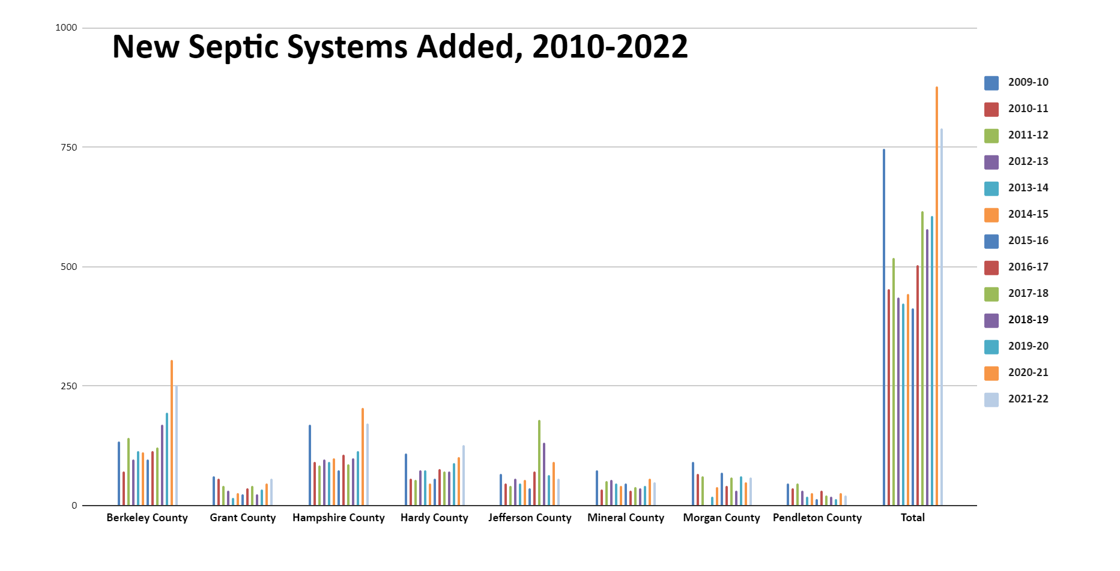

The cost of denitrification BMP systems is high relative to the resulting pollution reduction benefit. For those reasons, West Virginia’s Phase 3 Watershed Implementation Plan did not emphasize implementation of such BMPs.

D.6.2. Connections to Public Sewer
West Virginia annually tracks and reports onsite systems that are assimilated by POTWs. Specific requests for this information are made to the POTWs and their responses are documented and reported. The reported numbers have been small, and the information is straightforward and results from local public records.

D.6.3. Septic System Pumping
West Virginia also annually tracks and reports conventional system pump-outs. Specific requests for this information are made to licensed commercial service providers and their responses are documented and reported. This is a labor-intensive process and the associated nitrogen reduction model credit is negligible. It is implemented primarily to stress the importance of onsite system maintenance.

D.7. BMPs owned or operated by Federal agencies, facilities and landowners
The same verification protocols in previous sections of this document could be applied to practices owned or operated by Federal agencies, facilities and landowners. However, BMPs tracked on these properties represent a small proportion of our implementation progress overall. The following are the practices we have tracked or are considering adding to our historic BMP inventory.

The US Fish and Wildlife Service submits a table of BMPs annually to the jurisdictions. Through 2015 in West Virginia, Chesapeake Bay-approved BMPs have included the following, all of which are at National Conservation Training Center in Jefferson County:
BMP | Year(s) reported | Total Amount
Tree Planting, widen and connect forest | 2009, 2010, 2012 | 4.8 acres
Land Retirement (Hay to perm. wildlife cover) | 2011 | 40 acres
Widen riparian buffers | 2011, 2012 | 2.4 acres
Barnyard Runoff Control, controlled flows, stabilized | 2013 | 1.0 acres

The Veterans Administration Medical Center has planted trees.

The Monongahela National Forest staff submits a letter to WVDEP periodically, stating which BMPs have been installed on U.S. Forest Service lands; forest harvesting BMPs are captured as described in the Forestry BMP section of the QAPP.
BMP | Year(s) reported | Total Amount
Livestock Exclusion Fence @ Smoke Hole Champ grazing allotment, Grant County | 2013 | 8 acres
Allotments no longer grazed & removed from MNF grazing allotment system, Pendleton Co. | N/A | 223 acres

Federally owned facilities that have had stormwater BMPs installed as part of new construction activities would have been reported through the WVDEP stormwater permitting system and will be verified in accordance with the semi-regulated section of the QAPP.

TABLE 14. MAPPING OF JURISDICTION BMP VERIFICATION PROTOCOL COMPONENTS TO THE RELEVANT QAPP SECTIONS (SUGGESTED IN APPENDIX Q OF VERIFICATION FRAMEWORK)
 | BMP Verification Component | QAPP Section
1 | BMPs Collected
 | Type (structural, management, annual, etc.) | Agriculture: Table 1 &2  Stormwater: Table 8  Stream Restoration: Table 10  Wetland Restoration: Table 12
 | BMP Funding/Cost shared (federal, state, NGO, non-cost shared) | Agriculture: D.1.2 & Table 3  Forestry: Table 7  Stormwater: Table 9  Stream Restoration: Table 11  Wetland Restoration: Table 13
 | Distinct state standards/specifications | Group B, definitions & source of data  Agriculture: also D.1.5, D.1.6
 | Matching CBP BMP definition/efficiencies | All sectors: Group B, definitions;  Group D within sector sections
2 | Method/System of Verification/Assessment
 | Description of methods/systems to be used | All sectors: Group D  Agriculture: Table 1 &2  Forestry: Table 4  Stormwater: Table 8  Stream Restoration: Table 10  Wetland Restoration: Table 12
 | Documentation of procedures used to verify BMPs | Group D (see table of contents)
 | Instruction Manual for system users | Agriculture: Appendix C
3 | Who will Complete the Verification
 | Qualification requirements | Group A; also Agriculture: D.1.9
 | Training requirements
 | Certification requirements
 | CEU follow-up training requirements in the future
4 | Documentation of Verification Finding
 | Date of installation | Group D
 | Location (lat/long) if applicable
 | Level of reporting (watershed, HUC, county, etc.)
 | Units (number, acres, length, etc.) needed for NEIEN | Group B; also Appendix D
 | Ownership (public, private) | Group D
 | Documentation:
 | Pictures, Worksheets, Electronic Tool, Aerial Photos, Maps, other, report generator
5 | How Often Reviewed (Cycle of review)
 | 1-2 years, 5 years, 10 years, other | All sectors: Group D  Agriculture: Table 1 &2  Forestry: Table 4  Stormwater: Table 8  Stream Restoration: Table 10  Wetland Restoration: Table 12
6 | Independent Verification of Finding
 | Is this a requirement? | Group D
 | Internal Independent, External Independent
 | BMP Data Validation | QAPP Section
7 | Quality Assurance/Spot Checking
 | Who-qualifications/training/certification | Group A, Group C
 | Method to select BMP for follow-up check
 | Method to select the # of BMPs to review
 | Other
8 | Data Entry of BMP Implementation
 | What is the system? | Group C
 | Who enters data? (training/certification)
 | Does the system connect to NEIEN?
 | System in place to prevent double-counting | Group C; also Group B under individual BMP descriptions; also see “validation” in Group D (see Table of Cont.)
9 | External Provided Data Validation Meeting CBP Partnership Guidance
 | Method to validate data | Group C; also see “validation” in Group D (see Table of Cont.);  Agriculture: Table 3  Forestry: Table 7  Stormwater: Table 9  Stream Restoration: Table 11  Wetland Restoration: Table 13
 | Who will validate data (training/certification)?
10 | Historic Data Verification
 | System to re-certify or remove | Generally same as regular annual progress BMPs
 | Who will verify historic data (training/certification)? | Generally same as regular annual progress BMPs
 | Documentation of action | Group B
 | BMP Performance
11 | Does state collect data to address BMP Performance? | Agriculture: Table 3  Forestry: Table 7  Stormwater: Table 9  Stream Restoration: Table 11  Wetland Restoration: Table 13
 | System used to collect BMP performance data
 | Who collects BMP performance data?
 | Who analyzes collected data and report to CBP?

REFERENCES
Center for Watershed Protection. 2009. Technical Report: Stormwater BMPs in Virginia’s James River Basin – An Assessment of Field Conditions and Programs. Center for Watershed Protection. Ellicott City, MD
Chesapeake Bay Partners Verification Review Panel (CBP-VRP). 2013. Verification Guidance and Recommendations to Six Source Sector Workgroups, the BMP Verification Committee and the Seven Watershed Jurisdictions. November 19, 2013.
Chesapeake Bay Program. 2018. Chesapeake Bay Program Quick Reference Guide for Best Management
Practices (BMPs): Nonpoint Source BMPs to Reduce Nitrogen, Phosphorus and Sediment Loads to the
Chesapeake Bay and its Local Waters. https://www.chesapeakebay.net/documents/BMP-Guide_Full.pdf

Chesapeake Stormwater Network (CSN). 2013. Bioretention Illustrated: A Visual Guide for Constructing, Inspecting, Maintaining and Verifying the Practice. Ellicott City, MD. http://chesapeakestormwater.net/wp-content/uploads/downloads/2013/04/REVIEW-DRAFT-OF-BIORETENTION-ILLUSTRATED-040113.pdf).
Schueler, T. and B. Stack (May 13, 2013) Recommendations of the Expert Panel to Define Removal Rates for Individual Stream Restoration Projects, http://www.chesapeakebay.net/documents/Stream_Panel_Report_Final_08282014_Appendices_A_G.pdf
Stormwater Performance Standards Expert Panel (SPSEP). 2012. Recommendations of the expert panel to define removal rates for new state stormwater performance standards. Approved by Chesapeake Bay Water Quality Goal Implementation Team. Annapolis, MD. www.chesapeakebay.net/.../Final_CBP_Approved_Expert_Panel_Report_on_ Stormwater_Performance_Standards_SHORT.pdf
Water Quality Goal Implementation Team (WQGIT). 2010. Protocol for the development, review and approval of loading and effectiveness estimates for nutrient and sediment controls in the Chesapeake Bay Watershed Model. US EPA Chesapeake Bay Program. Annapolis, MD.
West Virginia Department of Environmental Protection. 2015a. Stormwater Program. Construction General Permit. http://www.dep.wv.gov/WWE/Programs/stormwater/csw/Documents/bay%20addendum%20form%20may%202012.pdf
West Virginia Department of Environmental Protection. 2014 Stormwater Program. MS4 permit. http://www.dep.wv.gov/WWE/Programs/stormwater/MS4/permits/Documents/MS4%20GP%202014.pdf

Williams, B. and E. Brown. 2012. Adaptive Management: The U.S. Department of Interior Applications Guide. Adaptive Management Working Group. USDOI. Washington, DC.

APPENDIX A: 2011 BMP REPORTING WORKSHEET.XLS
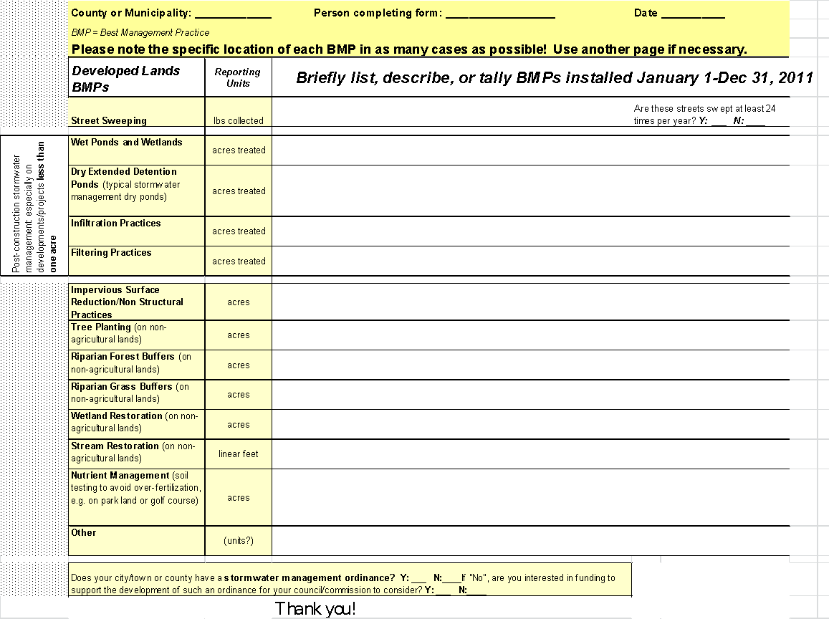

APPENDIX B: DESCRIPTION OF “AGGREGATED NRCS AND FSA DATA FOR ANNUAL PROGRESS REPORTING”
Information provided via email by Olivia Devereux 11/08/2021.

Data included: There are spreadsheets of NRCS Land BMPs, NRCS Animal BMPs, and FSA BMPs. NRCS Conservation Technical Assistance (CTA) are included in separate tabs. All FSA and NRCS practices are included. Not all FSA and NRCS practices provide a water quality benefit or are accepted by the Chesapeake Bay Program for the Annual Progress Report. However, all practices are considered valid in NEIEN.

In the NRCS data, livestock and land BMPs are included in the data sets where present in the NRCS source data. Where not present, those fields are listed as null. In some cases, there were several instances of the BMP not meeting the privacy protection criteria if the animal type or land use was considered and the data were not releasable. Should you prefer that the land use or animal type be considered differently for purposes of aggregation, please let me know and I can provide the data differently or give you an idea how much drops out to protect producer privacy. Forest buffers on forest and land practices applied to water are not included. NRCS made corrections to some data prior to providing to USGS. Where practice 313-Waste Storage Facility was greater than 5 for the same customer, contract, and year, then the number was set to 1. In some cases, the original number was 313, the practice code. In others, it appeared to be the number of square feet (such as 160,602) rather than the count of facilities. NRCS made the same correction to Barnyard Runoff Management.

In the FSA data, there are two columns of implementation: Practice Acres and Expired Acreage. The practice acres are the total acres implemented and includes re-enrolled acres. Since historical data is rarely removed, including the re-enrollment would result in double-counting. The expired acreage is the amount per contract, not practice. Subtracting the expired acreage for a contract from the total acres per practice may result in a negative amount, since multiple practices can be in the contract.

The record count column in the spreadsheets contains the number of producers that reported the practice in a particular geography. Generally, there is no number less than 5, which follows the agreed upon aggregation rules to protect producer privacy. Where there is a number less than 5, it is because easements are included. Easements do not need to follow the same rule, per NRCS.

Data Notes: These NRCS data were taken from the National Planning and Agreements Database (NPAD). NPAD pulls data from multiple datasystems. CSP enhancement practice can cover many land units. If any of those land units fall within the Chesapeake Bay boundary, the CSP practice is included here. The practice was assigned a lat/long for the centroid of the practice, and that centroid may not fall within a county (FIPS) that overlaps the Chesapeake Bay Watershed. Likewise, the centroid may fall within a Chesapeake Bay county and located outside the watershed. Practices marked as applied and reported in PRS are included. Self-certified (farmer certified) practices do not have a report applied amount or date and are not included.

Data Source: NRCS data were provided by the Nicola Giardina and Anjaneyulu Kurkunda of the Tier 3 Team in the Colorado central data office on November 4, 2021 in response to USGS’s September 26, 2021 data request. FSA data were provided by Patrick McLoughlin in the Kansas City, Missouri central data office on November 3, 2021 in response to a data request initiated on October 7, 2021.

Aggregation for Producer Privacy: The rules specified by USDA and agreed to by USGS are that data may be shared only when each practice is reported by five or more producers. Otherwise, individual producers potentially could be identified and this would violate producer confidentiality. Where there were five or more producers reporting a practice in a county, then the data are provided at the county scale. Where there were less than five producers reporting a practice in a county, then the data are provided at the state scale. You may see some data aggregated at both the county and state scale. In these cases, it was possible to aggregate county level data in some places, but not in others. For instance, there could be some counties where there were many producers implementing a practice. In other counties, the practice was less popular. In the counties where the practice was less popular, a few of the counties were aggregated to the state scale. There were some practices where there were less than five producers reporting that practice in the state. These data cannot be shared in unaggregated form and are not included. The NRCS data were provided with the easement records separated from the other practice records. The easement records do not follow the same aggregation rule as the land is owned by the federal goverment. As such, these are provided regardless of record count. They are denoted as NA-Easement in the record count column.

Geographic Scale: FSA practices are included for the entire county for all counties that are in the Chesapeake Bay Watershed for your state. There are some counties that have only a portion in the Chesapeake Bay Watershed. When you report FSA practices to NEIEN, indicate that you are reporting for “state” and do not specify “CBWS-only” since the entire county is included. By providing the data at the county scale, there were fewer practices that had to be aggregated to the state scale and fewer that were not able to be reported at all. CAST apportions the BMPs throughout the entire county, which typically results in the most amount credited. NRCS BMPs are for the Chesaepaek Bay Watershed only.

Timeframe: The data are provided by year of practice installation. FSA data are for 2005 through July 31, 2021. NRCS data are for 2006 through July 31, 2021. The year is for the Chesapeake Bay Program progress reporting year of July 1 through June 30. The Chesapeake Bay Program will use the total for 2020 for annual practices. For cumulative practices, the Chesapeake Bay Program sums the 2021 number with all prior years. Data prior to 2005 for FSA and 2006 for NRCS are not considered accurate by FSA and NRCS because of changes to their data systems, so those data are not provided. Inspection dates are not available in this dataset.

CTA: The NRCS Conservation Technical Assistance (CTA) data are included for your information. Conservation Technical Assistance is any practice that: is recommended by NRCS, meets NRCS technical standards, and is not funded by USDA. Those practices implemented as CTA did not receive cost-share from USDA. Because the CTA practices are not under contract, it is not known if the practice was maintained, re-reported in other years, or what entity may have provided funding. Where another entity provided funding, it is likely that the funding entity included the CTA practice in their reporting.

FSA and NRCS overlap: For practices that FSA cost-shares, but NRCS provides technical assistance, the practices are included in the FSA data and are not included in the NRCS data. The overlap only occurs for some CRP practices. These practices were identified by NRCS using the FSA Handbook for Agricultural Resource Conservation Program for state and county offices (2-CRP (Revision 5) 8/7/2013). The section referenced begins on page 596.

Duplication with state data: The practices included here may have received funding from other sources as well as NRCS or FSA. Now that you have these NRCS and FSA data, please double check to make sure there is no risk of duplication. There are likely practices that you may not have previously reported and may want to check the unit conversions in NEIEN. Sometimes those unit conversions use assumptions that are state specific. In addition, program names are not included in these data, but are available upon request. Program names can be an indicator of the amount of each practice that also received state funding.

APPENDIX C: WV AGRICULTURE BMP DATABASE USER’S GUIDE

WV Ag BMP Database
User Guide for Version 1

March 2015

Introduction

About this Guide

Welcome to Agricultural BMP Database System for the state of West Virginia. This online database serves as a means of reporting and tracking Best Management Practices (BMPs). The use of this tool will allow for a more streamlined approach for generating reports needed for agricultural BMP assessment and monitoring purposes. Additionally, this database is used to submit data for inclusion to the National Environmental Information Exchange Network (NEIEN). Individual organizations are responsible for entering their practices with their provided login information and will only be permitted to review their own data.

This brief document is a basic user guide to familiarize users with the technical aspects of the application and its functions. Most frequent users of the system will find it to be intuitive and will not need to review this guide once they begin to use it regularly.

This guide will offer example of most functions within the system and will depict many screens. Each screen will be shown only once in the guide.

Getting Started
Request an Account
Accounts in the system are managed by system administrators Contact your system administrators to request an account, or to change your access privileges.

Requirements
Use of the Agricultural BMP Database System requires the following technologies on users’ computers.

- A computer with Internet access to Web sites.
- A Web browser (Mozilla Firefox 10.0 or newer, Microsoft Internet Explorer 9.0 or newer).
- Microsoft Office 2007 or newer (to open the Excel import templates in .xlsx format, or open the attached documents)
- Any other software needed to view attach documents
- A valid username and password

Logging In
The Agricultural BMP Database System is housed on WV servers. The Ag BMP Database System password should be kept confidential. If you cannot remember your username or password, select the Forgot Password link on the Sign In page. The image below is example of the information you need to login.

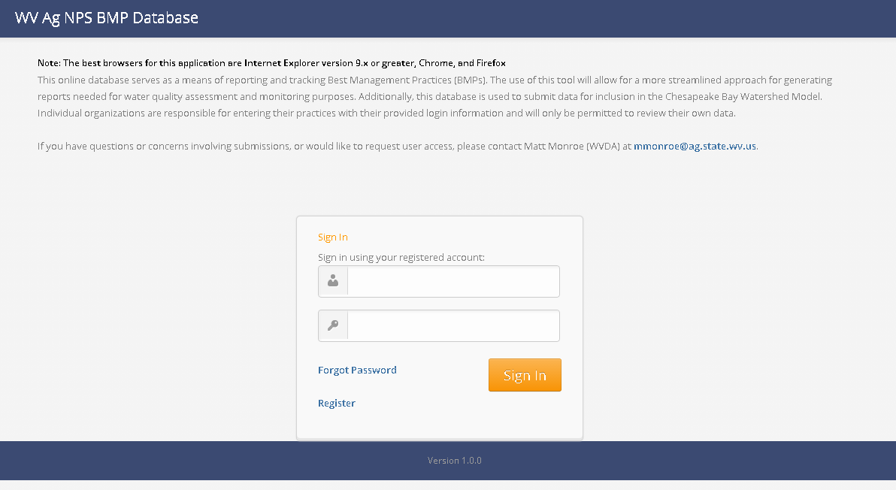
Figure 1.2.1 A basic username and password is needed for login

Overall Screen Structure

The screen is broken into several regions whose names may be used throughout this guide. The figure below highlights these regions.

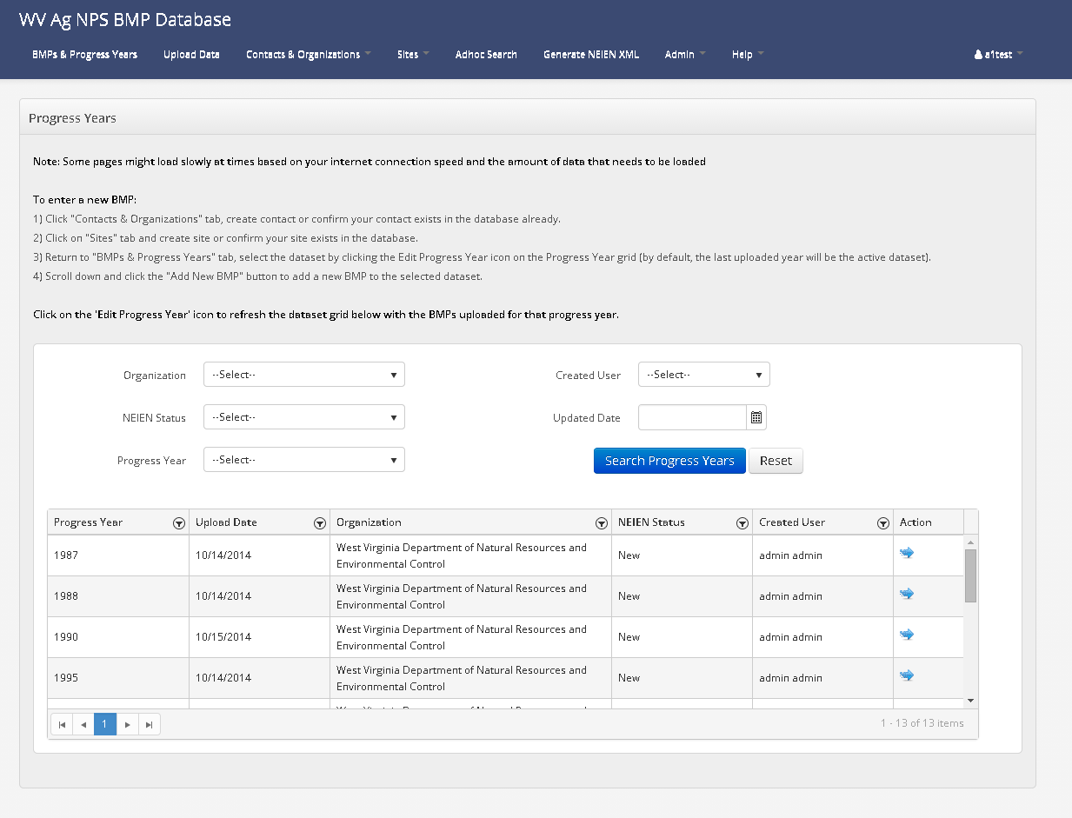
Figure 1.2.2. Screen region names

- The Menu Bar is always available on all screens and regardless of a user’s role. However, some items on the Menu Bar may not be available for use by certain users based on their assigned user roles within the system.
- The Page is the current screen where record details are displayed and may be edited. Users navigate to different Page screens via items in the Menu Bar, or from within other pages.
- The Footer is also visible on all screens and simply displays information to the user. Currently, the system version number is provided. Submit the version information presented in the footer whenever notifying the system administrator of problems.

Permissions
All users must login to the system to see any usable portion of it. Users are assigned a role which determines the types of actions that users may perform or information that they may see.

The following are the user roles currently provided and a summary of the operations these roles can perform. The further details and the meaning of the roles listed below will be explained later in this document.

- Admin – Admin user can access all functionality of the system. Admin will approve the registration and assign a role & organization before the user can log in for the self-register users.
- Super User – Super user has access to data across all organizations but do not have access to admin functions like managing users, and generating the NEIEN XML.
- General User – General user can edit and view only their own organization's data. They will have no access to admin functions like managing users, and generating the NEIEN XML.

Screen Conventions

Data Grids
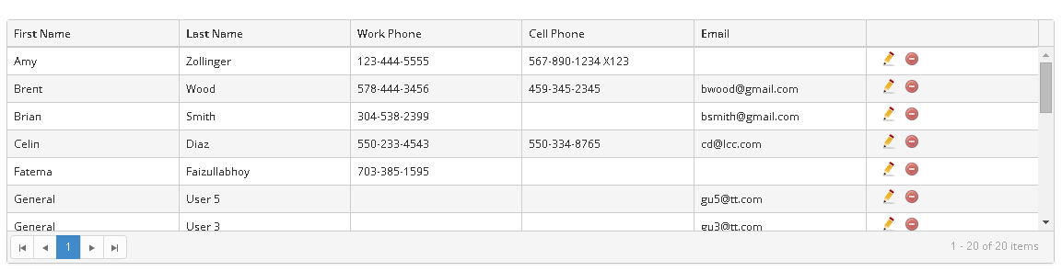
Figure 1.3.1 Conventions in data grids

The Ag BMP Database system refers to tables of information as “data grids.” Data grids are used throughout the system to list information and provide access to functions. The image above is a typical data grid example. User can use the blue button on the top left corner of the data grid to create (add) a new record.

The bottom left corner can be used to page through the results. The I◄ button navigates the user on the first page of the results on the data grid. The ◄ takes the user to the previous page. The ► button navigates to the next page and ►I button navigates to the last page of the search results. The number in blue tells the user on which results page they are. The bottom right corner message indicates the total number of records from the search results. The pencil icon in the last column is to edit that record and red circle minus sign is to delete that record.

Figure 1.3.2 Delete record warning

Certain users have the rights to delete particular records. The application will warn users before attempting to delete records (example image above).

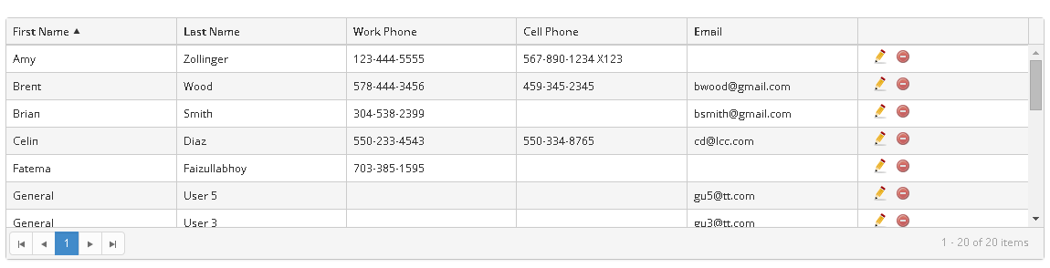
Figure 1.3.3 Sorting data grid values

All column heading names may be clicked to sort the values in the grid in ascending order (see example above sorting on WSF ID).

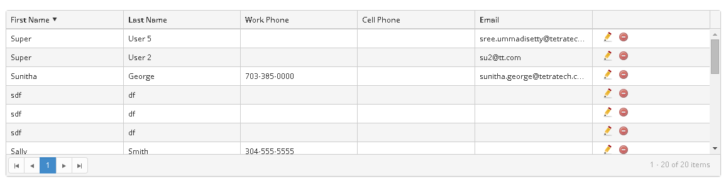
Figure 1.3.4 Sorting data grid values, the other way

The heading name may be clicked again to sort the values in descending order (see example above sorting on WSF ID).

Data Value Validations

Many fields throughout the system are mandatory. All mandatory fields in the system are marked with the red asterisk ‘*’. Some of the fields in the system limit what can be entered in order to protect the quality of data stored. Invalid or missing entries will trigger red error messages on the screen and allow you to correct.

Form Controls
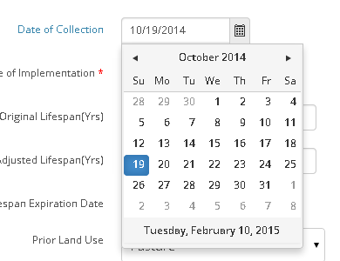
Figure 2 Form controls (date fields)

This is typical date and time picker used in the application. User can select the date by clicking a small calendar icon. User can also type the date and time in the field provided.

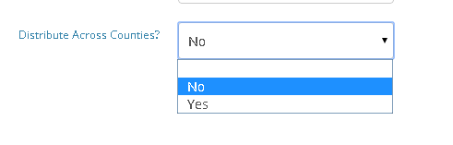
Figure 3.6 Form controls (single-select)

The image above gives an example of single select fields. The field is the single select where user can only select one value from the dropdown.

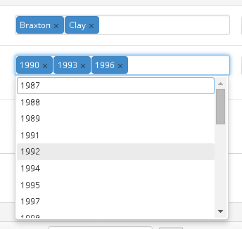

Figure 4.7 Form controls (multi-select)

The image above gives an example of multi select fields. The field is the multi select where user can select multiple values from the dropdown.

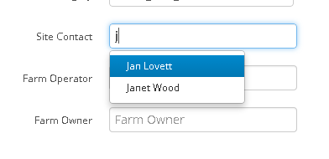

Figure 5.8 Form controls (Auto-complete)

The image above gives an example of the “auto-complete” function. Users may begin typing some portion of the expected value then the control will list possible matches that maybe refined by additional typing. The options may be selected by the user at any time

Icon Conventions

The icons presented in the table below are used throughout the application. Most often they will appear in the rightmost column of tables of information.

Control/Flag | Function/Indication
 | Edit
 | Delete
 | View

Instructions

2.1 Home Page

Figure 2.1.1 Home Page

The home page (see image above) gives users access to different functions of Ag BMP Database and you can track the progress of each year and all the BMPs of the that year can be seen on the Home page.

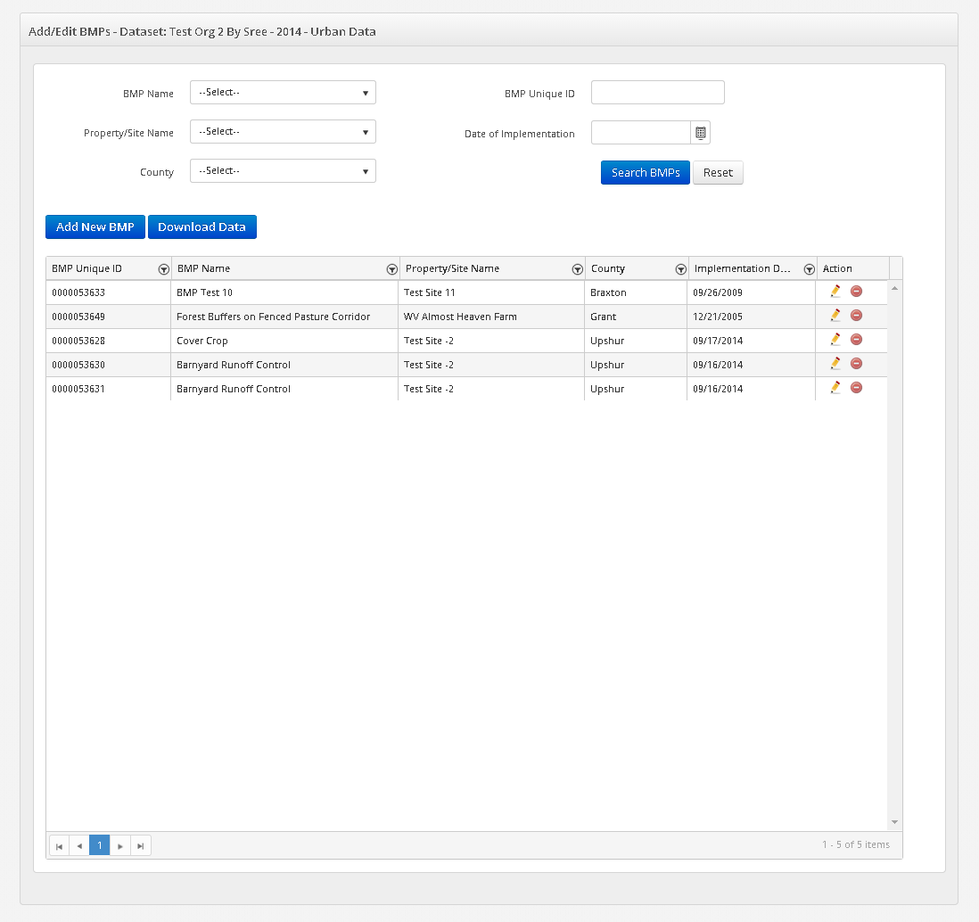

Figure 2.1.2 Home Page (contd..)

BMPs and Progress Year page serves as the home page for WV Ag BMP Database system.

The Home page is divided into sections – Progress Years and Add/Edit BMPs
User can search submissions by ‘Organization’, ‘NEIN Status’, ‘Progress Year’, ‘Created User’ and ‘Updated Date’. The results of this search will be displayed in the grid below. BMPs for each submission can be viewed by clicking the blue arrow button in the Add/Edit BMPs section of the page.

2.2 BMPs & Submissions

Submissions

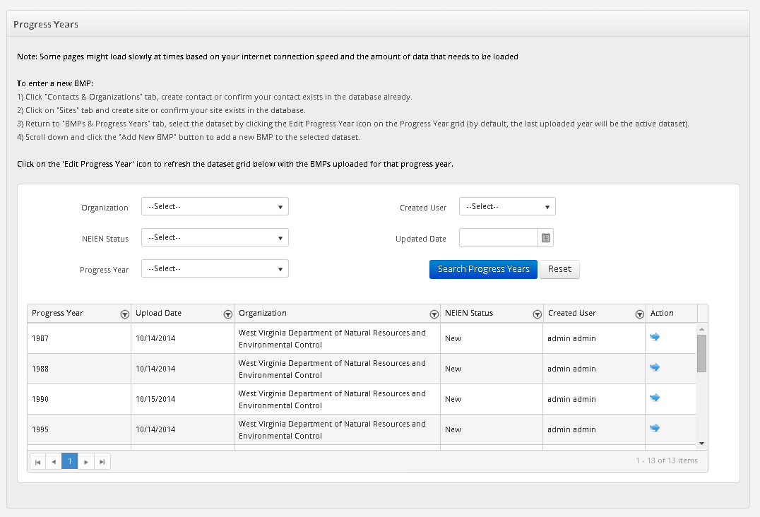
Figure 2.2.1 Submission Listings

This page is divided into sections – Progress Years and Add/Edit BMPs
User can search submissions by ‘Organization’, ‘NEIN Status’, ‘Progress Year’, ‘Created User’ and ‘Updated Date’. The results of this search will be displayed in the grid below. BMPs for each submission can be viewed by clicking the blue arrow button in the Add/Edit BMPs section of the page.

BMPs

Figure 2.2.2 BMPs Listing Screen

The user can export the records of uploaded BMPs into an excel file by clicking the ‘Download Data’ button. Users can also add a new BMP record to the selected submissions by clicking ‘Add New BMP’ button.

The BMP forms allow users to edit and enter new information for a BMP, as seen in figure below. There are several required fields in the main section that need to be populated before the user can save the data.
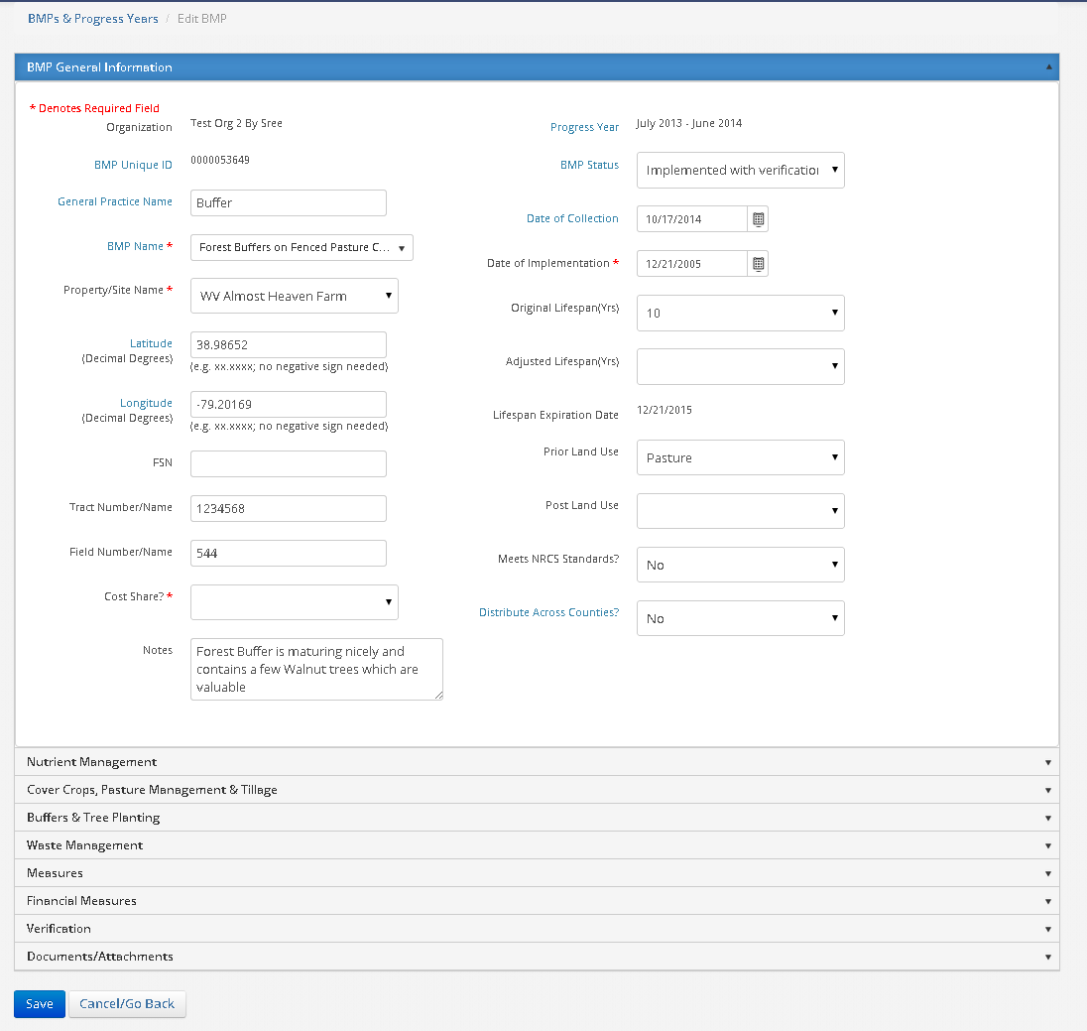
Figure 2.2.3 BMPs Detail Screen – BMP General Information

This is the General section to enter general information of the BMP. User should select a ‘BMP Name’ and the Site on which the BMP is/will be implemented. If the BMP is going to be implement on multiple counties then select ‘Yes’ for Distribute Across Counties? And do not select the location (Latitude and Longitude values) and the measures for the BMP will be split across counties.

Enter additional information for the BMP in the following sections – Nutrient Management, Cover Crops, Pasture Management & Tillage, Buffers & Tree Planting, Waste Management, Measures, Financial Measures, Verification and Documents and Attachments

Below are the screens for all the subsections of BMP information.
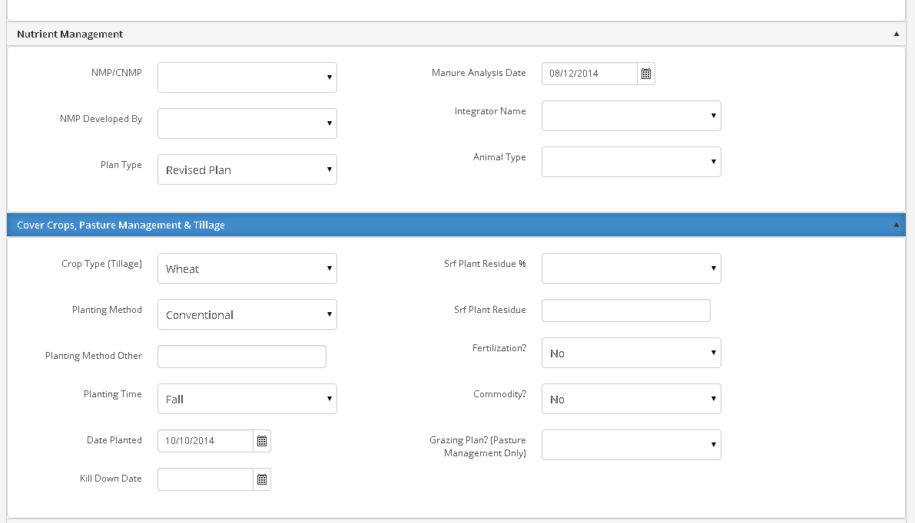
Figure 2.2.4 BMPs Detail Screen – Nutrient Management and Cover Crops, Pasture Management & Tillage

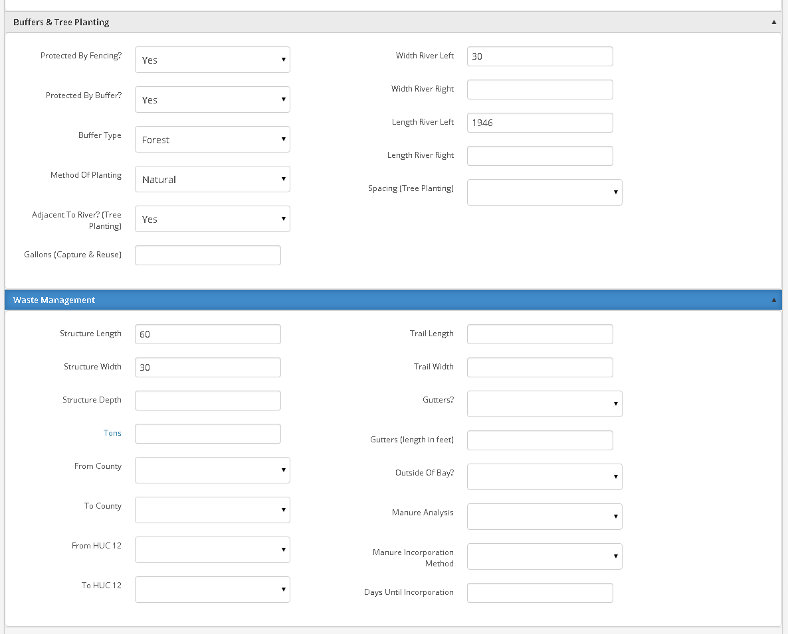
Figure 2.2.5 BMPs Detail Screen – Buffers & Tree Planting and Waste Management

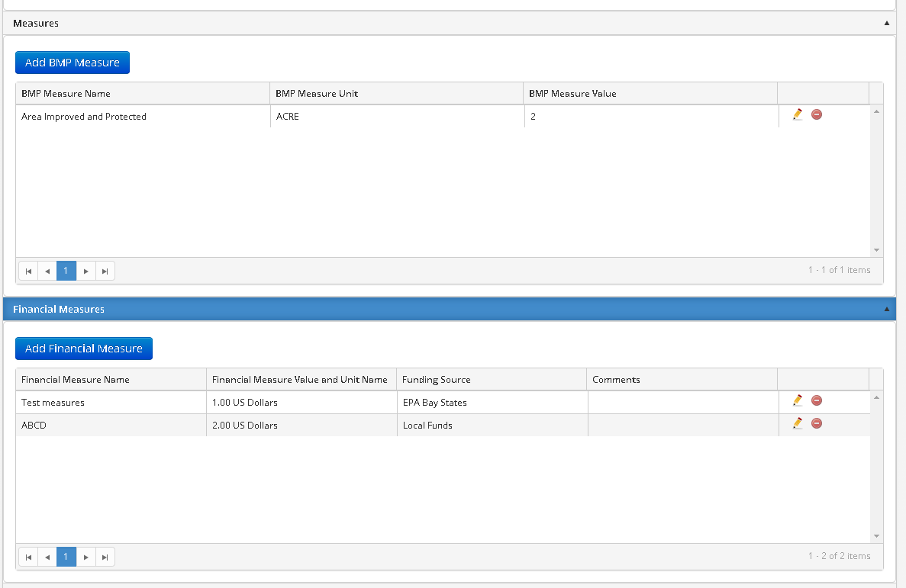
Figure 2.2.6 BMPs Detail Screen – Measures and Financial Measures

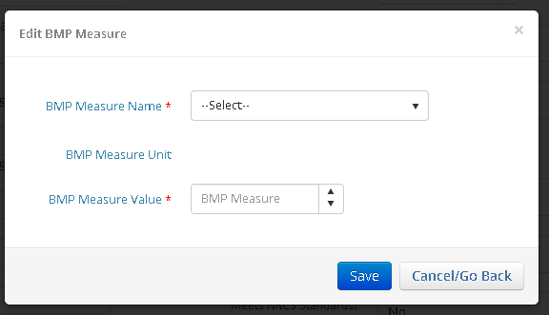
Figure 2.2.7 BMPs Detail Screen – Measures Detail popup

In this section a user can add a BMP measure and view the list of BMP measures associated with the selected BMP. The user can also edit or delete an existing BMP measure from the data grid
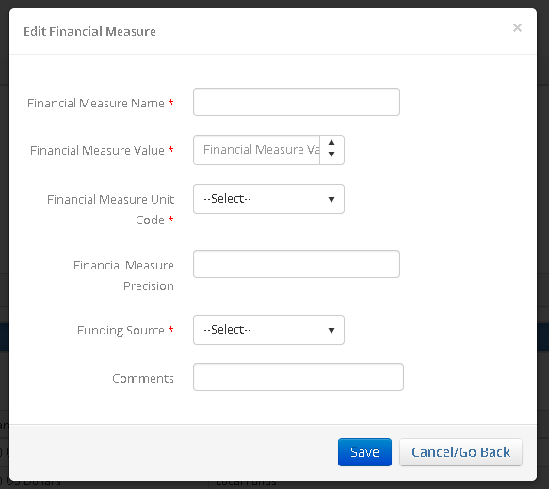

Figure 2.2.8 BMPs Detail Screen – Financial Measures Detail popup

In the Financial Measures section users can add a BMP financial measure and view the list of existing measures associated with the selected BMP

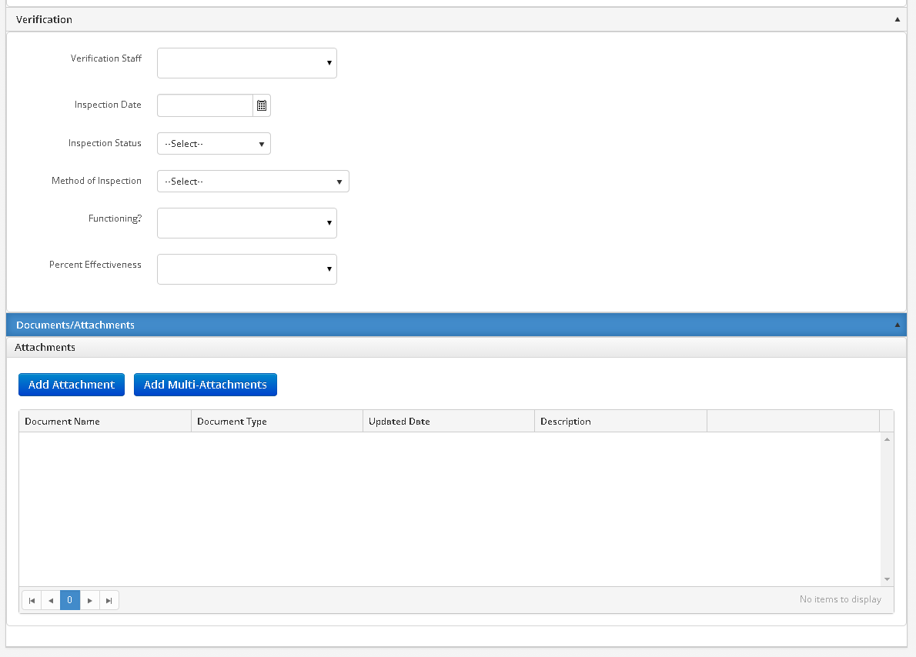
Figure 2.2.9 BMPs Detail Screen – Verifications and Document Attachments

2.3 Upload Data

This page allows users to import their BMP data as a complete set per year using the upload templates. For the import to work successfully the user must use one of the provided templates for WV Ag BMP Data or WV Aggregated BMP Data. Users can download these templates by selecting the appropriate type and clicking the Download Blank Template button, seen below in figure. The user may then enter all their data in the format specified in the template.

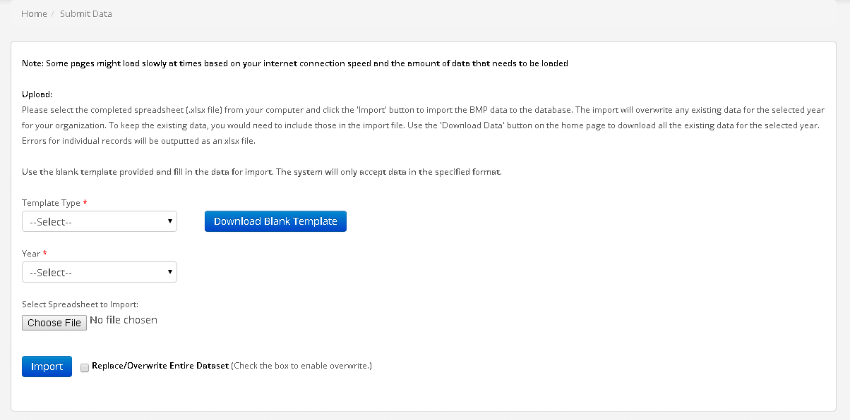
Figure 2.3.1 Upload Data Screen

Once the user has entered their data into the correct template, the next step is to upload the template into the database. To do this the user must select the correct template type, either WV Ag BMP Data or WV Aggregated BMP Data, and then select the year that the data applies to. Finally the user needs to browse for their template and click the Import button. Please note, that each template must contain data for only one Chesapeake Bay Program submission year, e.g., July 1st, 2012 – June 30th, 2013. The data will be “added to” any existing data. Only the Admin has the ability to overwrite existing data.

2.4 Contacts & Organizations

Manage Contacts

There will be a contacts section which serves as an address book. The contacts would usually be the list of farm/site owners, operators etc.

All user roles will have access to all the contacts in the system and all the contact information. Once a contact has data tied with it, the contact cannot be deleted.

Contacts can be accessed through the Contact & organization menu, and ‘Manage Contacts’ option displays the screen below.

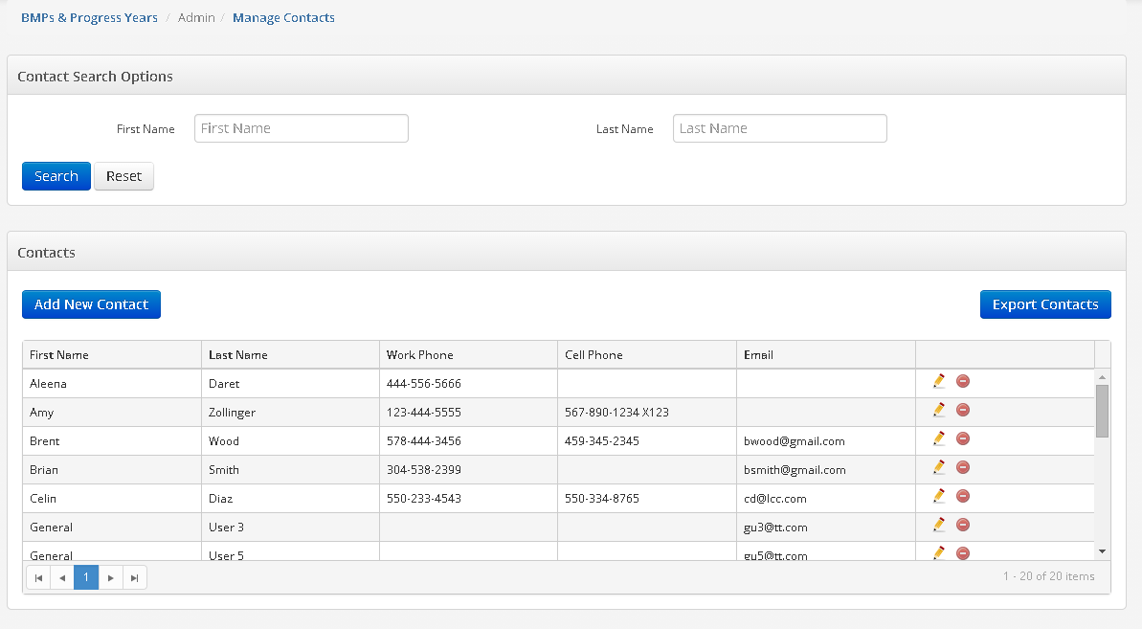
Figure 2.4.1 Contact Search Screen

The page is divided into sections – Contact Search Options and Contacts
Search the contacts by ‘First Name’ and ‘Last Name. The results of this search will be displayed in the Contacts Section of the page. Contacts section displays all the Contacts by default. All user can edit or delete a Contact from the grid, upon deletion user will be provided a confirmation message.

Add a new contact by ‘Add New Contact’ button, which will display the screen shown below. The Edit icon of an existing contact will also show the same screen with the information.

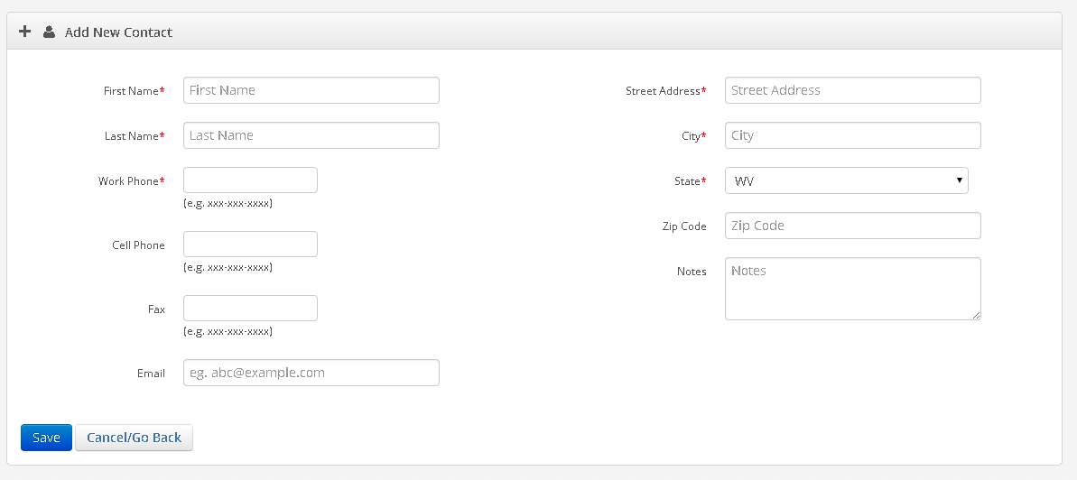
Figure 2.4.2 Contact Detail Screen

All the required fields needs to be entered before saving the contact. System will display a confirmation message on saving the entered information. Cancel/Go Back button will take back to the search page without saving any unsaved information.

Organization

Organization can be accessed through the Contact & organization menu, and ‘Manage Organization’ option displays the screen below.

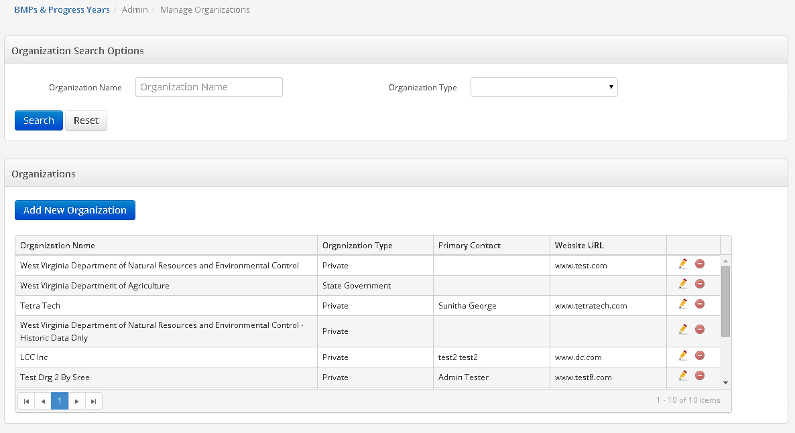
Figure 2.4.1 Organization Search Screen

The page is divided into sections – Organization Search Options and Organizations
Search the organizations by ‘Organization Name’ and ‘Organization Type’. The results of this search will be displayed in the Organizations Section of the page. Organizations section displays all the Organization by default. All users can edit or delete an Organization from the grid, upon deletion user will be provided a confirmation message.

Add a new organization by ‘Add New Organization’ button, which will display the screen shown below. The Edit icon of an existing organization will also show the same screen with the information.

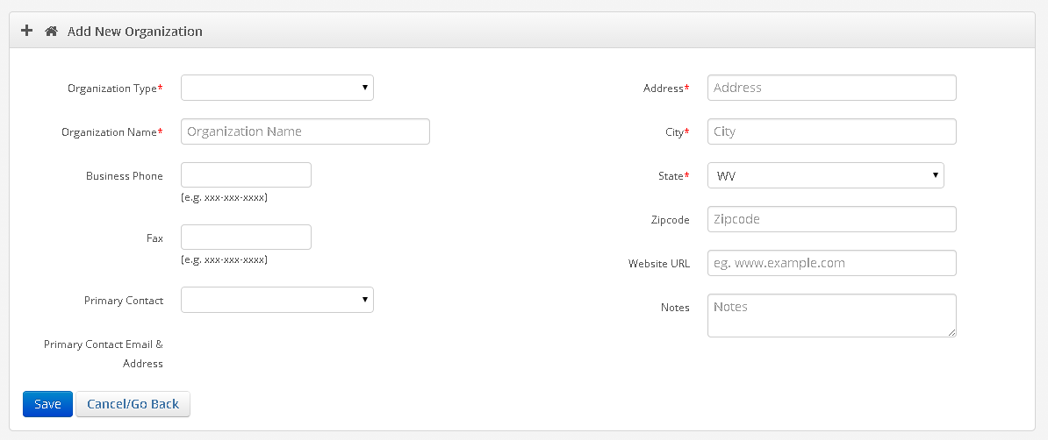
Figure 2.4.2 Organization Detail Screen

All the required fields needs to be entered before saving the contact. System will display a confirmation message on saving the entered information. Cancel/Go Back button will take back to the search page without saving any unsaved information.
The Primary Contact cannot be added when an organization is first created. The organization must be created and user’s/contacts assigned to the organization before a Primary Contact can be selected.

2.5 Sites

Sites can be accessed through the Sites menu, and ‘Manage Sites’ option displays the screen below.

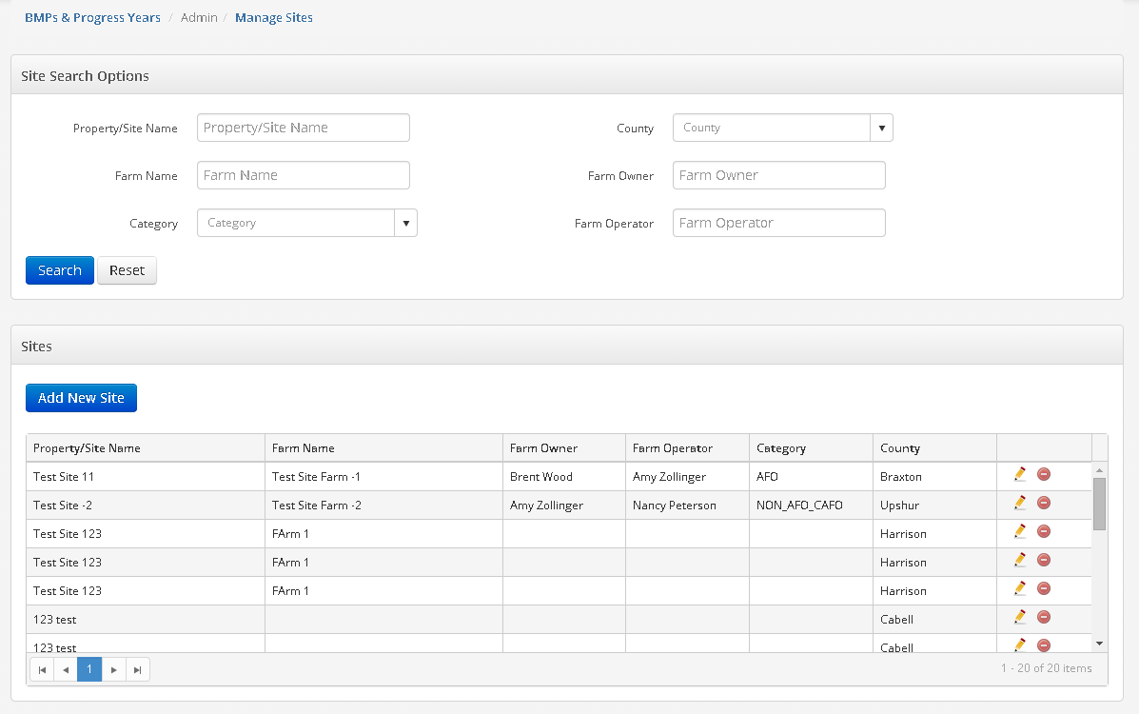
Figure 2.5.1 Sites Search Screen

The page is divided into sections – Sites Search Options and Sites
Search the sites by ‘Property/Sites Name’, ‘County’, ‘Farm Name’, ‘Farm Owner’, ‘Category’ and ‘Farm Operator’. The results of this search will be displayed in the Sites Section of the page. Sites section displays all the sites by default. All users can edit or delete a Sites from the grid, upon deletion user will be provided a confirmation message.

Add a new sites by ‘Add New Sites button, which will display the screen shown below. The Edit icon of an existing sites will also show the same screen with the information.

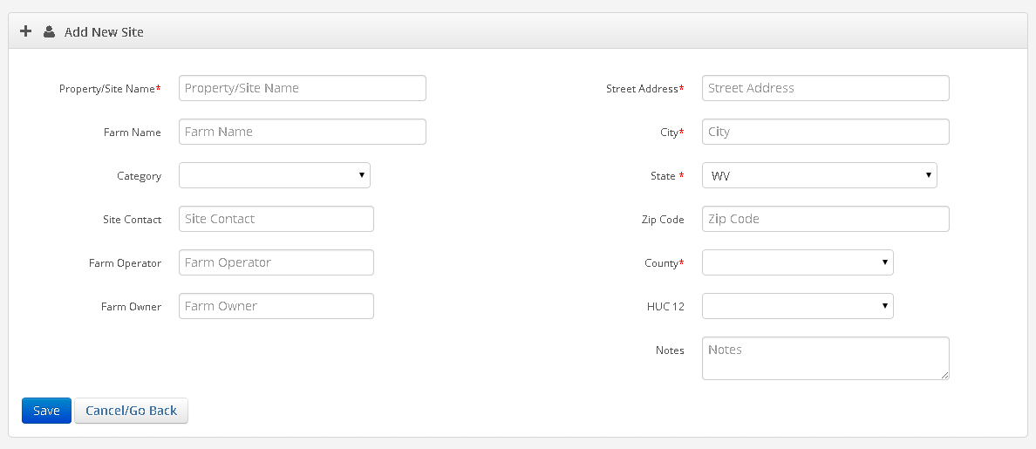
Figure 2.5.2 Sites Detail Screen

All the required fields needs to be entered before saving the contact. System will display a confirmation message on saving the entered information. Cancel/Go Back button will take back to the search page without saving any unsaved information. It will generate error log if the data is not in the correct format.

On upload

2.6 Adhoc Search

This section of the application allows user to query the database based on various fields. All the user can search the database using Adhoc Search. User can access the Adhoc Search from the top menu, which will display the following page.

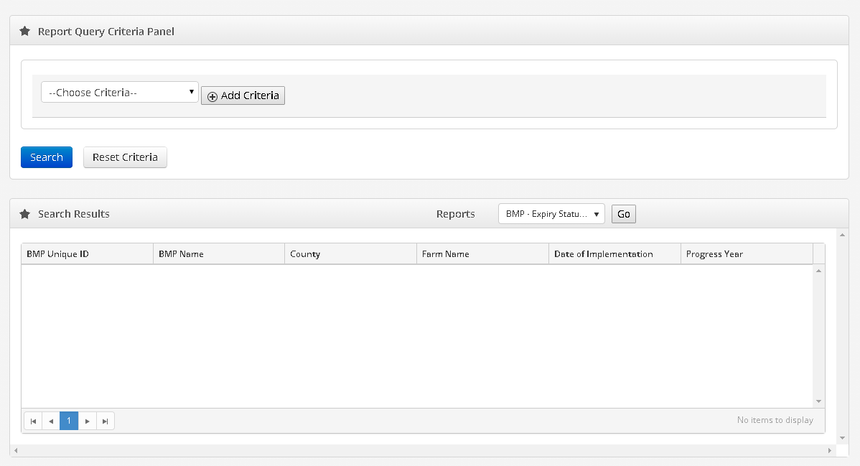

Figure 2.6.1 Adhoc Search Screen.

This page is divided into two sections- Report Query Criteria Panel where user can define search criteria and the search results are displayed in the bottom section. User can query the database by various database fields. Select the name of the field on which you want to query, then click the Add Criteria button, then then select the operator and select the value for that field. User can add as many criteria to search for the desired record.
The criteria can use “And” or “Or” logic. “And”, the default, stipulates that the results must conform to all of the criteria specified. “Or” stipulates that the results must conform to at least one of the criteria specified.

Please note that if the user clicks search without defining any search criteria then all the records will be displayed in the search results section of the page.
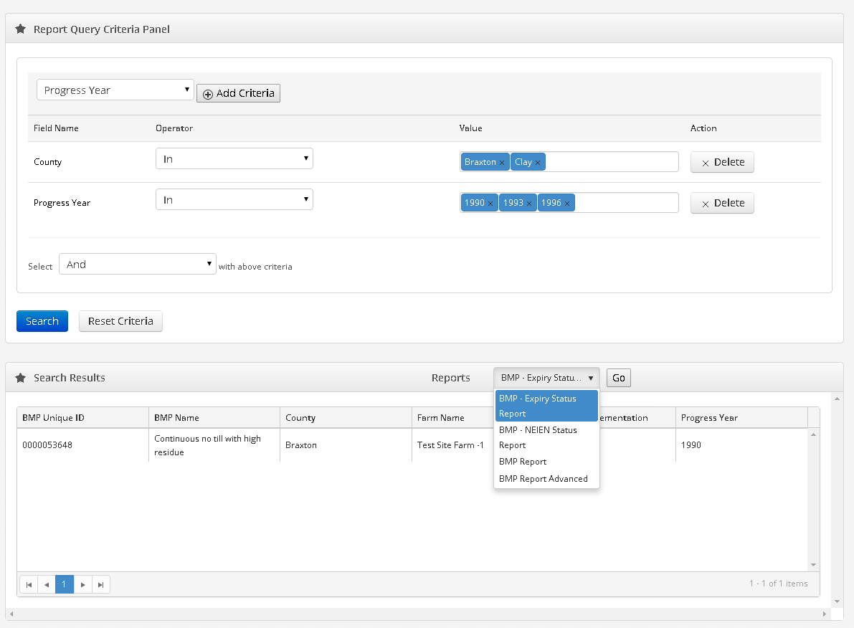

Figure 2.6.2 Adhoc Search Screen (with query).

User can generate the following reports either for all the records in the database or for specific set of records.
- BMP – Expiry Status Report
- BMP – NEIEN Status Report
- BMP Report
- BMP Advance Report

2.7 Generate NEIEN XML

Only Admin User can generate the Xml file for each year to submit the data to NEIN Node. The XML would be generated for a specified year and would export all the data across agencies. The data being exported would be aggregated data. All the data will be aggregated at county level before reporting to NEIEN.

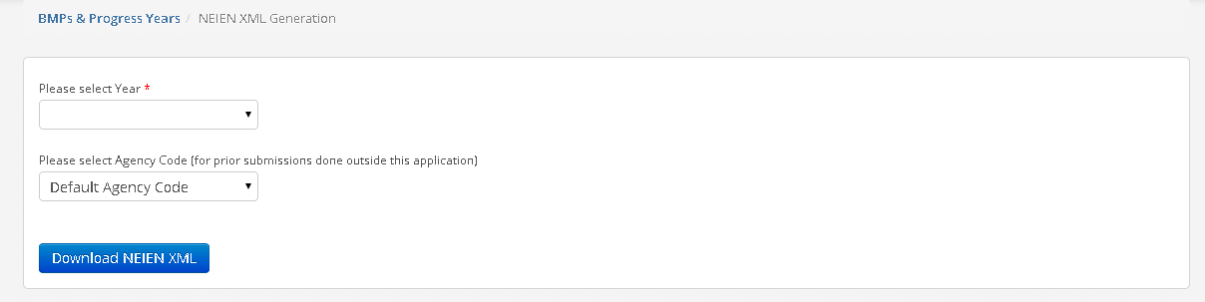
Figure 2.7.1 XML Generation Screen

The Generate NEIEN XML section of the application allows admin users to create a NEIEN compliant XML file that can then be submitted through a NEIEN node.. The user must first select the year that they would like to send, and then the appropriate Agency Code. The Agency Code is used only to re-submit historic data that was previously sent to the Program via a different application or submission method. For all data entered directly into this application via the user interface or upload templates, the Default Agency Code value can be used.

User Guide

This is a link form where you can download the User Guide of Ag BMP Database System.

Administration

The Admin section in the system allows the simple creation, editing and deletion of various supporting records. These functions are limited to a very small number of administrative users only. The following items may currently be administered in these screens.

- Manage Users
- Manage BMP Names
- Manage Lookups
- Manage Settings

Manage Users
From the Admin menu, user can select ‘Manage Users’ to view the page below.

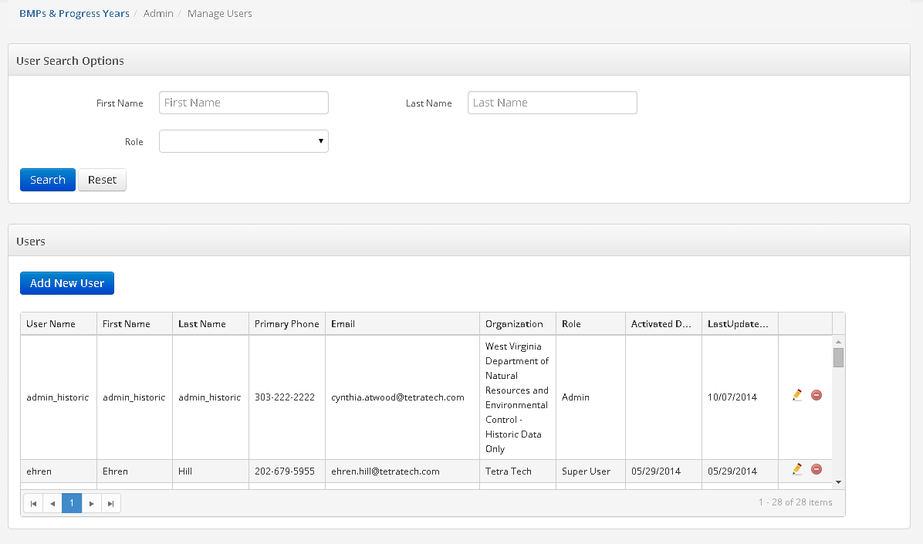
Figure 3.1 User administrator screen

The page is divided into sections – User Search Options and Users
Search the users by ‘First Name’, ‘Last Name’ and ‘Role’. The results of this search will be displayed in the Users Section of the page. Users section displays all the users by default. Only Admin user can edit or delete a User from the grid, upon deletion user will be provided a confirmation message.

Add a new user by clicking the ‘Add New User’ button, which will display the following screen. The Edit icon of an existing user will also show the same screen with the information.

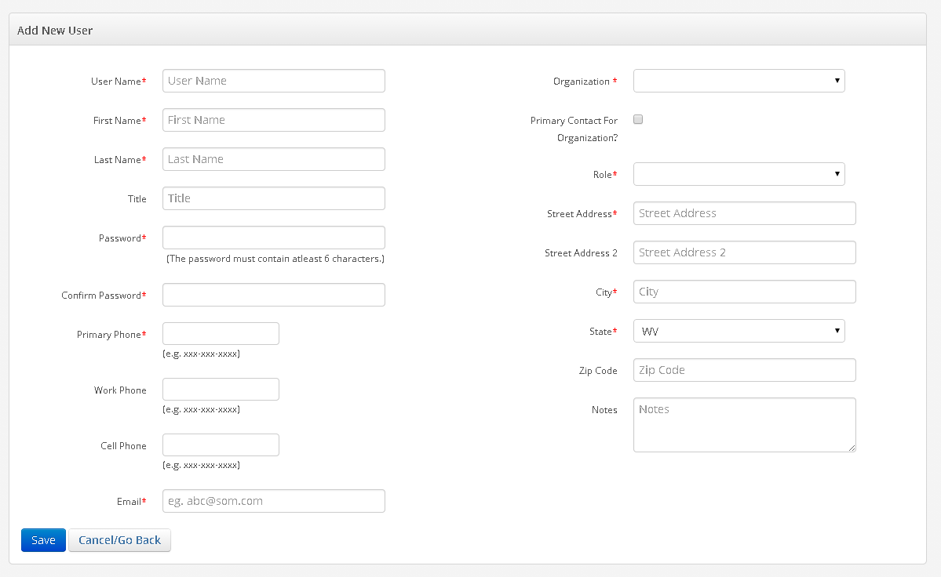
Figure 3.2 Add New User screen

All the required fields needs to be entered before saving the contact. System will display a confirmation message on saving the entered information. Cancel/Go Back button will take back to the search page without saving any unsaved information.

Manage BMP Names

Only certain measures are applicable to each BMP Name. An admin or super user can add/edit BMP Names within the system & the edit the measures associated to it.

To add an FE BMP user has to append ‘_FE’ at the trailing end of a BMP name and leave the NEIN BMP Name field blank. Multiple BMP measures can be associated to a BMP.

From the Admin menu, user can select ‘Manage BMP Names’ to view the page below.

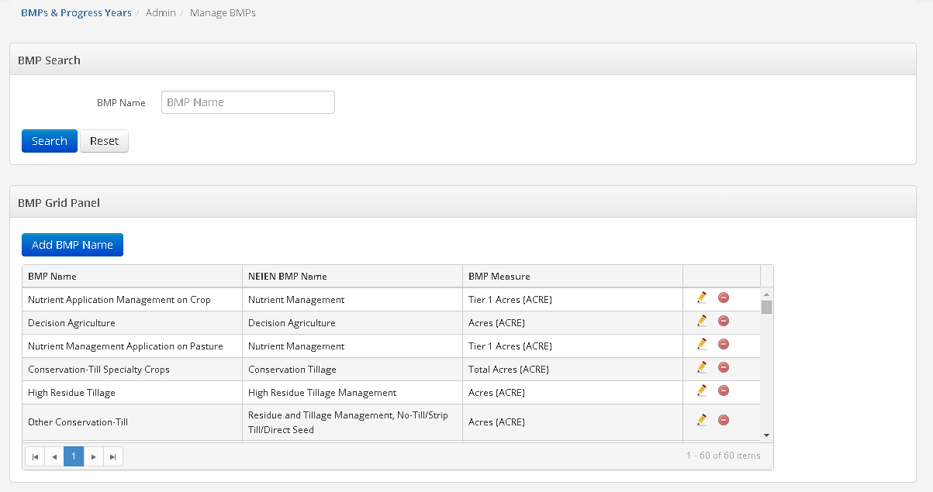
Figure 3.3 Manage BMP Names administrator screen

The page is divided into sections – BMP Search Options and BMP Grid Panel
Search the BMPs by ‘BMP Name’. The results of this search will be displayed in the BMP Grid Panel section of the page. BMP Grid Panel section displays all the BMPs by default. Only Admin user can edit or delete a BMPs from the grid, upon deletion user will be provided a confirmation message.

Add a new BMP by ‘Add BMP Name’ button, which will display the following screen. The Edit icon of an existing user will also show the same screen with the information.

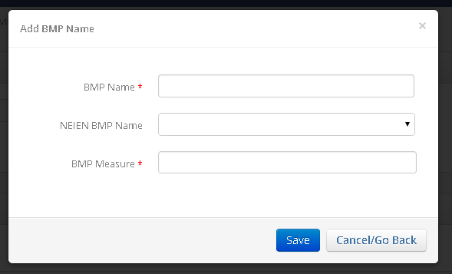
Figure 3.4 Add BMP Name Detail Popup

All the required fields needs to be entered before saving the contact. System will display a confirmation message on saving the entered information. Cancel/Go Back button will take back to the search page without saving any unsaved information.

Manage Lookups

An Admin can edit and manage the lookups lists from this section.
From the Admin menu, user can select ‘Manage Lookups’ to view the page below.

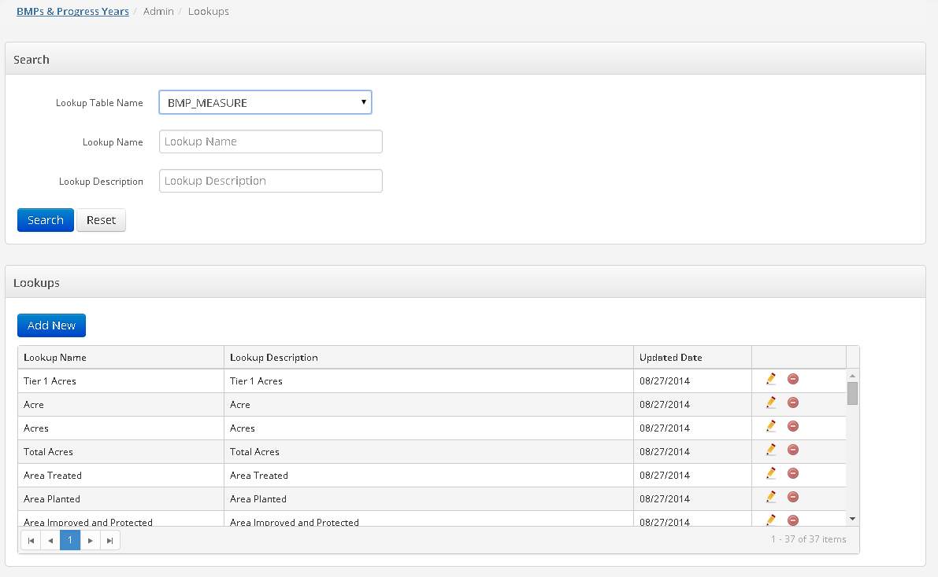
Figure 3.5 Look search screen

The page is divided into sections – Lookup Table Search Options and Lookups
Select the name of the Lookup Table form the dropdown to view the lookup values in the section below.

Search the lookup tables by ‘Lookup Name’ and ‘Lookup Description’. The results of this search will be updated in the Lookups Section of the page. Lookups section displays all the Lookups by default of the lookup table selected. Only admin has the permission to view, add or delete the tables. Any new values can be added to lookup tables.

Clicking the ‘Add New’ button of the lookup tables will display the screen shown below.

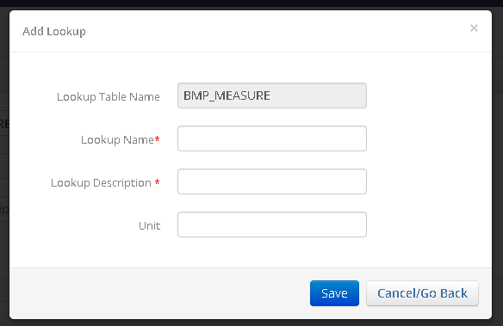
Figure 3.6 Look detail popup

Manage Settings

From the Admin menu, user can select ‘Manage Settings’ to view the page below.

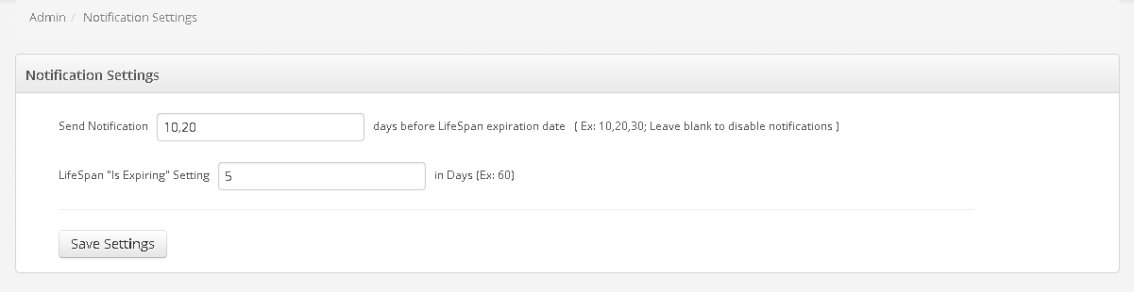

Figure 3.7 Notification Setting screen

Here you can set when an admin and site contact receives a notification that a lifespan of a BMP practice is coming to an end. It will send the notification on days set before the BMP is expired. How many days prior to expire date is considered can be set on ‘Lifespan IS Expiring Setting field.

If Send Notification field is set to blank then no notification will be sent.

APPENDIX D: WEST VIRGINIA’S CUSTOM NEIEN APPENDIX WVCustom_NEIEN_NPS_BMP_P6_Appendix_111721.pdf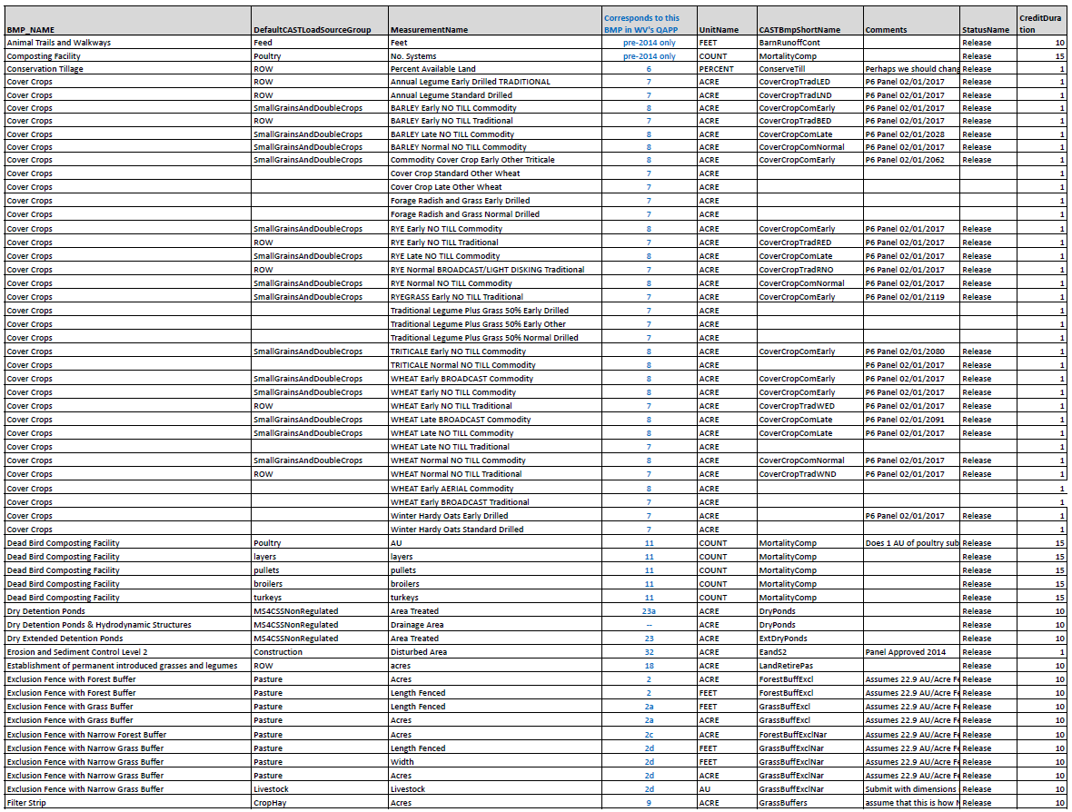
Appendix D, continued
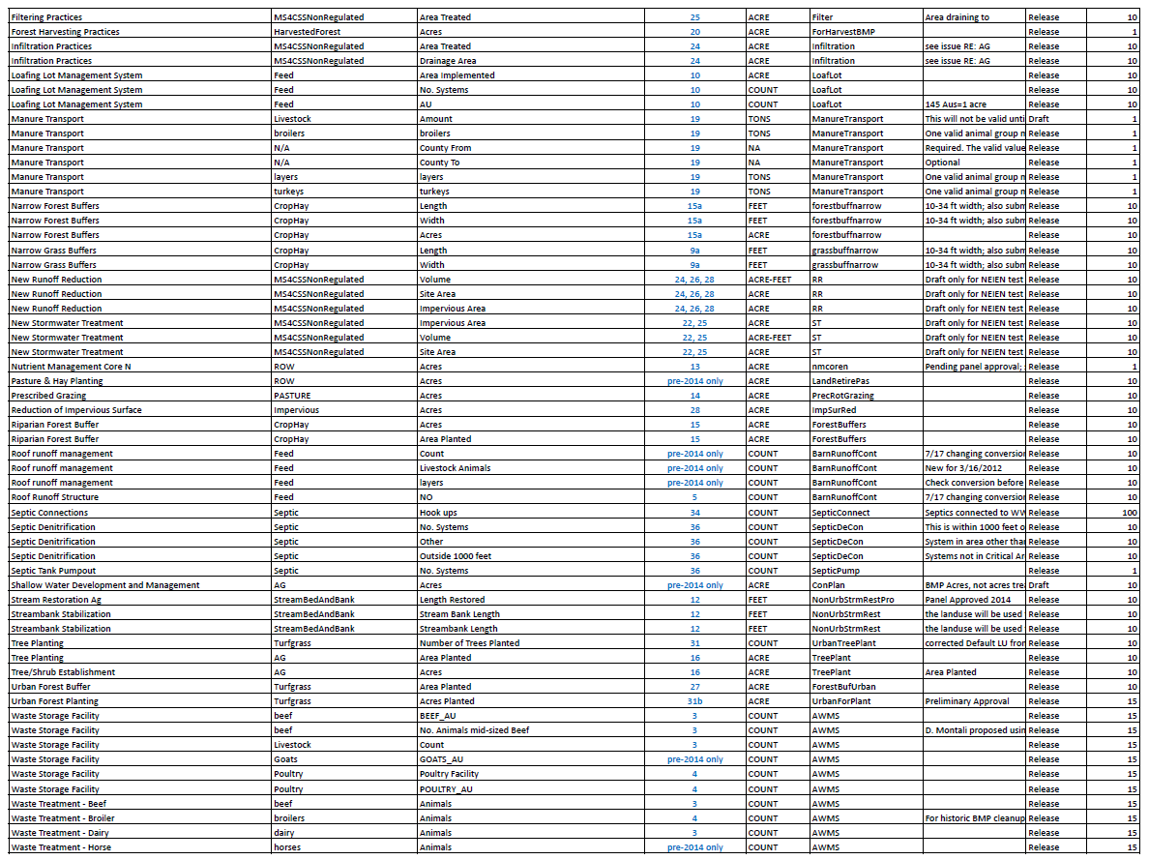

Appendix D, continued

APPENDIX E: PRACTICE REVIEW FORM USED BY NRCS STAFF

This page is intentionally left blank.

