COMMONWEALTH of VIRGINIA

Standard Operating Procedures for Managing and Reporting Agricultural Non-Point Source Data to Virginia DEQ

Standard Operating Procedures for Soil and Manure Testing for Nutrient Management Plan Development

QUALITY ASSURANCE PROJECT PLAN
For the 2023 BMP Data Submission

September 2023

Department of Conservation and Recreation
Division of Soil and Water Conservation
600 East Main Street, 24th Floor
Richmond, VA 23219
(804) 786-2064

Department of Conservation and Recreation

Quality Assurance Project Plan

Group A – Project Management

A1 – Title and Approval Sheet

Plan Coverage: This Quality Assurance Project Plan: Standard Operating Procedures for Managing and Reporting Non-Point Source BMP Data to the U.S. EPA – Chesapeake Bay Program Office in combination with the Quality Management Plan: Virginia Nonpoint Source Pollution Management Program (Virginia DEQ, 2014) reflects the overall Quality Assurance Program framework and management systems necessary to assure that data generated by the Virginia Department of Conservation and Recreation’s Division of Soil and Water Conservation (DCR-DSWC) are of acceptable quality to meet the needs of the United States Environmental Protection Agency’s Chesapeake Bay Program Office (EPA-CBPO).

Name: Stuart Blankenship
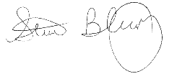
Title: DCR-DSWC, DSWC Quality Assurance Officer

Signature: Date: 12/1/2023

Name: James E. Martin
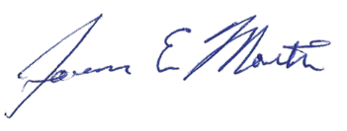
Title: DCR-DSWC, Director

Signature: Date: 12/1/2023

Name: Durga Ghosh
Title: R3 Delegated Approving Official

Signature: Date:

Name: Erin Chapman
Title: R3 Designated Project Manager
Signature: Date:

Questions or comments regarding this QAPP should be referred James Martin 804-786-2291 or james.e.martin@dcr.virginia.gov

A2 – Table of Contents
Group A – Project Management
A1 – Title and Approval Sheet ………………………………………………………………… 2
A2 – Table of Contents ………………………………………………………………………… 3
A3 – Distribution List ………………………………………………………………………….. 5
A4 – Project / Task Organization ……………………………………………………………… 5
A5 – Problem Definition and Background …………………………………………………..… 6
A6 – Project / Task Description ……………………………………………………………..… 8
A7 – Quality Objectives and Criteria …………………………………………………….……. 16
A8 – Special Training Certifications ………………………………………………………….. 17
A9 – Documentation of Records …………………………………………………………….….18
Group B – Data Generation and Acquisition
B1 – Sampling Process Design (Experimental Design) ………………………………………. 19
B2 – Sampling Methods ……………………………………………………………………….. 21
B3 – Sample Handling and Custody ……………………………………………………………22
B4 – Analytical Methods ……………………………………………………………………… 24
B5 – Quality Control …………………………………………………………………………... 26
B6 – Instrument / Equipment Testing, Inspection, and Maintenance …………………………. 26
B7 – Instrument / Equipment Calibration and Frequency …………………………………….. 27
B8 – Inspection / Acceptance of Supplies and Consumables …………………………………. 27
B9 – Non-direct Measurements ……………………………………………………………...... 27
B10.1 – Data Management: Agricultural BMP Cost Share Data ……………………………... 36
B10.2 – Data Management: Nutrient Management Data ………………………………….….. 38

Table of Contents (continued)

B10.3 – Data Management: External Data …………………………………………………….. 39
B10.4 – Data Management: Reporting to EPA-CBPO ………………...………………………. 39
Group C – Assessment and Oversight
C1 – Assessments and Response Action …………………………………………………….… 40
C2 – Reports to Management ……………………………………………………………….…. 45
Group D – Data Validation and Usability
D1 – Data Review, Verification, and Validation ……………………………………………… 46
D2 – Verification and Validation Methods ……………………………………………………. 49
D3 – Reconciliation with User Requirements ……………………………………………….… 52
References ……………………………………………………………………………………… 54
Appendix 1
- DCR and DSWC Organizational Charts......…………………………….……..…....…. 56
Appendix 2
- General Flow Chart of Ag BMP Data Deployment........................................................ 63
Appendix 3
- Agricultural BMP Verification Groups……………….................................................... 64
Appendix 4
- Nutrient Management Verification Forms……………................................................... 69
Appendix 5
- Virginia Farm Voluntary Agricultural Best Management Practices Inventory............. 80
Appendix 6
- Additional 2022 Tillage Survey Information…………………………………............. 88
A3 – Distribution List
This document is being provided to the following:
- Katherine Antos, EPA-CBPO, Project Officer
- Mary Ellen Ley, USGS / EPA-CBPO, Quality Assurance Coordinator
- Susan Hale, DEQ, Chesapeake Bay Grant Manager
- Darryl Glover, DCR-DSWC, Deputy Director for Dam Safety, Floodplain Management, and Soil and Water Conservation
- James Martin, DCR, Director, Division of Soil and Water Conservation
- William Keeling, DEQ-WD, NPS Modeling & Data Coordinator
- Sara Bottenfield, DCR-DSWC, Agricultural Incentives Program Manager
- Hunter Landis, DCR-DSWC, Nutrient Management Program Manager
- Jennifer Edwards, DCR-DSWC, Conservation Data Technician

A4 – Project / Task Organization
Nonpoint source (NPS) pollution reduction tracking data is generated by a coordinated effort of DEQ and other agencies staff. The DCR Conservation Programs Data Manager is responsible for the administration of the Agricultural Cost Share database, quality assurance (QA) of the cost share data and for directing computer code development and modification. The DCR regional conservation district coordinators (CDCs) provide quality assurance functions by reviewing the data generated by the soil and water conservation districts (districts or SWCD's) they work with and by going on verifications of installed BMPs.
The DCR Conservation Programs Data Manager serves as the quality assurance officer and is in an independent unit from those generating the data. The Conservation Programs Data Manager and the Nutrient Management Program Manager are responsible for maintaining the official approved Quality Assurance Project Plan. Organization charts showing lines of authority and reporting responsibilities are provided in the Appendix #1.

A5 – Problem Definition and Background
The project objectives are to fulfill the reporting requirements of the EPA-CBPO for the Virginia Chesapeake Bay Implementation Grant, the Chesapeake Bay Regulatory and Accountability Program grant and the EPA Section 319(h) funding by supplying annual NPS BMP implementation data. This data is provided to EPA-CBPO for inclusion in the annual watershed model progress evaluations as stipulated in the grant documents. Professionally trained SWCD conservation technicians and Virginia Department of Conservation and Recreation Nutrient Management staff work directly with landowners and operators to implement NPS BMPs designed and located to reduce and/or treat agricultural runoff. One hundred percent of BMPs implemented are certified as installed to specifications before Virginia Agricultural BMP Cost Share (VACS) payments are made. A robust verification program involving both SWCD and DCR staff is performed annually. Based on these inspections, Virginia is confident that BMPs reported to the NEIEN are correctly located, installed, functioning as designed and reported with a high degree of accuracy. The EPA-CBPO requested this document for their understanding of the various sources of NPS BMP data within and among jurisdictions as well as any analysis done by the jurisdictions prior to submission to EPA-CBPO.

The VACS Program’s goal is to improve water quality in the state's streams, rivers, and the Chesapeake Bay. VACS offers cost-share assistance as an incentive to carry out construction or implementation of selected BMPs. The basis of VACS is to encourage the voluntary installation of agricultural BMPs to meet Virginia's NPS pollution reduction water quality objectives. Although resource based problems affecting water quality occur on all land uses, VACS promotes efforts for corrective action on agricultural lands only. VACS emphasizes the implementation of agricultural BMPs in locations that provide the greatest nutrient and sediment reductions for the taxpayer’s dollars spent. Cost-shared BMPs must maximize nutrient and sediment reductions and also protect the taxpayer’s interest by implementing the most cost-effective BMPs possible in locations that achieve the greatest pollutant reductions on a field by field basis. VACS objectives include: reducing nutrients (nitrogen and phosphorus) and sediment loadings to the Chesapeake Bay, preventing additional pollution from entering state waters and meeting the criteria for Virginia's compliance with Section 319 of the Clean Water Act. VACS implementation should be based upon sound conservation planning and best professional judgment.
The agricultural BMPs reported through the NEIEN to the CBPO are generated by qualified professional conservation technicians from one of Virginia’s forty-seven SWCDs. These conservation technicians receive technical training in conservation planning and resource management as well as cost-share program administrative training from DCR. Secure logons and built-in quality assurance checks within the AgBMP Tracking Module ensure that accurate data is recorded for each BMP implemented and reported. Each BMP contract and instance within the contract is given a unique identifier tied to the SWCD of its origin. The VACS data is accumulated by DCR’s data management staff and transmitted to DEQ to be forwarded to CBPO.
The Nutrient Management Program Manager and his three designees are responsible for verification of implementation of nutrient management plans in Virginia. Nutrient management specialists review activities with farmers after year one of a plan being written on any given farm, discuss and review his records of application of nutrients and cropping systems and fill out a 33 question form on what the farmer is doing on a field by field basis. The specialists report to the program manager on a monthly basis the number of farms verified, the total acres implemented and the total acres not implemented. The specialists notify the Program Manager, the Verification-Animal Waste Coordinator, or the Bio-solids Coordinator for third party verification on at least 10% of the acres that are verified on a regular basis. The 10% sample only applies to the core nutrient management acres, and the 10% are chosen randomly from nutrient management plans that are in the process of being revised. Supplemental nutrient management practices (rate, timing, placement) are renewed annually, and 100% of those practices are verified. The original verification forms are maintained in the file with the nutrient management plan in the specialist’s office, the 3rd party verification forms are compared to the specialist’s forms on a regular basis, and any discrepancies are deducted from implemented acres and discussed at quarterly staff meetings to maintain consistency in verification procedures. This information is reported on a quarterly basis.

A6 – Project / Task Description
The project includes NPS data collection and compilation covering the reporting period for the 2023 progress runs. A full description of the quality assurance performed annually is included in the following sections. The environmental data produced from this project is used by the EPA-CBPO to project NPS reductions of nutrients and sediment via implementation of NPS BMPs within the Chesapeake Bay drainage of Virginia based on data needs for the 2015 progress runs.
Internal NPS data. DCR obtains NPS tracking data from internal sources. The primary internal source of data is the AgBMP Tracking Module database. Other data provided internally is for nutrient management planning acreage and for tillage practice determination.
Agricultural BMPs. Data in the AgBMP Tracking Module database originates from the 47 SWCDs and reflects the implementation of Agricultural and Conservation Reserve Enhancement Program (CREP) BMPs installed and funded through VACS, state tax credits, and CREP incentive programs. Specifications for all DCR approved BMPs are in the Virginia Agricultural BMP Manual. The 2023 Program Year version of the manual can be accessed through the following URL:
http://consapps.dcr.virginia.gov/htdocs/agbmpman_2023/agbmptoc.htm
Each SWCD has internet access to a secured server to access the VACS tracking program. The DCR central office staff maintains the database and updates data requirements associated with each BMP reported for each program year. The AgBMP Tracking Module is used to track and report data associated with BMP implementation. The tracking program application and database are stored on remote servers accessed through the internet to allow for all information associated with BMP implementation to be entered and maintained in an enterprise database. The database web application provides printable contract forms that are used to obtain participant signatures. These paper files are archived by the SWCD and retained for three years beyond the lifespan of the practice.
In order to adequately track program effectiveness and to make necessary management decisions, it is vital that all data requested on the DCR Incentives Programs Contract be input and updated in the AgBMP Tracking Module in a timely fashion. The tracking program and BMP database will be maintained on the centralized servers and will be available for generating reports through Logi Ad Hoc software accessible by the SWCD and DCR staff.
DCR database management staff will review data for all practices on an on-going basis. All necessary data must be entered into the tracking program according to the identified cost-share program schedule. SWCDs are to submit an estimated funding need based on data entered into the AgBMP Tracking Module for the coming quarter to their Conservation District Coordinator (CDC) before quarterly disbursement letters can be generated.
The 2023 VACS Program schedule is as follows:

July 1, 2022 2022 Cost-Share Program Year began.
June/July 2022 CDCs inform Districts of program allocations.

July 2022 Districts may begin practice approval after Secondary Considerations have been approved.

September 30, 2022 End of First Quarter. Quarterly reports due, including requests for disbursements in 2nd quarter due to CDCs by 10/15/2021.

December 31, 2022 End of Second Quarter. Quarterly reports due including requests for disbursements in 3rd quarter due to CDCs by 1/15/2023.

March 31, 2023 End of Third Quarter. Quarterly reports due including request for disbursements in 4th quarter due to CDCs by 4/15/2023.

March 2023 Matrix of TAC suggested Changes for Fiscal Year 2023 to Virginia Soil and Water Conservation Board for approval.

May 2023 Districts’ review and update of secondary considerations and submit to CDC by 6/30/2023.

June 30, 2023 End of Program Year. All applications entered into the BMP Tracking Program are to be identified as; (1) Complete, or (2) Canceled, or (3) Carryover with an approved carryover date (only if practice is on the approved list and under construction). All completed projects must be paid by 6/30/2023. Final 2023 Cost-Share Program quarterly reports are due to CDCs by 7/15/2023.

NOTE: All BMP payment data for a quarter must be entered into the Tracking Program by the 15th of the next month in order to qualify for a quarterly disbursement. Tracking Program reports will be run by the DCR CDC on the 18th of the month.

Tillage Practices. Determinations of tillage practices is based on transect residue surveys conducted by survey teams consisting of professionals in the agricultural community - typically SWCD employees and retired USDA employees. The SWCD employees and retired USDA employees have experience in evaluating the level of residue on the fields, and additional training sessions are given by DCR on the methodology that should be used to determine the residue levels. Recordings of the training sessions are made available to all surveyors along with the training materials (PowerPoints, etc). Additional technology training was given for the 2022 survey which utilized a mobile data collection application which will be describe in further detail below.
Surveys were conducted in the spring of 2015 and again in the spring of 2022. An expected 5 year survey cycle was interrupted by the Covid pandemic, Surveyors are trained by DCR staff regarding where, when, and how to conduct the survey. The tillage data is not currently verified during the intervening 5 years between cycles. For the 2022 survey DCR followed the guidance of the roadside transect survey method as described in the CBP report Recommendation Report for the Establishment of Uniform Evaluation Standards for Application of Roadside Transect Surveys to Identify and Inventory Agricultural Conservation Practices for the Chesapeake Bay Program Partnership’s Watershed Model (16 March 2017) with one exception for the process of verification which is described in Section D2 of this document.
The 2015 survey followed CTIC guidance, which is very similar. With the exception of one survey area, the 2022 survey data will replace the data reported from the 2015 survey so there will not be any duplication. The 2022 survey will be the sole source for tillage data with the exception of the Robert E. Lee survey area, so there will not be duplications from any other sources. Data collected for the Robert E. Lee survey area did not meet the minimum accuracy requirements, so 2015 data is being reported during this cycle. This area will be surveyed during 2024, and data from the 2024 survey will be reported for this area for the next reporting period.
As per the CBP transect survey report, DCR calculates how many data collection points are required per survey unit in both surveys using the multinomial distribution (Tortora) since there were three residue levels in the 2015 survey and four in the 2022 survey.
The 2015 survey collected tillage data for the following categories:
- Less than 30%
- 30% - 60%
- Greater than 60%
The 2022 survey collected tillage data for the following categories:
- Less than 15% (Conventional Tillage)
- 15% - 30% (Reduced Tillage)
- 30% - 60% (Conservation Tillage)
- Greater than 60% (High Residue Tillage Management)
The a priori estimate for the 2015 survey was the latest CTIC survey results whereas the 2015 results were the a priori estimates for the 2022 sample size calculations.
With few exceptions the survey units in both surveys were the same. They consisted of single jurisdictions with significant crop land or a conglomerate of adjoining jurisdictions where necessary and acceptable. Jurisdictions with little crop land were joined to adjacent jurisdictions with similar past survey results. The a priori estimate for these joined units would always be the closest to 0.5.
Surveyors work in designated survey units to minimally obtain that specific number of crop land survey points. The survey team submitted hardcopies of their completed survey forms in the 2015 survey but recorded and reported using a mobile application for the 2022 survey.
The mobile application that was used to collect data for the 2022 survey is ESRI’s Quick Capture. This application allows for easy capture of point locations using a very straightforward interface and also has the ability to collect photos that are associated with each point. Photos were captured and used for the verification process as described in a later section of this document. This application integrates with ArcGIS Online and has the ability to work offline when connectivity is not available for synching the data that’s being collected. The interface that was used to collect the data points is shown in the graphic below. The categories can be collapsed and expanded, and each button has the ability to add a picture.
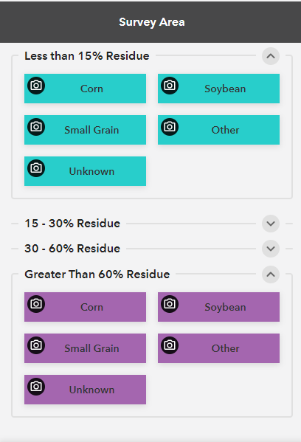
The data collected through this application is automatically synched with a feature class in ArcGIS Online which allowed for near real-time monitoring of the progress of the surveyors. An ESRI Dashboard was created to allow for tracking of the progress of the survey as shown below:
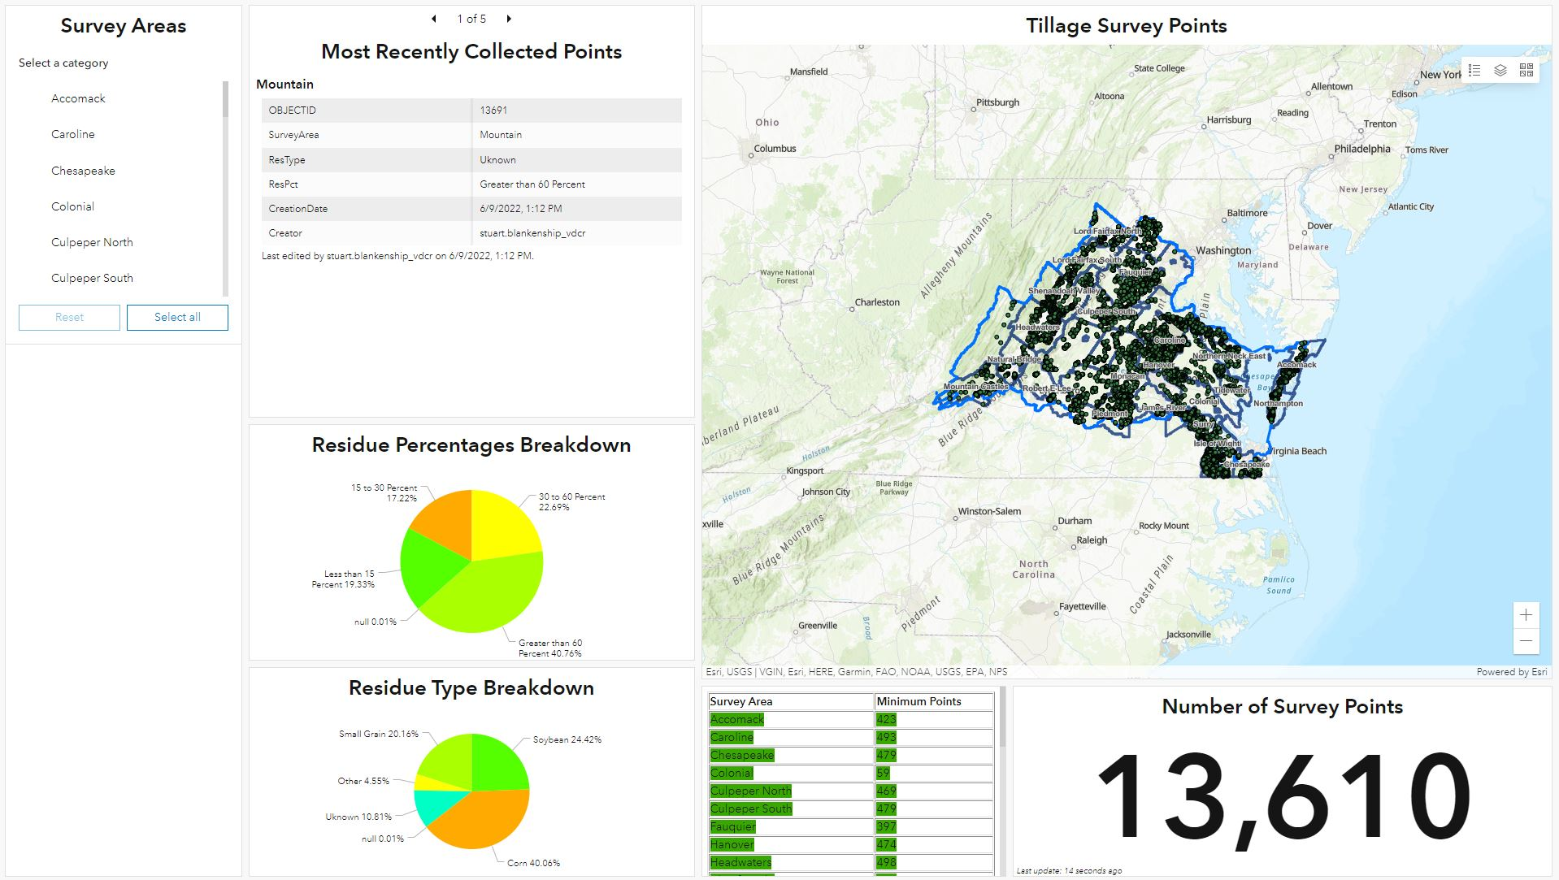
The dashboard also has the ability to filter to show progress on a specific survey area as shown below for Hanover survey area: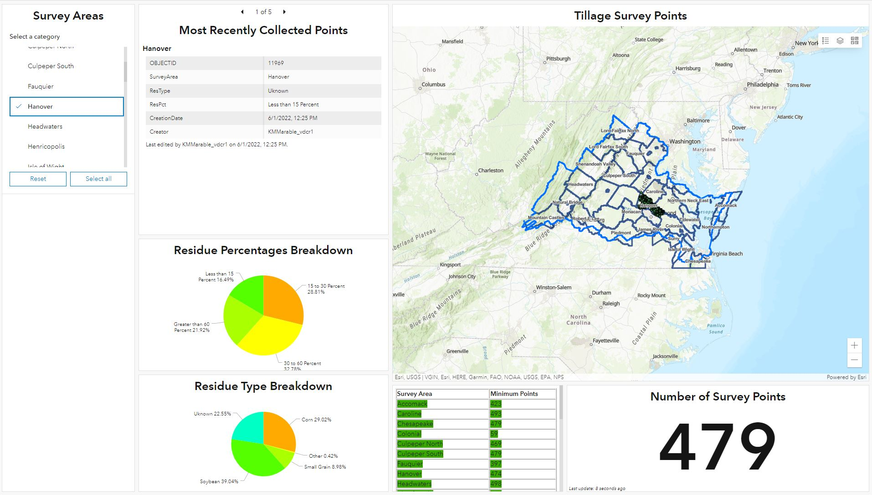

Nutrient Management: Agricultural nutrient management plan implementation and urban nutrient management acres are supplied by the DCR nutrient management staff, which includes plans developed by certified private nutrient management planners as well as DCR's certified nutrient management specialists. As required in Virginia’s Nutrient Management Training and Certification Regulations all certified nutrient management planners must submit an annual activity report including number of nutrient management plans completed for new and revised plans; acreage covered by plans and planned acreage by county and state watershed codes; breakdown of planned acreage by cropland, hay, pasture, specialty crops, and turf/landscape by county and watershed code; and other information indicating number of practices facilitated by the planner such as manure testing and use of the pre-sidedress nitrate test.
Nutrient Management plans are tracked using a variety of methods and criteria for DCR specialists and private planners in Virginia. Depending on application or format, data is periodically submitted to DCRs data management team to be reviewed, QAQCed, and uploaded to DCR’s central SQL server database. The SQL database is the core point where all data is aggregated and all reporting is derived from. The QA/QC process includes reviewing the data to ensure there is no duplication which includes spatial queries to look for any potential overlap in plan areas. Data from revised plans is also checked to ensure that it is not also being reported as acreage in any new plans. For the 2023 data submission, it was found that acres were left out of the 2022 submission as mistakenly being seen as duplicative. Plans created in the NM Module in the Conservation Application Suite that were showing with a status of “expired” were left out of the reported acreage for the 2022 submission even if they were active at some point during the reporting period and were not revised. This error in logic has now been corrected which resulted in a larger increase than expected of active nutrient management plan acres for the 2023 submission.
This project also includes the quality assurance measures relevant to samples and laboratory procedures used during the development of nutrient management plans. (See pages 15 through 23.)
For NPS BMP implementation levels, the project is considered ongoing because reporting to the EPA-CBPO office is required annually. DEQ reports annual BMP implementation only once, the first year of the total lifespan of the practice. All non-annual BMPs are accumulated by EPA for annual progress runs. Only those Forestry and Residential Septic practices included in the VACS Program or the DEQ TMDL Grant Programs that are tracked in the AgBMP Tracking Module are reported to DEQ by DCR. These BMPs are included in the BMP Crosswalk for the NEIEN mapping report in Appendix 2.
It is noted that DEQ and CBPO have different names for the same practice. DCR and DEQ staff have attempted to crosswalk DCR practice codes to Scenario Builder names. This data is attached as Appendix 2.

A7 – Quality Objectives and Criteria
The EPA-CBPO is responsible for the planning and design aspects regarding the use of the NPS data provided by DEQ in the annual progress model runs. Details regarding the systematic planning process used to plan and design the study for this data requirement should be addressed to the EPA-CBPO. Details on the quality of data provided by DCR are included in the following sections.
All BMPs completed must be certified as complete and meeting appropriate VACS and NRCS standards prior to the issuance of any state cost share or tax credits. Each year BMP Verifications will be completed per the rules detailed in Appendix 3. Any BMP found out of compliance with specifications is noted and the SWCD follows the procedures in the Virginia Agricultural Cost Share Manual BMP Verification Procedures section (Pg. II-68) and Practice Failure section (Pg. II- 35) if appropriate. Participants that do not maintain practices or do not bring the practice up to specification and standards are expected to return on a pro-rata share basis any cost share and tax credits authorized by the SWCD.
DCR verifies that an appropriate number of transect residue survey collection points has been reached per survey unit such that DCR can be 90% certain of the percent occurrence of tilling practices within +-5% of their true occurrence before reporting results.

A8 – Special Training Certifications
Details regarding specialized training and certifications for DCR NPS programs are provided in Section IV, Personnel Qualifications and Training of the Quality Management Plan: Virginia Nonpoint Source Pollution Management Program (Virginia DEQ, 2013). Each new program year, training sessions are held to discuss any revisions to the VACS program. Any revisions to the agricultural BMP technical specifications and program policies are reflected in the VACS program revisions each program year. Training sessions and workshops are provided on the VACS program application with special emphasis on any revisions or improvements to the application. These trainings help maintain data quality by ensuring that the SWCD personnel entering data into the application are properly trained on how to use the application and that the input of data is uniform and correct. The trainings emphasize the importance of quality data and data reporting. The CDCs, Richmond Central Office staff and Data Management Staff also offer VACS Helpdesk support to address specific questions and data concerns. This helps maintain data quality by ensuring that the agricultural BMP technical specifications and program policies are interpreted properly. Furthermore, guidelines, policies and training aides are available for reference on the DCR website. Specific Staff and Director Resources can be found at https://www.dcr.virginia.gov/soil-and-water/cd-tng-res-landing. SWCD conservation specialist personnel typically have agricultural experience or educational backgrounds and over time gain job approval authority through the DCR District Engineering Services Program. Agricultural BMPs implemented require the signature of the SWCD conservation specialist who is required to have job approval authority on that agricultural BMP type, certifying that the BMP was implemented according to the applicable technical specifications.

A9 – Documentation of Records
SWCDs will retain all billings and supporting data in their files according to the following unless notified by DCR.
- SWCDs must complete their data input to the AgBMP Tracking Module according to the program schedule published in the front of the manual.
- Conservation plans and practice design sheets should be kept with individual case files according to SWCD policy.
- Minimum document retention for VACS application forms will be three (3) years. Canceled applications may be discarded after the (3) year period if not needed for future reference by the SWCD.
- If the practice is installed, documentation should be retained for three (3) years beyond the lifespan of the practice.

Each SWCD’s VACS data is entered into the AgBMP Tracking Module accessible via a secured web-based interface. DCR and other agency data are appended to the data tables needed to supply data to the NEIEN schemas and are the transmitted via established NEIEN protocols for inclusion in the annual progress run input deck by DEQ.

Group B – Data Generation and Acquisition

Sections B1 through B8 of this QAPP pertain to samples collected for developing Virginia nutrient management plans. Nutrient management plans are prepared to indicate how primary nutrients are to be managed on farm fields and other lands for crop production and in ways which protect groundwater and surface water from excessive nutrient enrichment.
Laboratories approved by DCR perform soil test and manure sample analysis. The pre-sidedress soil nitrate tests are conducted as a field procedure. Soil test analysis includes information on soil fertility levels for phosphorus and potassium, and pH levels. Manure test analysis includes percentage of moisture, total nitrogen or total Kjeldahl nitrogen, ammonium nitrogen, total phosphorus, and total potassium. The pre-sidedress nitrate test is a procedure used to determine soil nitrate-nitrogen levels at a specific time during a corn crop, small grain, and a few horticultural crops growing season. Sections B1through B8 below are completed as relevant for each of these three types of samples.

B1 – Sampling Process Design (Experimental Design)
Soil test samples. The design strategy for nutrient management soil test samples is found in Virginia’s Nutrient Management Training and Certification Regulations, 4 VAC 50-85, § 10.1 – 104.2 of the Code of Virginia (Effective: June, 2014). Soil analysis is required for each field at least once every three years to determine the soil fertility and pH, and to update the nutrient management plan. The excerpt below is from the “Required nutrient management plan procedures” section of the regulations:
“…. Soil analysis results shall be dated no more than three years prior to the beginning date of the nutrient management plan. A single composite soil sample should represent an area up to approximately 20 acres. Fields such as those common to strip cropping may be combined when soils, previous cropping history, and soil fertility are similar….”.

Manure samples. Manure samples are collected from specific operations in order to accurately assess the nutrient concentrations for the purpose of calculating manure application rates to supply crop nutrient needs. Manure samples are collected for laboratory analysis in order to determine the exact nutrient content. Manure analysis is recommended before field application until a baseline nutrient content is established for the specific manure type on the corresponding farm operation. After a baseline nutrient content is established, a manure analysis is recommended at least once every three years for dry or semisolid manures, and at least once every year for liquid manures. The analysis determines the appropriate rate of animal manures to apply based on the nutrient needs of various crops, soil types, and other production factors.
Soil nitrate test. The pre-sidedress soil nitrate tests involve field sampling and field analysis of soil nitrate levels found in the top 12 inches of soil. The sample is taken when corn is approximately 10 to 15 inches in height. The amount of nitrate-nitrogen in the soil sample is a representative index of the plant-available nitrogen that will mineralize from soil organic matter. Recommendations for sidedress nitrogen fertilizer rates applied to corn at the ~ 12 to 24 inch growth state can be modified depending on the level of nitrate-nitrogen found in the soil. Certified nutrient management specialists use these tests to modify top dressing or side dressing application rates of nitrogen in accordance with the Virginia Nutrient Management Standards and Criteria (June 2014).
The soil nitrate test is a field procedure and is not normally performed by a laboratory. Past research data used to calibrate the soil nitrate tests, for both lab tests and various field test kits, was not conclusive for readings below 21 ppm of nitrate-nitrogen in soils. Above this level, the data statistically justified that no crop responses to additional nitrogen was expected. This may limit the use of the procedure in certain instances (i.e. for readings below 21 ppm). The test is used primarily to identify fields which need no additional nitrogen, and is a reliable predictor in this setting. Recommendations for nitrogen sidedress application rates for fields with 20 or less ppm is based on the soil nitrate test results and guidance provided on page 64 of the Virginia Nutrient Management Standards and Criteria (June 2014). Use of the test results when soils are found to be at 21 ppm or greater does result in significant nitrogen use reductions by farmers, so targeted use of the kits is essential to Chesapeake Bay and statewide nutrient reduction efforts.

B2 – Sampling Methods
Soil test samples. The sampling method including data collection procedures to be followed for soil testing samples is found in Virginia’s Nutrient Management Training and Certification Regulations, 4 VAC 50-85, § 10.1 – 104.2 of the Code of Virginia (Effective: March 13, 2014). The excerpt below is from the “Required nutrient management plan procedures” section of the regulations:
“Representative soil sample cores shall be obtained from the soil surface to a depth of four inches (0-4”) for fields that have not been tilled within the past three years, and from the soil surface to a depth of six inches (0-6”) for fields, which are tilled or have been tilled within the past three years. Soil sampling of fields based on the subfield grids or management zones may be utilized….”

Manure samples. It is important that representative samples are obtained. Accepted manure-sampling techniques are outlined in Chapter 9, “Manure as a Nutrient Source”, in the Mid-Atlantic Regional Water Program’s February 2006 publication, The Mid-Atlantic Nutrient Management Handbook (MAWP 06-02). Detailed sampling and handling procedures for semi-solid lot manure, liquid manure slurry, lagoon liquid, and boiler or turkey litter are provided on pages 212-213 of this publication. DCR provides sampling bags and bottles for collection of manure samples. Samples are collected in zip-lock bags for solid samples and plastic bottles for liquid samples. Each sample is less than 1 pint.
Soil nitrate test. The pre-sidedress soil nitrate test is used on select fields where organic sources of nitrogen rates have been applied in accordance with the appropriate timing criteria to supply nitrogen to the present corn or small grain crop along with certain horticultural crops. Samples are taken when corn height is 10 to 15 inches tall at the whorl as it stands, not to the tallest part of the plant or just before horticultural crops flower or begin to send out runners. The sample collection procedure involves taking 10 to 20 cores from across the field to a depth of 12 inches. Samples are taken between rows to avoid starter fertilizer bands and areas where roots have depleted nitrogen. The samples are combined, mixed, and crumbled and then a test kit is used to determine the soil nitrate-nitrogen concentration. Documentation for the soil nitrate test can be found in a document titled “Nitrogen Soil Testing for Corn in Virginia” published through the Virginia Cooperative Extension.

B3 – Sample Handling and Custody
Soil test samples. Currently DCR-approved soil test laboratories that are correlated to the Virginia Tech soil test lab using the Mehlich III procedure for phosphorus analysis include A & L Eastern Agricultural Laboratories, Brookside Laboratories, and Spectrum Analytical Laboratories, Agri Analysis Testing Laboratories, Agro Lab, Inc., Logan Labs, LLC. And Midwest Laboratories. Waters Agricultural Laboratories uses the Mehlich I procedure and therefore the phosphorus soil test results can be interpreted the same as Virginia Tech phosphorus soil test results. Additional details on required soil test procedures that related to handling are in the sections that follow.
Manure samples. Manure storage and handling facilities and equipment results in moderate variability in both manure consistency and actual rate of material applied. Accepted manure sampling, handling and storage techniques are outlined on pages 212-213 in The Mid-Atlantic Nutrient Management Handbook (February 2006). Currently the DCR approved laboratory for analysis of manure samples is the Clemson University Agricultural Service Laboratory (Lab). The Lab must maintain a maximum sample turn-around time of 7 working days measured from the date a sample is received by the laboratory until the complete analysis is mailed out. If unforeseen circumstances are expected to delay sample analysis beyond the 7-day time, the project manager of DCR must be notified.
All samples submitted to the Lab by certified nutrient management planners must include a sample submission form. The Lab must log each sample with a unique lab number, adding this information to the sample submission form. One sub sample of each sample must be stored in a refrigerator at 5 degrees C and a second sub sample must be weighed, dried at 80 degrees C overnight, then weighed and ground through a Tecator Mill to pass through a 0.5 mm screen. The moisture will be determined from the weighings. The laboratory staff involved in the sample analysis and their roles includes laboratory technician logs and grinds the samples, a lab chemist prepares and analyzes samples and lab director reviews and sends analysis reports.
The sample results are mailed to the individual listed on the form if a mailing address is included. If an email address is listed on the form, an email notification will be sent so that the results can be viewed on the web. DCR has access to all results. The Lab must notify DCR by email to seek pre-approval if any single farm appears to have submitted more than two samples that arrive at the Lab in the same year unless the samples were submitted by DCR staff.
B4 – Analytical Methods
Soil test samples. The analytical method to be followed for soil test samples is found in Virginia’s Nutrient Management Training and Certification Regulations, 4 VAC 50-85 § 10.1 – 104.2 of the Code of Virginia (Effective: June, 2014). Soil test analysis includes information on soil fertility levels for phosphorus and potassium, and pH levels. The excerpt below regarding the required analytical method is from the “Required nutrient management plan procedures” section of the regulations:
“…. Representative soil analysis results for fields shall be determined by using standard soil sampling and analysis methods according to Methods of Soil Analysis, Part 3, Chemical Methods, 1996 utilizing the Mehlich I extraction procedure for phosphorus or other methods and laboratories approved by the department and correlated to Mehlich I and utilizing correlation procedures contained in Virginia Nutrient Management Standards and Criteria, revised June 2014.”.

Manure samples. Manure test analysis includes percentage of moisture, total nitrogen or total Kjeldahl, ammonium nitrogen, total phosphorus, total potassium, calcium, magnesium, sulfur, zinc, manganese, copper, aluminum and sodium. Manure test results must be reported on an as-sampled basis in pounds per ton for dry manure and pounds per 1,000 gallons for liquid manure. Manure analysis must be performed using laboratory methods consistent with Recommended Methods of Manure Analysis, 2003 publication # A3769 of the University of Wisconsin. Guidelines from this publication and additional analytical methods and reporting requirements are described below.
- Results will be reported on an “as-is” basis and also calculated to lbs/ton for solid samples of lbs/1000 gallons for liquid samples.
- Laboratory Procedure 3.2 Total Kjeldahl Nitrogen will determine TKN for liquid manure.
- Laboratory Procedure 3.3 Total Nitrogen by Combustion will determine nitrogen for solid and semi-solid manure (greater than 15% solids).
- Laboratory Procedure 4.1 Ammonium-N Determination by Distillation will determine ammonium nitrogen, except that KCI will be used as a reagent instead of MgO.
- Laboratory Procedure 5.4 Nitric and Hydrochloric Acid Digestion with Peroxide will determine Phosphorus, Potassium, Calcium, Magnesium, Zinc, Copper, Manganese, Sulfur, and Sodium, and then analyzed on inductively coupled plasma (ICP).

Laboratories are required to provide a suitable report approved by DCR that utilizes the mineralization rates and ammonium nitrogen availability coefficients, which have been agreed to by DCR as currently listed in the Virginia Nutrient Management Standards and Criteria (June 2014). The laboratory will print expected nitrogen availability based on immediate incorporation and no incorporation along with the manure analysis results on the approved report. The initials of the appropriate lab analyst must be printed on the approved report for the nitrogen, phosphorus, potassium, calcium and magnesium results as well as a brief reference to method of analysis for those parameters.
Soil nitrate tests. Merckoquant 10020 Nitrachek meters are utilized to read color metric test strips which are exposed to soil solutions extracted with 0.025 molar aluminum sulfate-solution. The test meters are standardized daily using a 10 ppm nitrate-nitrogen standard solution. The extracted soil solution is analyzed at least two times to ensure consistent results.

B5 – Quality Control
Manure samples. DCR requires that the laboratory used for manure samples hold a Manure Testing Laboratory Certification by the Minnesota Department of Agriculture. The laboratory is also requested to participate in sample exchange programs including: North American Proficiency Testing Program, Manure Analysis Program, National Forage Testing Association, and Association of American Feed Control Officials, Inc. All analysis reports of results must include the initials of the lab analyst that performed the analysis for percent moisture, total nitrogen, ammonium nitrogen, total phosphorus, calcium, and magnesium. The laboratories are required to provide DCR with monthly and annual reports including a summary of the total manure samples analyzed, and average test values for all parameters analyzed each quarter for each category of manure type. The data is being provided primarily for collection purposes by can be analyzed by DCR if necessary.

B6 – Instrument / Equipment Testing, Inspection, and Maintenance
The individual laboratories performing soil test and manure analysis are responsible for meeting appropriate operating standards for equipment testing, inspection, and maintenance.
Soil nitrate tests. Merckoquant Nitrate Test, test strips are used for the detection and semi-quantitative determination of nitrate ions. Unopened Merckoquant Nitrate Test packs are stored in a refrigerator. After opening, the kits are stored in a dry and cool area, but not in a refrigerator to avoid too much atmospheric moisture condensation in the tube. Test strips are dipped into the solution for 1 second to allow the reaction zones to be fully wetted. The test strip is removed and excess liquid shaken off. After 1 minute has passed the test strip is compared to the reaction zones on the color scale provided on the test kit tube / container. All field nitrate test kits are carefully maintained in order to obtain reliable results. The test meters are checked daily during the use season, using a 10-ppm nitrate-nitrogen standard solution, and standardizing the results with the fixed color strip to ensure proper functioning of the meter.

B7 – Instrument / Equipment Calibration and Frequency
Manure samples. The LECO combustion units used by the DCR approved laboratory must be calibrated with certified EDTA and checked with NIST peach or orchard leaf reference materials. The inductively coupled plasma (ICP) is standardized with standards made in house from stock solutions purchased from High Purity. The ICP standardization is checked with the NIST peach reference material. The reference materials for the LECO combustion unit and standard for the ICP are to be rechecked by the laboratories after every 15 samples.

B8 – Inspection / Acceptance of Supplies and Consumables
This section does not apply to this QAPP.

B9 – Non-direct Measurements
Agricultural BMPs. Data in the VACS database originates from the 47 SWCDs and reflects the implementation of Agricultural and CREP BMPs installed and funded through VACS, state tax credits, and CREP incentive programs. Specifications for all DCR approved BMPs are in the Virginia Agricultural BMP Manual. Each SWCD has internet access to the AgBMP Tracking Module secured web application. The AgBMP Tracking Module is used to track and report data associated with BMP implementation. The AgBMP Tracking Module application and database are stored on remote servers accessed through the internet to allow for all information associated with BMP implementation to be entered and maintained in an enterprise database. The database web application provides printable contract forms to obtain participant signatures. These paper files are archived by the SWCD and retained for three years beyond the lifespan of the practice.

Resource Management and Conservation Plans. In 2011, the Virginia General Assembly passed House Bill 1830 (Chapter 781 of the 2011 Virginia Acts of Assembly), which allowed for the creation of the Resource Management Planning (RMP) program. Representatives from agricultural commodity groups, conservation organizations, and state and federal agencies developed the RMP regulations. The Virginia Soil and Water Conservation Board approved the regulations in 2013. The effective date of the regulations is July 1, 2014.
A Virginia RMP is a comprehensive conservation plan that includes proven agricultural best management practices to ensure the farm is meeting a conservation farming standard. A farmer's decision to have an RMP written, or to implement the plan, is completely voluntary. The plans are written by certified RMP developers and are specific to the farm operation. The RMP will address onsite erosion issues, including measures to protect perennial streams, and include recommendations for nutrient management. The RMP provides a list of agricultural BMPs for the farmer to implement. The requirements of an RMP meets the standards for reporting conservation plan acres for inclusion in the Bay Model, so all acres under certified and current active RMPs are reported as conservation plan acres to the Virginia DEQ’s BMP Warehouse.
Once all required BMPs are implemented, the RMP can be certified. In addition to the environmental benefit to the community, RMP certification means several things for the farmer, including “certainty” that they are considered environmentally compliant. Should newer, more stringent state regulations related to the Chesapeake Bay or local stream TMDLs be adopted, the certified RMP farm operation is considered already to comply with nutrient, sediment and water quality standards. The certificate is valid for nine years provided the farmer continues to implement the RMP.

Whole Farm Approach. The whole farm approach is an expanding program that allows producers to submit one application to receive cost-share funding for a variety of nutrient reducing practices versus applying for numerous individual practices. The whole farm approach does not include all practices available through VACS but, instead, is focused on nutrient management and cover crop practices. The whole farm approach was originally piloted in one soil and water conservation district and has been expanded to several districts across the Commonwealth. As this expansion has taken place, it was expected that the number of acres being reported for nutrient management and cover crop practices would potentially increase as additional producers enroll in the program. Those increases have been realized and additional increases will likely be seen as the program continues to expand.

Nutrient management. Agricultural nutrient management plan implementation and urban nutrient management acres are supplied by the DCR nutrient management staff, which includes plans developed by certified private nutrient management planners as well as DCR's certified nutrient management specialists. As required in Virginia’s Nutrient Management Training and Certification Regulations all certified nutrient management planners must submit an annual activity report including number of nutrient management plans completed; acreage covered by plans and planned acreage by county and state watershed codes; breakdown of planned acreage by cropland, hay, pasture, specialty crops, and turf/landscape by county and watershed code; and other information indicating number of practices facilitated by the planner such as manure testing and use of the pre-sidedress nitrate test. The DCR Urban Nutrient Management Coordinator also tracks all acreage of golf courses, acreage of state owned lands receiving nutrients, MS4’s requiring nutrient management plans on publicly owned lands, and acreage reported by master gardener programs and other sources. The coordinator also performs third party reviews on a minimum of 10% of all urban acreage on a yearly basis.
Enhanced Nutrient Management Practices – Information for rate, timing, and placement nutrient management practices is collected through several sources including BMPs funded through the VACS program and information collected through verification forms.

The following VACS funded BMPs provide reportable data for rate, timing, and placement nutrient management practices.
- Practice Name: SIDEDRESS APPLICATION OF NITROGEN ON CORN AT THE 6-LEAF STAGE OR AT LEAST 15" IN HEIGHT
  - VACS Code: NM-3C
  - Description and Purpose: This practice will encourage the sidedress application of nitrogen (organic OR inorganic) on corn. For fields receiving only nitrogen fertilizer; sidedress applications will be based upon soil sample results and the Nutrient Management Plan (NMP). All secondary or sidedress applications will be applied at a growth stage (15" to 24" tall) when the plant is entering the highest demand for nitrogen.
  - Reported for Nitrogen Rate and Timing
- Practice Name: LATE WINTER SPLIT APPLICATION OF NITROGEN ON SMALL GRAINS
  - VACS Code: NM-4
  - Description and Purpose: Late winter split application of nitrogen on small grain consists of applying nitrogen during the late winter in two increments based on the progression of growth of the small grain crop.
  - Reported for Nitrogen Rate and Timing
- Practice Name: PRECISION NUTRIENT MANAGEMENT ON CROPLAND – NITROGEN APPLICATION
  - VACS Code: NM-5N
  - Description and Purpose: This practice will encourage the use of precision nutrient management practice components that support a higher intensity of nitrogen management in the field than existing standard nutrient management practices. This practice is limited to row crops, small grains and highly managed hayland (see glossary for definition) production systems.
  - Reported for Nitrogen Rate and Placement
- Practice Name: PRECISION NUTRIENT MANAGEMENT ON CROPLAND – PHOSPHORUS APPLICATION
  - VACS Code: NM-5P
  - Description and Purpose: This practice will encourage the use of precision nutrient management practice components that support a higher intensity of phosphorous management in the field than existing standard nutrient management practices.
  - Reported for Phosphourous Rate and Placement
- Practice Name: WHOLE FARM APPROACH
  - VACS Code: WFA-1
  - Description and Purpose: The development of a practice to collect data, assure that implemented nutrient management plans are accurate and up to date, to minimize the impact of nutrients used in crop and highly managed hay production, and to provide for the establishment of vegetative cover on agricultural land for protection from erosion and the reduction of nutrient losses to groundwater. The Chesapeake Bay Program Watershed Model Phase 6.0 separates nutrient management into independent sets of practice elements for Nitrogen and Phosphorus, which stack onto a required core (Core Requirements) set of management elements; this practice is intended to enable reporting for each of these practice elements.
In addition, the practice is also intended to offer financial assistance to agricultural producers to ensure implementation of core nutrient management requirements, support multiple enhanced nutrient management components such as precision nutrient management on cropland, and provide an incentive to keep a cover on agricultural land. Participants are provided an incentive to annually revise plans to accurately reflect field conditions so that farmers can maintain eligibility for other cost-share practices.
This practice bundles components of the following best management practices: NM-3C Split Application on Corn Using Pre-Sidedress Nitrate Test; NM-4 Late Winter Split Application of Nitrogen on Small Grains; NM-5N Precision Nutrient Management on Cropland – Nitrogen Application; NM-5P Precision Nutrient Management on Cropland – Phosphorus Application; SL-8 Protective Cover for Specialty Crops; SL-8B Small Grain and Mixed Cover Crop for Nutrient and Residue Management; SL-8H Harvestable Cover Crop; and WQ-4 Legume Based Cover Crop
  - Reported for enhanced nutrient management credit as shown in the table below:
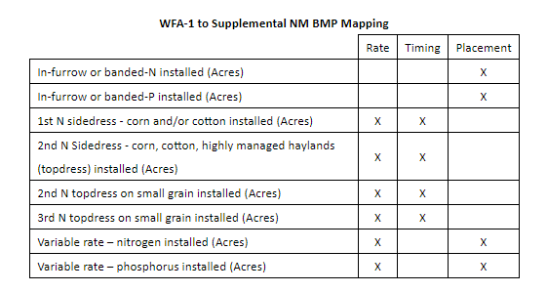
An additional form is also used to report data for enhanced nutrient management credit for rate, timing, and placement. An example of the relevant questions from a this form is shown below:
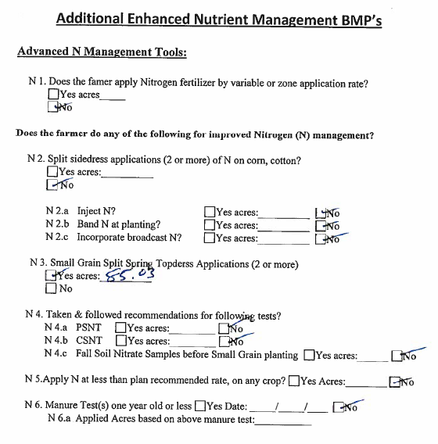
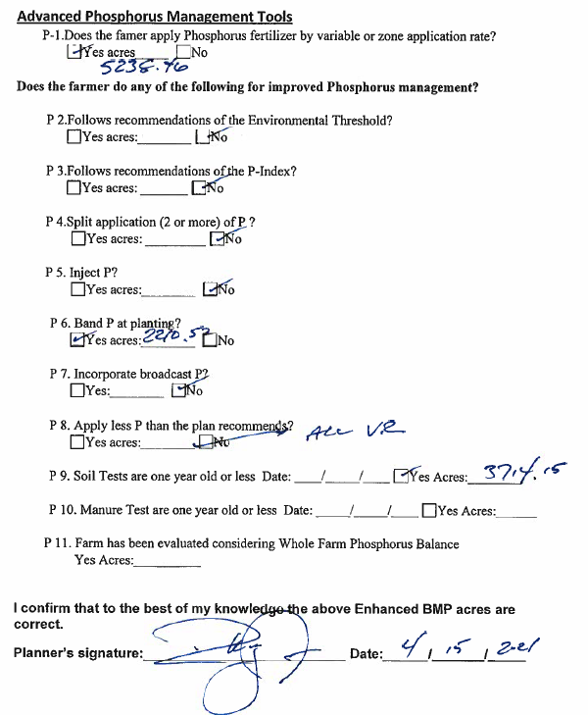
The above questions translate to enhanced nutrient management practices as follows:
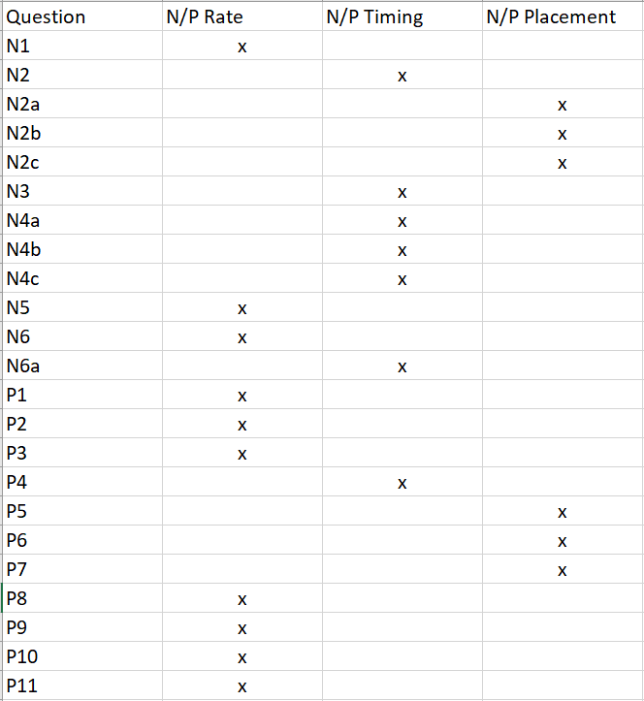
For more information on Virginia DCR’s enhanced nutrient management data, click the link below to download a PowerPoint presentation that was used for a discussion with the EPA:
https://consapps.dcr.virginia.gov/htdocs/qapp/2022/DCR_Enhanced_NM_data.pptx

B10.1 – Data Management: Agricultural BMP Cost Share Data
Automated quality assurance. Beginning July 1, 2009 at the start of the 2010 state fiscal year, the AgBMP Tracking Module was redesigned and implemented as a web-based application using MS SQL Server. Highly relational database schema and application logic, coded in ASP.NET, allows very strict control of data entry to ensure data quality. At the start of each program year, the database is setup to restrict entries to allowable practices for allowable funding sources in specific geographic areas. BMP installations cannot be marked as completed and paid without a minimum set of fields entered. A mapping component, utilizing ArcGIS Server, incorporates recent high resolution aerial imagery that helps ensure the quality of spatial attributes as well.
In addition, a biweekly email is automatically generated using SQL server tools that identifies some of the most common data entry errors for information entered into DCR’s Conservation Application Suite. These emails are provided to Soil and Water Conservation District staff when data entry errors are identified. These emails ensure that errors are corrected as quickly as possible. An example of a portion of an automated email is shown below:
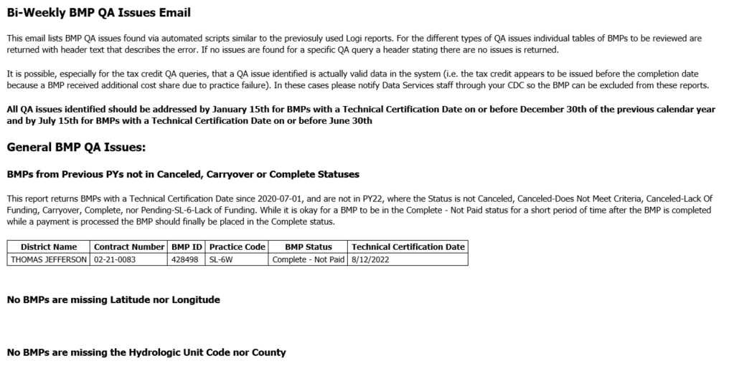
Regional review. Data in the VACS database originates from the 47 SWCDs. Data entries from SWCDs are initially screened by a DCR regional office CDC for a local knowledge review.
After the end of each quarter, SWCD records are reviewed by the assigned CDC for completeness and accuracy of financial reporting. Any irregularities are brought to the attention of the appropriate SWCD staff for corrections.
Business Intelligence Review. In addition to the strict control of data entry to ensure data quality, DCR also uses a Business Intelligence tool to allow for the QA of BMP data. DCR staff have built a suite of reports for both internal and SWCD Staff use to review data at any time during the program year and especially at data closeout. These reports allow for both simple QA (i.e. missing data) and more complex review (i.e. ensuring calculated buffer acres values match other data entered for a BMP).

B10.2 – Data Management: Nutrient Management Data
Currently DCR data management accepts data from the following systems and formats:
- NutMan 3 – Non enterprise data tracking application used by many private nutrient management planners that is currently being phased out as the Nutrient Management Module in the Conservation Application Suite takes over all data submittals. DCR nutrient management planners are no longer using NutMan 3 and are now only using the Nutrient Management Module for data submittals. Private nutrient management planners are beginning to be trained in the Nutrient Management Module, and NutMan 3 is expected to be entirely phased out by the end of the 2025 fiscal year.
- Nutrient Management Module – The Nutrient Management Module in the Conservation Application Suite is an enterprise data management application currently used by DCR specialists. Once DCR planners have entered data and saved the data in the system all data has been through system validation and data is available to data management staff for reporting. All nutrient management plan data is expected to be entered using the Nutrient Management Module starting at the beginning of the 2026 fiscal year.
- Activity Report – Excel file used by private planners to indicate new and revised plan acres for the year. Private planners submit this form once a year in September to report all NM plan acres conducted in the prior Virginia fiscal year. Once excel files have been received data management staff review, QAQC, and uploaded the data to DCR’s central database.
All data regardless of data submission method is run through a variety of validation and QAQC measures to increase the accuracy and confidence of DCR reporting data. Most reporting requests are developed in DCR’s business intelligence software Logi Ad Hoc. Logi Ad Hoc makes it easy to compile reporting requests from the central database were data has previously been validated, reviewed, and standardized.
The data is at the 12-digit hydrologic unit spatial scale for agricultural nutrient management and at the county or jurisdiction scale for urban nutrient management. The nutrient management data is provided to DEQ and mapped to the established NEIEN XML schemas and reported via established NEIEN protocols to CBPO.
The new web-based Nutrient Management Planning Module is integrated with the DCR’s Conservation Application Suite which also includes the Ag BMP Tracking, Conservation Planning and Resource Management Planning Modules. This new application is spatially enabled and based on the same MS SQL Server database used by the other DCR systems.

B10.3 – Data Management: External Data

This section does not apply to this QAPP.

B10.4 – Data Management: Reporting to EPA-CBPO
This section does not apply to this QAPP.

Group C – Assessment and Oversight

C1 – Assessments and Response Actions
BMP Verification. A primary form of QA of the BMP data occurs during the verification process, where records are pulled from the database per the logic in Appendix 3 and the practices identified are visited to assure that the BMPs that were recorded have actually been installed and are in compliance with the BMP’s specifications.
Number of BMPs. It is important to note that the AgBMP Tracking Module can track voluntary BMP installations if the SWCD personnel are willing to verify the BMP meets specifications and report on the installations.
Assessment responsibility. In early spring of each year, after the data is processed for the previous program year (July 1 through June 30), the Agricultural BMP implementation records of the practices funded through the VACS program are randomly selected for verification during the following summer and fall. The SWCD and CDC typically schedule the verification visits during the parts of the year when the producers are not so busy. CREP installations are also spot checked by USDA-NRCS staff under guidelines developed and followed by USDA NRCS and FSA personnel.

Frequency and type of assessment. Virginia DCR’s agriculture verification scheme was approved by the EPA CBP during the spring of 2016. During PY17 DCR developed guidance and modified existing systems (mainly the AgBMP Tracking Module) to fully implement this new verification scheme. The new verification scheme is described below and Table D4-1 summarizes the proposed changes.
Verification procedures for BMPs are subdivided into verification groups based primarily on the risk of failure as demonstrated by the spot check histories for each type of BMP, as well as program type (cost-share, voluntary, regulatory, cooperative), credit duration, and applicability to the Chesapeake Bay Watershed Implementation Plan. Details of this grouping can be found in Appendix 3. The result is nine verification groups, each with specific procedures for initial inspection, follow-up checks and lifespan/sunset provisions. Additionally, any agricultural BMPs required in CAFO/AFO permits are subject to compliance inspections associated with those programs. These regulatory compliance inspections are independent of and in addition to this verification protocol and will serve to add additional confidence in the BMPs installed on CAFO/AFO sites.

Onsite initial inspections for 100% of practices are the standard for all but three of the agricultural verification groups. These onsite inspections are performed by the implementing agencies, typically DCR, SWCDs and NRCS. Records of the initial onsite inspections are captured in the reporting agency’s databases, along with the appropriate reportable measures for the installed practice. Information on data management by these agencies are, or will be, included in each reporting agency’s QAPP or SOP.

The two practice groups that do not have 100% initial onsite inspections are tillage practices and manure transport. Tillage practice reporting will be based on a transect survey, described in section A6 of this plan. The transect survey approach is following the guidance presented in the following document: Recommendation Report for the Establishment of Uniform Evaluation Standards for Application of Roadside Transect Surveys to Identify and Inventory Agricultural Conservation Practices for the Chesapeake Bay Program Partnership’s Watershed Model (16 March 2017). Manure transport reporting will be based on weigh station tickets from manure haulers and transport records required in the Poultry General Permit (9VAC630). These two classes of BMPs do not lend themselves to traditional onsite inspections to ensure implementation, but these alternate measures represent a reasonable approach to satisfying the Verification requirements.

Several alternative approaches are used for the follow-up inspections to ensure reported BMPs are still in place and functioning as intended through time. Annual practices typically do not have follow-up checks. Three of the nine verification groups; Cover Crops, Tillage Practices, and Manure Transport fall into this category. However, cover crops are inspected by SWCD staff at least once to ensure establishment. Establishment is defined as 60% cover crop plant material on the enrolled acres through the lifespan of the practice. Currently, DCR only reports cover crops acres for practices that are part of the cost share program, so there is no danger of duplication from other data sources.

The Nutrient Management Program Manager and his three designees are responsible for verification of implementation of nutrient management plans in Virginia. Nutrient management specialists review activities with farmers after year one of a plan being written on any given farm, discuss and review his records of application of nutrients and cropping systems and fill out a 33-question form on what the farmer is doing on a field by field basis. See Appendix 4 for a complete version of the form used for nutrient management plan verifications. Enhanced nutrient management practices funded through VACS are 100% verified by District staff before payment is made. Enhanced nutrient management data collected from verifications forms is inherently verified as it is collected during the nutrient management plan verification process.

The specialists report to the program manager on a monthly basis the number of farms verified, the total acres implemented, and the total acres not implemented. The specialists notify the Program Manager, the Verification-Animal Waste Coordinator, or the Bio-solids Coordinator for third party verification on at least 10% of the acres that are verified on a regular basis. The original verification forms are maintained in the file with the nutrient management plan in the specialist’s office, the 3rd party verification forms are compared to the specialist’s forms on a regular basis, and any discrepancies are deducted from implemented acres and discussed at quarterly staff meetings to maintain consistency in verification procedures. This information is reported on a Quarterly basis. For 2022, farmer implementation was at 95.14% on all acreage under nutrient management plans.

Practices that are installed under State or Federal Cost-Share programs and have contracts requiring maintenance are divided into three BMP Types for the purpose of verification. The three BMP Types in this group are Structural, Land Management and CREP. It should be noted that failure to maintain BMPs during the contractual period also carries the potential for financial penalty to the producer. This requirement to repay cost-share funds if practices are not maintained serves as a significant deterrent to non-compliance. Additionally, cost-shared practices are designed and installed following strict standards and there is robust initial inspection (100% onsite initial verification) to ensure the practices, as built, meet those strict design standards.

The next BMP Group includes those practices that were designed and installed in accordance with the strict standards of agricultural cost-share programs, but no longer have a contractual maintenance requirement. These could be practices that used State or Federal Cost-Share programs, but have fallen out of the contractual period, as well as voluntary practices installed in accordance with the program standards and specifications but without the financial assistance or contractual stipulations of the State or Federal Cost-Share programs. Practices in this group are split into two types, structural and Land Management. CREP is not included in this group because the practices in the CREP type are specific to participation in that Cost-Share program.

The third verification BMP grouping in the agricultural sector that uses statistical sampling for follow-up inspections includes all practices that meet the Bay Program approved definitions of Resource Improvement Practices. In general, these are BMPs that are similar to a cost-shared BMP, but do not meet the same design and construction standards. Despite this fact, these BMPs have been determined during the initial onsite inspection to be functioning and producing a resource improvement. Typically, these practices have been voluntarily installed at the producers’ full expense. These practices have shorter credit durations in the modeling system which will result in the removal of the practice from the models unless a re-inspection is conducted. The high level of producer initiative and investment in the practices in this group lends itself to a high likelihood that the practices will be continually maintained.

The final grouping in the agricultural sector is for practices that may be part of a Resource Management Plan. This agricultural certainty program includes a compliance inspection every 3 years for all practices required for the RMP certificate. These inspections would be in addition to the other verification requirements described in this section.

The Bay Program approved credit durations will be used as the basis for removing reported BMPs for all verification groups in the agricultural sector unless the practices are re-inspected to verify continued operation. DCR plans to conduct 100% re-inspections for all BMPs prior to the end of their credit duration in order to maintain credit for CBP reporting. While this is encouraged for other providers of agricultural BMP data, it is not a requirement for satisfying the verification standard.

The CDC and the SWCD conservation specialist (sometimes accompanied by District directors or Richmond Central office staff) notify the producers of the verification visits and then go to the respective agricultural BMP implementation sites and inspect the installation. The staff then enters data into the Verification Module for that BMP.
The SWCD follows a written procedure for requesting the return of a pro-rated share of the cost share funds. This calculation is based upon the number of months that the practice was functioning before receiving a Not Function Properly status when the program participant is unwilling to return the calculated pro-rated cost-share amount. Participants may have a maximum grace period of 6 months to restore the BMP to its intended function or repay the pro-rated cost share amount. After sixty additional days the delinquency is turned over to the Office of the Attorney General for assistance in reclaiming the state funds.

C2 – Reports to Management
Compiling results. Ag BMP Verification results are entered into the AgBMP Tracking Module by SWCD staff for each BMP installation visited. SWCD staff may enter multiple inspections that may be a part of a single Verification. Each inspection requires SWCD staff to indicate that each specific verification criteria for the BMP either passes or fails. A BMP may not be marked as ‘verified’ until it passes all of the practice specific verification criteria. This information can be used to filter data extraction. Of the 115 BMPs tracked in the AgBMP Tracking Module (including voluntary BMPs) 91 or 79% are considered verification eligible. The majority of the BMPs which are not considered verification eligible are annual BMPs (e.g. cover crops) which are annual practices that are technically certified in the year when they are installed.

Group D – Data Validation and Usability

D1 – Data Review, Verification, and Validation
Acceptance criteria. Criteria for accepting or rejecting agricultural BMP cost share practices for the resulting data can be found under the individual practices in the most recent version of the Virginia Agricultural BMP Manual. SWCDs are responsible for the verification of all installations paid for through the VACS program. For example, even though cover crops are not considered a verification eligible BMP, before a participant can receive funds for this practice the SWCD conservation specialist verifies planting dates at or near the time of planting and verifies crop plant density at time of crop kill dates. These verification inspections ensure that the farmer is planting the crop in a timely manner and that the crop was of sufficient density to provide the desired water quality benefit. This is a somewhat recent modification in the tracking of this BMP and will allow DCR to report to EPA-CBPO acreage of cover crops as early or normally planted. Additional details regarding the verification and validation criteria for individual BMPs can be found under the previous section C1 – Assessments and Response Actions. Current planting dates for cover crops can be found in the table below:
Area | Early Planting Date | Standard Planting Date
Coastal Plain (including Eastern Shore) | November 10 | November 30
Piedmont | October 25 | November 15
Mountain Valley | October 20 | November 10

BMP verification and validation. Agricultural BMPs implemented require the signature of the producer and the SWCD conservation specialist (who is required to have job approval authority on that agricultural BMP type), certifying that the BMPs were implemented according to the applicable technical specifications. The signature form is a legal document that, for structural BMPs, typically requires maintenance and proper usage of the implemented BMPs during the design life spans. These are also typically the types of agricultural BMPs that are later eligible for verification during the design life span time window.
Tracking program QA. The specific types of QA conducted on the AgBMP Tracking Module and resulting cost share BMP data include:
- BMP location coordinate pair and other spatially determined fields are populated using a web-based mapping application. SWCD personnel locate BMP installation using a variety of base maps including USGS 7.5 minute quads, recent high resolution aerial imagery and high resolution road centerlines.
- Many fields of data are populated from drop down lists so that those items are uniformly entered (for example, County names, Agricultural BMP codes, Funding Source Types [Program Types], Practice status, Animal Type [on applicable Agricultural BMPs], etc.).
- Each SWCD personnel login is associated with a particular SWCD and data entry is limited to funding sources, practices and other variables approved for each SWCD.
- The cost share payment amount approved by the SWCD board cannot be greater than the estimated cost share payment.
- The cost share payment amount cannot be greater than the approved cost share payment amount (which in turn, cannot be greater than the estimated cost share payment).

Tillage survey verification and validation. The verification process for the 2015 survey was simply to contact the surveyors for explanations of any results that looked out-of-range of what was expected. This did result in some recapture or additional capture of survey point data. The 2022 survey however is guided by the roadside transect accuracy metrics of the Dressing report. The sample error matrix and accuracy report by survey team as constructed from the 2022 survey results can be found in Appendix 6. The accuracy report was created from the photo reviews for each survey team. Based on these results, the data collected by the team for the Robert E Lee survey unit (highlighted in yellow) did not meet the minimum accuracy requirement and was not submitted for inclusion in the Bay Model. Data from the 2015 tillage survey was reported for this survey area, and this area will be surveyed during 2024 to collect updated data for next year’s submission.

Virginia Department of Agriculture and Consumer Services (VDACS). The Virginia Department of Agriculture and Consumer Services (VDACS) administers the Agricultural Stewardship Program which has been put in place to correct reported water quality issues. VDACS staff work with farmers and local Soil and Water Conservation Districts to resolve water quality problems by giving the farmer an opportunity to correct a water quality problem voluntarily before any enforcement action is taken. This program also provides opportunities to educate all parties involved regarding best management practices and agriculture which, in many cases, results in the implementation of best management practices. Select VDACS staff utilize the Conservation Application Suite to track issues reported through the Agricultural Stewardship Program and will also use the Conservation Application Suite to enter any best management practices that have been created as a result of the program. Best management practices entered by VDACS staff are subject to verification requirements, and the procedures used by VDACS staff are generally the same as those listed in this document. VDACS policies cover the right of entry to perform verifications, so they do not utilize DCR’s voluntary BMP assessment form. VDACS staff will also contact the appropriate DCR Conservation District Coordinator to accompany them on the verification visit where they feel the producers would not react negatively to having a person from another agency present.

D2 – Verification and Validation Methods
General content regarding data verification and validation is provided in section C1 - Assessments and Response Actions. Information pertaining to the validation of data based on the tracking program is provided above in section D1 - Data Review, Verification, and Validation. These sections identify who is responsible for verifying and validating the different components of the cost-share data and how the 2022 tillage survey was ground-truthed.
All SWCD employees sign 1619 Agreements at the local level with their NRCS District Conservationist. This signed agreement is required before the employee can be set up in the DCR AgBMP Tracking Module with a username and password. All DCR staff that have access to the VACS and data reporting have a signed 1619 Agreement with the NRCS State Office.
Report of Verification Results. At any time, DCR can generate a report of the Verification results for a specific time period. This data will be provided if requested.
Data Review and Refinement – DCR Data Services Staff and other Division of Soil and Water staff will periodically review data entered into the web application by District users to ensure that quality standards are being met. The data is reviewed by setting up Logi Ad Hoc reports that analyze certain data quality factors. When necessary, efforts are undertaken, along with District staff, to refine data that has been entered into the web application.
Throughout the 2022 Program Year that came to a close on June 30, 2022, DCR Data Services staff worked closely with District staff to refine measurements that had been entered for stream exclusion practices. Through analysis of previously entered data, inconsistencies were found in how District users were entering the length of streambank protected and the average buffer widths. In many cases, District staff were entering the minimum buffer width instead of the average buffer width which was resulting in a buffer area that was smaller than what was actually installed. Many of these practices were updated through this refinement process which resulted in a 3,868 acre increase in buffer area that is reported for the Chesapeake Bay Watershed for 2017-2020.
Ground truth process of 2022 tillage survey. While the 2022 tillage survey followed the procedures outlined in the Dressing report, there was one deviation with regards to the procedures for verification.
Surveyors were instructed to take a picture of the residue cover indicative of their recording of residue occurrence at a set interval. Since these photos were tied to the survey site and noted condition it was possible to independently compare the residue occurrence in the photo to the recorded residue occurrence. These pictures were taken in lieu of an independent, separate site visit after the original residue observation was recorded. As a photograph is not the same as visiting the survey sites over 90 of these sites were revisited to, in essence, provide a third residue occurrence determination. A sample error matrix comparing the call made by the revisiting surveyor to the photo interrupted residue occurrence was constructed to evaluate the effectiveness of the photo as a ground-truthing alternative. This matrix can be found in Appendix 6.
Representative photos for the four residue categories used for the 2022 survey can be found in the graphic below:
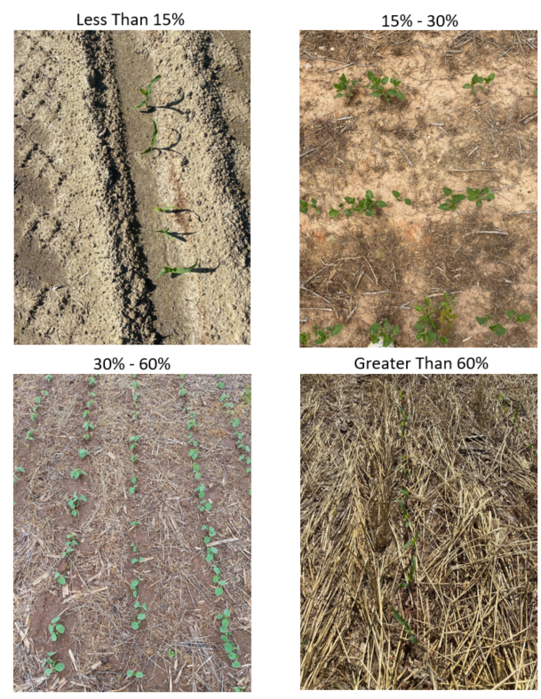

Due to the departure from the verification procedures outlined in the Dressing report, DCR staff requested to be included on the agenda of the July 2023 meeting of the Agriculture Workgroup for the Chesapeake Bay Program to present on the alternative verification approach with the goal of receiving approval on the methodology. A presentation was given at the July 2023 meeting which was then followed by an independent technical review by Tetra Tech. DCR addressed the recommendations given in the independent technical review and gave a follow up presentation at the August 2023 meeting of the Agriculture Workgroup. The workgroup approved the methodology during the August meeting, so the data from the 2022 survey will now be submitted to replace the data from 2015 survey. Links to documents and presentations from the July and August Agricultural Workgroup meetings can be found in Appendix 6.

D3 – Reconciliation with User Requirements
There are various factors related to possible uncertainty during the collection of historic NPS BMP implementation data from the 47 SWCDs and historically the majority of data quality issues have been data input errors with these errors primarily being the entering of invalid data in the VACS tracking program. The redesigned VACS tracking program, implemented July 2009, has a great number of features to ensure the quality of data entered and avoid common types of data entry errors that the previous tracking application could not address.
Another source of potential uncertainty in the historic data is in the field collection of the data. An example of this type of uncertainty is variable interpretations on where to collect representative location coordinates. This arises in part due to the type of BMP(s) being installed on various farms. Cover crops may have coordinates taken at a representative point near or in the field(s) where the crops are planted such as the middle of the farm or middle of the individual fields. Stream exclusion fencing may have these coordinates collated at a central point along a linear feature (the fence) near the stream or could be collected in the upland pasture if rotational grazing of the upland acres benefiting from the exclusion/rotational grazing system BMP is installed. These types of collection uncertainty are significant if very fine scale modeling is of concern since they could induce error of plus or minus tens to hundreds of meters between the BMPs actual location coordinates and that of those reported. These types of inaccuracies cannot be programmed away with any software type fixes.
It is possible that a conservation specialist with a SWCD picks a point of convenience for collecting the data (the center of the farm, near the front gate, at the farmhouse) that is not actually reflective of the individual BMP installation point. For a practice such as stream exclusion without rotational grazing a SWCD conservation specialist according to the BMP manual is required to report linear feet of streambank excluded, not the linear feet of fencing installed. However, it is possible that the fence is what is measured and reported. These types of collection uncertainty are significant if medium scale modeling is of concern since they could induce errors of plus or minus hundreds to thousands of meters between the BMPs actual location coordinates and that of those reported.
For all data collected for program years 2009 and forward utilizing the location selection associated with the mapping function of the new tracking program will significantly reduce locational inaccuracies. For the EPA-CBPO phase 5.x watershed model the level of uncertainty described above should be acceptable since the confidence that the data exists within a given watershed model segment is very high due to the very large scale of the models segmentation and the very high probability that the reported coordinates are valid for the topographic quadrangle reported and that those quadrangles are in a given hydrologic unit or county contained within a model segment. Additionally, DCR provides training on correct data collection and input in order to minimize this type of uncertainty. The previous sections provide details on the multiple quality assurance measures that DCR undergoes to develop, track, and report quality BMP implementation data to the citizens of Virginia, Executive and Legislative branches of state government, and to the EPA.

References

Code of Virginia. (2006, January 11). § 10.1-104.2 Nutrient Management Training and
Certification Regulations. 4 VAC 5-15. Commonwealth of Virginia: Virginia Department
of Conservation and Recreation. These regulations are available on the DCR website, http://www.dcr.virginia.gov/soil-and-water/document/nmtraincertregs.pdf

Cunningham, J. (2003, August). An Assessment of the Quality of Agricultural Best Management
Practices in the James River Basin of Virginia. Blacksburg, VA: Virginia Polytechnic Institute and State University’s Biological Systems Engineering Department.

Dressing, S, Harcum,J. (2017, March 16). Recommendation Report for the Establishment of Uniform Evaluation Standards for Application of Roadside Transect Survey to Identify and Inventory Agricultural Conservation Practices for the Chesapeake Bay Program Partnership’s Watershed Model. Annapolis, MD; Chesapeake Bay Program.

Haering, K. C., Evanylo, G. K. (2006, February). The Mid-Atlantic Nutrient Management
Handbook. MAWP 06-02. Mid-Atlantic Regional Water Program: A Partnership of USDA CSREES & Land Grant Colleges and Universities.

Mostaghimi, S., Lowery IV, J., Gupta, R., McClellan, P. (1997). Factors Influencing
Implementation of Best Management Practices in Virginia’s Chesapeake Bay Drainage Basin. Report No. CS0896. Blacksburg, VA: Virginia Polytechnic Institute and State University’s Biological Systems Engineering Department. Submitted to Virginia Department of Conservation and Recreation, Richmond, VA.

Peters, J. (2003). Recommended Methods of Manure Analysis. A3769. Madison, WI: University
of Wisconsin - Madison.

Virginia Department of Conservation and Recreation (2014 – Program Year 2015). Virginia
Agricultural BMP Manual. Richmond, VA. [This manual is updated annually. The current version is at http://consapps.dcr.virginia.gov/htdocs/agbmpman/agbmptoc.htm]

Virginia Department of Conservation and Recreation, Virginia Soil and Water Conservation Districts. http://www.dcr.virginia.gov/soil-and-water/swcds

Virginia Department of Conservation and Recreation (2014, June). Virginia Nutrient
Management Standards and Criteria. Richmond, VA. This document is available on the DCR website at http://www.dcr.virginia.gov/document/standardsandcriteria.pdf

Appendix 1
Virginia Department of Conservation and Recreation
September 2023

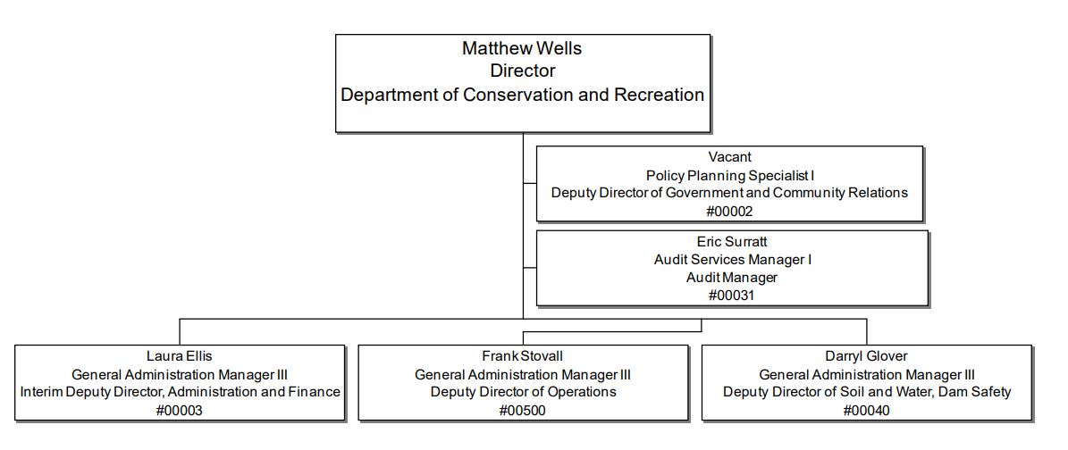

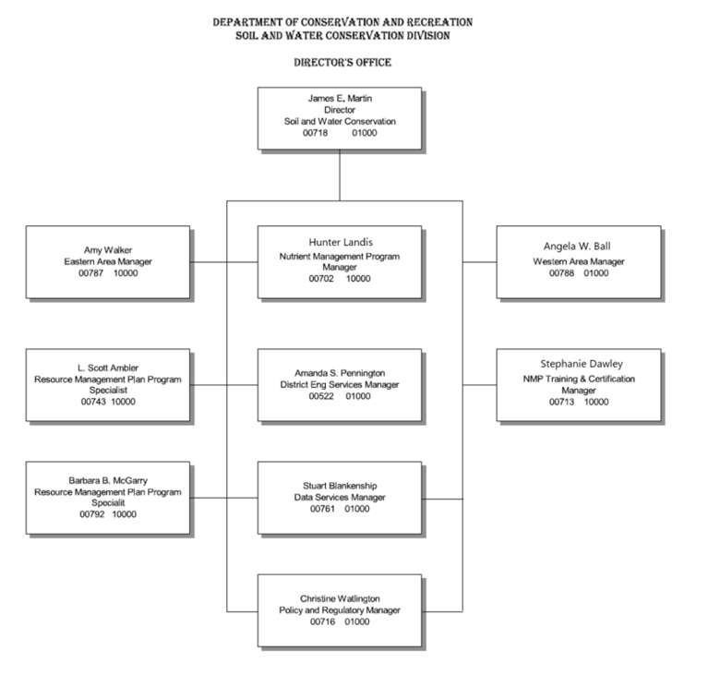
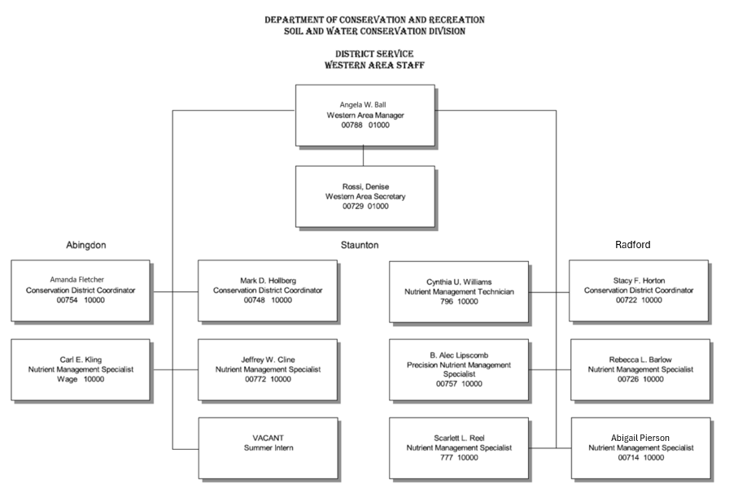

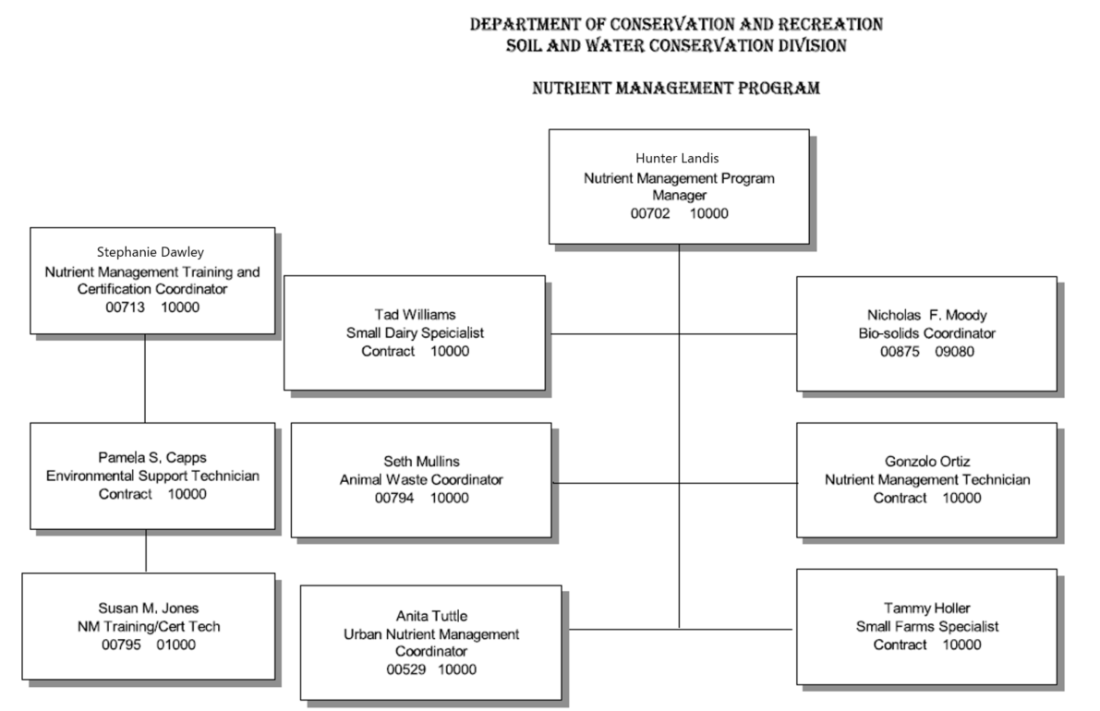
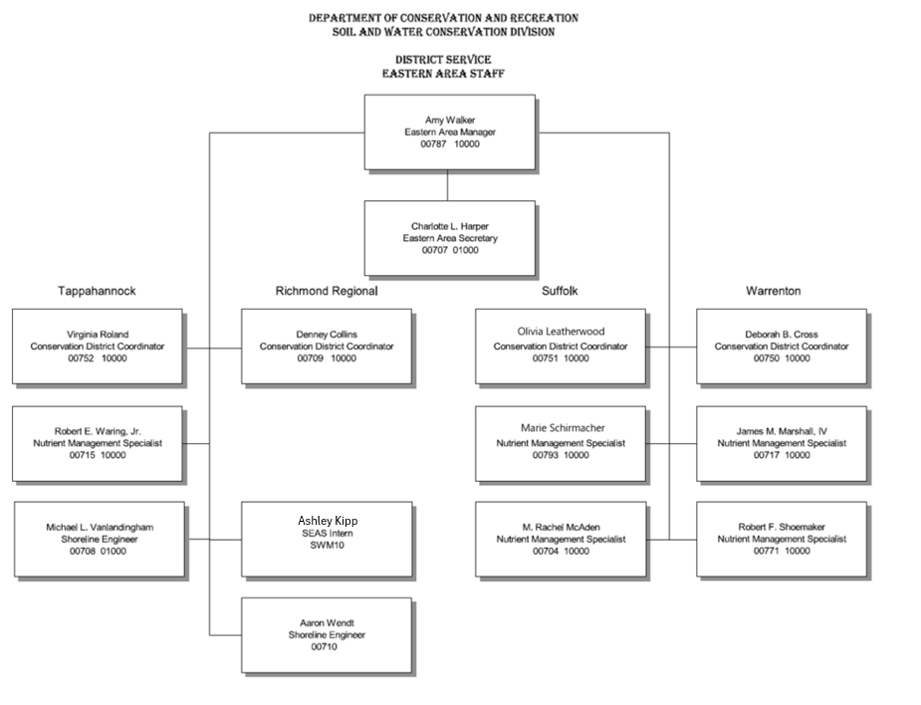
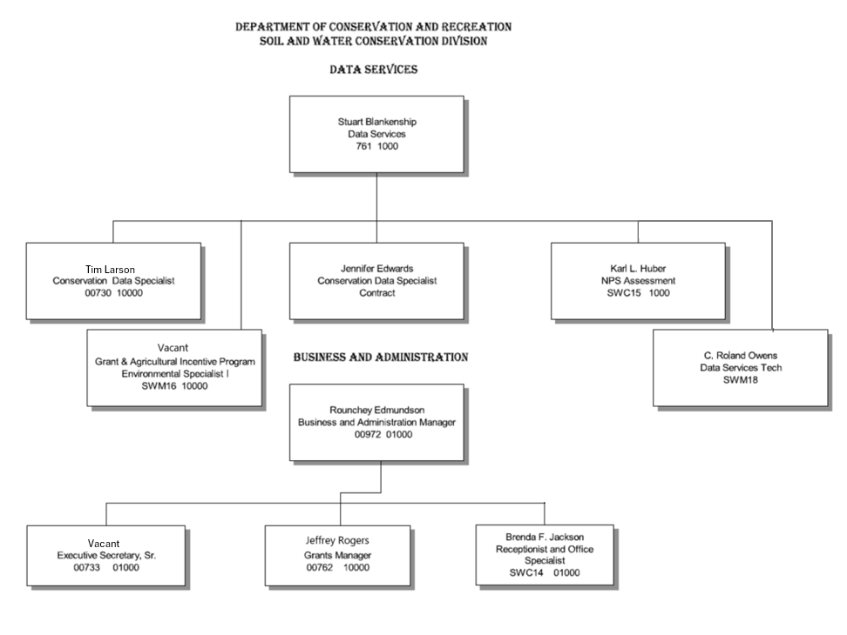
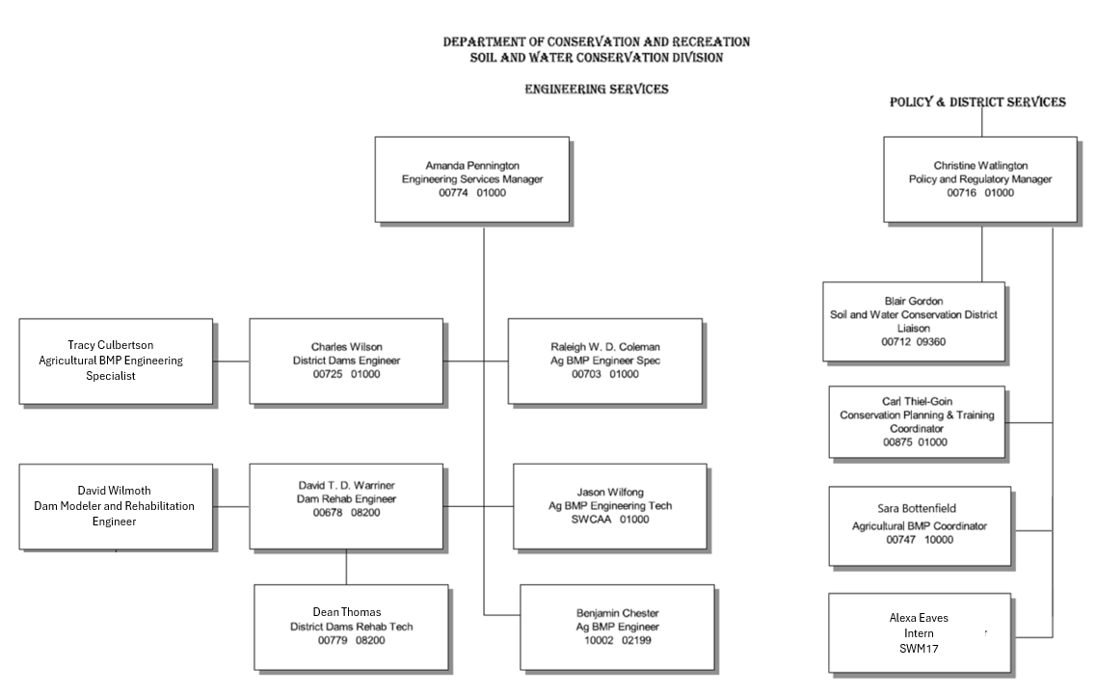
Appendix 2
General Flow of Agricultural BMP Data Deployment
Web Server
AG BMP Tracking Application
LogiXML Ad Hoc Reporting

Publicly accessible data queries
Publicly accessible GIS data/services
Database Server
SWCDs enter BMP and CREP data
SWCDs & DCR design & run reports
PDCs
VDOF & other State Agencies
localities
TMDLs
general data requests
AG Incentives Program
Quarterly Summary Report
CREP Quarterly Summary Report
CREP Annual Report (state FY)
CREP Federal Fiscal Year Report
VACS Annual Report

FSA
NRCS
NEIEN XML
EPA- CBPO
GIS Summary Files

Biennial NPS Watershed Assessment Report
EPA
DEQ
TMDLs
Regional Offices
general data requests

Future Plans
General Public
General Public

Appendix 3
Agricultural BMP Verification Groups

Verification Grouping | BMP Type | Initial Inspection |  |  |  | Follow-up Check |  |  | Verification Tracking
 |  | (Is the BMP there?) |  |  |  | (Is the BMP still there?)
 |  | Method | Frequency | Who inspects | Documentation | Follow-up Inspection | Statistical Sub-sample | Response if Problem
State or Federal Cost-Share  Cover Crops | Annual | Onsite | 100% at planting | DCR, SWCD, NRCS | VACS Database, NRCS | Onsite | 100% at establishment to ensure required cover is achieved | Practices that fail to establish sufficient cover are disallowed and not reported as cover crops | The AgBMP Tracking Module tracks the date the cover crop was planted and the date it was established at 60% cover crop plant material on enrolled acres. Data available to be reported to CBP
Tillage Practices | Annual | Transect Survey | Quinquennial | DCR, SWCD or Certified Planner | VACS Database | N/A | N/A | N/A | Transect Survey methodology previously approved. The most current transect survey (2022) is only source of tillage data that is reported.
State or Federal Cost-Share  In Contractual Period | Structural | Onsite | 100% | DCR, SWCD, NRCS | VACS Database, NRCS | Onsite | Statistical sample of 2% per year  100% Re-inspection of practices two years prior to end of contract is encouraged. | Practices found not functioning as intended are issued a 60 day Correction of Maintenance Issue Agreement (CMIA) to restore BMP function. If CMIA is not completed, BMP is deemed failed in survey. Failed verification records will be reported to CBP so the BMP can be removed from receiving credit. | AgBMP Tracking Module randomly selects a 2% portion of this BMP Type and produces a BMP specific verification form. The system also produces a BMP specific re-inspection form/list for practices two years prior to end of contract. Results of verification are entered into the Verification portion of the AgBMP Tracking Module. Successful verification records will be reported to CBP so the BMP can continue receiving credit.
 | Land Management | Onsite | 100% | DCR, SWCD, NRCS | VACS Database, NRCS | Onsite | Statistical sample of 5% per year  100% Re-inspection of practices two years prior to end of contract is encouraged. | Practices found not functioning as intended are issued a 60 day Correction of Maintenance Issue Agreement (CMIA) to restore BMP function. If CMIA is not completed, BMP is deemed failed in survey. Failed verification records will be reported to CBP so the BMP can be removed from receiving credit. | AgBMP Tracking Module randomly selects a 5% portion of this BMP Type and produces a BMP specific verification form. The system also produces a BMP specific re-inspection form/list for practices two years prior to end of contract. Results of verification are entered into the Verification portion of the AgBMP Tracking Module. Successful verification records will be reported to CBP so the BMP can continue receiving credit.
 | CREP | Onsite | 100%  Forestry verification during first 2 years | NRCS, VDOF | NRCS | Onsite | Statistical sample of 5% per year  100% Re-inspection of practices one year prior to end of contract is encouraged. | NRCS will respond to any issues identified. | While CREP BMPs can be manually selected for verification, the AgBMP Tracking Module does not select BMPs for verification as part of the yearly process.
State or Federal Cost-Share  Out of Contractual Period or Voluntary meets program design standards | Structural | Onsite | 100% | DCR, SWCD, NRCS or Certified Planner | VACS Database | Onsite | Statistical sample of 4% per year  100% Re-inspection of structural and land use change practices one year prior to end of credit duration is encouraged. | Practice components found not functioning as intended are deemed failed in the survey. Failed verification records will be reported to CBP so the BMP can be removed from receiving credit. | AgBMP Tracking Module randomly selects a 4% portion of this BMP Type and produces a BMP specific verification form. The system also produces a BMP specific re-inspection form/list for practices one year prior to end of contract. Results of verification are entered into the Verification portion of the AgBMP Tracking Module. Successful verification records will be reported to CBP so the BMP can continue receiving credit.
 | Land Management | Onsite | 100% | DCR, SWCD, NRCS or Certified Planner | VACS Database | Onsite | Statistical sample of 7.5% per year  100% Re-inspection of structural and land use change practices one year prior to end of credit duration is encouraged. | Practices components found not functioning as intended are deemed failed in the survey. Failed verification records will be reported to CBP so the BMP can be removed from receiving credit. | AgBMP Tracking Module randomly selects a 7.5% portion of this BMP Type and produces a BMP specific verification form. The system also produces a BMP specific re-inspection form/list for practices one year prior to end of contract. Results of verification are entered into the Verification portion of the AgBMP Tracking Module. Successful verification records will be reported to CBP so the BMP can continue receiving credit.
Voluntary  Resource Improvement  (Does not meet program design standards, but adequately provides the desired resource improvement) | Structural | Onsite Visual Indicators | 100% | DCR, SWCD or Certified Planner | VACS Database | Onsite | Statistical sample of 5% per year  100% Re-inspection of structural and land use change practices one year prior to end of credit duration is encouraged. | Practices found not meeting the visual indicators are deemed failed in the survey. Failed verification records will be reported to CBP so the BMP can be removed from receiving credit. | AgBMP Tracking Module randomly selects a 5% portion of this BMP Type and produces a BMP specific verification form. The system also produces a BMP specific re-inspection form/list for practices one year prior to end of contract. Results of verification are entered into the Verification portion of the AgBMP Tracking Module. Successful verification records will be reported to CBP so the BMP can continue receiving credit.
 | Land Management | Onsite Visual Indicators | 100% | DCR, SWCD or Certified Planner | VACS Database | Onsite | Statistical sample of 10% per year  100% Re-inspection of structural and land use change practices one year prior to end of credit duration is encouraged. | Practices found not meeting the visual indicators are deemed failed in the survey. Failed verification records will be reported to CBP so the BMP can be removed from receiving credit. | AgBMP Tracking Module randomly selects a 10% portion of this BMP Type and produces a BMP specific verification form. The system also produces a BMP specific re-inspection form/list for practices one year prior to end of contract. Results of verification are entered into the Verification portion of the AgBMP Tracking Module. Successful verification records will be reported to CBP so the BMP can continue receiving credit.
Manure Transport | Annual | Report with weight records | 100% | DCR, DEQ | DCR and DEQ databases | N/A | N/A | N/A
Feed Additives | Annual | Cooper-ative Agree-ment | 100% | DCR | DCR databases | Manure /Litter Sampling required by permit and associated with Nutrient Manage-ment Plan develop-ment | Manure P concentrations are compared against pre-Phytase baseline data to calculate reductions. | Reported treatment levels are adjusted accordingly.
Nutrient Management Plans | Annual | Onsite Plan Develop-ment | 100% | Certified Planner | NutMan Database | Onsite, Farmer interview, yield and fertilizer/manure application records evaluation | 10% DCR and DCR Contractor Developed Plans at time of plan renewal or revision in 205 and 2016 to establish baseline data.  Program design to be adjusted based on initial findings. | Frequency of sampled plan acres found to have not been implemented consistent with nutrient management planning standards will be used to discount implemented BMPs included in future reporting.
Resource Management Plans (with RMP Certificate) | Group | Onsite Imple-mentation Certifi-cation | 100% | Certified Planner, SWCD, DCR | VACS Database, RMP module | Triennial onsite compliance evaluation | 100% Triennial | Practices found not functioning as intended are issued a 90 day Correction of Maintenance Issue Agreement (CMIA) to restore BMP function. If the CMIA is not completed, RMP Certificate is revoked and the failed verification records will be reported to CBP so the BMP can be removed from receiving credit. | RMP Module has been modified to produce a BMP specific verification form for BMPs required as part of a RMP in addition to the RMP inspection form. BMP verification results will be entered into the AgBMP Tracking Module. RMP verification results will be tracked through the RMP Module

Appendix 4
Nutrient Management Verification Forms

This appendix contains forms use for Nutrient Management Plan Verifications as well as a form used to collect data for enhanced nutrient management practices for rate, timing, and placement.

Form 1 – Full nutrient management plan verification form that contains explanatory text in addition to the lines for data collection.

Virginia Nutrient Management Verification Form
-Planner Document-

Farmer Name or Tracking Number as Reported on Your Latest Activity Report: _____________________________________
County(s): if several counties list each with acres: _______________________
Number of acres covered by the plan:_____________________________
Virginia Nutrient Management Planner Certification Number:______________
Instructions:
In this evaluation the verification period is the most recent previous 12 month period: / / to / /

If all fields in the NMP receiving nutrient applications are not under the operational control of the farmer and/or the owner, the plan needs to be modified to contain only the fields under the operational control of the farmer and/or the owner prior to conducting a verification.

Does farmer have records showing they have implemented the NMP? (No specific format or form is required. Nutrient application rates, dates, methods, etc. should be documented in sufficient detail to reasonably demonstrate that the plan has been followed.)

Yes acres ________; No acres __________
Notes:

Answer all of the questions below to evaluate your client’s implementation of their Nutrient Management Plan (NMP). Many of the questions below address the specific activities that the farmer must carry out to implement the NMP. Base your answers on an interview with the farmer and review of the farmer’s nutrient application and crop management records. Attaching copies of farmer nutrient records is not required.

Use the “notes” sections (where provided) to explain any “justifiable deviations*” by the farmer from the NMP or other discrepancies between the plan and the farmer’s records.

A “justifiable deviation” would be a situation where the farmer takes action that is not exactly as specified in the NMP, but which follows the Purpose, Nutrient Management Plan Content and Procedures of the Virginia Nutrient Management Program. (4VAC 50-85-20, 130, 140)
Examples would include: applying lower N and P rates than called for in the plan (as long as crop yields are acceptable to the farmer), spreading on snow covered fields only after contacting and working with the Department of Environmental Quality (DEQ) to best identify low risk fields that should be used for application, to prevent a waste storage facility from overtopping, adjusting the nutrients applied to reflect changes in the crops actually planted if different from what was written in the NMP, etc.

If a Certified Nutrient Management Planner determines that there is a “justifiable deviation”, they must fully document why the deviation is justified. Justification will be based on how closely the deviation still aligns with plan writing criteria. A significant number of justifiable deviation acres indicates that a plan should have been modified or revised prior to the surveyed plan year. Modifications or revisions should be made, ideally, before the actual operation, but at least as soon after the change as possible. Additional follow up communication may be warranted in these situations to ensure the farmer’s planning needs are being adequately addressed and “implemented” acres can show a positive commitment on behalf of the farmer and the planner.

Implemented acres = yes acres + justifiable deviation acres.

Total acres = yes acres + justifiable deviation acres + no acres.

Nutrient Management Plan Content

- Does the NMP cover sheet include a DCR-certified NMP writer’s name, certification number, and signature?
Yes No; Missing items: _______________________________
Notes:

- Does the farmer have a current NMP that qualifies for verification?
  - Yes = plan shall be current or revised, as long as expiration date is equal to or greater than 12 months, following the date of verification, then verification of previous 12 months from the date of verification can be conducted
  - No = no verification can be done

- a. Date of Verification: ________/________ /__________
b. Plan Begin Date: _______/________/___________
c. Plan Expiration Date: _______/_________/___________

- Is the NMP based on up-to-date:
  - Soil Tests: Yes acres:___________ No acres:_________
  - Sample Date Range: ______/____/____ to ____/____/_____
  - Manure Tests: Yes acres:________ No acres:____________
  - Manure Sample Date(s): ____/____/_____

- For the period of verification, do crops in the records match the NMP?
(If the crop does not match the NMP did the farmer adjust his nutrient applications to fit the crop in the field while not over applying nutrients? To accept this deviation, there must be records on the farm which document the changes made.)
Matching Acres: ______________

Justifiable Deviation Acres:____________

Acres not Matching:_________________
- Example: Acceptable - Corn in plan. Sorghum planted, but nutrients applied
at Sorghum rate.
ii. Example NOT acceptable: Corn in plan, nutrients applied at corn rate, sorghum planted or field left fallow
Notes:

- Does the farmer follow recommendations in the NMP related to timing of inorganic nitrogen (N fertilizer) applications to every field? Specifically, apply no inorganic N fertilizer applications in the absence of an actively growing crop or more than 30 days ahead of planting.
Yes acres: __________
No acres:___________
Notes:

- Does the farmer follow all application rate recommendations for nitrogen (N), phosphorous (P), in the NMP for all fields covered by the NMP? (Note, if the farmer applies nutrients at a rate lower than indicated in the NMP the farmer is still considered to be following the NMP, as long as crop yields are acceptable*) This includes any P-based restrictions or prohibitions on application of manure.
Yes acres:___________
No acres:____________
Justifiable Deviation Acres:____________

i. Example: Acceptable P Index indicates 1.5 times P on crop. Farmer applies to meet crop removal.
(Field note indicates farmer intention to apply less than plan recommendation)
ii. Not acceptable: No P added and crop production is less than acceptable yields*.
*(Acceptable yields match yield expectation of farmer)

Notes:

- Does the farmer own and/or rent fertilizer application equipment to apply his own fertilizer:
Yes
No

(If yes, has the fertilizer applicator equipment been calibrated during the period of verification?
Yes Date of Calibration: ________/_________/________
No:
OR

Fertilizer applications are done by a commercial or custom applicator, farmer would not be responsible for verifying calibration but has representative sample of commercial/custom application invoices as part of the records.

- On fields listed in the NMP as environmentally sensitive sites, does the farmer follow the more intensive guidelines listed in the NMP for rate, timing of nutrient applications? (In particular, split all inorganic nitrogen (N) applications to row crops and small grains.
Yes acres: ________
No acres: _________
Notes:

Animal Waste Production & Utilization
(if no animal waste is produced or used on farm, skip to next section)

- Are the following NMP numbers within 10% of the current farm operation?
Livestock numbers: Yes No N/A
Poultry Numbers: Yes No N/A
Manure Production: Yes No N/A
Manure allocation: Yes No N/A

If no, the actual amounts are:
Livestock: _____________ Manure Prod.: _____________ Allocation: ____________
Poultry: ______________ Manure Prod.: _____________ Allocation:____________
Notes: (if the number of animals has changed by 10% or more the plan must be modified to qualify for verification)

- Is poultry litter exported? Yes No
  - If yes, Tons Produced:__________
Tons Exported: ___________
Manure Allocated: ___________

- Does the farmer own and/or rent manure application equipment to apply his own manure:
Yes
No
(If yes, has the manure applicator equipment been calibrated during the period of verification?

Yes:Date of Calibration: ________/_______/______
No

OR

Manure applications are done by a commercial or custom applicator, farmer would not be responsible for calibration but has representative sample of commercial/custom application invoices, showing volume of manure related to acres applied.

- Does the farmer follow the spreading schedule in the NMP for applied manure? (Less restrictive application timing may be allowed to manage storage constraints on sites that are not environmentally sensitive)
Yes acres: __________
N acres: ___________
N/A Acres: __________acres
Notes:

- Does the farmer follow all restrictions in the NMP regarding nutrient applications to frozen or snow covered ground as stipulated in the approved NMP?
Yes
No
Notes:

- Does the farmer follow all NMP recommendations for not spreading manure in designated setback areas?
Yes No ___________acres = setback acres receiving applications
Notes:

- Does the farmer follow recommendations in the NMP related to rate of organic nitrogen (N) and phosphorus (P) applications to fields to receive manure?
Yes acres: ________
No acres : ________
Notes:

I confirm that to the best of my knowledge the above information is correct.
Based upon the information collected, I believe that the farmer is implementing the Nutrient Management Plan in accordance with the Virginia NMP standards and criteria to the degree depicted below. DCR will track and report all categories.
- Yes acres:

- Justifiable Deviation acres:

- No Acres:

- Total Plan Acres (= A + B + C):
Percentage implemented: (=A+B divided by D then x 100) ________

Planner’s signature Date_____/______/_____

Form 2 – Shortened nutrient management plan verification form that only contains lines for data collection. Planners are instructed to refer to the longer version of the form, if necessary, for clarifications on the data to be collected.

Tracking Number: _____________________________________
County(s): if several counties list each with acres: _______________________
Number of acres covered by the plan:_____________________________
Virginia Nutrient Management Planner Certification Number:______________
Verification period: / / to / /
Does farmer have records showing they have implemented the NMP?
 |  |  |  | Yes acres: |  |  |  |  | No acres:
Does the NMP cover sheet include a DCR-certified NMP writer’s name, certification number, and signature?
 |  |  |  | Yes |  |  |  |  | No
 |  |  |  | Missing items:
Does the farmer have a current NMP that qualifies for verification?
 |  |  |  | Yes |  |  |  |  | No
Date of Verification: ______/_____/_____ |  |  |  | Plan Begin Date: _______/________/_______ |  |  |  |  | Plan Expiration Date: _______/_________/_______
Is the NMP based on up-to-date:
Soil Tests: |  |  |  | Yes acres: |  |  |  |  | No acres:
Sample Date Range: |  |  |  | ______/____/____ to ____/____/_____
Manure Tests: |  |  |  | Yes acres: |  |  |  |  | No acres:
Manure Sample Date(s): |  |  |  | ____/____/_____
For the period of verification, do crops in the records match the NMP?
Matching Acres:______ |  |  |  | Justifiable Deviation Acres:__ |  |  |  |  |  | Acres not Matching:______
Does the farmer follow recommendations in the NMP related to timing of inorganic nitrogen (N fertilizer) applications to every field?
 |  |  |  | Yes acres: |  |  |  |  | No acres:
Does the farmer follow all application rate recommendations for nitrogen (N), phosphorous (P), in the NMP for all fields covered by the NMP?
Yes acres: |  |  | No acres: |  |  |  | Justifiable Deviation Acres:
Does the farmer own and/or rent fertilizer application equipment to apply his own fertilizer:
 |  |  |  | Yes |  |  |  |  | No
(If yes, has the fertilizer applicator equipment been calibrated during the period of verification?)
 |  |  |  | Yes |  | No |  | Date of Calibration:
Fertilizer applications are done by a commercial or custom applicator
On fields listed in the NMP as environmentally sensitive sites, does the farmer follow the more intensive guidelines listed in the NMP for rate, timing of nutrient applications?
 |  |  |  |  | Yes acres: |  |  |  | No acres:

Animal Waste Production & Utilization
(if no animal waste is produced or used on farm, skip to next section)
Are the following NMP numbers within 10% of the current farm operation?
Livestock numbers: |  | Yes | No | N/A
Poultry Numbers: |  | Yes | No | N/A
Manure Production: |  | Yes | No | N/A
Manure allocation: |  | Yes | No | N/A
If no, the actual amounts are:
Livestock:____________ |  | Manure Prod.: _____________ |  | Allocation: ____________
Poultry:_____________ |  | Manure Prod.: _____________ |  | Allocation:____________
Notes: (if the number of animals has changed by 10% or more the plan must be modified to qualify for verification)
Is poultry litter exported?
 |  | Yes | No | N/A
If yes |  | Tons Produced: __________ | Tons Exported: __________ |  | Tons Allocated: ___________
Does the farmer own and/or rent manure application equipment to apply his own manure:
 |  | Yes | No | N/A
If yes, has the manure applicator equipment been calibrated
 |  | Yes | No | Date of Calibration:
Manure applications are done by a commercial or custom applicator
Does the farmer follow the spreading schedule in the NMP for applied manure?
 |  | Yes acres: | No acres: | N/A acres:
Does the farmer follow all restrictions in the NMP regarding nutrient applications to frozen or snow covered ground as stipulated in the approved NMP?
 |  | Yes | No
Does the farmer follow all NMP recommendations for not spreading manure in designated setback areas?
 |  | Yes | No Acres:
Does the farmer follow recommendations in the NMP related to rate of organic nitrogen (N) and phosphorus (P) applications to fields to receive manure?
 |  | Yes Acres: | No Acres:
I confirm that to the best of my knowledge the above information is correct.
Based upon the information collected, I believe that the farmer is implementing the Nutrient Management Plan in accordance with the Virginia NMP standards and criteria to the degree depicted below. DCR will track and report all categories.
- Yes acres: | - Justifiable Deviation acres:_____ |  |  | - No Acres:
Total Plan Acres (= A + B + C):
Percentage implemented: (=A+B divided by D then x 100) ________
Signature _____________Date_____/______/_____

Form 3 – This form is used to collect data for enhanced nutrient management BMPs for rate, timing, and placement.

Additional Enhanced Nutrient Management BMP’s

Advanced N Management Tools:

N 1. Does the famer apply Nitrogen fertilizer by variable or zone application rate?
Yes acres_____
No

Does the farmer do any of the following for improved Nitrogen (N) management?

N 2. Split sidedress applications (2 or more) of N on corn, cotton?
Yes acres:__________
No

N 2.a Inject N? Yes acres:__________ No
N 2.b Band N at planting? Yes acres:__________ No
N 2.c Incorporate broadcast N? Yes acres:__________ No

N 3. Small Grain Split Spring Topdress Applications (2 or more)
Yes acres:__________
No

N 4. Taken & followed recommendations for following tests?
N 4.a PSNT Yes acres:_________ No
N 4.b CSNT Yes acres:_________ No
N 4.c Fall Soil Nitrate Samples before Small Grain planting Yes acres:______ No

N 5.Apply N at less than plan recommended rate, on any crop? Yes Acres:________ No

N 6. Manure Test(s) one year old or less Yes Date: _____/_____/____ No
N 6.a Applied Acres based on above manure test:___________

Advanced Phosphorus Management Tools
P-1.Does the farmer apply Phosphorus fertilizer by variable or zone application rate?
Yes acres_____ No

Does the farmer do any of the following for improved Phosphorus management?

P 2.Follows recommendations of the Environmental Threshold?
Yes acres:________ No

P 3.Follows recommendations of the P-Index?
Yes acres: _______ No

P 4.Split application (2 or more) of P ?
Yes acres: _________ No

P 5. Inject P?
Yes acres:________ No

P 6. Band P at planting?
Yes acres:________ No

P 7. Incorporate broadcast P?
Yes:________ No

P 8. Apply less P than the plan recommends?
Yes acres:________ No

P 9. Soil Tests are one year old or less Date: ____/_____/____ Yes Acres:________

P 10. Manure Test are one year old or less Date: _____/_____/____ Yes Acres:______

P 11. Farm has been evaluated considering Whole Farm Phosphorus Balance
Yes Acres:__________

I confirm that to the best of my knowledge the above Enhanced BMP acres are correct.
Planner’s signature:___________________________ Date:______/_______/_____

Appendix 5
Virginia Farm Voluntary Agricultural Best Management Practices Inventory

The Virginia farm voluntary agricultural best management practices inventory was led by the Virginia Cooperative Extension and was guided by a task force with members from across many different organization. This section is being included in DCR’s QAPP to ensure that the EPA and the Chesapeake Bay Program receive the necessary information for acceptance of data submitted for inclusion in the Bay Modeling process.

Contact Information:
Survey Administrator Contact Name: Dr. Dan Goerlich
Survey Administrator Contact Title: Associate Director, Economy, Community, and Food
Survey Administrator Contact Email: dalego@vt.edu
Survey Administrator Contact Phone #: 540-231-7610
QA/QC Data Contact Name: Dr. Lauren Bryant labryant@vt.edu

The sections below include the majority of the information relevant for inclusion in the QAPP. However, if additional information and/or clarifications are needed, please see the official summary document titled “An Analysis of the Virginia Farm Voluntary Agricultural Best Management Practices Inventory” which is available as an embedded document at the end of this appendix.

Executive Summary

The Virginia farm voluntary agricultural best management practices inventory was designed to learn more about voluntary conservation practices on Virginia farms in the Chesapeake Bay watershed. Information shared by agricultural producers in response to this survey contributes to telling the story of what farmers are doing to conserve soil, improve water quality, and will help agriculture achieve its water quality goals for the Watershed Implementation Plan (WIP) for the Chesapeake Bay.

The survey used as the basis for the inventory was crafted over many months by members of Virginia’s Voluntary Agricultural Best Management Practices (BMP) Task Force. This task force was convened on June 25, 2019 by Ann Jennings, then Deputy Secretary of Natural Resources. Task force members worked closely together and included representatives from the: Natural Resources Conservation Service (NRCS), Virginia Association of Soil and Water Conservation Districts (VASWCD), Virginia Department of Conservation and Recreation (DCR), Virginia Agribusiness Council (VAC), Virginia Cooperative Extension (VCE), Virginia Department of Agriculture and Consumer Services (VDACS), United States Environmental
Protection Agency (EPA), Virginia Department of Forestry (VDOF), Virginia Department of Environmental Quality (DEQ), Virginia Farm Bureau (VFB), and Virginia Tech Office of Analytics and Institutional Effectiveness (VTOAIE).

The survey was made available electronically and open for data collection from January 11, 2021 through March 12, 2021. Recognizing that not every producer has computer and/or Internet access, paper copies of the survey were made available through local VCE and SWCD offices. Participation in the survey was completely voluntary. Overall, 618 agricultural producers completed surveys.

To confirm the reliability of self-reported information, 14.4% of farms were selected for follow-up site visits. These site visits were conducted by VCE agents that had been trained by subject matter experts with DCR and the University of Maryland Cooperative Extension. Upon completion of the site visits data was cleaned, de-duplicated, and statistical analyses carried out. During the statistical analyses consistent under-reporting by agricultural producers was identified.

Overall, this effort concludes that 611 farmers in the Chesapeake Bay Watershed have collectively implemented non-cost shared and / or previously unreported conservation practices, as follows: core nitrogen and phosphorus nutrient management (88,475 acres); supplemental nitrogen nutrient management for rate (50,547 acres), placement (40,693 acres), and timing (25,174 acres); supplemental phosphorus nutrient management for rate (34,727 acres) and placement (47,715 acres); manure incorporation/injection (2,074 acres); 23 animal waste management units serving 643,218 animals; 131 barnyard water diversion and runoff control systems impacting 187,893 animals; 13,136 acres of prescribed grazing; 8,929 acres with soil conservation and water quality plans; 115,197 acres of no till / minimum tillage practices; 10,661 acres of traditional cover crop, 604 acres of traditional cover crop with fall nutrients, and 4,521 acres of commodity cover crops, and; 6,434 acres of riparian buffers (inclusive of all buffer types).

This final summarized data will be included in Virginia’s annual data submission to the EPA Chesapeake Bay Program Office for consideration in applying to Virginia’s goals for the Chesapeake Bay Watershed Implementation Plan (WIP).

Background Information

Agricultural producers often carry out conservation practices voluntarily and at their own expense. This survey inventoried practices carried out in this manner by Virginia’s agricultural producers (Appendix 1). The specific practices from the BMP Warehouse, courtesy of concentrated effort by the DCR NPS Data Services Manager, include the following:

- Manure Incorporation High Disturbance Immediate
- Manure Incorporation High Disturbance
- Manure Incorporation Low Disturbance Immediate
- Manure Incorporation Low Disturbance
- Waste Storage Facility
- Nutrient Management Core N *
- Nutrient Management Core P
- Nutrient Management N Rate
- Nutrient Management N Placement
- Nutrient Management N Timing
- Nutrient Management P Rate
- Nutrient Management P Placement
- Barnyard Runoff Controls
- Prescribed Grazing
- Conservation Plans
- High Residue Tillage Management *
- Conservation Tillage *
- Reduced Tillage *
- Cover Crop, Cover Crops (Early Other Rye, Early Other Wheat, Late Other Wheat, Standard Other Rye, Standard Other Wheat)
- Cover Crops (Traditional with Fall Nutrients Rye Normal Other, Traditional with Fall Nutrients Rye Early Other, Traditional with Fall Nutrients Wheat Normal Other, Traditional with Fall Nutrients Wheat Early Other, )
- Commodity Cover Crop - Standard
- Riparian Forest Buffers **
- Narrow Forest Buffers ***
- Riparian Herbaceous Cover **
- Narrow Grass Buffers ***
- Exclusion Fence with Forest Buffer **
- Exclusion Fence with Narrow Forest Buffer ***
- Exclusion Fence with Grass Buffer **
- Exclusion Fence with Narrow Grass Buffer ***

* While data for core nutrient management and tillage practices were collected in the survey, data from the survey for those practices will NOT be reported as it is already being reported through other sources at DCR. Core nutrient management data is reported through DCR and private nutrient management planners and tillage data is reported through the 2021 transect survey.
** A 35 foot width is assumed for these practices for Bay Modeling reporting.

*** A 10 foot width is assumed for these practices for Bay Modeling reporting.

With regard to cost-shared BMP’s, professionally trained SWCD conservation technicians work directly with landowners and operators to implement non-point source BMPs designed and located to reduce and/or treat agricultural runoff (Blankenship, et. al. 2021). However, with specific regard to the initial implementation of voluntary practices that align with the BMP’s listed in (a) above, the agricultural producers themselves are responsible.

For cost-shared BMP’s SWCD and DCR oversee a robust verification program with annual implementation. One hundred percent of cost-shared BMP’s implemented are certified as installed to specifications before Virginia Agricultural BMP Cost Share (VACS) payments are made (Blankenship et. al. 2021). With regard to voluntarily implemented BMP’s, however, assessment and accompanying verification have not previously been carried out in Virginia in survey form. Virginia modeled the Chesapeake Bay Voluntary Agricultural BMP Producer Survey after an effort conducted by Pennsylvania in 2016. To ensure consistency with the CBPP approved PA process, Virginia used DCR trained Extension agents to conduct the follow-up site visits (i.e., verification). Site visits were conducted from late July 2021 through mid-September for practices in existence the previous year.

Virginia received 618 unique responses to the farmer survey. This was approximately 10% of the response received by Pennsylvania to their survey effort and thus required a different scale for data summarization as county/city scale was not an alternative given the small sample size. With input from the UMD Agricultural Technical Coordinator with the Chesapeake Bay Agricultural Programs we scaled the response data from the county/city level to the river basin scale (HUC-6) using the home address provided by the responders and employing the address by watershed template provided by VADEQ. Data will then be reported through DEQ on the Chesapeake Bay watershed scale. The data collected in this project will be used for agriculture sector.

Data Compilation Procedures

  - For the producer survey, BMP data were obtained directly from producers via a Qualtrics survey. Survey responses were downloaded into an Excel file and stored on a secure server.
  - For the verification survey, BMP data were obtained from Extension agents who conducted site visits to a sample of respondents and entered data into a separate Qualtrics survey. These responses were also downloaded into an excel file and stored on a secure server.
  - Data sources for this project were individual producers. This project uses two databases to complete its analyses: survey response data obtained directly from producers, and on-site data from extension agents conducting site visits.

Over the course of this project, the project team has used the following:

- Qualtrics XM.
- Microsoft Excel for Microsoft 365 MSO (Version 2109 Build 16.0.14430.20256) 64-bit.
- NTFS Network Drive, which is backed up regularly by our institution (Virginia Tech).

  - See Figure 1 below for workflow diagram:

Survey Data

VT Institutional Effectiveness:

Bethany Bodo, Director
Lauren Bryant, Assistant Director
Cesur Dagli,
Research Analyst

Qualtrics Survey
VA Producers in the Chesapeake Bay Watershed
On-Site Verification Data
VT Institutional Effectiveness:

Bethany Bodo, Director
Lauren Bryant, Assistant Director
Cesur Dagli,
Research Analyst

VA Extension Agents via Qualtrics Site Visit Form
VA Producers in the Chesapeake Bay Watershed

Figure 1: Workflow diagram for the Chesapeake Bay Voluntary Ag BMP Producer Survey.

Data Verification Procedures

In contrast to cost-shared BMP’s, verification protocols and procedures are not routinely carried out in Virginia for voluntary/privately funded (i.e., non-cost shared) BMP’s. Thus this project required a unique approach to verifying responses that agricultural producers self-reported through their surveys.

With specific regard to the agent site visits to confirm the presence of practices, the following process was implemented.

Extension agents were trained in verification practices and procedures on July 14, 2021 during a six-hour in person training hosted on the Shenandoah Valley Agricultural Research and Experiment Center and a private producer’s farm in Raphine, VA. Principle trainers include the DCR Agricultural BMP Engineering Specialist, DCR District Engineering Services Manager, and UMD Extension Agricultural Technical Coordinator. The training provided a walk-through of the site visit survey (Appendix 2), opportunity to discuss and verify practices in the field under expert supervision, and provided resources to support decision-making such as checklists contained in the Chesapeake Bay Program Resource Improvement Practice Definitions and Verification Visual Indicators (AWRITRP 2014).
Virginia received 618 unique responses to the farmer survey. This was approximately 10% of the response received by Pennsylvania to their survey effort and thus required a different scale for data summarization as county/city scale was not an alternative given the small sample size. With input from the UMD Agricultural Technical Coordinator with the Chesapeake Bay Agricultural Programs the following thought process guided the selection of producer visits.

• Scale the response data from the county to the river basin scale (HUC-6) using the home address provided by the responders and employing the address by watershed template provided by VADEQ.
• Select a 10% plus sample of respondents based on river basins (HUC-6) for onsite verification. Normally samples are taken randomly, but since the data collected was for a county-scale and we were required to scale up to a river basin, operations with the following characteristics were prioritized for sampling: located near river basin watershed divides to improve the determination of what BMPs are in the selected watershed (or are located in another adjacent watershed); farming in multiple locations, and; have both crop and livestock related practices. (Lists of farms selected per these criteria were provided to the 11 Extension agents conducting verifications, who in turn contacted producers and carried on-site visits. Overall, 89 site visits were made for an effective 14.4% sample across the Bay watershed region.)
- The results from the sample verification at HUC-6 were used to modify the responses received from the matched river basin (HUC-6) and a verified population of responses and BMPs at the river basin scale (HUC-6) was derived. BMP data was divided into separate groups (i.e., cost-shared/contractual versus non-cost shared/privately funded) with emphasis on non-cost-shared/privately funded BMPs for the purpose of the aggregated report.
- An aggregated report of non-cost-shared/privately funded BMPs was developed based on a river basin scale (HUC-6) and reported through NEIEN on a Chesapeake Bay Watershed scale for Virginia.
Please see the “Data Compilation Procedures” for additional information related to data collection, entry, and summarization.

To ensure that none of the data submitted as result of this survey were duplicates of data reported through other sources the following procedures were followed.

First, for each BMP collected through the survey, a question was asked as to whether or not cost share funding was used to assist in the deployment of the practice. If the respondent indicated “yes” for cost share being used then that BMP was considered to be a duplicated as it would likely be reported through another source such as Virginia DCR or USDA NRCS. Only BMPs that we indicated to not be funded through cost share were considered for reporting for Bay Modeling purposes.

For BMPs that indicated cost share was not used, additional steps were taken to ensure no duplicates would be reported. BMPs were compared to Virginia DCR’s database of voluntary BMPs by matching names and/or addresses as well as comparing relative locations such as the County in which the BMP was located. This was a mostly manual matching process due to differences in spellings and other nuances that did not necessarily allow for automatic matching. All BMPs reported as not using cost share in the survey were compared to the voluntary BMPs in Virginia DCR’s database and any duplicates were removed.

In addition, 20% of the BMPs that indicated cost share was not used were checked again the entire DCR BMP database, including those using cost share, to see if duplicates could be found. For this 20% sample, no duplicates were found in the comparison to Virginia DCR’s entire database, so additional matching was not attempted due to the manual nature of the task. Following the tasks listed above, VCE and Virginia DCR are confident that little to none of the BMPs being reported from the survey are duplicates of BMPs being reported through other sources.

Qualifications of Program Personnel

Extension agents working in Agriculture and Natural Resources subject matter are non-tenure track, lecturer rank faculty at Virginia Tech. The minimum qualifications for an Extension agent include a B.S. degree in a relevant discipline (i.e., crop and soil science, animal science, agronomy, soil fertility, farm business management, etc.) with the requirement to obtain an M.S. degree within six years of hire. Extension agents that conducted site visits for this project have been employed with VCE from two to 35 years.

References

Agriculture Workgroup’s Resource Improvement Technical Panel. 2014. Chesapeake Bay Program Resource Improvement Practice Definitions and Verification Visual Indicators Report. 40 p.
Blankenship, S., D. Glover, M.E. Ley, and K. Antos. 2021. Standard Operating Procedures for Managing and Reporting Agricultural Non-Point Source Data to Virginia DEQ: Quality Assurance Project Plan for the 2021 BMP Data Submission. 53 p.
Royer, M., J. Shortle, and A. Cook. 2016. An Analysis of the Pennsylvania Farm Conservation Practices Inventory for Purposes of Reporting Practices to the Chesapeake Bay Program. Penn State College of Agricultural Sciences. 92 p.

Survey Instruments, BMP Crosswalk, and Final Survey Analysis

Additional files can be accessed through the links below:

Chesapeake Bay Voluntary Ag BMP Producer Survey – Final Survey Instrument

https://consapps.dcr.virginia.gov/htdocs/qapp/2022/final_survey_instrument.pdf

Chesapeake Bay Voluntary Ag BMP On-site Survey

https://consapps.dcr.virginia.gov/htdocs/qapp/2022/VCE_Virginia_Farmer_On-Site_Survey.pdf

Survey with Crosswalk References

A copy of the survey can be found below which also contains highlights of the questions that were used to obtain BMP information. The questions that were used to obtain BMP information are highlighted, and the survey questions are marked with the related Practice IDs from the Excel file that can also be found below.

https://consapps.dcr.virginia.gov/htdocs/qapp/2022/survey_key.pdf

Excel Crosswalk

This Excel spreadsheet contains all of the BMPs that could be extracted from the survey. There’s a column that lists the survey question numbers that need to be referenced for the BMP, and the “Summary” column describes the criteria that need to be met. The survey question numbers are highlighted in the marked up survey document included above. The number listed in the Practice ID is the key to looking at the marked up survey document.

https://consapps.dcr.virginia.gov/htdocs/qapp/2022/survey_crosswalk.xlsx

Final Survey Analysis

A copy of the final survey analysis titled “An Analysis of the Virginia Voluntary Agricultural Best Management Practices Inventory” can be found in the embedded file below.

https://consapps.dcr.virginia.gov/htdocs/qapp/2022/final_survey_analysis.pdf

Appendix 6
Additional 2022 Tillage Survey Information

Documents and Presentations from the July and August Agricultural Workgroup Meetings

July 2023 Tillage Survey Presentation to Agriculture Workgroup

https://consapps.dcr.virginia.gov/htdocs/qapp/2023/VA_DCR_2022_Tillage_Survey_AgWG_7-20-2023_Presentation.pdf

July 2023 Agriculture Workgroup Meeting Minutes

https://consapps.dcr.virginia.gov/htdocs/qapp/2023/AgWG-Minutes-July-2023-v2.pdf

Tetra Tech Technical Review Memorandum

https://consapps.dcr.virginia.gov/htdocs/qapp/2023/CBP-TO_08-2023_08_11-Review-of-VA-DCR-Virginia-Tillage-Residue-Survey-Follow-up.pdf

August 2023 Tillage Survey Presentation to Agriculture Workgroup

https://consapps.dcr.virginia.gov/htdocs/qapp/2023/VA_DCR_2022_Tillage_Survey_AgWG_8-17-2023_Presentation.pdf

Final Document Presented to Agriculture Workgroup for 2022 Tillage Survey

https://consapps.dcr.virginia.gov/htdocs/qapp/2023/VA_DCR_2022_Tillage_Survey_AgWG_8-17-2023.pdf

August 2023 Agriculture Workgroup Meeting Minutes

https://consapps.dcr.virginia.gov/htdocs/qapp/2023/AgWG-Minutes-Aug-2023-Final.pdf

2022 Tillage Survey Sample Error Matrixes

* 1 = Less than 15%, 2 = 15%-30%, 3 = 30%-60%, 4 = Greater than 60%

This matrix is a result of the comparison of the original survey residue classification to the classification that was made when reviewing photos.
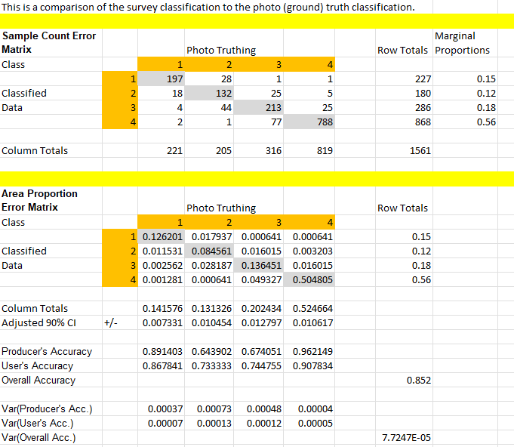

This matrix is a result of the comparison of an in-person verification of 95 survey points to verification made from photos.

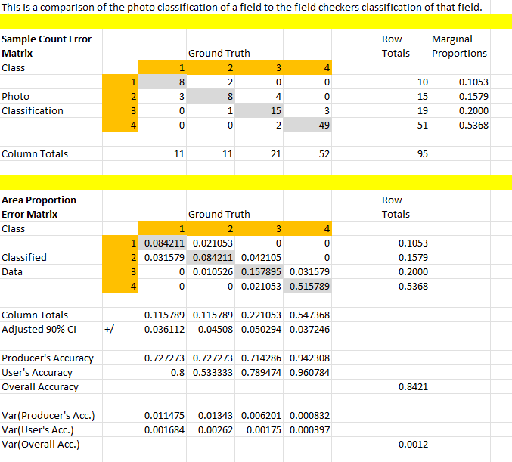

This accuracy report was created from the photo reviews for each survey team. Based on these results, the data collected by the team for the Robert E Lee survey unit (highlighted in yellow) did not meet the minimum accuracy requirement and was not submitted for inclusion in the Bay Model. Data from the 2015 tillage survey was reported for this survey area, and this area will be surveyed during 2024 to collect updated data for next year’s submission.

